SAPPER JAMES WOOD
5867 – 3rd Tunnelling Company

At Nightcaps, South Island, New Zealand in 1883 was born James S. Wood the son of James and Mary Elinor (nee McLauchlin) Wood. The family came to Helensburgh, New South Wales, Australia initially and he married on 13 January, 1912 at Woollahra, Sydney to Annie Greenfield. In 1915 he was a miner at the Killingworth Colliery.

At the recruiting depot at Teralba, NSW on 8 May, 1916 the thirty-two-year-old married miner applied to enlist for active service abroad and passed the preliminary medical examination. Personal particulars taken show he was 177cms (5ft 9½ins) tall with a chest measurement of 94cms (37ins). Declared fit his application was accepted by the recruiting officer.

Attestation forms describe him further weighing 68kgs (150lbs) with a fair complexion, hazel eyes that tested to good vision and brown hair. Distinctive mark was a purple 3inch scar and religious faith Church of England. Next-of-kin nominated was his wife Anna Maud Wood of Killingworth, NSW allotting three-fifths of his pay in support of her. He took and signed the Oath of Allegiance the same day.

He was allotted for basic training to the Newcastle Depot Battalion on 22 May, 1916 at Broadmeadow camp.

While home on leave the following farewell took place at Killingworth and reported in the:
Newcastle Morning Herald and Miners’ Advocate Tuesday June 20, 1916:
KILLINGWORTH – SOLDIERS FAREWELLED
An enjoyable evening was spent at the Killingworth Hotel on Saturday, when the mechanics and staff of the Killingworth Colliery entertained four of their number, who have recently enlisted, namely, Privates John M’Millan (company’s weighman), Dan M’Millan (fitter) Arthur Farrar (carpenter) and Corporal William Mussen (deputy). Mr T.W. Kennaway, head of staff, who was voted to the chair, called upon Mr T. Hindmarsh, to present the abovenamed privates with a fountain pen and periscope each.
Corporal Mussen briefly responded for himself and comrades. Privates James Lennox, James Woods, John Horn, D. Punton and Corporal Horace Wilson, all of Killingworth were also present and were toasted, the chairman explaining that these would be publicly entertained latter by the patriotic committee.
The memory of the departed comrades. Privates William Ingess and Thomas Woods killed in action at Anzac and Private Clarence Horn, who died in hospital at Ismailia, Egypt, was drunk in silence, all standing. Article abridged

On 5 July, 1916 was transferred to the Miners’ Corps training camp at Seymour, Victoria and joined for further training the November, 1916 Reinforcements to the Tunnelling Companies. His rank was Sapper with the regimental number 5867.

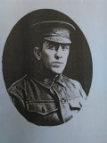
The 516 Reinforcements departed Melbourne, Victoria on October 25, 1916 at 1.30pm aboard the transport HMAT A38 Ulysses.
Sapper James Wood
Photo – Virtual War Memorial Australia website

The Australian coastline disappeared from view on October 30, 1916 with the port of Durban reached at 11.30am on November 13, 1916. Windy weather was experienced going around the Cape and arrived at Cape Town at 7am on November 19. Sierra Leone was the next port of call but their departure was delayed until December 14, 1916 as it was not safe to proceed further.

Arrived at Plymouth, England on December 28, 1916 after 65 days at sea, with the troops disembarking at 1.30pm and detrained to the station at Tidworth and marched in to Perham Downs the following day for further training for the front at the Aust. Details Camp.

The Reinforcement proceeded to France from Folkstone on 28 January, 1917 on the troopship S.S. Onward arriving at the Aust General Base Depot a day later.

On 6 February was taken on strength with the 3rd Tunnelling Company.

In the After War Report of the 3rd Tunnelling Company the following was recorded:

“During the month of January, 1917, one thousand nine hundred and fifteen feet (1915 feet) of 6’ x 3’ galleries were driven in all faces in the Hill 70 mining system under somewhat difficult conditions. Bad ventilation and long tunnels prevented a natural flow of fresh air & forced ventilation by means of hand-powered air pumps had to be resorted to. Wet conditions also hampered work.

On 6/2/17 2/Lt Trebilcock reported with a draft of 95 O.R. as reinforcements.”

He received gifts of comfort sent from the Goldfield Women’s Club, Kalgoorlie and each recipient signed the letter of Thanks and reprinted in the:
Western Argus (Kalgoorlie) Tuesday February 13, 1917:
GIFTS FOR THE SOLDIERS
Sapper J. Back, writing from France on Nov 5 to Mrs R.M. Jordan, secretary of the Goldfields Women’s Club, says—
“I have much pleasure in writing you a few lines on behalf of the men in my section, for the kindness bestowed on us by yourself, and the Women’s Club of Kalgoorlie and Boulder, in sending us a packet containing cigarettes, tobacco, socks, mittens, etc. We all enjoy a good smoke, coming as it does all the way from the West and we give great credit to you one and all. Our company has been very lucky up to the present, and I hope it will continue so, that we may be able to come back and thank you personally. Excuse this short note of thanks; I am a poor one with the pencil or pen, for this is not in a soldier’s line. But for all that, our hearts are all back there with you. So now I will conclude by sending our best of wishes and the compliments of the season to you all.”
The undersigned signatures of soldiers who received gifts were attached— J. Wood Article abridged

He went sick on 17 May, 1917 to the 17th Field Ambulance with Bronchitis then was moved to the 1st Casualty Clearing Station. On May 21 was conveyed on Ambulance Train no.14 to the 13th Stationary Hospital in Boulogne. Left from the 83rd General Hospital, Boulogne on 10 June and invalided to England on the hospital ship St Andrew being admitted to the 1st Birmingham War Hospital, Rednall the next day. Sapper was reclassified with B2a debility by the medical board.

On 9 July, 1917 was transferred to the 3rd Auxiliary Hospital at Dartford until discharged to furlough on 3 August and to report at Perham Downs on 17 August. On 10 October marched out of the No. 1 Command Depot at Sutton Veny to the No. 2 Command Depot at Weymouth until 7 January, 1918 then sent to the No. 4 Command Depot at Hurdcott.

On 14 April left for the Overseas Training Brigade at Deverill and proceeded to France on 2 May from Southampton arriving a day later to the Aust General Base Depot and left to re-join his unit on May 6 and returned on 8 May, 1918.

He was with his unit when Peace was declared and the Tunnelling Companies remained on the front as part of the Army of Occupation assisting with rehabilitation of their district by clearing roads and bridges of booby traps and delayed action mines left by the enemy.

His last payment was made in France on 17 January, 1919.

Orders were received on 10 March, 1919 to report to the Aust Infantry Base Depot and left from Havre on 17 March arriving in England the next day marching into the 2nd Training Brigade at Codford to await their voyage home.
After demobilisation Sapper Wood embarked on 11 May, 1919 for return to Australia on H.T. Zealandia. Base Records advised his wife that he was on his way home.

This news was shared in the:

Newcastle Morning Herald and Miners’ Advocate Saturday June 21, 1919:
KILLINGWORTH
Mrs James Wood, of Killingworth, has been notified that her husband, Sapper James Wood, is returning by the transport Zealandia, due in Melbourne June 26. He left with the 3rd Tunnelling Co.
The transport reached Melbourne (3rd Military District) on 28 June, 1919. News of their arrival was reported in the:
The Argus Monday June 30, 1919:
DISEMBARKATION DELAYS – BERTHING ARRANGEMENTS FAIL – SCENES OF CONFUSION
Inconvenience and annoyance were caused to thousands of relatives and friends and hundreds of returned men by the delay in berthing the transports Zealandia and Orontes on Saturday afternoon, due, according to the military officials, to the naval authorities.
The Zealandia was originally timed to disembark troops at 9 o’clock on Sunday morning, but word was received at midday on Saturday that the vessel would berth at the New Pier, Port Melbourne, at 4 o’clock on Saturday. This hour was subsequently extended to 5, and then to half-past 5 o’clock. Finally, the troops reached Sturt-street half-past 6, and were granted to leave until a quarter-past 2 to-day.
Article abridged
News of their impending arrival in Sydney (2nd M.D.) of 439 men for New South Wales and 140 for Queensland was placed in the:

Sydney Morning Herald Tuesday July 1, 1919:
RETURNED SOLDIERS – ARRIVING TO-DAY
The following are the altered arrangements for the reception of returned soldiers by the Zealandia, the Orontes, and the Wahene, who will arrive in Sydney to-day.
Holders of tickets marked “Zealandia” or “Wahene” will be admitted to the Anzac Buffet shortly before 9 a.m. Those who have tickets marked “Orontes” will be admitted at 2 p.m.
Troops by the Wahene and the Zealandia will disembark at 9 a.m.
Cars numbered on the Red Cross register from 54 to 159 are required to be at No. 1 wharf, Woolloomooloo, at 2.30 p.m.
Article abridged
Newcastle Sun Friday July 2, 1919:
KILLINGWORTH WELCOME
Private J. Woods, Horn and Walker arrived home last night and were met at the Barnsley platform by representatives of the Repatriation Committee and the Girls’ League. The soldiers were conveyed to their respective homes in Mr Brownlee’s motor.
A public welcome was extended to the five returned heroes at the School of Arts. Mr Humble presided and read an apology from Mr and Mrs T. Kennaway, stating that some members of the family were indisposed they were unable to attend. Mr Humble extended to the returned men a cordial welcome and spoke in appreciation of their deeds. The returned men in responding spoke of the work of the Red Cross and Comfort’s Fund Committee and Girls’ League, who were to a certain extent responsible for the winning of the war, and thanked them all for the many gifts and other kindnesses received at their hands.
Harmony and dancing were indulged in till midnight.
Article abridged

Returned soldiers to the district were welcomed home with reports of the function appearing in the:

Newcastle Morning Herald and Miners’ Advocate Thursday July 3, 1919:
KILLINGWORTH
Five returned soldiers were welcomed home on Tuesday evening. They were Lieut. Frank Thomas, Sappers W. Walker and J. Woods, and Private J. Storer and J. Horne. The chairman, Mr E. Humble, read an apology from Mr and Mrs T.W. Kennaway, who, owing to illness in the family, were unable to be present. In welcoming the soldiers, the chairman congratulated them and their relatives and friends on their safe return. Miss Craig, on behalf of the Girls’ League, extended a welcome, and Mrs G. Blatchford, president of the Red Cross, presented the citizens’ medal, and welcomed each man on behalf of the Red Cross and Comforts Fund. The soldiers, in responding, spoke appreciatingly of the work done by the ladies’ committees, and thanked them and the citizens for their kindness. A musical item was rendered by Miss Brownlee and Miss Phyllis Nelson entertained the audience with two amusing recitations. Dancing was indulged in to music supplied by Misses Sneddon and A. Ross, and Messrs M'Manus, Jefferson and Winter, Mr J.B. M’Manus was M.C.
He participated in the procession to celebrate the Children’s Peace Day at Killingworth and presented medals to the children at the Public School and the day’s events were reported in the:
Newcastle Sun Monday July 21, 1919:
KILLINGWORTH PEACE
A large number of citizens and children assembled at the Killingworth Public School on Friday to celebrate the “Children’s Day” and distribution of the medals. Mr J. Simpson, principal of the school stated the occasion of the gathering and read the address of Mr Bean. Mr Simpson asked the returned soldiers, Private C. Faith and Sapper J. Woods, to make the first presentations of medals. Mr Humble thanks the children and remarked on their smiling faces. Peace Day was merrily kept in this small township. A procession marched to the football ground where a children’s picnic took place. The procession was headed by all the local returned men in uniform, then the Red Cross, the Girl’s League, the school children carrying banners, and flags of all descriptions. A pleasant day was spent, the special events being the children’s races. Light refreshments were served by the ladies’ committee. In the evening a concert and dance were held in the Literary Institute.

Military Discharge was issued in Sydney (2nd M.D.) on 3 November, 1919 on termination of his period of enlistment. He was issued with a Statement of his Medical History while with the Aust Imperial Forces on 19 September, 1919.

In Memoriam notices were placed for his brother and his wife killed in the war in the:
Newcastle Morning Herald and Mining Advocate Thursday December 16, 1920:
ROLL OF HONOUR
GREENFIELD—In loving memory of our dear brothers, Pte Albert, killed in action December 16, 1916, aged 21 years, also Pte Stephen, killed in action July 23, 1916 aged 23 years.
Always remembered by their loving sister and brother-in-law, Annie and James Wood, Killingworth.

For serving his country Sapper 5867 James Wood, 3rd Tunnelling Company was issued with the British War Medal and the Victory Medal. [His service documents have this page missing.]

The Sydney branch of the Repatriation Department requested a copy of his service records from Base Records which were compiled on 31 March, 1921.

He appeared in the Wallsend Police Court for stealing coal as reported in the:
Newcastle Sun Wednesday March 16, 1921:
KAISERS AT COURT – COAL WHICH DISAPPEARED – CASES FROM WESTY
At West Wallsend Police Court yesterday, before Mr Le Brun Brown, S.M.:
James Wood and George Wallace, charged with stealing coal, the property of the Commonwealth, were fined 20s and 1s 6d costs each. The evidence showed that the coal, which is at grass at Killingworth, has bene gradually disappearing for a long period. Constable Stewart arrested both men. In Wood’s case the amount taken was 2cwt, and Wallace’s case [word cut off]

A further tribute to their brothers killed in action was in the:
Newcastle Morning Herald and Miners’ Advocate Wednesday December 16, 1925:
ROLL OF HONOUR
GREENFIELD—WOOD –A tribute of love to the memory of Private Stephen Greenfield, killed in action December 16, 1916 and Private Albert Greenfield, killed in action July 23, 1916, also Private Thomas Wood, killed in action September 21, 1915, beloved brothers of Annie and James Wood, Killingworth.

From 1930 to 1937 they are listed residing at Killingworth with his occupation as a miner.

A further request for his Service Records by the Repatriation Commission was completed by Base Records on 18 March, 1937.

Mrs Annie Wood died on 10 April, 1957 aged 63 years.

James Wood passed away on 4 May, 1960 at 76 years of age. Interment took place in the old section of West Wallsend General Cemetery in section 3 within row S in plot no.2 with his wife.

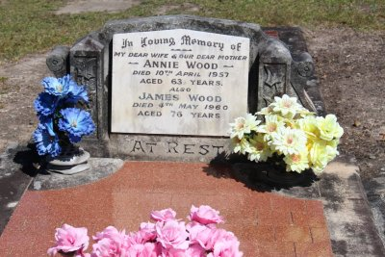
Their grave in West Wallsend General Cemetery, NSW
Photo sourced from Find-a-Grave contributed by Forget Me Not

His service is commemorated on the War Memorial, Killingworth, NSW listed under the 1916 enlistees.

His brother also served.

PRIVATE THOMAS WOOD
1030 – 17th Battalion

Thomas Wood was born at Bulli, South Coast, New South Wales on 22 October, 1891 the son of James and Mary Elinor (McLoughlin) Wood. He was educated at the Helensburgh Public School and by 1914 was working at the Killingworth colliery.

At the recruiting depot in Sydney (2nd Military District) on 2 February, 1915 the single twenty-three-year-old miner applied to enlist for active service abroad and passed the medical examination. Described in Attestation forms as 169cms (5ft 6½ins) tall, weighing 64.5kgs (142lbs) with a chest expansion of 76-84cms (30-33ins) and a fair complexion with blue eyes and light hair. Religion was Roman Catholic.
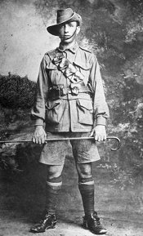
Next-of-kin nominated was his mother Mrs Mary Wood of Helensburgh, NSW.
Private Thomas Wood
Photo sourced from Aust War Memorial

The Oath of Enlistment was signed and taken at Liverpool camp, near Sydney on 3 February, 1915. After basic training he was allotted on 4 April, 1915 to C Company, 17th Battalion, 5th Infantry Brigade at Liverpool, NSW. His rank was Private with the regimental no, 1030.

The Reinforcements embarked on 12 May, 1915 at Sydney on board the HMAT A32 Themistocles under Master of the Ship Captain Percy J. Collins. The transport docked at Colombo on 30 May and left the same day arriving at the Suez, Egypt on 12 June, 1915 after a voyage of thirty-two days.

The Reinforcements proceeded to the Gallipoli Peninsula and he was killed in action on 21 September, 1915 aged twenty-three years.

His burial took place in Shrapnel Valley Cemetery in plot A, row 4 in grave no. 6 with Chaplain J. Murphy officiating.

Announcement was placed in the:
Sydney Morning Herald Monday October 18, 1915:
OUR MEN OF GALLIPOLI
PRIVATE WOOD
Private Thomas Wood, of the 17th Battalion, who has been killed in action, was a son of Mr and Mrs Wood, of 462 Riley-street, Surry Hills. He was born in Helensburgh 23 years ago, and was employed in the Killingworth colliery.

A year later the following appeared in the In Memoriam section of the:
Daily Telegraph Thursday September 21, 1916:
ROLL OF HONOUR
WOOD—In sad remembrance of our dear brother, Private Thomas Wood, who was killed in Gallipoli, on the 21st of September, 1915, aged 23 years.
Inserted by his loving brother and sister, Sapper James and Annie Wood, Killingworth. Article abridged

His name is commemorated at the Australian War Memorial in the commemorative area on panel 84 and his name is inscribed on the Killingworth War Memorial.

His mother received his war memorabilia.
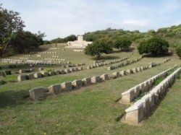
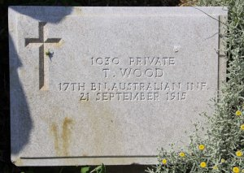
LEST WE FORGET
Photo of grave marker sourced from FindaGrave contributed by DC
Photo of Shrapnel Valley
by kind permission of
The War Graves Photographic Project
www.twgpp.org

His grave can be located in Shrapnel Valley Cemetery, Gallipoli Peninsula, Turkey.
Two of Annie’s brothers also died serving their country:

PRIVATE ALBERT GREENFIELD
774 – 34th Infantry Battalion
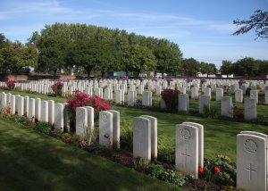
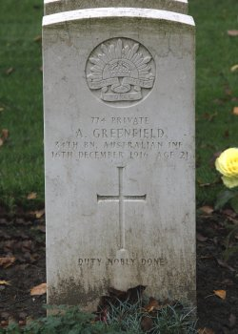
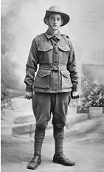
Photo of headstone and cemetery by kind permission of
The War Graves Photographic Project
ww.twgpp.org

Albert Greenfield was born in Yorkshire, England about 1895 son of Samuel and Isabella Greenfield and came to Australia at the age of eight years and was educated at the Public School then worked at the Killingworth Colliery, NSW as a miner.

Enlisted for active service abroad and passed the medical examination. Was allotted to the Reinforcements to the 34th Infantry Battalion in the rank of Private with the regimental number 774 and embarked from Sydney on 2 May, 1916 on the transport A20 HMAT Hororata.

He was killed in action in France on 16 December, 1916 aged 21 years with burial taking place in Cite Bonjean Military Cemetery, Armentieres, France.

Grave location is in plot three, row C in grave 1 of Cite Bonjean Military Cemetery France.
Pte Albert Greenfield
Photo sourced Aust War Memorial

He is commemorated in the Commemorative area of the Australian War Memorial on panel 23 and his name is inscribed on the Killingworth War Memorial.

Newcastle Herald - 28 March 1917:
THE LATE PRIVATE GREENFIELD.
Mrs. Greenfield, of Killingworth, has received letters relating to the death of her son, Private Albert Greenfield, who, was killed in action is France. Private Lyle Murray, who was a great friend of Private Greenfield, states that he was killed as he was getting over the parapet after doing duty at a listening post in No Man's Land. He was to get a spell of two hours, but was caught by German machine gun fire. Private Murray hastened to get assistance to convey him to a dressing station, but he died before the A.M.C. was reached. His personal effects were to be forwarded to his relatives.
Sergeant Robert J. Kay, in his letter, says that Private Greenfield was struck in the back by four bullets. He speaks most highly of his character as a man and as a soldier, and states that his end was greatly regretted.
Chaplain, the Rev. A. L. M. Cook, also writes, expressing his sincere regret, and offering his condolences to the relatives of the deceased soldier.
LEST WE FORGET

PRIVATE STEPHEN GREENFIELD
3325 –1st Infantry Battalion
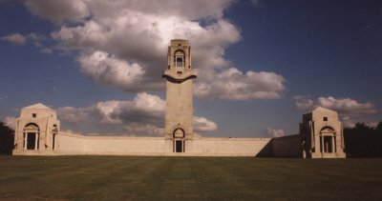
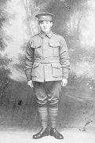
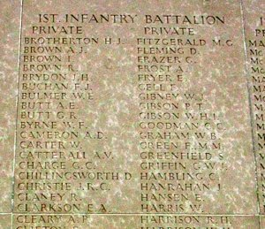
Pte Stephen Greenfield
Photo Aust War Memorial
Stephen Greenfield came to Australia at nine years of age having been born in Yorkshire, England about 1894 the son of Isabella and Samuel Greenfield. Received early education at the Public School and went to work at the Killingworth Colliery, NSW.

Passed the medical examination on enlistment and allotted to the 1st Infantry Battalion Reinforcements. Embarked from Sydney on 5 October, 1915 on the troopship A32 HMAT Themistocles.

He was killed in action between 22 July and 25th July, 1916 at twenty-two years of age at the Battle of the Somme
.
The major contribution of Australian troops to the Somme offensive was in the fighting around Pozières between 23 July and 3 September.

The 1st, 2nd and 4th Australian Divisions suffered more than 24,000 casualties at Pozières, including 6,741 dead. Official war correspondent C.E.W. Bean described the small village as “more densely sown with Australian sacrifice than any other place on earth”.
Photo of Villers Bretonneaux Memorial by kind permission of
The War Graves Photographic Project - www.twgpp.org

He is commemorated on the Australian War Memorial at Villers-Bretonneaux, France for those soldiers with no known grave.
He is also commemorated on the Aust. War Memorial in the commemorative area on panel 29 and his name is inscribed on the Killingworth War Memorial.
Newcastle Morning Herald and Miner’s Advocate, NSW – Tuesday 12 September 1916:
KILLINGWORTH.
A service in memory of the late Private Stephen Greenfleld, who was recently killed in action in France, was conducted by the Rev. G. M. Brown, in St. Peter's Anglican Church, Killingworth, on Sunday evening. The church which was too small to contain all who attended was draped with national flags and a mass of beautiful white flowers, the lectern itself being draped in purple, showing narrow bands of white. The Rev. Mr. Brown spoke on the text "Where have they laid him, come and see." Their young friend had laid down his life for his King and country's liberties, and was laid to sleep in sunny France, which would once more become a garden when peace had been won by the heroic sacrifices of such as he. The service was concluded to the strains of the "Dead March" in "Saul."

LEST WE FORGET

Memorial notices were placed by family members in the:
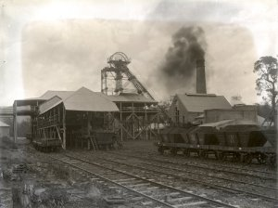
Newcastle Morning Herald and Miners’ Advocate Wednesday December 16, 1925:
ROLL OF HONOUR
GREENFIELD—WOOD –A tribute of love to the memory of Private Stephen Greenfield, killed in action December 16, 1916 and Private Albert Greenfield, killed in action July 23, 1916, also Private Thomas Wood, killed in action September 21, 1915, beloved brothers of Annie and James Wood, Killingworth.
Killingworth Colliery in 1903 where they were all employed
Photo sourced from Newcastle University

© Donna Baldey 2022
www.tunnellers.net

The brothers Wood and the brothers Greenfield are all commemorated on the Killingworth War Memorial [Tunneller marked with yellow star – other Units with red star]
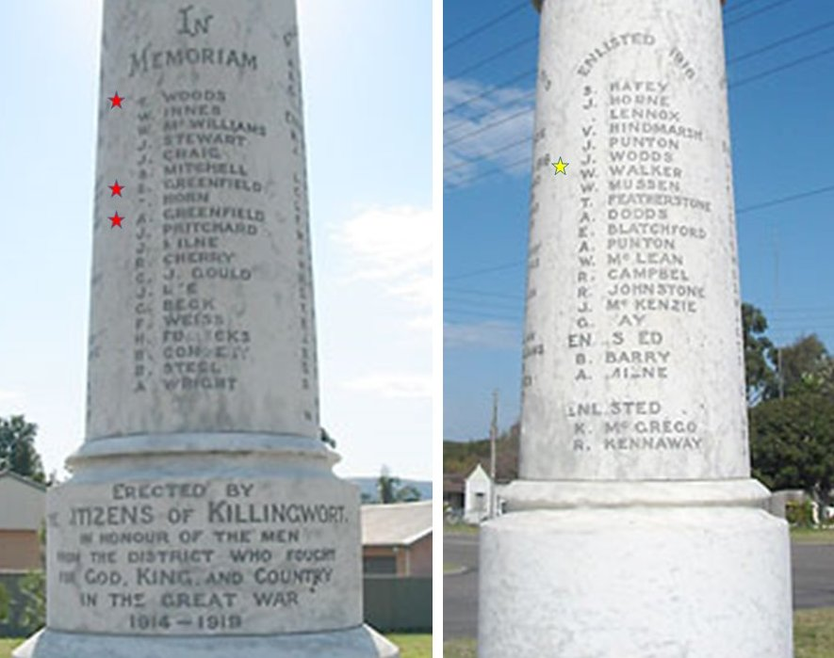
Killingworth War Memorial
Photo sourced from Places of Pride website – Killingworth Memorial

