SAPPER PETE WISHKENLSKI
7815 – 2nd Tunnelling Company

Slonim, Belarus is a city in the Grodno Region located at the junction of the Ščara and Isa Rivers. In the second half of the 18th Century the Polish-Lithuanian Commonwealth was dismantled into three partitions and divided among its neighbours of Prussia, Habsburg Austria and Russian Empire which took the largest portion of the territory. Slonim was in the area of the Russian Empire in 1795. In 1897 it was the fourth largest city of the Governorate until 1915 when the German Army captured the town.

Pieter Wiselenski was born on 6 December, 1895 the son of Adam and (mother’s name not given) Wiselenski in Slodim, Russia. Around the age of eighteen years, he stated he went to the United States of America staying until 1917 when he came to Brisbane, Queensland on the Canadian Sailing Vessel David David arriving on 10 July, 1917.

Six days later at the Recruiting Depot in Brisbane (1st Military District) on 16 July, 1917 the twenty-two-year-old labourer applied to enlist for active service abroad and passed the preliminary medical examination. His address was the Adelaide Boarding House, South Brisbane. Declared fit his application was accepted by the recruiting officer.

Attestation forms were completed the next day and describe him as 163cms (5ft 4ins) tall, weighing 65.9kgs (145lbs) with a chest expansion of 92-97cms (36-38ins) and a fair complexion with poor vision in one of his blue eyes and good sight in the other and had fair hair. Distinctive marks were three vaccination scars on his left arm and two small scars on the right side of his chest. Religion was Greek Orthodox. Next-of-kin nominated was his sister Miss Annie Wishkenlski of Slonum, Russia. He had to sign a Statutory Declaration that his father and mother were both born in Russia; he was born in Russia and not of German, Austrian, Bulgarian or Turkish parentage. He signed and took the Oath of Allegiance the same day.

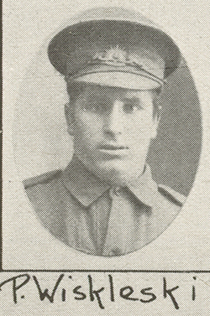
Basic training commenced at Enoggera Barracks with the No. 1 Depot Battalion from 18 July to 2 August, 1917 then was transferred to another section until August 22. Home leave was granted during this time. Further instruction was with the 10th Reinforcements to the 52nd Battalion until 5 September, 1917 and allotted to the Miners’ Depot the following day. A transfer to their training camp at Seymour, Victoria followed and on September 13 was sent to Bendigo for specialised training to 2 November with the November, 1917 Reinforcements to the Tunnelling Companies. They returned to Seymour until November 20 before spending the night at Broadmeadows camp, near Melbourne in preparation for departure. Military authorities noted his Will was lodged with them and his rank was Sapper with the regimental number 7815 under the name Wishkenlski.
Photo Supplement to The
Queenslander 3 Nov, 1917

The troopship HMAT A71 Nestor departed Port Melbourne, Vic on November 21, 1917 with 168 Reinforcements on board. The voyage of twenty-five days duration terminated at the Suez on December 15, 1917 and the men disembarked going to the Australian Infantry Camp, Suez the same day. They entrained for Alexandria on January 4, 1918 and marched into the Australian Camp, Gabbary, in Alexandria on January 5. They boarded on January 8, 1918 the Transport E620 Abbasiah, disembarking at Taranto, Italy on 12 January.

It was an unusual journey for the troops to undertake the weeklong train travel from Taranto to Cherbourg, France, and to then cross the English Channel to Southampton, England disembarking on January 24, 1918. A further entrainment completed their journey to Tidworth and they marched into No. 3 Details Camp at Parkhouse for further training for the front.

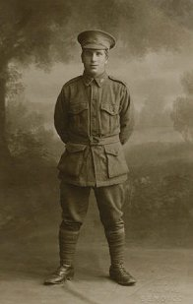
The Reinforcements proceeded overseas from Southampton to France on 15 March, 1918 arriving the following day at the Aust General Base Depot in Rouelles. Sapper left the Aust Corps Depot at Caestre on 20 March for the 2nd Tunnelling Company and taken on strength on March 24.
Photo sourced from Russian Anzacs website supplied by Wiselenski Family

The day he arrived the enemy was advancing and all Divisional Headquarters moved back. By 9 a.m. the enemy had taken Combles and Sailly Saillisel and were rapidly advancing on Le Transloy. Orders were received to evacuate camp and the Company moved to Longueval leaving three officers and 100 other ranks as a rear guard and get the baggage away which was completed by noon. At 11 a.m. while at Longueval orders were received from C.E. 5th Corps to march to Pozieres.

He went sick on 24 June, 1918 to the 15th Aust Field Ambulance with P.U.O. (Pyrexia (fever) uncertain origin) and moved to the 20th Casualty Clearing Station and discharged to duty on 30 June.

Sapper proceeded on leave on 9 November, 1918 and while away Peace was declared and he returned to duty on November 17.

The Tunnelling Companies remained on the front as part of the Army of Occupation assisting with rehabilitation of their districts by clearing roads and bridges of booby traps and delayed action mines left by the enemy.

On 5 December, 1918 he was to report to the Aust General Base Depot for a Medical Board review and decided to return him to England for demobilisation. Arrived at Southampton on 10 December and to report to the No. 2 Command Depot at Weymouth.

Disciplinary action was taken for the following:
Offence: Verne camp 29/12/18 Weymouth using obscene language to
Superior officer
Award: 21 days F.P. No. 2 [field punishment] by C.O. 30/12/18
Total forfeiture: 21 day’s pay

Sapper Wishkenlski embarked for Australia on 7 February, 1919 on board the hospital ship Lancashire. The transport docked in Melbourne (3rd Military District) on 24 March, 1919 with the Victorian troops going into quarantine. News of their arrival was published in the:
The Argus Tuesday March 25, 1919:
SOLDIERS IN QUARANTINE.
The transport Lancashire arrived in Port Phillip yesterday and landed her Victorian troops in quarantine. They will be released on Monday next, and will disembark at the New Pier, Port Melbourne, at 10 o'clock on that day. The munition workers from the ss City of Cairo, who entered quarantine on Sunday, will also land on Monday.

The troops for other States continued on by the Lancashire arriving in quarantine on March 29. It appears that he disembarked at Melbourne (3rd Military District).

Military Discharge was issued in Melbourne (3rd M.D.) on 23 April, 1919 as medically unfit.

He married Mary Eliza Revell in Melbourne in 1919 and became part of the Soldiers’ Settlers Scheme as a farmer. Their address was Research Farm, Werribee with his occupation as a farmer.

The British War Medal (71279) and the Victory Medal (65119) were issued to Sapper 7815 Pete Wishkenlski, 2nd Tunnelling Company for serving his country.

These medals were not collected at the designated barracks and returned to Base Records on 10 May, 1923. The Medals Section sought his address from Repatriation Records and sent their form dated 27 May, 1924 to him care of C. Revell, 31 Raphael Street, Abbottsford, Vic and he completed his address for posting of the medals to the Red Cliffs Post Office on June 7 and were sent by registered post (no.8175) on June 24, 1924.

They were listed at Red Cliffs, Mildura in 1924 and he was a labourer.

A snippet appears in the:
Sunraysia Daily (Mildura) Friday December 30, 1927:
WANTED TO SELL
PONY Jinkor and Harness, good turnout, cheap—P. Wiselenski, Block 307, Red Cliffs.

As World War II loomed in 1939, he applied for Naturalisation at Bruthen, Vic and the following was advertised in connection with this in the:
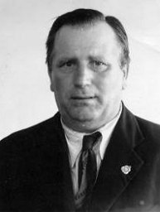
Naturalisation Photo 1939
Photo sourced from National Archives of Aust
Argus Wednesday November 15, 1939:
PUBLIC NOTICES
I, Peter Wilesenski, of Russian nationality, born Slonim Province, Grodno, Russia and resident twenty-two years in Australia, twenty months in the Australian Imperial Forces and twenty-three years in Victoria, now residing at Swan Reach, Victoria, intend to Apply for Naturalisation under the Nationality Act 1920-30.

He was granted a Certificate of Naturalisation No. 109 to Bairnsdale, Vic. on 12 October, 1939.

Further information on his farm work appeared in the:
Gippsland Times Thursday June 12, 1941:
BAIRNSDALE STOCK MARKET
SALES—P. Wiselenski, cow and calf £6-2-6; Article abridged

He re-enlisted during the Second World War from Swan Reach, Vic at Bruthen on 23 March, 1942 with the Australian Army.

Next-of-kin nominated was his wife, Mary Wiselenski. Private V36497 Peter Wiselenski was discharged on 14 June, 1943 from the 13th Volunteer Defence Corps.

In 1943 they were listed at Swan Reach, Bruthen, Vic with his occupation given as farmer. By 1949 they were residents at 15 High Street, Abbottsford, Vic and retired. In 1963 home was 339 Victoria Street, Melbourne.

Peter Wiselenski passed away on 3 July, 1974 aged 81 years in Melbourne. Cremation took place at Fawkner Memorial Park two days later. Ashes were place in the New Lawn Area Tree Niches at Tree 12, niche 5.

Mrs Mary Wiselenski died on 2 August, 1982 and also cremated. Ashes were place with her husband.

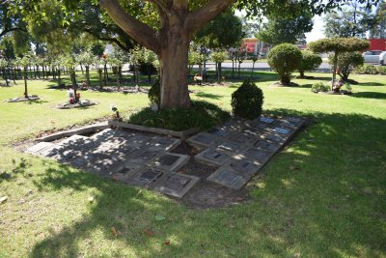
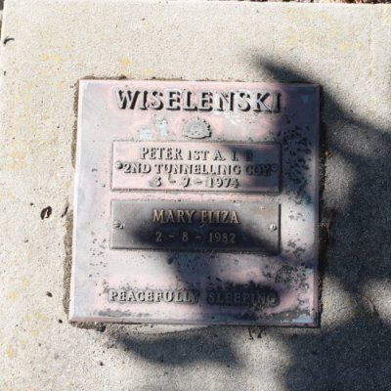
Fawkner Memorial Park, Melbourne, Vic – Tree 12 niches
Photos sourced from Find-a-Grave website
Their son Peter Kelvin Wiselenski also enlisted in World War II with the Australian Army at Caulfield, Vic from Swan Reach. Born at Red Cliffs, Vic on 23 June, 1920 named his father Peter Wiselenski as next-of-kin when enlisting on 30 May, 1940. Service number was VX19582 as a Gunner with the 2 /4 Field Regiment and discharged on 3 December, 1945.
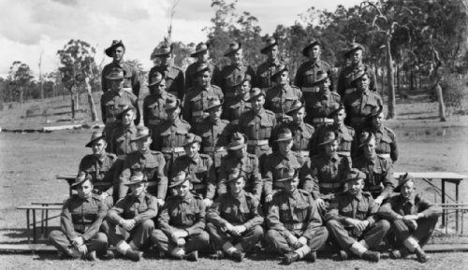
Members of the Brigade Headquarters No. 7 2 /4 Field Regiment – Strathpine, Qld - Gunner P.K. Wiselenski circled
Photo sourced from Aust War Memorial – copyright expired public domain photo

© Donna Baldey 2022
www.tunnellers.net

