SAPPER WALTER PATRICK WINTERFIELD
394 – 1st Tunnelling Company

Allendale, Mount Gambier, South Australia was the birthplace of Walter Patrick Winterfield on 11 December, 1871 the son of John and Ellen (nee Cody) Winterfield.

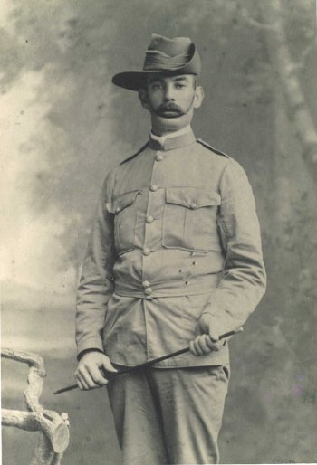
During the Boer War in South Africa, Walter enlisted for service from Allendale East on 21 April, 1901 at Mount Gambier giving his age as twenty-nine years and occupation of shearer to the recruiting officer. He was 176cms (5ft 9ins) tall with a chest measurement of 89cms (35ins). His father was named next-of-kin.

He was allotted to 3rd Troop recruited from the Wallaroo and environs and placed in “B” Squadron in the rank of Private with the regimental number 226 for the 8th Battalion, Australian Commonwealth Horse Regiment. They departed from Port Adelaide on 26 May, 1902 on the transport St Andrew arriving at Durban, South Africa on 19 June. The left wing of the Battalion proceeded to Newcastle under Major Morgan while the right wing remained in Durban. The Regiment was not destined to do active service in the Boer War as the British had crushed the Boer resistance and on May 31 the Peace of Vereeniging had been signed ending the hostilities. The 8th Battalion re-embarked at Durban on 1 July on the ship Manchester Merchant. The Regiment returned via Albany, Western Australia to Largs Bay on 24 July, 1902.

The South Australian Squadron was disbanded in Adelaide on 9 August, 1902. News of their arrival was reported in the:
Adelaide Observer Saturday July 26, 1902:
RETURN OF TROOPS
A sharp lookout was kept for the troopship Manchester Merchant, which was expected to arrive at the Semaphore anchorage on Wednesday morning. The absence of news from Cape Borda created considerable uncertainty, and a heavy fog, which hung like a pall over the anchorage, intensified anxiety. The steamer dropped anchor at Largs at a quarter-past 1 in the afternoon.
The Manchester Merchant had on board 1,461 troops of whom 210 represented A and B Squadrons of the 8th Battalion, Australian Commonwealth Horse. The troops carried the most disappointed lot of men who have yet to return from South Africa, in view of the fact that peace had been proclaimed, ordered the return of all Australians. The 8th Battalion landed in Durban on June 17, disembarked on June 21, and re-embarked six days later.
TROOPERS
W. Winterfield Article abridged

He returned to Allandale East where in 1912 he purchased land with details appearing in the:
Border Watch (Mount Gambier) Wednesday January 24, 1912:
THE GOVERNMENT GAZETTE
Thursday, January 18.
Block 56a, 2 roods, value £40, to Walter P. Winterfield, Allandale East.
Article abridged

At the recruiting depot at Mount Gambier early in September, 1915 the single forty-two-year-old labourer applied to enlist for active service abroad and passed the medical examination. Attestation forms would have been completed but these have been lost.
Acknowledgment to the volunteers was published in the:
Border Watch Wednesday September 1, 1915:
ENLISTMENTS FOR THE WAR
During last week the rush of enlistments slackened considerably at Mount Gambier. Eleven applicants were medically examined, seven were passed, two were deferred and two were considered unfit. Those who were passed were: T.P. Lloyd, M.L. Laidlaw, F.J. Holmes, W.P. Winterfield (Allandale), A.C. Howe, F.D. Douglas and W.J. Meyer. Article abridged

The new recruits left by train for camp in Adelaide (4th Military District) and their send-off was reported in the:
Border Watch Wednesday September 8, 1915:
SOLDIERS FAREWELLED
There was a large crowd at the railway station on Monday evening to say farewell and good-luck to nineteen young men who left to go into camp in Adelaide. The Mayor (Mr J.F. Palamountain), and Colonel F.H. Daniel made speeches, and complimented the young men on their pluck. The Vice-Regal Band attended, and played appropriated music, and on their behalf the President of the band (Ald. E.A. Gerioff) presented two departing bandsmen Messrs E. Hefferman and F. Holmes, with sets of military hair brushes. As the train left cheers were given and the band played the National Anthem. Those who left were W.P. Winterfield (Allandale). Article abridged

News of his arrival for basic training was reported in the:
Register (Adelaide) Wednesday September 8, 1915:
INTO CAMP ON TUESDAY
Following men enlisted and were sent to Field Artillery Camp on Tuesday: W.P. Winterfield
Article abridged
Register (Adelaide) Friday September 10, 1915:
THE COUNTRY – MOUNT GAMBIER
September 7—The following recruits left her by train last evening for the camp:
W.P. Winterfield Article abridged

During leave prior to leaving for Casula camp, near Liverpool, New South Wales to join the Mining Corps he was farewelled with a social evening in Allandale East which was reported in the:
Border Watch Wednesday December 1, 1915:
ALLANDALE EAST
(From our correspondent)
The Allandale Racing Club and others interested, tendered a farewell smoke social to Priv. W.P. Winterfield on Wednesday evening. Priv. Winterfield was home for a few days only prior to embarkation, and the affair had to be got up hurriedly. There were about 20 gentlemen present and Mr J.W. Kemp was voted to preside. Mr John Hennessey, on behalf of the Racing Club, spoke in glowing terms of Priv. Winterfield as a real live member of the Racing Club. Mr Dwyer then presented the departing soldier with a wristlet watch, and wished him God-speed and a safe return. Mr W. Loslett spoke on behalf of the local branch of the U.L.P. Mr J.W. Kemo, for the Allandale Ambulance Association, and Mr J.A. McAskill, on behalf of the Port MacDonnell Rifle Club, all of which Priv. Winterfield has been a member of. Songs were contributed by Messrs Jacobs, G. Moulden, and H. Tibbles; recitations by Messrs W. Loslett, M. Dwyer and McAskill and Mr J.W. Kemp danced the Irish jib. Priv. Winterfield, in reply, thanked the members of the Racing Club for the generous manner in which they had rewarded him for whatever services he had rendered the club. He was going on active service because he knew it was his duty to go. He would counsel every man to join the Rifle Club and get at least some little knowledge of shooting which may be extremely useful some day.

He was also a member of the Australian Natives’ Association and was mentioned at a meeting of the Board of Directors held in Adelaide published in the:
Daily Herald (Adelaide) Tuesday December 7, 1915:
AUSTRALIAN NATIVES’ ASSOCIATION – SOUTH AUSTRALIAN BOARD OF DIRECTORS
The application of the following members for suspension of payment of contributions, who have joined the Australian expeditionary forces, were granted, subject to contributions being paid in full. Mr Gambier branch W.P. Winterfield. Article abridged
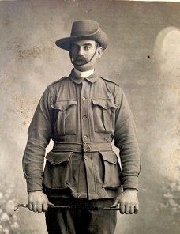
As preparations for embarkation of the Mining Corps took place it was found that his forms of Attestation were missing and subsequently compiled again at Casula camp on 11 February, 1916. Personal particulars taken show he weighed 75kgs (165lbs) with a dark complexion, grey eyes and dark hair. Religion was Roman Catholic and had four vaccination scars on his left arm.
Spr Bob Winterfield
Photo www.Flicker.com/photos

Next-of-kin nominated was his brother James Winterfield of Allendale East, S.A. He signed and re-took the Oath of Allegiance the same day.

His rank was Sapper with the regimental number 394 and allotted to No. 1 Company of the Corps.

At a civic parade in the Domain, Sydney on Saturday February 19, 1916, a large crowd of relations and friends of the departing Miners lined the four sides of the parade ground. Sixty police and 100 Garrison Military Police were on hand to keep the crowds within bounds.

The scene was an inspiriting one. On the extreme right flank, facing the saluting base, were companies of the Rifle Club School; next came a detachment of the 4th King’s Shropshire Light Infantry, then the bands of the Light Horse, Liverpool Depot, and the Miners’ on the left, rank upon rank, the Miners’ Battalion.

The Corps boarded HMAT A38 Ulysses in Sydney, NSW on February 20 and sailed for the European theatre. Arriving in Melbourne, Victoria on February 22 the Miners camped at Broadmeadows for a stay of 7 days while further cargo was loaded.

Another parade was held at the Broadmeadows camp on March 1, the Miners’ Corps being inspected by the Governor-General, as Commander-in-Chief of the Commonwealth military forces.

Leaving Melbourne on March 1, Ulysses arrived at Fremantle, Western Australia on March 7 where a further 53 members were taken on board.

On Wednesday March 8, 1916 the whole force, with their band and equipment, paraded at Fremantle prior to leaving Victoria Quay at 9.30 o’clock.

The ship hit a reef when leaving Fremantle harbour, stripping the plates for 40 feet and, although there was a gap in the outside plate, the inner bilge plates were not punctured. The men on board nicknamed her ‘Useless’. The Miners were off-loaded and sent to the Blackboy Hill Camp where further training was conducted.

The Mining Corps comprised 1303 members at the time they embarked with a Headquarters of 40; No.1 Company – 390; No.2 Company – 380; No.3 Company – 392, and 101 members of the 1st Reinforcements.

Finally departing Fremantle on April 1, Ulysses voyaged via Suez, Port Said and Alexandria in Egypt. The captain of the ship was reluctant to take Ulysses out of the Suez Canal because he felt the weight of the ship made it impossible to manoeuvre in the situation of a submarine attack.
The troops were transhipped to HM Transport B.1 Ansonia, then on to Valetta, Malta before disembarking at Marseilles, France on May 5, 1916. As a unit they entrained at Marseilles on May 7 and detrained on May 11 at Hazebrouck.

A ‘Mining Corps’ did not fit in the British Expeditionary Force, and the Corps was disbanded and three Australian Tunnelling Companies were formed. The Technical Staff of the Corps Headquarters, plus some technically qualified men from the individual companies, was formed into the entirely new Australian Electrical and Mechanical Mining and Boring Company (AEMMBC), better known as the ‘Alphabetical Company.’

Sapper went sick on 7 June, 1916 to the 2nd London Field Ambulance suffering diarrhoea and returned to duty on June 13. He went with dental caries on 5 December to the 47th Divisional Rest Station and two days later re-joined his unit.

Mr W. Dickson care of F.C. Thomas, The Gums, Blackheath, via Horsham, Victoria wrote to Base Records on 25 September, 1916 about this soldier friend of his and gave details of his enlistment at Mt Gambier and sailing from Sydney but did not know his number or battalion and would appreciate at their first opportunity his address. Base Records replied on 4 October, 1916 advising the postal address he required to write to Sapper Winterfield.

The No. 1 Company was officially absorbed into the 1st Tunnelling Company in the field on 24 December, 1916.
Sapper again entered the 47th Divisional Rest Station suffering from piles on 20 February, 1917 and a day later transferred to the 10th Casualty Clearing Station. Was conveyed on Ambulance Train no.26 on February 23 to the 2nd Aust General Hospital at Wimereux remaining a patient until February 27 then invalided to England in the hospital ship Cambria from Boulogne entering the County of Middlesex War Hospital for treatment of haemorrhoids (slight) and myalgia (muscular pain.)

On 16 March, 1917 was discharged to furlough and to report to the No. 1 Command Depot at Perham Downs on March 21. Reported as ordered and classified with B1B debility.

His letter home to his brother was published in the:
Border Watch Saturday May 12, 1917:
AUSTRALIAN IMPERIAL FORCES
Mr Jas. Winterfield, has received word from his brother, Sapper W.P. Winterfield, stating that he was in hospital in London, suffering from trench fever. Sapper Winterfield is attached to the 1st Australian Tunnelling Company, and has spent nine months in the trenches in France.

Proceeded to France from the Overseas Training Brigade on 9 July, 1917 from Southampton arriving at the Aust General Base Depot in Rouelles the following day. Left to re-join his unit on July 13 returning two days later.

Reported to the 4th Aust Field Ambulance on 27 August, 1917 moving to the Divisional Rest Station then progressing to the 12th Aust Field Ambulance. Left on Ambulance Train no.35 for Etaples and admitted to the 26th General Hospital with piles on August 31. Was transferred on 8 September to the 6th Convalescent Depot and a week later moved to the 5th Convalescent Depot in Cayeux till 4 October when discharged to Base Details in Rouelles. Marched out on October 22 and re-joined his unit three days later.

Blue Chevrons were issued to wear on his uniform for serving twelve months abroad.

Discipline was issued for the following:
Crime: While on Active Service AWL from 9 a.m. 11/2/18 to 9 a.m. 12/2/18
Award: Admonished by Officer Commanding 1 Tun. Coy. 12/2/18
Forfeiture: 10 shillings (2 day’s pay)
Went sick on 6 March, 1918 to the 14th Field Ambulance with defective vision and discharged to duty a day later. Went sick on 30 March to the 140th Field Ambulance with piles moving to the 56th Casualty Clearing Station with bleeding piles then transferred on Ambulance Train no.7 to Etaples entering the 26th General Hospital on April 1. Five days after was moved to the 6th Convalescent Depot and appeared before the Medical Board on April 8. Returned to the Aust General Base Depot in Rouelles until transferred to England suffering from Rheumatism on 30 April. Marched in on May 1 to the No. 2 Command Depot at Weymouth. He was at Littlemoor camp from 2 May with No. 1 Company moving to No. 5 Company on May 11 and classed with C2 debility. Occupation given as a farmer.

Sapper Winterfield embarked from Liverpool, England for discharge in Australia on 6 June, 1918 due to Rheumatism on board H.T. Barambah. Base Records advised his brother that he was returning home. This news was shared in the:
South Eastern Times (Millicent) Friday July 5, 1918:
SOUTH-EASTERN SOLDIERS
Mr Jas. Winterfield, of Moorak, has been advised that his brother, Sapper W.P. Winterfield, is returning to Australia. Sapper Winterfield enlisted in September, 1915, and was wounded in France.

The transport docked in transport docked in Melbourne (3rd Military District) on 31 July, 1918 and soldiers for Adelaide (4th M.D.) boarded a train for home. News of their arrival was reported in the:
Daily Herald (Adelaide) Friday August 2, 1918:
LIST “B” RETURN OF INVALIDED SOLDIERS
A number of invalided soldiers comprising of List “B” whose names were published in “The Daily Herald” on July 3, arrived in Adelaide yesterday and were accorded a welcome remarkable for its warmth and sincerity. The city was gay with bunting and the glorious weather prevailing did much to make the circumstances of the home-coming most pleasant.
A large crowd assembled on the railway platform and in the vicinity of the station and as the train pulled in volley upon volley of cheers rang out and were vigorously responded to by the soldiers, each one of whom fairly radiated smiles.
The arrivals number 54 and of these 48 were invalids, 3 returned on duty and 3 returned for “special” reasons. There was a guard of honour at the station consisting of 50 infantrymen in charge of Lieuts. J. Wilkinson and A. Mitchell and the Mitcham Camp Band was also in attendance. The train was met at Murray Bridge by Captain A.N. Campbell and Sergeants K.H. Pritchard D.C.M., M.M. and F. Bowden. Motor cars provided by members of the Automobile Association conveyed the soldiers to Keswick and as they passed through the streets the war veterans had a stirring reception at the hands of the citizens and the “strong posts” which were established at several places along the route.
Article abridged

Disciplinary action was taken for the following after his return:

Offence: Adelaide 29/8/18 (1) disobedience of orders in that he never arrived at
Barracks
While at No. 7 Aust General Hospital (2) AWL from 12.30 p.m. 29/9/18
to 4.45 p.m. 29/9/18
Award: Fined £5 8s and 14 days confined to barracks collectively

Military Discharge was issued in Adelaide (4th M.D.) on 14 October, 1918 as medically unfit – disability rheumatism.

His address given to military authorities was Allendale East, Mt Gambier, S.A.

The 4th Military District forwarded all cards, medical, dental and conduct sheets to Base Records on 16 October, 1918 advising that the soldier had returned and been discharged after serving 2 years and 246 days of which 2 years and 162 days were served abroad.

His name was inscribed on the Port MacDonnell Roll of Honour with the unveiling ceremony published in the:
Border Watch Tuesday February 4, 1919:
PORT MACDONNELL ROLL OF HONOR – THE UNVEILING CEREMONY
Port MacDonnell present quite a busy appearance yesterday afternoon, on the occasion of the unveiling ceremony of the roll of honor recently presented by Mr W.J.T. Clarke, of Mount Schank, to perpetuate the memory of the soldiers of the districts of Port MacDonnell and Caroline, who enlisted in the great European war. The ceremony took place in the Friendly Societies’ Hall, which was gaily decorated for the occasion with flags of Great Britain and her Allies. At a little before 3 o’clock the Port MacDonnell school children, 50 in number, under the supervision of their teachers, Miss Reddan and Miss Madelay, marched from the school to the hall, led by the school band of 11 players, discoursing appropriate music. On the platform of the hall were the Chairman of the Port MacDonnell District Council (Cr. R.C. Hayman), who conducted the proceedings, Mrs W.J.T. Clarke, and Mesdames M.A. Gordon, of Kongorong, L. Kekewich, of Allandale, S. Butler of Mount Schank, and W. Holland of Allandale, the four women in the districts who have the largest number of sone—three each at the war.
THE HONOR ROLL
At the request of the Chairman, Mesdames Butler, Kekewich, Gordon and Holland, amid loud applause, gracefully unveiled the roll, which had been covered with the Union Jack. By doing so a substantial and highly polished roll, of unique design, constructed of mountain ash and mounted with fiddlback blackwood, was revealed. Across the top, in large gold letters were the words “All Honor to those who fought for King and Country, 1914-18, Hds of MacDonnell and Caroline,” and three columns underneath were the following 82 names, also in gold lettering:
W.P. Winterfield, C.J Winterfield, J. Winterfield, J.P. Winterfield
Article abridged

For serving his country Sapper 394 Walter Patrick Winterfield, 1st Tunnelling Company was issued with the British War Medal (10116) and the Victory Medal (10052).

Base Records forwarded a copy of his service records to the Adelaide branch of the Repatriation Commission on 8 March, 1930 as per their request.

He was listed in the Electoral Rolls from 1939 to 1941 at Mt Gambier with the occupation of labourer. He was residing at South Terrace, city in 1943.

Walter Patrick (Bob) Winterfield died suddenly on 21 October, 1943 aged 72 years. Circumstances of his demise was reported in the:
News (Adelaide) Friday October 22, 1943:
WAR PENSIONER’S DEATH
A few minutes after he had walked into the bar of a city hotel yesterday and complained of feeling ill, Walter P. Winterfield, 72, war pensioner, of South terrace, City, collapsed and died.
A civil ambulance removed the body to the City Morgue.

Arrangements were published in the:
News (Adelaide) Friday October 22, 1943:
DEATHS
WINTERFIELD—On October 31, at Adelaide (suddenly), Walter Patrick (Bob) Winterfield, late of Allandale East, formerly of Mount Gambier, late Boer War and 1st A.I.F. Aged 72 years. Requiescat in pace.

FUNERAL NOTICES
WINTERFIELD—The Friends of the late Mr WALTER PATRICK (BOB) WINTERFIELD, late of Allandale East, formerly of Mount Gambier (Late Boer was and First A.I.F.), are respectfully informed that his Funeral will leave the Funeral Parlors 47 Wakefield-street, on SATURDAY at 4.30 p.m. for the A.I.F. Cemetery, West terrace.
FRANK J. SIEBERT, Funeral Directors

Burial took place in the Light Oval, A.I.F. portion of West Terrace Cemetery withing Road 3S in site no. 25.
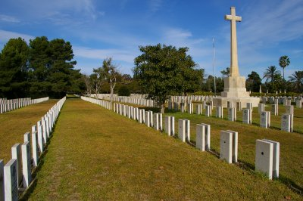
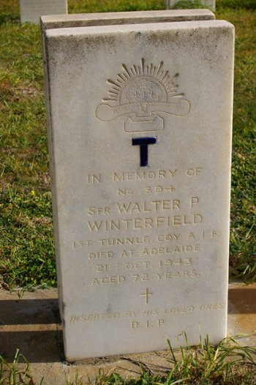
Adelaide War Cemetery,
South Australia
Photos courtesy Heather Pearce

He is commemorated on the Port MacDonnell War Memorial.

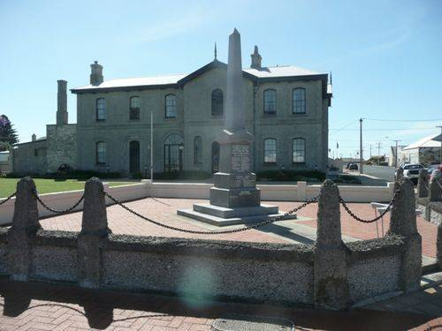
Photo sourced from https://monumentaustralia.org.au

© Donna Baldey 2023
www.tunnellers.net

