SAPPER ROY WILLIAM WELFARE
317 – 2nd Tunnelling Company

Roy William Welfare was born in Grenfell, New South Wales on 28 September, 1893 the son of Walter William and Matilda Ann (nee Wright) Welfare.

At the recruiting depot in Brisbane, Queensland (1st Military District) on 23 September, 1915 the single twenty-one-year-old labourer applied to enlist for active service abroad and passed the medical examination. Attestation forms describe him as 171cms (5ft 7½ins) tall, weighing 65kgs (144lbs) with a chest expansion of 92-97cms (36-38ins) and a dark complexion with light blue eyes testing to good vision and dark hair. Distinctive marks were three vaccination scars on his left arm.

Next-of-kin nominated was his mother Mrs Matilda McIntosh of Crombie Street, Milton, Brisbane. The Oath of Allegiance was signed and taken the same day.

After basic training at Enoggera Barracks was transferred to the Mining Corps at Casula, near Liverpool, New South Wales who were in their establishment phase. His rank was Sapper with the regimental number 317 and allotted to No. 1 Company of the Corps.

At a civic parade in the Domain, Sydney on Saturday February 19, 1916, a large crowd of relations and friends of the departing Miners lined the four sides of the parade ground. Sixty police and 100 Garrison Military Police were on hand to keep the crowds within bounds. The scene was an inspiriting one. On the extreme right flank, facing the saluting base, were companies of the Rifle Club School; next came a detachment of the 4th King’s Shropshire Light Infantry, then the bands of the Light Horse, Liverpool Depot, and the Miners’ on the left, rank upon rank, the Miners’ Battalion.

The Corps boarded HMAT A38 Ulysses in Sydney, NSW on February 20 and sailed for the European theatre. Arriving in Melbourne, Victoria on February 22 the Miners camped at Broadmeadows for a stay of 7 days while further cargo was loaded.

Another parade was held at the Broadmeadows camp on March 1, the Miners’ Corps being inspected by the Governor-General, as Commander-in-Chief of the Commonwealth military forces.

Leaving Melbourne on March 1, Ulysses arrived at Fremantle, Western Australia on March 7 where a further 53 members were taken on board.

On Wednesday March 8, 1916 the whole force, with their band and equipment, paraded at Fremantle prior to leaving Victoria Quay at 9.30 o’clock.

The ship hit a reef when leaving Fremantle harbour, stripping the plates for 40 feet and, although there was a gap in the outside plate, the inner bilge plates were not punctured. The men on board nicknamed her ‘Useless’. The Miners were off-loaded and sent to the Blackboy Hill Camp where further training was conducted.

The Mining Corps comprised 1303 members at the time they embarked with a Headquarters of 40; No.1 Company – 390; No.2 Company – 380; No.3 Company – 392, and 101 members of the 1st Reinforcements.

Finally departing Fremantle on April 1, Ulysses voyaged via Suez, Port Said and Alexandria in Egypt. The captain of the ship was reluctant to take Ulysses out of the Suez Canal because he felt the weight of the ship made it impossible to manoeuvre in the situation of a submarine attack. The troops were transhipped to HM Transport B.1 Ansonia, then on to Valetta, Malta before disembarking at Marseilles, France on May 5, 1916. As a unit they entrained at Marseilles on May 7 and detrained on May 11 at Hazebrouck.
A ‘Mining Corps’ did not fit in the British Expeditionary Force, and the Corps was disbanded and three Australian Tunnelling Companies were formed. The Technical Staff of the Corps Headquarters, plus some technically qualified men from the individual companies, was formed into the entirely new Australian Electrical and Mechanical Mining and Boring Company (AEMMBC), better known as the ‘Alphabetical Company.’

Sapper moved to the No. 2 Company and was officially transferred to the 2nd Tunnelling Company in the field on 29 December, 1916.

Went sick to the New Zealand Field Ambulance on 11 January, 1917 with Influenza moving to the New Zealand Divisional Rest Station. On 21 January, 1917 returned to duty.

Blue Chevrons were issued to wear on his uniform for serving two years abroad.

Proceeded on leave on 18 January and returned to his unit on February 2, 1918.

Influenza sent him to the 26th Casualty Clearing Station on 9 June, 1918 and on June 14 was conveyed on Ambulance Train no.38 to the 32nd Stationary Hospital at Wimereux. Five days later moved to the 10th Convalescent Depot at Escault then discharged to Base Duties on 25 June at the Aust General Base Depot in Rouelles. He re-joined his unit on 12 July, 1918.

He was with his unit when Peace was declared and the Tunnelling Companies remained on the front as part of the Army of Occupation assisting with rehabilitation of their area by clearing roads and bridges of booby traps and delayed action mines left by the enemy.

Leave from France was taken from 13 December and re-joined his unit on 2 January, 1919.

Orders were received on 30 March, 1919 to return to the Aust General Base Depot and departed from there crossing to England on April 4 and marching into the No. 2 Group camp the following day.

He sent sick 9 April to the 1st Aust Dermatological Hospital at Bulford and returned to the Convalescent Training Camp with ure-catarrhal at Parkhouse on April 14 and marched out to the No. 2 Group camp at Sutton Veny on 29 April, 1919.

After demobilisation Sapper Welfare embarked for Australia on 12 June, 1919 on board H.T. Port Darwin. Base Records advised his mother on 10 July that he was returning home.

His name was among those soldiers returning and listed in the:

The troopship docked in Melbourne (3rd M.D.) on 27 July, 1919 with news of their arrival reported in the:
Daily Standard (Brisbane) Wednesday July 16, 1919:
RETURNING SOLDIERS – PER H.T. PORT DARWIN
The following have been listed for return to Australia and are actually en route from abroad.
Spr. R.W. Welfare, 2nd Tunn. Co., Brisbane Article abridged
The Argus Monday July 28, 1919:
RETURNING TROOPS – ARRIVAL BY PORT DARWIN
After a pleasant and uneventful voyage of exactly six weeks from London via Durban, the s.s. Port Darwin discharged 527 troops at Port Melbourne early yesterday afternoon. The men were received at the Sturt-street depot shortly after 3 o’clock, and the whole list was cleared in less than two hours. About 200 men belonging to the New South Wales military district left for Sydney by two special trains, and a few who had enlisted in Perth, Adelaide, or Hobart were conveyed to the Domain camp for temporary accommodation.
Article abridged
New South Wales and Queensland soldiers were entrained to their home states.

Military Discharge was issued in Brisbane (1st M.D.) on 20 September, 1919 on termination of his period of enlistment. The British War Medal (12221) and the Victory Medal (12062) were issued to Sapper 317 Roy William Welfare, 2nd Tunnelling Company for serving his country.

Later that year was living at Moora, Merthyr Road, Fortitude Valley working as a labourer.

In 1925 he was at 458 Upper Roma Street, Brisbane with the same occupation.

He married on 28 August, 1926 in St Stephen’s Cathedral, Elizabeth Street, Brisbane to Ellen Marie Power.

The couple were living at Oxford Street, Paddington in 1931. He was at Hall Street, Newcastle working as a labourer in 1933.

The Brisbane branch of the Repatriation Commission requested a copy of his service records from Base Records which were sent on 7 October, 1936.

Mrs Welfare is mentioned in the following article:
Telegraph (Brisbane) Monday April 26, 1937:
ST STEPHEN’S ANZAC DAY LUNCHEON
Between five and six hundred returned men were entertained at luncheon to-day by members of St Stephen’s Anzac Day luncheon committee in the church grounds. Bases of dahlias, marigolds, chrysanthemums, and palms decorated the tables, arranged in the marquee. Father E. Barry (Presided) Mrs N. O’Brien (hon treasurer) and Miss L. Cavanagh (hon secretary) supervised. Table assistants included Mesdames R.W. Welfare Article abridged

He wrote to Base Records in November, 1937 from 10 Hall Street, Newcastle for a duplicate copy of his Discharge and Discharge Badge to the best of his knowledge were destroyed by fire.

Base Records replied on 1 December, 1937 acknowledging his communication and postal note for one shilling and advised that a Statement of Service takes the place of his lost Certificate of Discharge and a duplicate Soldier’s Badge may be issued on furnishing a Statutory Declaration in terms of the circular enclosed. He completed at statutory declaration on 6th December, 1937 declaring that the circumstances they were lost were destroyed by fire and not in the hands of any other person.
Base Records forwarded these items to him on 14 December, 1937.

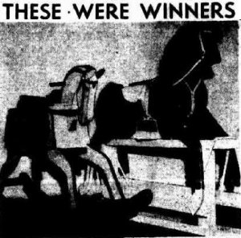
Base Records sent a copy of his service records to the Sydney Branch of the Repatriation Commission on 31 May, 1938.
Courier-Mail (Brisbane) Friday December 7, 1945:
TOYMAKERS EARN JUDGES’ PRAISE – THE PRIZE WINNERS
CLASS I 3rd £2 Roy Welfare, Transcontinental Hotel, George Street—rocking horse
Highly commended: Roy W. Welfare.

Photo caption: Rocking horses which won second and third prizes in the toys of wood section. Horse on right by Mr Roy Welfare, Transcontinental Hotel, Brisbane. (third)
He was a prize winner in the Wooden Toy Makers’ Competition with the following reported in the:
Roy William Welfare passed away on 15 May, 1948 aged 53 years. Family arrangements were placed in the:
Brisbane Telegraph Saturday May 15, 1948:
FUNERAL NOTICES
WELFARE, Roy W.—The Relatives and Friends of Mrs E.M. Welfare, Mrs M. McIntosh, Mr & Mrs T. Welfare & Family, Mr & Mrs ?A. Welfare & Family, Sister Mary Edward, Mr & Mrs W. Hicky, Mr & Mrs L. Walsh & Family, Mr & Mrs D. Patullo & Family, Messrs A.S. Power are invited to attend the Funeral of her beloved Husband, their son, Brother, Brother-in-law & Uncle, Roy William Welfare late 2nd Tunnelling Battn, 1st A.I.F.; to leave St Stephen’s Cathedral, Elisabeth Street, City, This (Saturday Afternoon, at 3.30 o’clock for Lutwyche Cemetery.
K.M. SMITH
Courier-Mail Tuesday May 18, 1948:
DEATHS
WELFARE—On May 15, 1948, Roy William Welfare, dearly beloved husband of Mrs E.M. Welfare, Transcontinental Hotel. R.I.P. Sadly missed.

His wife placed a bereavement notice on his birthday in the:
Brisbane Telegraph Tuesday September 28, 1948:
DEATH NOTICES
WELFARE—Loving birthday remembrance, Roy William Welfare, A.I.F. departed 15th May, last R.I.P. Inserted by his sorrowing wife.

Interment took place in the monumental portion of Lutwyche cemetery within section 5, row 91 in grave no. 57.

Mrs Ellen Welfare was buried on 24 November, 1965 aged 70 years with her husband.

He has a Commonwealth War Grave.
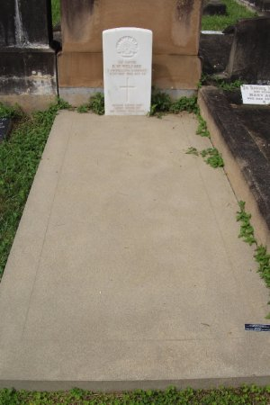
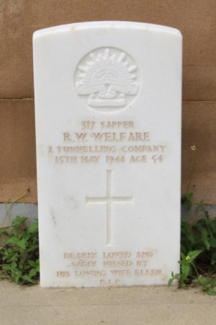
Welfare Graves in Lutwyche Cemetery Brisbane, Qld. Photos sourced from Dept. of Veterans’ Affairs

© Donna Baldey 2023
www.tunnellers.net

