SAPPER GEORGE WATSON
1432 – 2nd Tunnelling Company

Launceston, Tasmania was the birthplace of George Marshall Watson on 30 June, 1877 the son of Thomas and Ann (Marshall) Watson. He married in 1896 at Woonoona, New South Wales to Margaret Shields P. Fitzpatrick and continued to reside in the Wollongong district. In 1913 their residence was Raymond Road, Thirroul and he was a miner.

At the recruiting depot at Victoria Barracks, Sydney, NSW on 18 January, 1916 the thirty-eight year old married miner applied to enlist for active service abroad and passed the preliminary medical examination. Personal particulars taken show he was 174cms (5ft 8½ins) tall with a chest expansion of 88-94cms (34½-37ins) and his postal address was Kembla Street, Wollongong. Declared fit his application was accepted by the recruiting officer.

Attestation forms describe him further weighing 65.5kgs (144lbs) with a medium complexion, good vision in his blue eyes and had brown hair. Distinctive marks were an old scar inside right thigh and two small scars on the back of his neck. Religion was Presbyterian faith. Next-of-kin nominated was his wife Mrs Margaret Watson of Kembla Street, Wollongong and allotted two-fifths of his pay in support of her and their three children.

Reporting to Casula camp, near Liverpool on 24 January, 1916 he was sworn in and allotted to the 1st Reinforcements to the Mining Corps. His rank was Sapper and his regimental number 1432.

His name was added to the Roll of Honour list being compiled by the newspaper and published on:
Illawarra Mercury Friday January 28, 1916:
ROLL OF HONOUR
We are anxious to send a complete list of the men and women that are serving or preparing to serve the Empire that were residents of the Illawarra District:
On Active Service: Watson, George Article abridged

At a civic parade in the Domain, Sydney on Saturday February 19, 1916, a large crowd of relations and friends of the departing Miners lined the four sides of the parade ground. Sixty police and 100 Garrison Military Police were on hand to keep the crowds within bounds. The scene was an inspiriting one. On the extreme right flank, facing the saluting base, were companies of the Rifle Club School; next came a detachment of the 4th King’s Shropshire Light Infantry, then the bands of the Light Horse, Liverpool Depot, and the Miners’ on the left, rank upon rank, the Miners’ Battalion.

The Corps boarded HMAT A38 Ulysses in Sydney, NSW on February 20 and sailed for the European theatre. Arriving in Melbourne, Victoria on February 22 the Miners camped at Broadmeadows for a stay of 7 days while further cargo was loaded.

Another parade was held at the Broadmeadows camp on March 1, the Miners’ Corps being inspected by the Governor-General, as Commander-in-Chief of the Commonwealth military forces.

Leaving Melbourne on March 1, Ulysses arrived at Fremantle, Western Australia on March 7 where a further 53 members were taken on board.

On Wednesday March 8, 1916 the whole force, with their band and equipment, paraded at Fremantle prior to leaving Victoria Quay at 9.30 o’clock.

The ship hit a reef when leaving Fremantle harbour, stripping the plates for 40 feet and, although there was a gap in the outside plate, the inner bilge plates were not punctured. The men on board nicknamed her ‘Useless’. The Miners were off-loaded and sent to the Blackboy Hill Camp where further training was conducted.
The Mining Corps comprised 1303 members at the time they embarked with a Headquarters of 40; No.1 Company – 390; No.2 Company – 380; No.3 Company – 392, and 101 members of the 1st Reinforcements.

Finally departing Fremantle on April 1, Ulysses voyaged via Suez, Port Said and Alexandria in Egypt. The Captain of the ship was reluctant to take Ulysses out of the Suez Canal because he felt the weight of the ship made it impossible to manoeuvre in the situation of a submarine attack. The troops were transhipped to HM Transport B.1 Ansonia, where he was transferred from the 1st Reinforcements to the No. 2 Company of the Corps on May 3. Travelling on to Valetta, Malta before disembarking at Marseilles, France on May 5, 1916. As a unit they entrained at Marseilles on May 7 and detrained on May 11 at Hazebrouck.

A ‘Mining Corps’ did not fit in the British Expeditionary Force, and the Corps was disbanded and three Australian Tunnelling Companies were formed. The Technical Staff of the Corps Headquarters, plus some technically qualified men from the individual companies, was formed into the entirely new Australian Electrical and Mechanical Mining and Boring Company (AEMMBC), better known as the ‘Alphabetical Company’.

The No. 2 Company was officially transferred to the 2nd Tunnelling Company on 29 December, 1916.

The 2nd Tunnelling was selected to work in the sand dunes at Nieuport-Bains on the Belgian Coast. In the Unit Diary of the Company the following was recorded:

“11/8/17
Capt. C.E.W. Bean, Official Commonwealth War Correspondent; Capt. ROSS
Official New Zealand War Correspondent, Lieut. W. DYSON, General List, and
Official Artist to A.I.F.; Lieut. HATHERIN Acting Photographer to A.I.F. came to
see the work of the Unit.
General HARVEY, Inspector of Mines G.H.Q. and Lieut.-Colonel PREEDY,
Controller of Mines, 4th Army visited the work of the Company.”
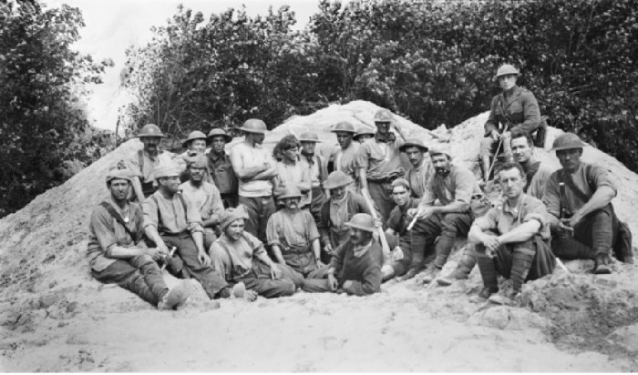
AWM Image ID: E01900 - Belgium: Nieuport-Bains - 11 August, 1917 - Group portrait of Major E. N. Mulligan, Officer Commanding DSO and miners of the 2nd Australian Tunnelling Company, at the mouth of a dugout in a reserve position.
Photo sourced from Major Mulligan collection – copyright expired – public domain. Photographer unknown

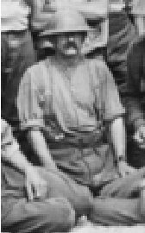
Blue Chevrons were issued to wear on his uniform for serving twelve months abroad.
Spr. G. Watson identified kneeling middle front row

On 3 March, 1918 he went sick to the 149th Field Ambulance with pleurisy and sent to the 48th Casualty Clearing Station and on to the 1st Aust General Hospital in Boulogne on March 6.

He was invalided on 9 March to England on the hospital ship Aberdonian entering the 1st Southern General Hospital at Edgbaston, Birmingham a day later for treatment of Tuberculosis of lung (severe).

On 21 March, 1918 was transferred to the 3rd Auxiliary Hospital in Dartford and appeared before the medical board on March 25.

His Statement of case reads:

Disability: Fibrous Pleurisy
Disability date: 24/2.18
Disability place: France
Essential facts: Gradual onset in cough and pain in right side of chest and shortness of breath. Pain in chest now on deep expiration friction out. Still present in right mid- axillary line at base. Has lost a good deal of weight. Age 43.
Attributed to: Infection
Present condition: Fibrous Pleurisy. Loss of weight. Age 43
Recommendation: Change to Australia 26/3/18
Disability cause: Infection
Permanent: Yes, in cold climate
Labour Market: 50%
Finding: Permanently unfit for general service and temporarily unfit for home service
Approved: 6/4/18

He was discharged to the Training Depot at Dartford and was listed to leave England on 8 April, 1918 on the hospital ship Dunluce Castle but this did not take place.

Two days later Base Records sent the following Telegrams to his wife as follows:
MN 1432/T WOOLANGONG NSW
MRS MARGARET WATSON
KEMBLA STREET
REPORTED SAPPER GEORGE WATSON ILL SEVERE WILL ADVISE ANYTHING FURTHER RECEIVED
BASE RECORDS 12/4/18

MN 1432/T WOOLANGONG NSW
MRS MARGARET WATSON
KEMBLA STREET
WSM
NOW REPORTED SAPPER GEORGE WATSON ADMITTED FIRST SOUTHERN GENERAL HOSPITAL BIRMINGHAM ENGLAND TENTH MARCH TUBERCULOSIS LUNG SEVERE
BASE RECORDS 12/4/18

Sapper Watson embarked for Australia on 12 July, 1918 on board H.T. Port Darwin. Base Records advised his wife on July 27 that he was on his way home. News of their impending arrival was announced in the:
Sydney Morning Herald Thursday 19 July, 1918:
INVALID SOLDIERS RETURNING
A number of invalid soldiers will arrive tomorrow morning.
Contd.
Continues
Friends and relatives who have received tickets marked “R” from the Staff Officer for Invalids and Returned Soldiers will be admitted to the Anzac Buffet at 9 a.m. to meet the men.
Queensland invalids will be taken direct to the Central Railway Station, where they may be seen by their friends. They will leave for Brisbane at 11.15 a.m. The Newtown Men’s Voluntary Aid Detachment will accompany the Queenslanders.
Red Cross motor cars numbered on the register from 174 to 220 are required to be at the No. 1 Wharf, Woolloomooloo at five minutes to 9 a.m.
The V.A.D.’s on duty will be: Petersham, at the wharf, eight girls; Chatswood, at the Anzac Buffet, 20 girls; and North Sydney (St John’s), at the Railway Station, for morning tea and Queenslanders, 10 girls.
The transport docked in Sydney (2nd M.D.) on 17 August, 1918.

He would have appeared before the Disembarkation Medical Board and referred for further treatment.

He attended the Medical Board at No. 4 Aust. General Hospital, Randwick on 26 February, 1920 where his Statement of Case was presented as follows:

Cough, pain in right side of chest – shortness of breath. Pain in chest on deep inspiration – friction put in right mid axillary line at base.
Lost weight considerably lately.
Present condition: Improved
Disability caused by: Military Service
Disability permanent: No
Improvement: 6 months
Labour capacity: 100%
Operation performed: No
Recommendation: Discharge unfit for General Service
Confirmed for Discharge: 28/2/1920 Sydney

Military Discharge was issued in Sydney (2nd M.D.) on 28 April, 1920 as medically unfit.

The same day the Base Records wrote to the Assistant Adjutant General (2nd Military District) that according to records this man was invalided to Australia per “Port Darwin” on 17/8/18 and on 16/12/18 was reported to be still on strength of the A.I.F. As no later report had been received regarding the disposal of this man and would they please advise their Branch of any further information that may be in their possession. The 2nd Military District replied on 6 May in reference to their letter advising that the mentioned soldier was discharged “Medically unfit” on 28/4/1920 vide R.O. 354/20 (S.O.I.&R.S.)

The British War Medal (34174) and the Victory Medal (33740) were issued to Sapper 1432 George Watson, 2nd Tunnelling Company for serving his country.

In 1931 their residence was 25 Victoria Street, Wollongong working as a civil engineer. On 7 October, 1936 the N.F.R. Badge was returned to storage at Base Records.

George Watson passed away on 24 May, 1956 aged 79 years in the Repatriation General Hospital, Concord, Sydney. Cremation took place at Woronora Crematorium under the name Thomas George Watson.

REUNIONS
Former members of the (Alphabet Company) Aust Electrical & Mechanical Mining & Boring Company and Tunnellers’ in Sydney would meet to march in the Anzac Day parade then attend their annual luncheon. Roll Registers for newsletters of this annual event were kept and his name appears as follows:
TUNNELLERS
1934 Watson, G. Railway St (106), Corrimal
LETTERS RETURNED & DECEASED
1960-68 Watson Reported deceased Reveille Sept, issue; confirmed in Nov. issue, 1956
His Commemorative plaque is located on the Wall of Memories, A.I.F. Panel F, Old Section at Niche 67.

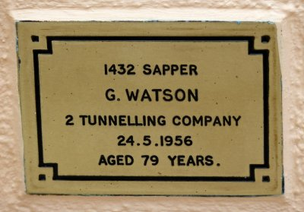
Plaque in Woronora Memorial Park
Photo sourced from Find-a-Grave website with photo originally supplied by B. Kojakone 19/12/2016

© Donna Baldey 2020
www.tunnellers.net

