SAPPER FRANK WARBURTON
310 – 1st Tunnelling Company

Stockport, Cheshire, England was the birthplace of Frank Donald Warburton in January, 1884 the son of Josiah and Clara (nee Dorrington) Warburton. He came to Queensland, Australia on the steamer Benalla from London to Sydney, New South Wales arriving on 5 September, 1914. He was thirty-years of age and occupation was a farmer. Later that year he was a labourer working at Sapphire, near Emerald.

About 12 August, 1915 he applied to enlist for active service abroad in Longreach, Qld with the following acknowledgement appearing in the:
Brisbane Courier Friday August 13, 1915:
COUNTRY VOLUNTEERS
Longreach, August 12.
This week Messrs Frederick Ford, W.H. Holme and Frank Warburton left here to go into camp at Enoggera.

At the Central District Recruiting Depot in Rockhampton on 24 August, 1915 he attested to enlist for overseas service and passed the preliminary medical examination. Attestation forms describe him as 172cms (5ft 7½ ins) tall, weighing 68kgs (150lbs) with a chest expansion of 89-94cms (35-37ins) and a fresh complexion with blue eyes and dark hair. Distinctive mark was an operation scar for varicocele (varicose veins in scrotum). Religious faith was Presbyterian. Next-of-kin initially nominated was his sister Ada Warburton of Cleadle Road, Old Stockport, England. He signed and took the Oath of Allegiance the same day.

Further acknowledgment to the new recruits was published in the:
Morning Bulletin (Rockhampton) Friday August 27, 1915:
CENTRAL QUEENSLAND VOLUNTEERS – FURTHER ENLISTMENTS
There has been a noticeable increase in the number of recruits who have offered for service with the Australia expeditionary forces since Monday last. This is no doubt the result of last week’s recruiting campaign. Between Monday and yesterday forth-three volunteers were accepted of these twenty-four have left for Brisbane. Eight additional recruits were examined yesterday afternoon. The names of those who were accepted this week are: F. Warburton
Article abridged

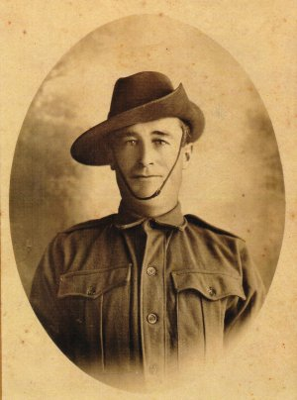
After basic training at Enoggera barracks, Brisbane was sent about 28 October, 1915 to join other recruits from across the country training at Casula camp, near Liverpool, New South Wales with the Mining Corps. His rank was Sapper with the regimental number 310 in No. 1 Company of the Corps.
Frank Warburton
Photo sourced from Ancestry
submitted by Michael Wiseman

He married in Sydney, NSW in 1916 to Nellie Jane Jackson formerly Adams and she became his next-of-kin with her address care of Mrs T. Adams, Sworde, Belltree Station, Scone, NSW.

At a civic parade in the Domain, Sydney on Saturday February 19, 1916, a large crowd of relations and friends of the departing Miners lined the four sides of the parade ground. Sixty police and 100 Garrison Military Police were on hand to keep the crowds within bounds. The scene was an inspiriting one. On the extreme right flank, facing the saluting base, were companies of the Rifle Club School; next came a detachment of the 4th King’s Shropshire Light Infantry, then the bands of the Light Horse, Liverpool Depot, and the Miners’ on the left, rank upon rank, the Miners’ Battalion.
The Corps boarded HMAT A38 Ulysses in Sydney, NSW on February 20 and sailed for the European theatre. Arriving in Melbourne, Victoria on February 22 the Miners camped at Broadmeadows for a stay of 7 days while further cargo was loaded. Another parade was held at the Broadmeadows camp on March 1, the Miners’ Corps being inspected by the Governor-General, as Commander-in-Chief of the Commonwealth military forces.

Leaving Melbourne on March 1, Ulysses arrived at Fremantle, Western Australia on March 7 where a further 53 members were taken on board.

On Wednesday March 8, 1916 the whole force, with their band and equipment, paraded at Fremantle prior to leaving Victoria Quay at 9.30 o’clock.

The ship hit a reef when leaving Fremantle harbour, stripping the plates for 40 feet and, although there was a gap in the outside plate, the inner bilge plates were not punctured. The men on board nicknamed her ‘Useless’. The Miners were off-loaded and sent to the Blackboy Hill Camp where further training was conducted.

The Mining Corps comprised 1303 members at the time they embarked with a Headquarters of 40; No.1 Company – 390; No.2 Company – 380; No.3 Company – 392, and 101 members of the 1st Reinforcements.

Finally departing Fremantle on April 1, Ulysses voyaged via Suez, Port Said and Alexandria in Egypt. The captain of the ship was reluctant to take Ulysses out of the Suez Canal because he felt the weight of the ship made it impossible to manoeuvre in the situation of a submarine attack. The troops were transhipped to HM Transport B.1 Ansonia, then on to Valetta, Malta before disembarking at Marseilles, France on May 5, 1916. As a unit they entrained at Marseilles on May 7 and detrained on May 11 at Hazebrouck.

A ‘Mining Corps’ did not fit in the British Expeditionary Force, and the Corps was disbanded and three Australian Tunnelling Companies were formed. The Technical Staff of the Corps Headquarters, plus some technically qualified men from the individual companies, was formed into the entirely new Australian Electrical and Mechanical Mining and Boring Company (AEMMBC), better known as the ‘Alphabetical Company.’

Disciplinary action was taken for the following:

Crime: In the field while on active service drunkenness 20/10/16
Award: 14 days Field Punishment No. 2 on 21/10/16

Service continued without illness or injury and was issued with Blue Chevrons to wear on his uniform for serving twelve months abroad.

On 29 March 1917, Nellie’s brother, 355a Private James Edward Adams, 53rd Infantry Battalion, was killed in action, along with 1 Officer and 4 other ranks of the Unit which had moved into the Front Line at Trones Wood, Somme, on 5 March.

Red Cross files indicate he and his comrades where killed by a H.E. shell at about 6.30 in the morning and was buried in the open near an isolated farm-house (Delsoux Farm) and close to his Officer. A cross was put up for the Officer and a piece of wood marked James’ grave with his and three other names on it.

Post war the Officers body was recovered and re-buried at Lebucquiere Communal Cemetery Extension.

The bodies of the Other Ranks were not recovered and they are memorialised on the Villers- Brettonneux

Leave from France was granted which Frank took from 24 February to 11 March, 1918.

He was with his unit when Peace was declared and the Tunnelling Companies remained on the front as part of the Army of Occupation assisting with rehabilitation of their area by clearing roads and bridges of booby traps and delayed action mines left by the enemy. Further leave to the United Kingdom was taken from 28 December, 1918 and re-joined his unit on 16 January, 1919. On 8 Feb 1919 the 4 Sections of 1ATC were separately photographed at Hainaut Chatelet, Wallonie, Belgium. (AWM images E04269 to E04272)

Orders were received on 12 February, 1919 to report to the Aust General Base Depot marching out from there to return to England on February 24 arriving a day later at the No. 3 Camp at Parkhouse. On 20 March were moved to the Reserve Brigade Aust Artillery Convalescent camp in Heytesbury to await their voyage home.

After demobilisation Sapper Warburton embarked for Australia on board H.T. Boonah. Base Records advised his wife on 22 May that he was on his way home. The troopship docked in Melbourne first and soldiers for New South Wales and Queensland were transhipped to Sydney (2nd Military District) on the Sardinia arriving on 11 June, 1919.

News of their impending arrival was announced in the:
Sydney Morning Herald Tuesday 10 June, 1919:
DISEMBARKING TOMORROW
The troopship China, which is expected tomorrow morning, is carrying in addition to her own troops, the New South Wales soldiers by the Boonah, who were transhipped at Melbourne.
Relations and friends who have the tickets marked China or Boonah will be admitted to the Anzac Buffet at 9.30 a.m. The Queenslanders will not disembark.
Cars numbers on the Red Cross Register from 321 to 461 are required to be at No. 1 Wharf at Woolloomooloo at 9.30 a.m.

Usual practise was to return to the State in which enlistment took place but seeing his next-of-kin was in New South Wales he disembarked in Sydney. Announcement of his non-arrival in Brisbane was reported in the:

Brisbane Courier Monday June 16, 1919:
BOONAH AND SARDINIA TROOPS WELCOMED
Those on the Boonah who did not arrive were: F. Warburton Article abridged
Frank was discharged from the A.I.F. on 11 September 1919 in the 2nd Military District (NSW). For serving his country Sapper 310 Frank Warburton, 1st Tunnelling Company was issued with the British War Medal (34082) and the Victory Medal (33638).

In 1925 his wife was at Murgon, Qld and they were listed from 1930 to 1934 at Toonpan, Thuringowa working as a labourer. In 1936 he was a ganger at Cardwell then at Beerburrum as a labourer the following year.

In 1943 the couple were living at Walsh Street, Mareeba and he was a fettler. While there he received burns from an accident which was reported in the:
Cairns Post Thursday March 9, 1944:
ACCIDENTS
When he threw petrol on a fire, Frank Warburton, a fettler, residing at Mareeba, received severe burns to the right leg and right lower arm. After Ambulance attention he was taken to the local hospital.

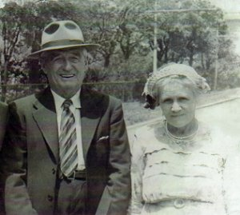
By 1949 they had moved house to Rankin Street, Mareeba with his occupation as a labourer and in 1954 their home was Downs Street, Mareeba.
Frank & Nellie Warburton
Photo sourced from Ancestry Public Member Tree – Wiseman –
submitted by Michael Wiseman 26/5/2013

The Brisbane branch of the Repatriation Commission requested a copy of his service records from Base Records which were forwarded on 25 January, 1949.

Frank Donald Warburton passed away on 23 July, 1959 aged 77 years. Interment took place in the Protestant section 3 of Mareeba Cemetery within Row F, Plot 1.

The Secretary of Cairns Legacy wrote to Army Records Office, Victoria Barracks, Melbourne on 29 March, 1962 advising that he had died and the Club was endeavouring to establish his widow’s eligibility for Legacy benefits and could they forward details of his service both at home and overseas. Base Records replied on 4 April, 1962 with the information they required.

Mrs Nellie Warburton died on 11 October, 1973 aged 80 years and buried beside her husband in Plot 2.

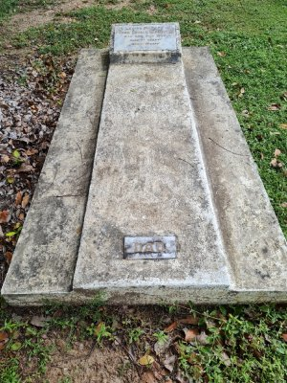
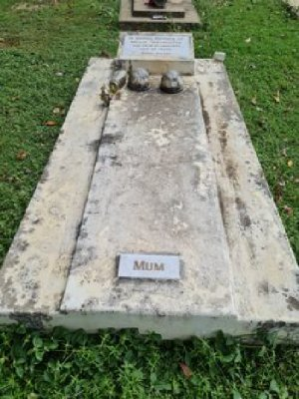
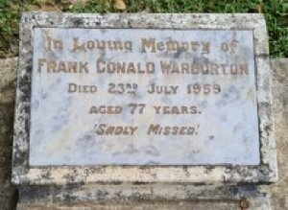
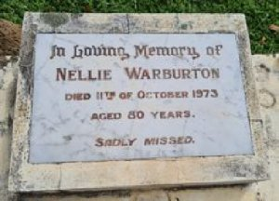
Graves in Mareeba Cemetery, Qld - Photos sourced from Find-a-Grave submitted by Gazza31
Their Headstones in Mareeba Cemetery, Qld - Photos sourced from Find-a-Grave submitted by Gazza31

© Donna Baldey 2023
www.tunnellers.net

