SAPPER STEPHEN JOHN TUENO
720 – 2nd Tunnelling Company
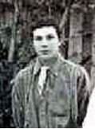
Stephen J Tueno
Photo sourced from Ancestry submitted by John Tueno 18/2/2010
Stephen John Tueno was born at White Hill, Bendigo, Victoria in 1888 the son of Peter and Georgeanna (nee De Vernet) Tueno. His father died in 1890. In 1909 he was working as a miner at Quarry Hill and a year later was mining at Chiltern. From 1912 to 1913 he was residing at 115 Lily Street, Bendigo with the occupation of miner.

He married in 1914 to Marie Theresa Hughes with their residence at Old Violet Street, Bendigo.

At the recruiting depot in Bendigo on 1 November, 1915 the twenty-seven-year-old married miner applied to enlist for active service abroad and passed the medical examination. Attestation forms describe him as 183cms (6ft) tall, weighing 80kgs (176lbs) with a chest expansion of 92-97cms (36-38ins) and a dark complexion with brown eyes and dark hair. Religious faith was Roman Catholic. Next-of-kin nominated was his wife Mary Tueno of corner Cecil and Barnard Streets, Bendigo, Vic and allotted three-fifths of his pay in support of her and their children. He took and signed the Oath of Enlistment on 8th November, 1915.

Basic training commenced with the 16th Depot Battalion the same day until the 19th November when transferred to the No. 2 Company of the Miners Corps in Melbourne. On 11 December the company travelled to Casula camp, near Liverpool, New South Wales to join other volunteers to train as a Corps. His rank was Sapper with the regimental number 720 and remained in No. 2 Company.

At a civic parade in the Domain, Sydney on Saturday February 19, 1916, a large crowd of relations and friends of the departing Miners lined the four sides of the parade ground. Sixty police and 100 Garrison Military Police were on hand to keep the crowds within bounds. The scene was an inspiriting one. On the extreme right flank, facing the saluting base, were companies of the Rifle Club School; next came a detachment of the 4th King’s Shropshire Light Infantry, then the bands of the Light Horse, Liverpool Depot, and the Miners’ on the left, rank upon rank, the Miners’ Battalion.

The Corps boarded HMAT A38 Ulysses in Sydney, NSW on February 20 and sailed for the European theatre. Arriving in Melbourne, Victoria on February 22 the Miners camped at Broadmeadows for a stay of 7 days while further cargo was loaded.

Another parade was held at the Broadmeadows camp on March 1, the Miners’ Corps being inspected by the Governor-General, as Commander-in-Chief of the Commonwealth military forces.

Leaving Melbourne on March 1, Ulysses arrived at Fremantle, Western Australia on March 7 where a further 53 members were taken on board.

On Wednesday March 8, 1916 the whole force, with their band and equipment, paraded at Fremantle prior to leaving Victoria Quay at 9.30 o’clock.

The ship hit a reef when leaving Fremantle harbour, stripping the plates for 40 feet and, although there was a gap in the outside plate, the inner bilge plates were not punctured. The men on board nicknamed her ‘Useless’. The Miners were off-loaded and sent to the Blackboy Hill Camp where further training was conducted.

The Mining Corps comprised 1303 members at the time they embarked with a Headquarters of 40; No.1 Company – 390; No.2 Company – 380; No.3 Company – 392, and 101 members of the 1st Reinforcements.
Finally departing Fremantle on April 1, Ulysses voyaged via Suez, Port Said and Alexandria in Egypt. The captain of the ship was reluctant to take Ulysses out of the Suez Canal because he felt the weight of the ship made it impossible to manoeuvre in the situation of a submarine attack.
The troops were transhipped to HM Transport B.1 Ansonia, then on to Valetta, Malta before disembarking at Marseilles, France on May 5, 1916.

As a unit they entrained at Marseilles on May 7 and detrained on May 11 at Hazebrouck.

A ‘Mining Corps’ did not fit in the British Expeditionary Force, and the Corps was disbanded and three Australian Tunnelling Companies were formed. The Technical Staff of the Corps Headquarters, plus some technically qualified men from the individual companies, was formed into the entirely new Australian Electrical and Mechanical Mining and Boring Company (AEMMBC), better known as the ‘Alphabetical Company.’

The No. 2 Company was officially transferred to the 2nd Tunnelling Company in December, 1916.

Service continued without illness or injury and was granted leave from France from 5 September to 15 September, 1917.

Sapper was classed as wounded in action of 28 February, 1918 suffering the effects of gas from a shell attack.

This was reported in the Unit Diary of the 2nd Tunnelling Company as follows:

“28/2/18
No 1 Section camp again heavily bombarded, many direct hits on Shelters taking place. Camp abandoned and men billeted in METZ. 38 cases of gassing. Total to date from three bombardments 77 cases. On account of these casualties the work in 2nd Div. area being done by No. 1 Sec was stopped.
Weather wet.”

“Report on Gas Shelling Cases

The forward camp (dugouts) occupied by No. 1 Section until the day of 1/3/18 is situate sheet 57c Q 16 c 1.2.
The enemy bombarded with Gas shells this area and the wood opposite on evenings of the 25/26th 26/27th 28th /1 March.
On the night 25/26th the shelling commenced approximately at 2 a.m. and lasted until 4.15 a.m.
With the exception of one sapper no one complained of the effects of gas until some considerable time afterwards. This sapper was in his dugout when same was knocked down by a direct hit from a gas shell, this occurring during the first salvo or two into the Quarry.
Shortly after the bombardment no trace of gas in the vicinity of dugouts could be noticed, but at isolated points on the ridge East and North of the Quarry there was evidence of gas 24 hours later.
Box respirators were inspected as men left each day to go on shift and in every instance found to be O.K. Gas helmet drill was last carried out on 22/2/18.
The same precautions were taken on the evenings of 26th/27th/28th /1st March.
The camp was abandoned on the 28th owing to the danger of further shelling and the gas hanging around this area.
Judging by the times that the men were effected by gas it would appear that with the exception of one sapper that the actual gassing took place some 18 to 24 hours after bombardment either in the vicinity of the camp or whilst proceeding over the gas shelled ridge East of the Quarry to their work.
1/3/18 E.M. Tooth Lieut.”

He was taken to the 57th Field Ambulance then on to the 47th General Hospital at Le Treport with gas shell poisoning. On 8 March was invalided to England on the hospital ship St Denis entering the Red Cross Hospital at Chelmsford.

On 11 March, 1918 Base Records regretted to advise his wife that it was reported her husband had been classed as wounded in action. His postal address was given for correspondence.

His name was among those soldiers listed in the Casualty List appearing in the:
Bendigonian (Bendigo) Thursday April 4, 1918:
WOUNDED
S.J. Tueno, Bendigo: Article abridged
Base Records again advised on 11 April, 1918 that he had been admitted to the General and Red Cross Hospital, Chelmsford on 8/3/18 suffering from the effects of gas poisoning. His address for correspondence was also included.

Was transferred to the 3rd Auxiliary Hospital in Dartford and a month later discharged to furlough and to report to the No. 3 Command Depot at Dartford. Marched in as ordered from Headquarters, London. On 25 June left for the No. 4 Command Depot at Hurdcott until 14 August marched out for the Overseas Training Brigade at Deverill.

Proceeded to France on 7 September, 1918 from Folkstone arriving at the Aust. General Base Depot in Rouelles two days later and marched out to his unit re-joining on September 14.

He was with his unit when Peace was declared and the Tunnelling Companies remained on the front as part of the Army of Occupation assisting with rehabilitation of their area by clearing roads and bridges of booby traps and delayed action mines left by the enemy.

Orders were received on 30 March, 1919 to return to the Aust. General Base Depot and left there for England on 4 April marching into the No. 2 Group camp a day later to await his voyage home.

After demobilisation Sapper Tueno embarked from Liverpool for discharge in Australia on board H.T. Nestor on 20 May, 1919. Base Records advised his wife on 21 June, 1919 that he was returning home. The troopship docked in Melbourne (3rd Military District) on 2 July, 1919.

News of their pleasant voyage from Liverpool during which very little sickness was reported in the:
The Argus Thursday July 3, 1919:
RETURNING TROOPS WELCOMED
Two contingents of Victorian soldiers comprising on 900 men landed at Port Melbourne yesterday afternoon. They were troops who returned on the s.s. Nestor and the s.s. Port Napier. As they arrived at the hours fixed for their disembarkation there was no delay in transporting them to the A.I.F. Depot in Sturt Street, where relatives and friends met them. The soldiers who looked well, received a cordial welcome as they passed through the city streets.

Military Discharge was issued in Melbourne (3rd M.D.) on 24 August, 1919 on termination of his period of enlistment.

In 1919 he went to 205 Williamson Street, Bendigo with the occupation of labourer.

The British War Medal (35279) and the Victory Medal (35023) were issued to Sapper 720 Stephen John Tueno, 2nd Tunnelling Company for serving his country.

These medals were not collected from the designated barracks and returned to Base Records on 10 May, 1923. A letter was sent to the last known address of his next-of-kin on 24 January, 1924. He applied for both medals on 11 February, 1924 which were sent by registered post (5550) on 21 March, 1924.

The Commonwealth Savings Bank of Victoria, Melbourne wrote to Base Records requesting desired information of the ex-soldier residing at 119 Barnard Street, Bendigo. A Statement of his Service was forwarded on 5 August, 1924.

In 1924 he is listed as a railway employee and the couple were living at 263A McCrae Street, Bendigo and a year later were residents at 223 McCrae Street where they remained.
Stephen John Tueno passed away on 26 April, 1929 aged 41 years. Interment took place in the Roman Catholic Monumental portion of Bendigo Cemetery within section K6 in grave no. 27852.

He has a Commonwealth War Grave.

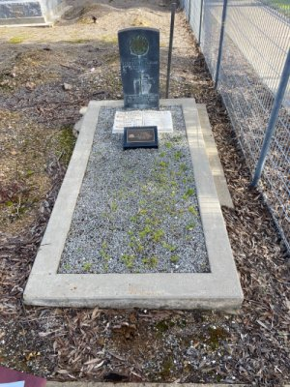
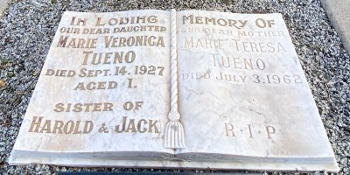
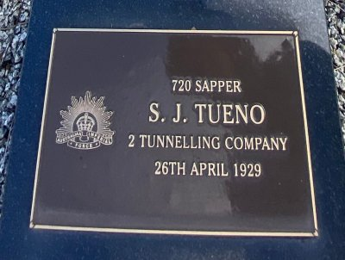
Tueno Family plot in Bendigo Cemetery, Vic
Photo sourced from Find-a-Grave website
Mrs Marie Tueno wrote on 21 October, 1956 to Base Records, Melbourne from 32 Houetoun Street, Bendigo requesting a Statement of her husband’s service which had been lost due to sickness and unsettled conditions.

Base records replied on 31 October, 1956 stating the regulations prevent the replacement of Certificates etc. after the death of the soldier in respect of whom they are issued. However, a brief statement of his service was issued showing enlistment and discharge details.

Mrs Marie Tueno died on 3 July, 1962 and was also interred in the family plot.

© Donna Baldey 2023
www.tunnellers.net

