SAPPER WILLIAM TOOGOOD
7874 – 2nd Tunnelling Company

William Henry Toogood was born at St Lukes, London, England on 22 June, 1866 the son of William and Elizabeth (Eliza) (nee Drage) Toogood and was baptised on 8 July in St Thomas’ Church, Charterhouse, Finsbury. His father was a belt cutter and they were living at 4 Punt? Court, Bridgewater Gardens.

In 1871 the family were residents 35 Great Arthur Street, Finsbury and were William (27) brace cutter, Eliza (27), Mary Ann (6), William (4), Eliza (2) with George Toogood (24) brother of William, porter.

The family went to New Zealand arriving about 1873 at Dunedin, Otago where his siblings were born.

He came to Victoria, Australia and married on 19 June, 1886 at the Registry Office, Carlton, Melbourne to Mary Grace Douglas and they had five children there between 1887 and 1896.

It appears he left the family and went to Sydney and partnered with Mary Alice who took the name Toogood.

He stated his previous military service was seven years with the 1st Victorian Regiment and A.F.A. and seven months voluntarily enlisted with the Guard at the German Concentration Camp.

At the recruiting depot in East Sydney on 2 May, 1917 the forty-four-year-old labourer applied to enlist for active service abroad and passed the preliminary medical examination. Personal particulars were no marital status and stood 163cms (5ft 4ins) tall with a chest measurement of 94cms (37ins) with postal address 225 Commonwealth Street, Sydney. Declared fit his application was accepted by the recruiting depot.

Attestation Forms described him at being born on 21 June, 1873 giving his age as 45 years and 11 months at Bow Bells Street, London. He stated was married and next-of-kin was his wife Mary Alice Toogood of 225 Commonwealth Street, Sydney. Described as 165cms (5ft 5ins) tall, weighing 61kgs (135lbs) with a chest measurement of 89-90cms (33½-35½ins) having a dark complexion, good vision in his grey eyes and grey hair. Two vaccination marks were distinctive on his left arm from childhood and a 2inch scar on his right thumb. Religion was Church of England. The Oath of Allegiance was signed at taken on 17 May, 1917 and was posted to the No. 2 District Guard. His regimental number was 447 in the rank of Private.

He appeared before the Medical Board on 14 May, 1917 and his disability was defective sight in both eyes rendering him medically unfit. The Board was uncertain of the history of the disability but he could not read and were unable to decide what his eyesight was. He would have nil incapacity from service.

After 55 days service from 17 May to 10 July, 1917 was discharged to join the A.I.F. with a good character.

At the recruiting depot at Newtown, Sydney on 5 July, 1917 he re-applied to enlist for active service abroad and passed the preliminary medical examination. Personal particulars of the married miner of 229 Addison Road, Marrickville he was 163cms (5ft 4ins) tall with a 92cms (36ins) chest measurement. His application was accepted at Victoria Barracks on 18 July, 1917.

Forms of Attestation describe him as weighing 64.5kgs (142lbs) with a good physique, a pulse of 75 and a fair complexion with good vision in his grey eyes and grey hair. Church of England was his faith. Other notations were three vaccination marks on his right arm and a 3inch ball scar on the right thumb. Hair grey went prematurely at 29 – looks older than age – but Statutory Declaration attached. Next-of-kin nominated was his wife Mary Alice Toogood of 229 Addison Street, Sydney and later changed to 32 Hordern Street, Newtown and allotted two-fifths of his pay in support of his wife. He took and signed the Oath of Enlistment the same day.

Basic training commenced with the recruits to July 24 at the Showgrounds camp then sent to Moore Park and the Engineer Reinforcements (2nd Military District). From there was allotted to the Tunnelling May, 1917 Reinforcements at Seymour, Victoria but was sent to the Isolation Camp at Ascot Vale on 28 August and re-joined the Reinforcements training at Bendigo on 1 October. Returned to Seymour on 2 November in preparation for service abroad. Military authorities noted his Will was lodged with the Public Trustees Office, Castlereagh Street, Sydney, NSW. His rank was Sapper with the regimental number 7874. The troops spent an overnight stay at Broadmeadows camp, near Melbourne in preparation for departure on November 21, 1917.

The troopship HMAT A71 Nestor departed Port Melbourne, Vic on November 21, 1917 with 168 Reinforcements on board. The voyage of twenty-five days duration terminated at the Suez on December 15, 1917 and the men disembarked going to the Australian Infantry Camp, Suez the same day.

The Reinforcement entrained for Alexandria on January 4, 1918 and marched into the Australian Camp, Gabbary, in Alexandria on January 5. They boarded on January 8, 1918 the Transport E620 Abbasiah, disembarking at Taranto, Italy on 12 January. It was an unusual journey for the troops to undertake the weeklong train travel from Taranto to Cherbourg, France, and to then cross the English Channel to Southampton, England disembarking on January 24, 1918. A further entrainment completed their journey to Tidworth and they marched into No. 3 Details Camp at Parkhouse.

They proceeded to France from Southampton on 2 March, 1918 arriving at the Aust General Base Depot in Rouelles then moved to the Aust Corps Depot at Caestre and attached to the 2nd Tunnelling Company on 19 March, 1918 where they were working on Artillery dugouts near Ytres.

Sapper went sick on 24 March, 1918 to the 49th Casualty Clearing Station with P.U.O. (Pyrexia (fever) uncertain origin) then sent to the 26th General Hospital at Etaples the next day.

Was invalided with myalgia (muscular pain) to England on the hospital ship Stad Antwerpen and admitted on March 31 to the 1st Southern General Hospital, Birmingham (P.U.O.)

Was transferred on 8 April, 1918 to the 1st Aust Auxiliary Hospital at Harefield then discharged to the No. 2 Command Depot at Weymouth on April 11.

Sapper Toogood embarked for Australia on 12 May, 1918 due to being overage and suffering myalgia on the H.T. Ruahine (D9). Base Records would have advised his wife that he was returning home.

The troopship docked in Sydney (2nd M.D.) on 5 July, 1918.

Military Discharge was issued in Sydney (2nd M.D.) on 1 January, 1919 as medically unfit.

His first wife Mary Grace Toogood died and was buried on 2 February, 1920 in the Pine Ridge Cemetery, Coburg, Melbourne.

His service entitled Sapper 7874 William Toogood, 2nd Tunnelling Company to be issued with the British War Medal (79509) and the Victory Medal (75391).

William Henry Toogood passed away on 5 April, 1931 aged 64 years in the Prince of Wales Hospital, Randwick.

Announcement and arrangements were published in the:

FUNERALS
TOOGOOD—The Relatives and Friends of Mrs ALICE M. TOOGOOD, 19 Stacey-street, Bankstown, are kindly invited to attend the Funeral of her late HUSBAND, William; to leave Wood Coffill’s Mortuary Chapel, South Terrace, Bankstown, THIS TUESDAY, at 2.15 p.m. for Church of England Cemetery, Rookwood, by road. Motor Funeral.
WOOD COFFILL LIMITED Motor Funeral Directors
Sydney Morning Herald Tuesday April 7, 1931:
DEATHS
TOOGOOD—April 5, at Prince of Wales Hospital, Randwick, William Toogood, 2nd Tunnelling Coy., late A.I.F., loved husband of Alice Toogood (Arras), 19 Stacey-street, Bankstown.
Interment took place in the Anglican portion of Rookwood Cemetery in section 10 within row 18 in grave no. 2851.

The Sydney Branch of the Repatriation Commission requested a copy of his service record from Base Records which were sent on 8 May, 1931.

His wife placed the following in the Bereavement Notices in the:
Sydney Morning Herald Saturday April 4, 1936:
IN MEMORIAM
TOOGOOD—In loving memory of my dear husband William, who passed away April 5, 1931, late 2nd Tunnelling Company, A.I.F.
Thoughts return to days that have passed.
Years roll on, but memories last.
His loving wife, Alice.

Mrs Alice Toogood was interred in the same grave as her husband on 14 June, 1947.

He has a Commonwealth War Grave.

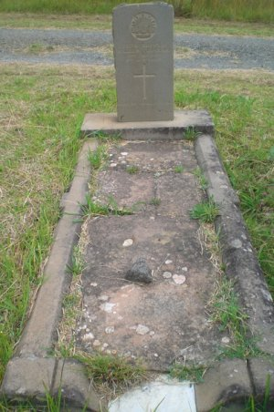
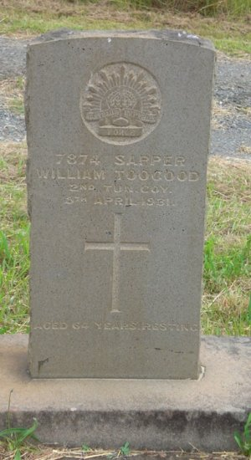
Commonwealth War Grave in Rookwood Anglican Cemetery, Sydney, NSW
Photo sourced from Find-a-Grave submitted by Kaz Bee 7/12/2022

© Donna Baldey 2024
www.tunnellers.net

