SAPPER JOHN ANDREW TILTMAN
5636 – 2nd Tunnelling Company

John Andrew Tiltman was born on 22 April 1886 at Sunderland, England, the son of Thomas James Allen and Alice (nee Laverick) Tiltman. His father died in June 1891 and his mother Alice re-married to Joseph Bell. In 1901 14-year-old John, a stone picker at the coal mine, is living with his mother and step-father at 6 Smith Street, Ryhope.

John Tiltman, a 23-year-old Miner, appears on the manifest as a Third Class passenger on board Caledonia which arrived at Glasgow, Scotland on 11 April 1909 from New York.

On 20 October 1909 John married Jane Annie Richardson at Ryhope, County Durham. Jane was born in October 1886 at Chester-Le-Street, Durham, the daughter of John Thomas and Clara Richardson. The couple had one child, Mary, in 1910 before emigrating to Australia where their second child, Gladys, was born in Sydney in October 1912. The Australian Electoral Rolls for 1913 record John Tiltman, labourer, living at 515 Kent Street, Darling Harbour, Sydney with Jane Tiltman performing domestic duties. A third daughter, Thelma, was born in 1914.

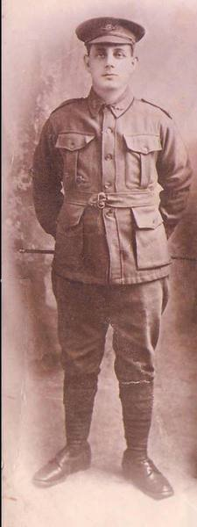
John signed the ‘Attestation Paper of Persons Enlisted for Service Abroad’ on 29 May 1916 stating he was a butcher by occupation. He named his wife, Mrs. Jane Tiltman of Park Street, Wallsend, NSW, as his Next-of-Kin, her address later changed to Thomas Street, Wallsend and allotted three fifths of his pay for the support of his wife and children.

A medical examination on 29 May 1916 recorded that he was 29 years and 1 month of age, stood 5ft 6ins tall and weighed 160lbs. He had a medium complexion, blue eyes and brown hair. He was of the Church of England faith. He signed the Oath to ‘well and truly serve’ the same day at Lambton, NSW.

Training began on 12 June 1916 with “E” Company, Depot Battalion, Newcastle, with the rank of Private. On 23 June he was transferred to “D” Company and on 5 July he was transferred to the Miners reinforcements, at the Seymour, Victoria, camp with the rank of Sapper and the service number 5636. He embarked at Melbourne, Victoria on board Ulysses bound for the Western Front.

516 Tunnellers Reinforcements departed Melbourne, Victoria on October 25, 1916 at 1.30pm aboard the transport HMAT A38 Ulysses, John Tiltman being one of them. The Australian coastline disappeared from view on October 30, 1916 with the port of Durban reached at 11.30am on November 13, 1916. They felt the effects of the wind going around the Cape and arrived at Cape Town at 7am on November 19. Freetown in Sierra Leone was the next port of call where they arrived on 29 November. Their departure was delayed until December 14, 1916 as it was not safe to proceed further. Ulysses arrived at Plymouth, England on December 28, 1916, after 65 days at sea, with the troops disembarking at 1.30pm and entraining for Tidworth.

5798 Sapper George Oxman, (later of the 3rd Australian Tunnelling Company) recorded the voyage in his Diary:
Dec 5. It took 1½ hours to take 1000 men ashore for the afternoon. We have to pay 6d each for the loan of the punts. We were fastened with ropes with one punt to the other coming back, the rope broke and we were drifting out pretty quick but the tug boat soon had us back again. Not too clean of a place. The women stand in a stream and wet their clothes they are washing and place them on a flat stone and then belt into them with a flat piece of wood like a bat.
Dec 9. Had to get some coal and fresh water. The officers went ashore to buy some fruit to sell to us they wouldn’t let us buy off the natives so when they came back with the fruit - none of us would buy it off them.
Dec13. 29 Big boats in here now.
Dec 14. Left for England with four other transport auxiliary cruiser escorting us.
Dec 25. On the sea between Gibraltar and England it has been very foggy. We had roast pork for Christmas dinner and some baked scones. They were as hard as rock.
Dec 26. Very foggy torpedo boats came to escort us in the rest of the way. Got our kit bags out of the holds.
Dec 28. We had nothing to eat from 7.30am to 3.30pm. We had to buy some cakes during the last week on the boat. We held the Dead March on a roast they gave us (250 of us) for our dinner. We marched up to the top deck with it, all the rest of the men were watching us and laughing. We got roared up a bit after it but we didn’t care.
Got on the train at 4pm. Got to Perham Downs camp at 11pm. Nothing to eat from the military until 8 or 9 the next morning. Then we had two tablespoons of boiled salmon and spuds and a mug of tea. Mud from 1-6 inches deep.

John proceeded overseas to France on 28 January 1917 on board S.S. Onward and marched in to the Australian General Base Depot (AGBD) the next day. He was attached to the 2nd Australian Tunnelling Company on 8 February 1917 and was taken on strength of that unit on 2 March.

He was due Blue Chevrons. Each blue Service Chevron denoted one year’s service from 1 January 1915. A red Chevron denoted service before 31 December 1914.

John enjoyed some leave to England from 3 January 1918, re-joining his unit on 17 January. A further leave from France (to England) was granted from 12 December 1918, re-joining his unit on 8 January 1919. His records also show he re-joined his unit in the Field on 12 April 1919 following leave to Paris.

John marched out to England on 18 April 1919 and marched in to No.2 Group, Sutton Veny, the next day, his time 2ATC at an end.

2ATC had relieved the 172nd Tunnelling Company, R.E. in May 1916 in the Neuville St Vaast/Vimy area just days after arriving in France. They supported the Australian 5th Division at Fromelles and relieved the Canadians at the Bluff in January 1917. The Company moved to Nieuport in the same month, to construct subways for Operation Hush. Involved in enemy attack - Operation Strandfest - in this coastal sector in July 1917, recorded in the official histories as ‘The Affair at Nieuport Bains’. In April 1918, troops of the Company fought a large fire in Peronne.

Following the Armistice, members of the company were involved in the clearance of mines and delayed-action booby-traps and in the re-construction of civilian infrastructure until the Company was recalled to Base on May 23, 1919 to organize their departure from France.

John went AWL (absent without leave) from 2359 (midnight) 10 May until 2200 (10 pm) on 12 May and was awarded forfeiture of 4 days pay for this indiscretion.

Leaving London on 4 June 1919 on board Mahia for return to Australia and demobilisation, he disembarked on 20 July and was discharged from the A.I.F. (TPE – Termination of Period of Enlistment) on 28 August 1919, entitled to wear the British War Medal and the Victory Medal.
The Newcastle Sun, NSW – Friday 20 February 1920:
DOUBLE DIVORCE
Man's Complete Change
SOLDIER'S HOMECOMING
The story of the wrecking of two homes, because a husband thought his wife did not know how to dress, was told in the Divorce Court, before Acting-Judge Mocatta, this morning. The evidence showed that one husband made a complete change over, even in the matter of furniture and children.
John Andrew Tiltman sought a divorce from Jane Tiltman, formerly Richardson, on the grounds of adultery. John Edward Hoff was joined as co-respondent.
Contd.
Newcastle morning Herald and Miners’ Advocate, NSW – Saturday 21 February 1920:
DIVORCE CASES.
Tiltman v. Tiltman.
John Andrew Tiltman asked for a dissolution of his marriage to Jane Tiltman, formerly Richardson. John Edward Hoff was joined as co-respondent. Mr. Braye appeared for the petitioner.
The suit was not defended. The grounds were alleged misconduct at Wallsend, Broadmeadow, and Lambton. Petitioner said that they were married in the Church of England, Ryhope, Co. Durham, England, on November 20, 1909. There were three children by the marriage. He left Australia with the A.I.F. on October 25, 1916, and returned on August 28, 1919. His wife met him at the Anzac Buffet. He stayed with her for two days and they went to Elder-street, Lambton. She told him that she had had a good time with someone else while he was away. He said, “If that is the case it is no use my stopping here.” Before he left for the front she wanted him to desert from the colours. When he told her that the proper person to look after the children was the mother, she told him that she did not care a d---- for the children. She told him when he met her at the buffet that she did not want him to live with her. She refused to tell him who the other man was. A fortnight after he returned from the war his wife left her home at Lambton. He had not seen her since. Phoebe Hoff, wife of the co-respondent, said that her husband returned from the front in 1917, and she continued to live with him until June, 1918. She met respondent in August, 1916, just after petitioner had gone to the front, and she was her greatest friend. In February, 1918, she left the hospital after being there eleven weeks. There was a coolness between her husband and her. On April 3 she saw him meet respondent. She followed them into the bush. She told respondent that she should have more consideration for her children if she had none for her. Her husband put witness and her children out of the house; and installed there Mrs. Tiltman and her children. He told her. “Now that you know everything, you should apply for a divorce.”
His Honor found the issues proved.
continues
Mr. Braye appeared for petitioner, and the case was undefended. Petitioner said they were married in 1909. There were three children. He left Australia in October, 1916, and returned in August, 1919. His wife met him at the Anzac buffet when he returned. He lived with her for two days, and then came to Lambton.
REWARD FOR SERVICE
His wife told him that she had had a good time with someone else, and didn't want her husband. He said, “If that is the case, it's no use me stopping here.” When asked why she was doing it, she said, “I wanted you to desert before you went; this is what you get for going to the war.” He told her to think of the youngsters, and she said she didn't give a — for them.
He then went to Sydney. He did not know that she had been carrying on until she told him so. When he returned a fortnight later, she had gone, and he had not seen her since. The children were in a neighbor’s charge. Phoebe Hoff, wife of co-respondent, said she was living at Wallsend. Her husband was in Goulburn. He returned from the front in April, 1917. She lived with him at Broadmeadow until June, 1918. In August, 1916, she first met Mrs. Tiltman. She lived near her. Mrs. Tiltman was her greatest friend, and their friendship continued till she came out of the hospital in February, 1918. Her husband was cool to her, and told her he didn't want to have anything to do with her. She was in hospital 11 weeks, and her husband came to see her only once. On April 3 she saw her husband meet Mrs. Tiltman. She followed them into the bush, and told Mrs. Tiltman to have a little consideration for her children and husband. She had seen them both together a number of times. Hoff put her and her children and furniture out of the house, and took in Mrs. Tiltman and her children and furniture.
The issues were found proved.

. . . . HUSBAND IN GAOL
Phoebe Hoff sought a divorce from her husband. John Edward Hoff, on the ground of adultery with Jane Tiltman at Wallsend, Broadmeadow, and Lambton.
Mr. Braye conducted the case for the petitioner. It was undefended.
According to petitioner, the respondent was in Goulburn Gaol, but his name was formally called. He returned from the war in 1917. When charged with his misconduct, petitioner said, her husband challenged her to get a divorce. She had not made trouble at once, because she did not want the two homes wrecked. She thought possibly that Mrs. Tiltman might return to her own husband. One day, when she came home, her children, who had been in bed with the measles, were sitting in the gutter crying. Next day the furniture was turned out. Mrs. Tiltman with her children and furniture, then took their place. Respondent said he had someone that suited him, and his own wife did not dress well enough to suit him. Mary Tiltman said that Mr. Hoff used to stay every week-end with her mother.
The issues were found proved.
The decree nisi was published on 24 March 1920 and declared absolute on 9 March 1921.

John married Martha Jane Chrystie in Wallsend in 1924. Martha was born in Newcastle in 1884, the daughter of Robert Lamonious and Mary Ann (nee Thompson) Christie.

In the following years the couple welcomed three children; John, Alice and Leslie.

John Andrew Tiltman died of a Cerebral tumour on 18 March 1930.
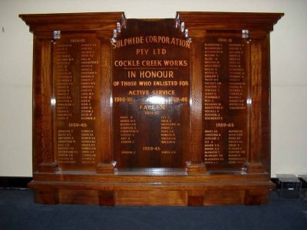
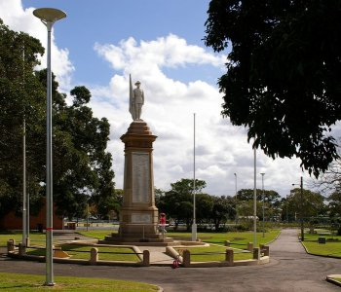
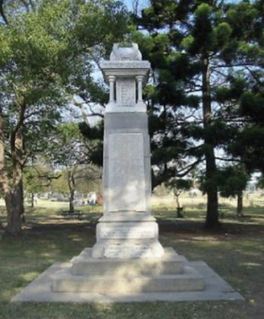
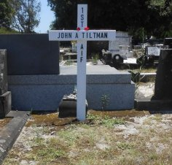
Newcastle morning Herald and Miners’ Advocate, NSW – Wednesday 18 March 1930:
FUNERALS
TILTMAN. - The Relatives and Friends of Mrs. MARTHA JANE TILTMAN and FAMILY, are invited to attend the Funeral of their late beloved Husband and their Father, JOHN ANDREW TILTMAN, to move from his late residence, Elder-street, Lambton, This Afternoon at 1.50 o'clock, for the Church of England Cemetery, Sandgate, per tram.
R. THOMAS & SON,2760 -Undertakers.
Newcastle Morning Herald - 22 March 1930:
"Mr. J. A. TILTMAN.
Mr. John A. Tiltman, a resident of Lambton for 16 years, died at his residence, Elder street, on Tuesday. He was in his 43rd year, and was born in the County of Durham, England. He followed the occupation of a labourer, and for a number of years resided at Wallsend, where he took an active part in sporting events. He enlisted as a sapper in the Second Tunnelling Company, and had three years active service. His health failed him soon after his discharge, and as the result of an accident which happened about three years ago, he went totally blind. His funeral, which was largely attended, took place on Thursday afternoon, the interment being in the Church of England portion of the Sandgate Cemetery. The Rev. O. Van was the officiating clergyman, and the pallbearers were Messrs. A. Baker, E. Middlemas, C. Walls, J. Hope, and Jo. Rountree. Wreaths were received from wife and children, Lizzie, Gladys, and Thelma, Mr. and Mrs. J. Chapman, Mr. and Mrs. H. Richards, Lay Methodist Sunday School, Mr. and Mrs. Middlemas, Mr. and Mrs. Wells, Mr. and Mrs. Jenness and family, Mr. and Mrs. May and family. Besides the widow, he is survived by a family of seven children."
the Sulphide Corporation Pty. Ltd. Cockle Creek Works Honour Board
and the Hamilton War Memorial.
the Wallsend Soldier's Memorial
John was buried in an unmarked grave at Sandgate General Cemetery, Newcastle, New South Wales at Plot: Anglican 2; Section 146; Plot 58.

On 9 April 1930 his medical and service documents were provided to the Repatriation Commission, Sydney, NSW.

He is commemorated on

Newcastle morning Herald and Miners’ Advocate, NSW – Wednesday 18 March 1931:
IN MEMORIUM
TILTMAN. - In loving memory of our dear husband and father, John Andrew, who passed away March 18, 1930; aged 42 years.
You have sailed on your last commission.
On that beautiful boat called "Rest."
But happy are they that to-day can say
They loved you and did their best.
Inserted by his loving wife. Martha, and children. Betty, Andrew, and Adell.

TILTMAN. - In loving memory of our dear father, John Andrew Tiltman, who died March 18, 1930; aged 43 years.
Inserted by his loving daughters, Lizzie, Gladys and Thelma. 6724
Newcastle morning Herald and Miners’ Advocate, NSW – Wednesday 18 March 1932:
IN MEMORIUM
TILTMAN. - In loving memory of our dear father, John Andrew Tiltman, who passed away March 17, 1930.
Loving memories.
Inserted by his loving daughters, Lizzie, Gladys and Thelma. 6027

TILTMAN - In loving memory of my dear husband and our dear father, who passed away March 17, 1930.
Inserted by his loving wife. Martha, and children, Betty, Andrew, and Adell.

From 1935 thru 1937, Martha was living at 31 Pearson Street, Lambton, NSW. In 1943 Martha is recorded as living at Park Street, Lambton with her son John Andrew Tiltman, machinist.

The Electoral Roll records for 1954 Martha living alone at 71 Young Road, Lambton.

Martha Jane Tiltman, nee Chrystie, died at Wallsend on 3 November 1955 and was buried with her husband and infant son Leslie Holden Tiltman who died on 15 November 1930.

© Donna Baldey 2023
www.tunnellers.net
with the assistance of Felicity Patrick, Florida, great granddaughter of John Andrew Tiltman
all photos courtesy Gary Mitchell, Sandgate Cemetery.
A biography for John Tiltman was constructed by Gary Mitchell and much of this profile is based on that bio which is available on the Virtual War Memorial Australia website: https://vwma.org.au.

