HARRY JAMES SHAW
5418 – 3rd Tunnelling Company

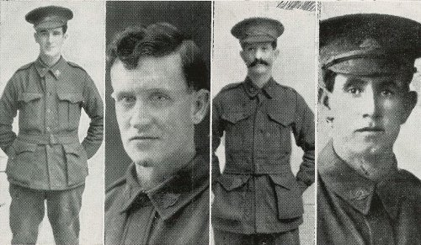
Sapper Harry James Shaw, who was married to Ida May Downing, daughter of Alfred and Jane Downing, of Walter-street, Kalgoorlie, in September, 1910, was born at Adelaide and educated at Broken Hill. He is 33 years of age, and enlisted in June, 1916, going in to Blackboy Camp for training. Later he was transferred to Seymour Camp, Victoria, and sailed from there for England. He was subsequently drafted to France with the 3rd Tunnelling Company, and took part in the battle of Ypres, round Hill 60, and other Somme engagements. While on service he was badly gassed, and also suffered from severe shell-shock. He returned to Melbourne in July, 1916, and came overland to W.A. by Trans-Continently Railway.

[Private Edward George Shaw was born at Morgan and educated at Broken Hill. He is 38 years of age, and in 1909 was married to Lilian May Fallows, daughter of frank and Victoria Fallows, of Money-street, Perth. He answered the call of the Motherland in June, 1916, and after undergoing considerable training at Blackboy Camp, was transferred to Seymour Camp, Victoria. He embarked from there in October, 1916, for England. On the completion of his training he crossed to France, and went into action on the Somme. During the battles of the Somme he was severely gassed, and also contracted trench fever, and as a result was sent to England into Harefield Hospital. He returned home in July, 1919, and is now employed as a fitter at the Government Tram Sheds, Perth.]

[Driver Arthur Percival Shaw (2797), - enlisted August, 1915 - served in Egypt with 28th Battalion – served in France with 4th Field Engineers – wounded in France in December, 1916, his right leg was amputated – invalided home in April, 1918]

[Private John Shaw (220), D.C.M. MID(2) - enlisted 1914 – served Gallipoli and warded D.C.M. – wounded August, 1918, at Somme, returned home 23rd December, 1918.]

Above four soldiers are the sons of Edward and Fanny Shaw, of Oroya Links, Kalgoorlie.

(Australia’s Fighting Sons of the Empire)

