SAPPER CHARLES HAROLD SARGENT
3681 – 1st Tunnelling Company

Cambridge, New Zealand was the birthplace of Charles Harold Sargent on 16 May, 1883 the son of Roger William and Catherine Elizabeth Cornelia (Driessen) Sargent. He came to Australia and worked at the Occidental Gold Mine in Cobar, New South Wales.
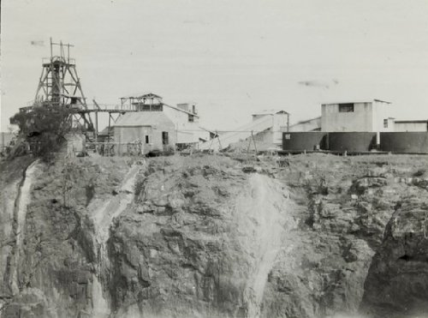
Occidental Gold Mining Company, Cobar 1935-1937 - Photo from Flickr

He married on 1 August, 1908 in Cobar to Kate Caroline Victoria Askew.

At the recruiting depot at Victoria Barracks in Sydney (2nd Military District) on 5 January, 1916 the married thirty-two-year-old miner applied to enlist for active service abroad and passed the medical examination. Attestation forms describe him as 164cms (5ft 4½ins) tall, weighing 59kgs (130lbs) with the chest expansion of 88-94cms (34½-37ins) and a dark complexion with good vision in his brown eyes and dark hair. Distinctive mark was a scar on the left side of his neck. Religion was Presbyterian. Next-of-kin nominated was his wife Mrs Kate Caroline Victoria Sargent of Mopone Street, Cobar and allotted two-fifths of his pay in support of her and their children. The Oath of Enlistment was signed and taken at Casula camp, near Liverpool, NSW on 8 January, 1916.

Basic training commenced with G. Coy, 17th Battalion, Casula to 12 January moving to G. Coy Depot Battalion until February 8, then C. Coy, Depot Battalion to 6 March, 1916. On 10 May was transferred to Rosebery Park allotted to the No. 4 Tunnelling Company.

He returned for a farewell in Cobar which was reported in the:
Western Age (Dubbo) Friday April 21, 1916:
COBAR SOLDIERS FARWELLED
On Tuesday evening, the Masonic Hall was crowded to its limit, the occasion being a farewell under the auspices of the Cobar Soldiers’ Red Cross Association, to Sapper Pritchard and Sargent, Gunner Frank Kinkead and Private Ball. The Mayor (Ald. Duffy), who is also president of the Red Cross Association presided.
The first part of the function consisted of a vocal and instrumental concert.
The Mayor then presented a set of military brushes to Sappers Pritchard and Sergeant, Gunner Kinkead and Private Ball, on behalf of the citizens of Cobar.
Cont’d
Continues:
Sapper Pritchard was a married man, and this was his second campaign. Sapper Sargent, was also a married man, and was leaving a wife and three young children. They all must admire the sacrifices these men were making.
The local Red Cross Association would as far as possible, see that the descendants of these men were associated if they required it.
Sapper Pritchard responded on behalf of himself and comrades. He was pleased to see such a large crowd, and they were thankful for the nice presents. He and his comrades intended to do their best and hoped to come back. (applause)
The proceedings terminated with the national Anthem. Article abridged
The recruits forming part of the No. 4 Tunnelling Company embarked from Brisbane, Qld early in May, 1916 aboard HMAT A69 Warilda for Sydney, NSW. Six officers and 152 other ranks together with the 1st Reinforcements of fifteen other ranks made up the two sections.

At Rosebery Park, Sydney, NSW they joined their Headquarters and two sections (8 officers & 153 O.Rs.) plus 1st Reinforcements consisting of one officer and seventeen other ranks for final training. The rank of Sapper and the Regimental number 3681 in No. 4 Tunnelling Company was assigned to him.

He participated in the Inspection of Troops are Moore Park, Sydney which was reported in the:
Sydney Morning Herald Monday May 22, 1916:

THE TROOPS – INSPECTION AT MOORE PARK
“In the presence of a crowd of 10,000 people the District Commandant, Brigadier-General Ramaciotti, V.D., held an inspection of troops at Moore Park, on Saturday afternoon. The troops consisted of Field Artillery, Tunnelling Section (including Queenslanders), under Major Vincent; Infantry, under Lieutenant Owen Gibbs, under Captain Brosnan, the whole parade being under the command of Major Holman, D.S.O.

Prior to arrival of the commandant and his staff, the men were drawn up in columns of companies on the Dowling-street side of the ground, facing the tramline. The bands of Liverpool Headquarters and the Engineers played selections of music.

Brigadier-General Ramaciotti, V.D. made a close inspection of the lines. Returning to the saluting base the Commandant took the salute as the various units marched past in columns of companies, and again as they returned headed by the band in columns of fours.

One company had with it a small kangaroo as a mascot. The animal was held on a ribbon, but when it drew level with the saluting base it bobbed up and down as if anxious to do its share in the saluting lines as its male friends were doing. Its antics were so ludicrous that the crowd roared.

At the conclusion of the inspection the men were marched across to the Royal Agricultural Ground, where they were provided with temporary quarters.” Article abridged

The 7713-ton transport departed Sydney, NSW on May 22, 1916 and collected in Melbourne, Victoria the No. 5 Company recruited from Victoria, South Aust. & Tasmania made up of Headquarters and 2 Sections (8 officers & 173 men) (3 M.D.). 1 Section from Tasmania (3 officers & 76 O.Rs.); also 1st Reinforcements for No. 5 Company (17 men from Vic. & 8 men Tas.) The ship departed on May 25, 1916 for Adelaide, S.A. to collect one Section of 3 officers & 76 O.Rs. with 1st Reinforcements of 8 O.Rs.

In Perth the No. 6 Tunnelling Company was in their final stages of preparation for departure giving a regimental show of their strength in parades.

Docking at Fremantle, W.A. on June 1, 1916 added No. 6 Company recruited from W.A. of 14 officers and 325 O.Rs. along with 1st Reinforcements of 1 Officer & 32 O.Rs. departing the same day.
Durban, South Africa was reached on June 16, 1916 and Cape Town on June 21, 1916 while St Vincent completed the African ports of call on July 7, 1916. Discipline was fairly good except at intermediate ports where Away without Leave caused concern. The fifty-eight-day voyage experienced remarkable pleasant weather terminating at Plymouth, England on July 18, 1916. Four, Five and Six Companies comprising of 1064 officers and other ranks were detrained to Amesbury and Tidworth to begin training for the front at No. 3 Details camp, Parkhouse.

Reinforcements proceeded to France on 22 September, 1916 marching into the 2nd Aust Divisional Base Depot at Etaples the next day. On 11 October left to join the1st Anzac Entrenching Battalion which was an advanced section of the Base Depot that organised works near the lines and through duties, usually of ten days duration, would accustom the reinforcements to war conditions before being assigned to a company in the field. Sapper was attached to the 11th Aust Army Service Corps for rations. On 12 October was taken on strength as Batman to Captain Trousselot and transferred to Headquarters three days later.

On 8 November, 1916 went with Captain Trouesslot to the 1st Anzac Entrenching Battalion.

The Cobar District kept a Roll of Honour of those enlisting from the district and was published weekly in the:
Western Age (Dubbo) Friday March 2, 1917:
THE ROLL OF HONOR
The following are the names of some of those who have volunteered for the war form the Cobar district:
Sapper Harold Sargent Article abridged

Sapper was attached to Headquarters from 1st Tunnelling Company as Batman to Captain Trousselot on 14 April, 1917.

Was detached from Headquarters and proceeded to the 1st Anzac Corps School on 20 July, 1917 and taken on strength.

Leave to England was granted from 6th to 18 August, 1917.

Went on duty to Rouen on 17 December and re-joined from duty on 29 December, 1917.

Left the Aust Corps School on 27 March, 1918 for the Reinforcement Camp, Caestre and attached for duty with the Aust Corps Working Company two days later.

Disciplinary action was taken for the following:
Crime: AWL from 8.30 a.m. 13/4/18 until apprehended by the Military Police
at 10.30 a.m. 14/4/18 (2 days)
Award: 5 days C.C. by O.C. Commanding Corps Working Coy 4/5/18
Total forfeiture: 2 day’s pay

On 30 June, 1918 ceased to be attached to the Working Company and marched out to the Aust Corps School and re-joined his unit from the Reinforcement Camp on 2 July, 1918.

He returned to the Australian Infantry Base Depot for classification and two days later suffered synovitis (inflamed tissue around knee) and classified with B1 debility. March out to Headquarters G.H.Q.

Leave was granted from 18 September and returned from the United Kingdom on 2 October, 1918.

He was at GHQ when Peace was declared.

The Tunnelling Companies remained on the front as part of the Army of Occupation assisting with rehabilitation of their districts by clearing roads and bridges of booby traps and delayed action mines left by the enemy.

He left G.H.Q 1st Echelon suffering influenza on 22 November, 1918 to hospital and returned to duty eight days later. He was readmitted to hospital on 7 December with influenza and discharged to duty on December 13. He was attached as a servant to Captain Trousselot on 30 December, 1918.

He applied on 22 January, 1919 for early demobilisation completing a form naming his dependants as wife Kate Caroline Victoria and children John 9½, Dick 7½ and Frank 4 years. His last employment before enlisting was mining contractor with the Occidental Gold Mining Company, Cobar. If he could not return to his previous employment, he proposed to do watchmaking.
He would use the assistance of the Repatriation Department in obtaining employment.
He was a member of the A.M.A. Union, Cobar.
He was married in New South Wales in the electorate of Darling.
The form was witnessed by Major Harry Trousselot on 22/1/19

Went before the Medical Board on 24 May, 1919 and had nil disability and declared fit.
General Remarks: Category B1 Aust General Base Depot, July 1919
I am anxious to return as my father wishes me to take over his business. I am married and
have three children and wish to supervise their education.
His Officer wrote:
While I should be sorry to lose Sapper Sargent, I cannot but recommend his early demobilisation
as he is a deserving case.

He returned to the Aust Infantry Base Depot with Quota 9 (1915 personnel) for return to England leaving Havre for Southampton on 21 February, 1919. They marched in to the Reserve Brigade Aust Artillery later that day to await their voyage home.

After Demobilisation Sapper Sargent embarked from Devonport, England for Australia on 19 April, 1919 on board H.T. Sardinia. Base Records advised his wife on 8 May that he was returning home.

The transport docked in Sydney (2nd M.D.) on 13 June, 1919. News of their arrival was reported in the:
Evening News Friday June 13, 1919:
NO COMPLAINTS – SARDINIA TROOPS SATISFIED – THIS MORNING’S WELCOME
Troops who returned today by the Sardinia were landed this morning at Woolloomooloo Bay, where they were received by the District Commandant (Major-General Lee). The Red Cross motor cars were waiting to drive the men to the Anzac Buffet where they were received an outstanding welcome.
On her last visit to Sydney the Sardinia was the cause of a major inquiry owing to allegations made by the troops with regard to the food and the general discipline of the ship.
Article abridged

He appeared before the Disembarkation Medical Board at the Anzac Buffet in the Domain the same day and his Case reads:
No Synovitis left knee. No disability at present. (Sgd.) C.H. Sargent.
General condition: normal
Heart & Chest: clear
No disability
Dentally fit
Confirmed for discharge 13/6/19

He wrote a letter of thanks on his return to the Cobar Soldiers’ Red Cross Association which was published in the:
Western Age (Dubbo) Tuesday July 22, 1919:
To the Editor, THE WESTERN AGE.
Dear Sir—Permit me through the columns of your paper to thank the Cobar Soldiers’ Red Cross Association for donation of £10, also to the Cobar Comforts Club for parcels received while on active service—Yours faithfully,
SPR C.H. SARGENT
Military Discharge was issued in Sydney (2nd M.D.) on 28 July, 1919 on termination of his period of enlistment.

His wife also wrote a letter to the editor:
Western Age (Dubbo) Friday September 5, 1919:
TO THE EDITOR, THE WESTERN AGE
Dear Sir—Permit me through the columns of your journal to thank the Cobar Soldiers’ Red Cross Association for donation given me—Yours faithfully,
MRS C.H. SARGENT

His request for assistance came before the Cobar Soldiers’ Association which was reported in the:
Western Age Friday September, 19, 1919:
COBAR SOLDIERS’ RED CROSS ASSOCIATION – ANNUAL MEETING
The Annual Meeting of the Cobar Soldiers’ Red Cross Association was held at the Council Chambers last night. The Mayor (Ald. Duffy) presided.
During the year help had been secured from the Repatriation Department for men not getting a square deal from the Department. By last mail he received work from Sapper Sargent that as the result of representations made by the Association his sustenance allowance was paid in full, also the rail fare of himself, wife and three children to Sydney. The Department however, would not recognise a claim for assistance for fares to New Zealand, stating it was not the policy of the Department to pay fares for anyone to leave the Commonwealth. Sapper Sargent was well dealt with by the Department.
Article abridged

His Will was returned to the 2nd Military District on 27 October, 1919.

For serving his country Sapper 3681 Charles Harold Sargent, 1st Tunnelling Company was issued with the British War Medal (46478) and the Victory Medal (45404).
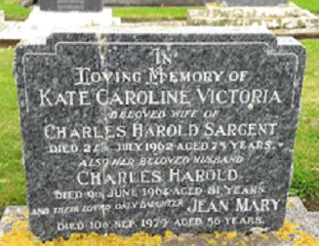
He and his family returned to New Zealand. In 1928 they were at Glover Road, Hawera, South Taranaki with his occupation as a watchmaker.

Mrs Kate Caroline Sargent, late of 70 Collins Street, Hawera died on 24 July, 1962 at 75 years of age and buried in the Presbyterian portion of Hawera Cemetery within block LXIV in Plot 6 (7606).

Charles Harold Sargent passed away on 9 June, 1964 aged 81 years and buried in Plot 7 beside his wife in Hawera Cemetery.
Family Plot in Hawera Cemetery, N.Z.
Photo sourced from Find-a-Grave
submitted by Alan Telford
Their only daughter Jean Mary who died on 10 September, 1979 aged 56 years was also interred in the family grave.

Their son served during World War II.

SECOND LIEUTENANT FRANK LOGAN SARGENT
34217 – 26th New Zealand Infantry Battalion
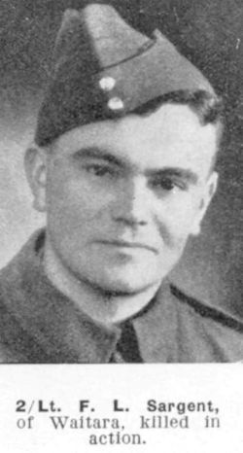
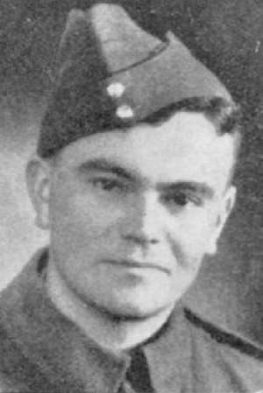
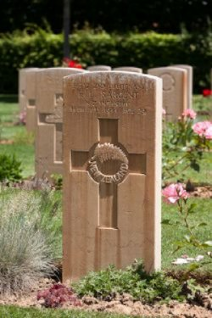
Corporal Frank Logan Sargent 34217 (born Cobar, NSW) married clerk, next-of-kin Mrs Jean Winifred Sargent of Browne Street, Waitara. Enlisted at New Plymouth, N.Z.

Served with the 26th N.Z. Infantry Battalion.

Second Lieutenant was killed in action 14 August, 1944.
Buried in portion III of Arezzo War Cemetery, Toscano, Italy in row A, grave no.4.

Photos sourced from Find-a-Grave submitted by wynrae

LEST WE FORGET

His brother served in World War I

PRIVATE GEORGE ERNEST SARGENT
33961 – 2nd Battalion Auckland Regiment, N.Z.E.F.

George Ernest Sargent was the fifth son of Roger William and Catherine Elizabeth Cornelia (nee Driessen) Sargent and was born in Cambridge, New Zealand in 1888.

He became a jeweller and worked in the family business at Hawera.

He enlisted in 1917 with A Company, Auckland Infantry Battalion. His rank was Private with the service number 33961. Next-of-kin was his father Roger William Sargent, Jeweller of Hawera.

He was reported injured on 16 June, 1918 while with the 21st Reinforcements in France.

On 1 October, 1918 was killed in action aged 29 years with burial taking place in Plot IV of Flesquieres Hill British Cemetery, France.

His demise was reported in the:
Hawera and Normanby Star on October 28, 1918:
ROLL OF HONOR
SARGENT—On October 1st, 1918, killed in action on the Western Front; George Ernest Sargent, fifth son of Mr and Mrs R.W. Sargent of Hawera; aged 29 years.

His grave can be located in Flesquieres Hill British Cemetery, France in Plot IV within row A in grave no.18.
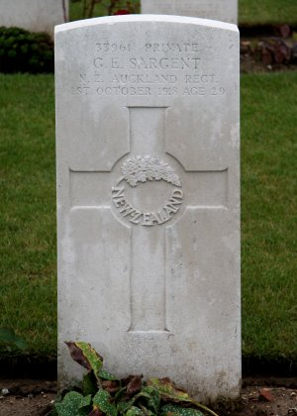
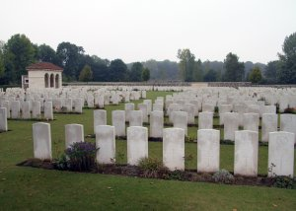
Photo of headstone and cemetery by kind permission of
The War Graves Photographic Project - www.twgpp.org

LEST WE FORGET

© Donna Baldey 2022
www.tunnellers.net

