SAPPER OSWALD JOHN SHAW RUSSELL
4468 – 3rd Tunnelling Company

Oswald (Ossie) John Shaw Russell was born in Brisbane, Queensland on 8 November, 1891 the son of Richard William and Laura Reid (Porteous) Russell. The family made their way to the Goldfields of Western Australia where he received his education at the Kalgoorlie Central School. In 1913 he was a miner residing at 632 Hannan Street, Kalgoorlie.

At the recruiting depot at Northam on 26 February, 1916 the twenty-three-year-old single labourer applied to enlist for active service abroad and passed the preliminary medical examination. Personal particulars taken show he was 170cms (5ft 7ins) tall with a chest measurement of 97cms (38ins). Post Office, Northam was his address. Declared fit his application was accepted by the recruiting officer.

Forms of Attestation were completed describing him further weighing 66.3kgs (146lbs) with a fair complexion, grey eyes and fair hair. Distinctive mark was a scar behind his left knee. Presbyterian was his religion.

Next-of-kin nominated was initially his father Mr Richard Russell care of Post Office, Kalgoorlie. The Oath of Allegiance was signed and taken at Blackboy Hill camp, near Perth on February 28.

Basic training commenced in Area 3 of the camp from February 28 until 3 March moving to the 52nd Battalion. On March 10 was allotted to the No. 6 Tunnelling Company.

Recruiting for the No. 6 Tunnelling Company had commenced on March 7, 1916 by Captain Lawson and his four officers. Instruction classes were formed of officers and N.C.O.’s as there was insufficient time to attend the Engineer’s School in Sydney. Recruits were forthcoming in abundant numbers and the aim was to have good physical types of skilled W.A. Miners. His rank was Sapper with the regimental number 4468.

At Blackboy Hill camp the new company paraded daily with sister companies until March 27 when the Company moved camp to Belmont camp. Russell arrived at the camp where four sections were created and training continued through April and May.

The remainder of May was occupied in the usual training; musketry, trench work and night work while equipment and clothing issue was also in progress. Here a difficulty was met in that the general size of the men was considerably above the average and some little trouble was experienced in getting all accurately fitted.

Early in May, 1916 the No. 4 Tunnelling Company consisting of six officers and 152 other ranks together with the 1st Reinforcements of fifteen other ranks making up two sections, embarked from Brisbane, Qld aboard HMAT A69 Warilda for Sydney, NSW.

At Rosebery Park, Sydney, NSW they joined their Headquarters and two sections (8 officers & 153 O.Rs.) plus 1st Reinforcements consisting of one officer and seventeen other ranks for final training.

The 7713-ton transport Warilda departed Sydney, NSW on May 22, 1916 and collected in Melbourne, Victoria the No. 5 Company recruited from Victoria, South Aust. & Tasmania made up of Headquarters and 2 Sections (8 officers & 173 men) (3 M.D.). One Section from Tasmania (3 officers & 76 O.Rs); also 1st Reinforcements for No. 5 Company (17 men from Vic. & 8 men Tas.)

The ship departed on May 25, 1916 for Adelaide, S.A. to collect one Section of 3 officers & 76 O.Rs with 1st Reinforcements of 8 O.Rs.

The public was kept informed on the progress of the No. 6 Tunnelling Company with the following published in the:
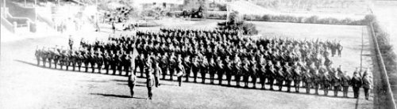
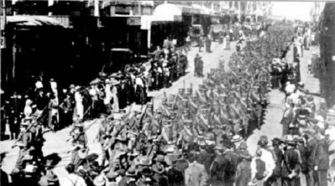
The West Australian June 1, 1916:
THE WESTERN MAIL
The war pictures appearing in this week’s issue of the Western Mail:
In addition, the “Mail” contains a fine photograph of the No 6 Tunnelling Company, as well as an illustration of their march through the streets of the city on Tuesday last, and a photograph of the officers who have been appointed to command the men.
The West Australian Wednesday May 31, 1916:
THE TUNNELLING COMPANY - PARADE THROUGH CITY STREETS
Although the numerical strength of the troops which paraded the city streets yesterday morning was considerably less than that of previous parades, and despite the fact that citizens have become accustomed to the sight of khaki-clad warriors, the men of the No.6 Tunnelling Company and the Claremont N.C.O. school met with a hearty reception as they swung along to the inspiriting music of the Blackboy Hill band. The line of route was freely bedecked with flags, whilst the large crowds, if somewhat undemonstrated denoted none the less by their presence their keen appreciation of that sense of patriotism which found its highest expression in the long line of soldiers answering to the call of Empire. In physique and general bearing the men were equal to their comrades who have gone before. Leaving James-street well on appointed time, the column swung into Beaufort-street and over the bridge in to Barrack-street. The members of the N.C.O. school, about 113 strong, under Captain Thompson, followed the band, the No.6 Tunnelling Company, with its first reinforcements, totalling nearly 400 men, under Captain Lawson, bringing up the rear. At the head of the Tunnellers was borne the flag recently presented to the company.
After traversing Barrack and Hay streets the column entered St George’s-terrace via Victoria-avenue. Opposite Government House his Excellency (Sir Harry Barron), with whom were the State Commandant (Colonel J.H. Bruche), Major P.H. Meeks and Major Wilkinson, A.D.C., took the salute. Passing along the Terrace the route was via William and Wellington streets to the station. The men paraded in full fighting equipment.
The No.6 Tunnelling Company - - Photograph taken at the W.A.T.C. Course, Belmont, where the men have been in training
The No. 6 Company paraded through the city of Perth where the fine physique of the men, who marched with arms bare to the elbow excited universal admiration.
Tuesday’s parade of troops. The No.6 Tunnelling Company and the members of the N.C.O. School, Claremont, marching through the city.

The transport arrived in port at Fremantle, W.A. on June 1, 1916. The whole company consisting of 14 officers and 325 O.Rs along with 1st Reinforcements of 1 officer and 32 O.Rs entrained at Belmont at 2 p.m., every man physically fit being present and boarded Warilda which left the harbour the same evening.

Durban, South Africa was reached on June 16, 1916 and Cape Town on June 21, 1916 while St Vincent completed the African ports of call on July 7, 1916. Discipline was fairly good except at intermediate ports where Away without Leave caused concern.

The fifty-eight-day voyage experienced remarkable pleasant weather terminating at Plymouth, England on July 18, 1916. Four, Five and Six Companies comprising of 1064 officers and other ranks were detrained to Amesbury and Tidworth to begin training for the front at Perham Downs.

The Reinforcements proceeded to France on 28 August, 1916 arriving at the 2nd Aust Divisional Base Depot on 30 August at Etaples.

On September 23rd instructions were received that the No. 6 Company was to be reinforcing the No. 3 Tunnelling Company already at work at the Front. The No. 6 Company accordingly in strength only left Etaples on the morning of September 25th arriving at Le Drumez the same evening. The next morning Captain Lawson formally handed over the whole party to Major Coulter, officer Commanding No.3 Company, who immediately proceeded to allot them to duty. The existence of No.6 Tunnelling Company was therefore terminated.

He was taken on strength with the 3rd Tunnelling Company on 30 September, 1916.

The No. 3 Tunnelling Company received orders from the Commanding Engineer at the beginning of November, 1916 to relieve the 258th Company Royal Engineers in the Hill 70 Sector at Loos in the 1st Corps, 1st Army Area. The sector at Laventie vacated by the 3rd Aust Tunnelling Company was taken over by the 257th Company Royal Engineers.

The Company moved to Bracquemont (near Noux-le-Mines) to new billets and was completed on 12 November, 1916. Their long period of mining at Hill 70 began including varied work along a Front covering the area from Loos to La Bassee. Work at Hill 70 was all in hard chalk and deeper than that carried out at Laventie. A complete survey of the mine galleries and the adjustment of levels was immediately undertaken by Capt. A. Sanderson.

Sapper Russell was accidentally killed on 27 November, 1916 along with 20 of his comrades. He was twenty-three years of age.

The Official History states this occurred in the Black Watch Shaft, Hill 70, Loos when an enemy camouflet opposite their gallery was blown at 12.40 p.m. destroying the gallery.

In the After War Report of the 3rd Tunnelling Company more information was recorded:

“Hostile activity in the Hill 70 area towards the last part of November was considerable.
On 27/11/17 while preparing to tamp gallery 21.DD at (36.c.S.W.1. M.b.87.60) the charging of 17,500 lbs of ammonal having been completed, the enemy exploded a camouflet, which exploded our charge. Casualties were 1 officer (Lt H. Russell) and 8 O.Rs were “mine gassed” and the following 20 O.Rs were killed :-

Killed: 4468 Spr. O.J.S. Russell [Names abridged]

On this occasion after the enemy “Blow” Lt O.R. Howie organised the rescue parties & wearing Proto apparatus, led them into the mine, thereby saving lives & performing valuable exploratory work underground. He carried out this arduous & dangerous work for 24 hours until relieved.”

Burial took place in row C of Hersin Communal Cemetery Extension 2¼ miles South of Noeux-les-mines.
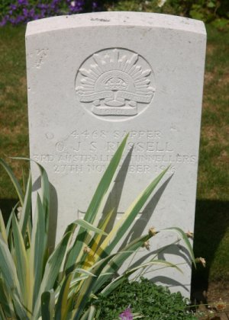
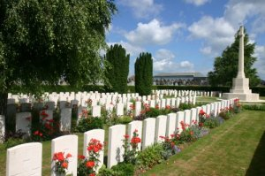
Register (Adelaide) Tuesday December 19, 1916:
WESTERN AUSTRALIA
DEAD—Cpl J. Pember, Lce-Cpl R.W. Gilbert, Saps. W.F. Horton and O.J.S. Russell.
Article abridged
Photo of headstone and Hersin Cemetery
by kind permission of
The War Graves Photographic Project www.twgpp.org

The 5th Military District was advised on 12 December, 1916 of the casualty and next-of-kin advised.

On December 18 a copy of his service was made for the War Pension Department.

His name was among those soldiers in the casualty list published in the:

The Field Service Report was sent to the Anzac Section, 3rd Echelon, G.H.Q. B.E.F. on 20th December, 1916. Looking to contact Mrs L. Russell military authorities placed the following in the:
Daily News Friday January 19, 1917:
MAINLY ABOUT PEOPLE
Military authorities would be pleased to hear from anyone knowing the whereabouts of Mrs Laura Russell, next-of-kin to Private O.J.S. Russell, 6th Tunnelling Company. Mrs Russell’s recent address was care of Mrs R. Eastgate, “Mauley,” Luritine-street, Katoomba.

Sun (Sydney) Saturday January 20, 1917:
UNCLAIMED LATTER
A communication addressed to Mrs Laura Russell, C/o Mrs R. Eastgate, “Manley” Lorine-street, Katoomba, re No. 4468 Sapper O.J.S. Russell, (3rd (late 6th) Tunnelling Co., has been returned unclaimed and may be had upon application to the A.A.G., Victoria Barracks, Paddington.

Information on his demise was reported in the:
Northam Advertiser Wednesday January 24, 1917:
LOCAL AND GENERAL NEWS
Information has been received by Mr W. Jolley, that Private O.J.S. Russell, of the Miners’ Corps, has been killed in France as a result of an accident.

On 30 January, 1917 the 2nd Military District at Victoria Barracks, Paddington advised Base Records that next-of-kin for Sapper Russell was now living care of Mrs Cookson, “Grevelyn” Darley Street, Katoomba, NSW.

In the page W.A. Soldiers Do Their Bit a tribute was published in the Sunday Times Sunday March 4, 1917:
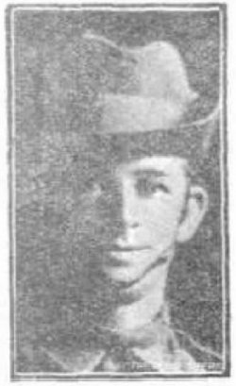
O.J.S. Russell
Killed November 28. Mother resides in Sydney.
Mrs L. Russell wrote to Base Records on 14 March, 1917 with the address care of Mrs E.R. Cookson, Bellevue, Leichhardt Street, Katoomba inquiring any news of the personal effects of her son killed in action on November 28 last. Base Records replied by printed card that no advice had been received to 20 March, 1917.

The A.I.F. Kit Store completed and Inventory of his personal effects as:
Belt, pipe, disc, medallion and letter.
These were addressed to Mrs L. Russell c.o. Mrs S. Gate, Bainby, Lurline Street, Katoomba, NSW.

Mrs Laura Russell was issued with a War Pension of £2 per fortnight from 15 September, 1917 in addition to the £2 per fortnight already granted in respect of Richard William Shaw. This was forwarded to her care of Mrs Goodwin, Foxdown, Tangmangroo, via Downing, NSW.

Base Records forwarded the parcel of his effects to his mother on 7 August, 1917 by registered post no. 633.

After transportation on the Themistocles to Australia and the package was receipted by his mother on 26 November, 1917.

On the first anniversary of his death the following were placed in the:

The Public Curator request from Base Records on 6 March, 1918 for three copies of the Death Certificate for the late soldier. This was prepared on 21 March, 1918 and forwarded to them.
Kalgoorlie Miner Wednesday November 28, 1917:
IN MEMORIAM
RUSSELL—Killed in action, somewhere in France, November 28, 1916, Private Oswald Russell.
Somewhere in France he is lying,
He answered his country’s call;
He died an Australian hero,
Fighting to save us all.
Inserted by his bereaved friend, Nellie Kirkham.

Western Argus Tuesday December 4, 1917:
IN MEMORIAM
RUSSELL—In loving memory of Dick Russell, aged 21 killed in action at Pozieres, August 1916. Edward Russell, 23 years. Oswald Russell, 26 years. Both killed on the Somme, November 28th, 1916.
They fought for their country, and did their duty.
Inserted by their loving father, R.W. RUSSELL.
RUSSELL—Killed in action, somewhere in France, November 28, 1916, Private Oswald Russell
Somewhere in France he is lying,
He answered his country’s call;
He died an Australian hero,
Fighting to save us all.
Inserted by his bereaved friend, Nellie Kirkham.
On 22 April, 1918 Miss M. Garvey of Craigielea, Glencoe, Hawkwood and Chinchilla, Qld wrote to Base Records asking for any information concerning Sapper Russell as his last letter was dated 10 October, 1916. A stamped addressed envelope was enclosed for their reply.

Base Records replied on 16 May, 1918 regretfully advising that Sapper Russell was killed in action in France on 27 November, 1916. Any further coming to hand would be promptly transmitted to next-of-kin and would be available to her on receipt of her request at a later date.

In the After War Report of the 3rd Tunnelling Company he is listed in their Roll of Honour as follows:
No. Rank Name Nature of Casualty Locality Date Buried at
4468 Spr. Russell, O.J.S. Enemy “Blow” at Hill 70 27/11/16 Hersin

He and his brother Richard Russell’s name were placed on the Kalgoorlie Central School’s Honour Roll and published in the:
Kalgoorlie Miner Tuesday June 24, 1919:
KALGOORLIE CENTRAL SCHOOL – HONOUR ROLL
The head teacher of the Kalgoorlie Central School, Mr Poynton, is anxious to have the list of the old boys who enlisted for active service as correct as possible before putting the names permanently on the honour roll.
The names of those who made the supreme sacrifice are:
Oswald S. Russell,
Richard Russell Article abridged

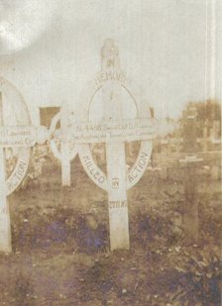
Base Records forwarded on 31 March, 1920 to Mr R. Russell, Post Office Kalgoorlie three photographs and description of the locality of the grave of her son and trusted they came safely to hand. Any discrepancy appearing on the temporary memorial would be rectified when the permanent headstone was erected. This letter was returned unclaimed. Records sent the same letter to Mrs Russell care of Mrs Cookson, “Bellevue,” Leichhardt Street, Katoomba, NSW dated 30 April, 1918.
Copy of original grave sent by Major
Sanderson to his mother in 1918

Major Alex. Sanderson, commanding officer of the 3rd Tunnelling Company forwarded on 20 October, 1918 photographs of her friend Sapper O.J.S. Russell and trusted the photographs would be of some comfort to her. The address sent to was care of Mrs S. Gate, Lurline Street, Katoomba, NSW.

Further photographs were sent to her on 21 May, 1919 and just addressed to her at Katoomba, NSW. All photographs were returned unclaimed.

The Deputy Assistant Adjutant-General’s Office, 5th Military District asked on 25 May, 1920 to furnish the address of next-of-kin.

The notice calling for next-of-kin of the late soldier was advertised in the:
West Australian Thursday June 3, 1920:
MISSING-NEXT-OF-KIN
The military authorities wish to communicate with the next-of-kin of the undermentioned deceased address:
No: 4468 Spr. O.J.S. Russell, 3rd Tunn. Co.; mother, Mrs L. Russell, c.o. Mrs Cookson, Bellview, Leichhardt-street, Katoomba, NSW.
Article abridged

On 14 August, 1920 the 5th Military District wrote in reply to their letter of May 25 to advise Base Records that repeated advertisements have been inserted in the local press for missing next-of-kin but without any result. Should the address be ascertained they would be advised.

His father Richard W. Russell died in September, 1920.

A Circular and Booklet re graves was forwarded in December, 1920 to his mother.

For his supreme sacrifice Sapper 4468 Oswald John Shaw Russell, 3rd Tunnelling Company was issued the British War Medal (42047) and the Victory Medal (41608) in serving his country.

Miss A. Jolley of Fitzgerald Street, Northam, W.A. wrote to Base Records in reply to the advertisement in the Western Australian paper for the next of kin of the late soldier and as far as she knew the father was deceased, also his mother, brother and sister. There are no other relatives living as far a she knew, as she was engaged to him prior to his enlisting and she would be obliged if they would advise her what they intend to do with his war medals etc. A notation on the copy states “War Medals to Untraceable List.”

The 5th Military District forwarded a copy of her letter to Base Records the same day and on 18 July, 1921 Records replied to her informing her the usual practise was to place the deceased medals etc upon an untraceable list which would then be published throughout Australasia with a view that some blood relations would be traced. It was not customary to hand these mementoes to anyone but blood relations unless there were good and sufficient reasons for varying the procedure – the mere fact that you were engaged to the late soldier cannot, it is regretted, be accepted in the present instance.
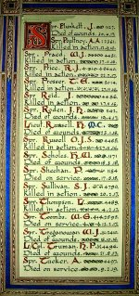

The Sydney Morning Herald - Saturday 23 July 1921:
ENGINEERS' ROLL OF HONOUR
The Royal Engineer War Memorial Committee are arranging to deposit a roll of honour of all ranks of the Royal Engineers whose names were officially published as killed in action or died of wounds or disease in the war in the chapel of St. Paul's Cathedral, and the Engineer corps of the dominions, colonial, and Indian armies have been invited to deposit similar rolls of honour in St. Paul's, to be attached to that of the Royal Engineers. This invitation has been accepted in Australia. The roll will be inscribed on vellum and enclosed in a casket of Australian timbers to rest on a slab of Australian marble.

This extract from Tunnellers Roll of Honour included in profile with the kind permission of the
Dean and Chapter of St Paul’s Cathedral, London
Photos courtesy of Robin Sanderson, Paris

Further notices of Memoriam were placed in the:
Northam Advertiser Saturday November 26, 1921:

IN MEMORIAM
RUSSELL—In loving memory of Sapper Oswald Russell, who was killed in action in France, on November 27, 1916.
No one he loved was by his side,
To hear his last faint sign;
Or whisper just one loving word,
Nor even say good-bye.
Inserted by his loving friend, A. Jolley, Northam.
Northam Advertiser Saturday November 29, 1924:
IN MEMORIAM
Russell—In loving memory of Sapper Oswald Russell, killed in action somewhere in France on November 27, 1916.
Just a memory, fond and true,
Loving thoughts dear Ossie, of you.
Inserted by his loving friend A. Jolly.

The outstanding form to Next-of-kin in regards to Hersin Communal Cemetery Extension was posted to his mother on 10 February, 1923.

On 19 February, 1923 Mrs Russell at 177A Albion Street, Moore Park, Sydney, NSW wrote to Base Records stating that she had received medals for her son Richard W. Russell (2309 2nd Battalion) and thought there might be a medal for her late son Sapper Oswald J.S. Russell (4468 3rd Tun. Co.) She would prize them very much as her sons were all she had left of her family and a widow. Late address was given as 608 Goulburn Street.

All returned photographs (6) were dispatched on 20 February, 1923 to his mother by Base Records. On 28 February, 1923 his War and Victory Medals were sent by registered post no. 7295.

The Memorial Scroll (321338) and the Memorial Plaque (321338) were also issued to her. She receipted delivery of the Scroll, photographs, Memorial plaque on 19 February and the Victory Medal on 3 March, 1923.

Base Records replied to Mrs L. Russell on 26 January, 1926 in compliance with her recent request, one copy of the 1923/24 Annual General Report of the Imperial Graves Commission which the writer trusted would come safely to hand. Official remittance receipt was enclosed. In connection with the Order Form of the Hersin Communal Cemetery Extension, containing reference to the burial of her son, accompanied the remittance but as only the amount of 1/3d was enclosed. Presumably it was not her intention to apply for a copy of this publication also, the cost of which was three shillings.

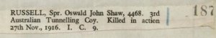
His name in the Register for Hersin Communal Cemetery Extension, France.
Photograph sourced from National Archives of Australia
Service Documents – O.S.J. Russell 4468 – 3 ATC

His name is on the State War Memorial at Kings Park, Perth and published in the:
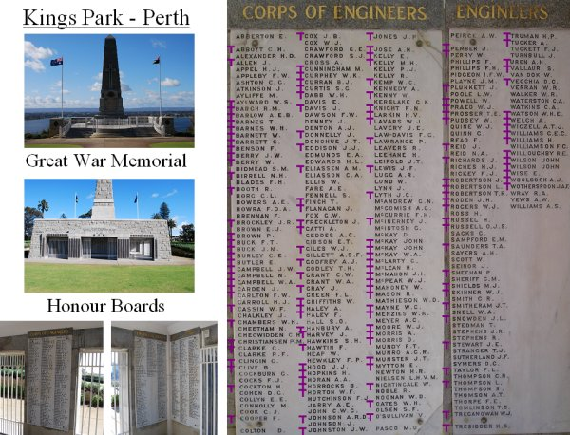
The West Australian Wednesday August 13, 1930
STATE WAR MEMORIAL - NAMES FOR TABLETS
The names of all West Australian soldiers who gave their lives during the Great War are to be handed down to posterity by means of a series of tablets bearing their names on the walls of a section of the State War Memorial on Mount Eliza. The final section of the list of names is published below:
Spr. RUSSELL, Oswald John Shaw, 3rd Tun CoyArticle abridged
Purple T
by tunnellers.net

He is also commemorated at the Australian War Memorial in the commemorative area on Panel 27.

Other Rolls of Honour that bear his name are:
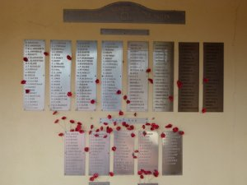
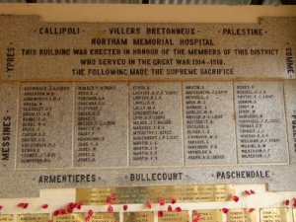
Northam Fallen Soldiers Memorial
Photos sourced from Virtual Anzacs website
Northam Memorial Hospital Honour Roll

His grave can be located in Plot I of Hersin Communal Cemetery Extension, France within row C in grave no. 9.

LEST WE FORGET

His brother also served:

21-year-old labourer Richard William Russell enlisted at Footscray, Victoria on 24 July 1915 as 2309 Private Richard William Shaw.

He named his mother, Mrs. Laura Shaw of Coolup, West Australia, as Next-of-Kin.

Embarking at Melbourne on 27 September 1915 on board HMAT Honorato, he was taken on strength of the 22nd Infantry Battalion at Tel-el-Kebir on 8 January 1916 and proceeded from Alexandria on 19 March 1916 to join the B.E.F., disembarking at Marseilles on 26 March.

His records show he was killed in action between 27 July and 4 August 1916 at Pozieres.

He has no known grave and is commemorated on the Villers Bretonneaux Memorial.

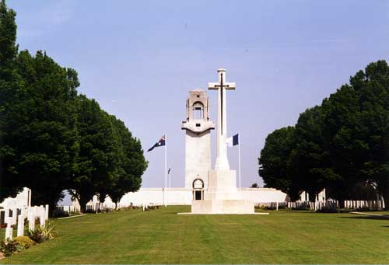

Richard William Russell's name is located at panel 97 in the Commemorative Area at the Australian War Memorial.

LEST WE FORGET

© Donna Baldey 2023
www.tunneller.net

