BLACKSMITH/SERGEANT WILLIAM CARL FRANK RULE
4082 – 2nd Tunnelling Company / 15th Aust Railway Operating Company

William Carl Frank Rule was born in Redruth, South Australia on 17 October, 1892 and registered at Burra, the son of William John and Ita Juliana (nee Topperwein) Rule. His grandfather was a blacksmith in the Burra district and his father was also of the same trade taking over the business on his father’s death and the skills were passed on to young William.

At sixteen years of age, he tendered the Burra Town Council as a lamp-lighter which was reported in the:

Kapunda Herald Friday November 20, 1908:
BURRA TOWN COUNCIL
Tenders were opened for lamp-lighting, as under, at per lamp per month—W.F.C. Rule, 5/
Cr. Wise moved, Cr. Ockenden seconded, an amendment that Thos. Duell’s tender for 7 lamps at 4/3 and W.C.F. Rule’s tender for 3 lamps at 5/ be accepted. Amendment carried. Article abridged
His appointment in 1911 was also reported in the:
Kapunda Herald Friday December 1, 1911:
BURRA CORPORATION
November 20. Present—All.
W.C.G. Rule appointed lamplighter for North Ward. Article abridged

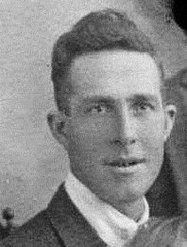
At the recruiting depot in Adelaide (4th Military District) the twenty-three-year-old blacksmith applied to enlist for active service abroad and passed the medical examination.
William Carl Frank Rule
Photo sourced from Ancestry Public Member Tree – Rule shared by Robin Hickman Aug 2013

Described in Attestation forms as 174cms (5ft 8½ins) tall, weighing 68kgs (150lbs) with a chest expansion of 86-92cms (34-36ins) and a fair complexion with light brown hair and his hazel eyes passed the eye test with fair eyesight in the right eye and very poor vision in the left one. Distinctive marks were three vaccination scars on the left arm. Religion was Church of England.

Next-of-kin nominated was his mother Mrs Ita Julia Rule of Aberdeen, Burra, S.A. The same day he took and signed the Oath of Allegiance.

Basic training commenced with the Mining Corps at the Exhibition ground camp the same day.

Acknowledgement to the new recruits was published in the:
Journal (Adelaide) November 12, 1915:
INTO CAMP ON FRIDAY
Following are the names of the men who enlisted at Adelaide and went into the Exhibition Camp on Friday: W.C.F. Rule Article abridged

Long leave was granted from 21st to 26th December, 1915 and he remained training in Adelaide until transferred to Melbourne, Victoria (3rd Military District) on 29 February, 1916 to Broadmeadows camp and assigned to the No. 5 Tunnelling Company. His rank was blacksmith with the regimental number 4082.

Meanwhile recruits forming part of the No. 4 Tunnelling Company embarked from Brisbane, Qld early in May, 1916 aboard HMAT A69 Warilda for Sydney, NSW. Six officers and 152 other ranks together with the 1st Reinforcements of fifteen other ranks made up the two sections.

At Rosebery Park, Sydney, NSW they joined their Headquarters and two sections (8 officers & 153 O.Rs.) plus 1st Reinforcements consisting of one officer and seventeen other ranks for final training.

The 7713-ton transport departed Sydney, NSW on May 22, 1916 and collected in Melbourne, Victoria the No. 5 Tunnelling Company recruited from Victoria, South Aust. & Tasmania made up of Headquarters and 2 Sections (8 officers & 173 men) (3 M.D.). 1 Section from Tasmania (3 officers & 76 O.Rs.); also 1st Reinforcements for No. 5 Company (17 men from Vic. & 8 men Tas.)

Members of the Lodge in Burra were also acknowledged for enlisting in the:

Burra Record Wednesday May 17, 1916:
A GOOD RECORD
The following Members of Court Unity A.P.F., Kooringa, have volunteered for Active Service: E.T.J. Rule, W.C.F. Rule Article abridged
The ship departed on May 25, 1916 for Adelaide, S.A. to collect one Section of 3 officers & 76 O.Rs. with 1st Reinforcements of 8 O.Rs.

Docking at Fremantle, W.A. on June 1, 1916 added No. 6 Company recruited from W.A. of 14 officers and 325 O.Rs. along with 1st Reinforcements of 1 Officer & 32 O.Rs. departing the same day.

Durban, South Africa was reached on June 16, 1916 and Cape Town on June 21, 1916 while St Vincent completed the African ports of call on July 7, 1916. Discipline was fairly good except at intermediate ports where Away without Leave caused concern. The fifty-eight-day voyage experienced remarkable pleasant weather terminating at Plymouth, England on July 18, 1916. Four, Five and Six Companies comprising of 1064 officers and other ranks were detrained to Amesbury and Tidworth to begin training for the front at Perham Downs’ camp.

The Reinforcements proceeded to France on 28 August, 1916 arriving at the 2nd Aust Divisional Base Depot on 30 August and marched out to reinforce the 2nd Tunnelling Company on 25 September and taken on strength four days later.

On 3 November, 1917 he was transferred to the 15th Aust Light Railway Operating Company at Ellardye and taken on strength two days later.

In an audit of the company, he was noted to be still serving on 15 June, 1918.

Leave to the United Kingdom was granted and taken from 1 September and re-joined on September 22, 1918.

He was with his unit when Peace was declared and they remained on the front as part of the Army of Occupation assisting with rehabilitation of their area.

Orders were received on 8 March, 1919 to return to the Aust General Base Depot and left there for England from Havre on 17 March arriving at the No. 3 Group camp at the 2nd Training Brigade at Codford the following day.

At the Church of England Parish Church, Dudley on 29 March, 1919 the twenty-six-year-old bachelor was married by license to Norah Ann [Laura Ann] Shuttleworth (27) spinster daughter of Charles James Shuttleworth (deceased) of 30 Abberley Street. They were married by Rev. W. Noel Tilley, parish priest.

Mrs Laura Rule of 61 King Street, Dudley, Worcestershire became his next-of-kin.

On April 10, 1919 the soldiers were moved to No. 2 Group camp at SuttonVeny.

Accompanied by his wife, Blacksmith Rule embarked for Australia on 23 July, 1919 on board the transport H.T. Canberra. Base Records advised his mother on 11 August that he was returning home.

His name was listed with the soldiers returning published in the:

Register (Adelaide) Friday August 22, 1919:
RETURNING SOLDIERS – THE CANBERRA CONTINGENT
Following are the names of South Australian members of the A.I.F. who are returning to Australia by the Canberra, which left England on July 23.
4082. B.B.Sgt W.C.F. RULE, 1st L.R.O.C. Article abridged
News sent to his mother was shared in the:
Burra Record Wednesday September 3, 1919:
Mrs S. Rule, Aberdeen, has been notified that her son, B.S.-Sergt W.C.F. Rule, is returning to Australia by the Canberra, due to arrive on Sept. 7th. Sergt. Rule, who is accompanied by his wife, enlisted in 1915.

The transport docked in Adelaide (4th M.D.) on 9 September, 1919. News of their arrival was reported in the:

Register (Adelaide) Wednesday September 10, 1919:
ARRIVAL OF THE CANBERRA
The troopship Canberra with 50 soldiers, 43 soldiers’ wives and six children, arrived at the Outer Harbour at about 4 o’clock on Tuesday afternoon. The Y.M.C.A. Army Department assisted by the V.A.D., provided refreshments. The Semaphore Cheer-up Society distributed “welcome home souvenirs” and also supplied refreshments for the guards. Capt. Hartley Cross went to the vessel at the anchorage to greet the soldiers on behalf of the Y.M.C.A., and on arrival at the wharf the home-comers were welcomed by Lieut. L.C. Colley for the Military Commandant, and the Mayor of Port Adelaide (Mr R.H. Smith). Lieut. R.L. Buller represented the District Naval Officer. Lieut. McPhee was in charge of the Naval Guard. The vessel left for the eastern States at about midnight. The military disembarkation officers were Lieut. A.B. Mortimer, Capt. W. Campbell and Sgt J. R. Murray. The District Military Band under the direction of Warrant Officer Stanley, played selections on the wharf. Two deaths and one birth occurred on the voyage—the deaths having been those of a wife and child. All the passengers spoke highly of the treatment on board, and particularly regarding the care bestowed upon the children.
A welcome home to Burra was also reported in the:
Burra Record Wednesday September 17, 1919:
BURRA CHEER-UP SOCIETY
On Thursday evening Cpl Reg. Hopcraft and B/S. W.C.F. Rule arrived. This welcome home was a little out of the ordinary, as both soldiers were accompanied by their English brides, and their arrival had been looked forward to with interest by all the Cheer-up girls. Influenza, however, had stepped in, and instead of our usual large attendance of bank and Cheer-up girls their number was sadly depleted, nearly all being down with the prevailing epidemic and only ten band girls were present, one first cornet “carrying on” successfully on her own. The lack of numbers did not mean the lack of warmth and the soldiers and their brides met with a most enthusiastic reception. The Mayor greeting them specially welcomed the two young ladies. It was the first time he had had the honour, and he was proud to welcome two English girls not only to South Australia, but to the Burra and also extended the best wishes for their future health and prosperity. Miss Ethel James, Assist. Sec. of the Cheer-up Society, in a neat speech then presented both ladies with a bouquet of our national flower, the native wattle, after which cheers were given and the couples left the station amidst cheers and Messrs J.H. Gallagher, J. Austin and M. Radford kindly lent their cars for the occasion.

Military Discharge was issued in Adelaide (4th M.D.) on 25 October, 1919 on termination of his period of enlistment.

About six weeks later he and his wife participated in the Soldiers’ Aid Society’s fete at Burra and covered in the:
Burra Record Wednesday December 3, 1919:
SOLDIERS’ AID SOCIETY – STRAWBERRY FETE IN AIR OF ROYAL INSTITUTION FOR THE BLIND
The members of the Soldiers’ Aid Society, now the war is over and the scope for their energy in certain directions is closed, are now putting the old phrase “Charity begins at home” to a practical use, and the effort put firth by them on Wednesday last in the Jubilee Hall, Redruth, in aid of the Royal Institution for the Blind was a very commendable one indeed. The fete was opened by Mr H. Raymond of the Blind School at 3 o’clock and despite the extreme heat there was a very fair attendance.
Afternoon Tea—Mesdames W. Rule, J.H. Gallagher, P.M. Pearce, sen., H. Brown, T. Fuller and W.C.F. Rule.
The gross proceeds were £56 10s 11d and the institution benefits by £50.
In the same month he and his brother Phil Rule took over their father’s Blacksmith business at Aberdeen and advertised the following in the:
Burra Record Wednesday December 24, 1919:
ABERDEEN SMITHY – CHANGE OF PROPRIETARY
W.C.F. Rule (late A.I.F.) and P. Rule wish to notify the general public of Burra and district, that they have taken over their father’s (W. Rule) Blacksmith business, Aberdeen and hope by careful attention and good workmanship to merit a fair share of public patronage.

Blacksmith 4082 William Carl Frank Rule, 2nd Tunnelling Company / 15th Aust Light Railway Operating Company was issued to wear the British War Medal (17274) and the Victory Medal (17127) for serving his country.

The following was advertised in the:
Register (Adelaide) Monday January 28, 1924:
WANTED TO SELL
Sixty-eight Army and Navy Store Shares: no reasonable offer refused. Apply W.C.F. Rule, Farreil’s Flat.

From 1939 to 1941 they are listed at Manoora with his occupation as a blacksmith and ganger. By 1943 they had moved to Edwardstown, Adelaide where Mrs Rule passed away on 26 May, 1945 with burial in Centennial Park Cemetery and announcement published in the:
Advertiser Monday May 28, 1945:
DEATHS
RULE—On May 26, at hospital, Laura Rule, 62 Castle Street, Edwardstown, late of Manoora, beloved wife of William C.F. Rule and loved mother of Cecelia and Wilfred. Aged 53 years. At Rest.

The family placed the following in the:

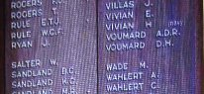
Burra District Honour Board
Photo taken by Chris McLaughlin
May 2016
Advertiser (Adelaide) Thursday June 14, 1945:
BEREAVEMENT NOTICES
RULE—Mr W.C.F. Rule and family wish to sincerely thank relatives and friends for floral tributes, telegrams, letters and cards in their sad loss of their dear wife, and mother, especially thanking Mrs Burton, Mrs Campbell, Mrs Metcalf, Dr White and the staff of Ha [cut-off] Ward, Magill. Will all please accept this as our personal expression of sincere thanks.

His name was inscribed on the Burra District World War I Honour Board.

Statements of his service were requested by the Adelaide Branch of the Repatriation Department from Base Records and forwarded on 20 September, 1961 and 17 September, 1968.

William Carl Frank Rule passed away on 14 June, 1970 aged 78 years.
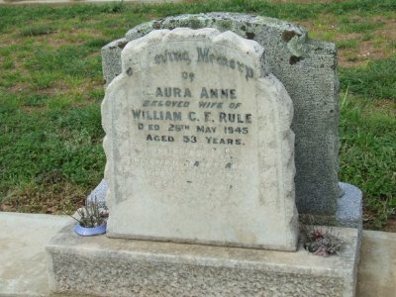
Interment took place with his wife in the Centennial Park Cemetery, Pasadena, Adelaide.

His inscription (below Laura’s) reads:

William C.F. Rule
Beloved husband of Laura
Died 14 June 1970
Aged 78 years

Their headstone in Centennial Park Cemetery, Pasadena, Adelaide
Photo sourced from Find-a-grave website

His brother also served.

LIEUTENANT ESSON THOMAS JAMES RULE
Company Sergeant-Major 188 - 10th Battalion / Lieutenant – 50th Battalion
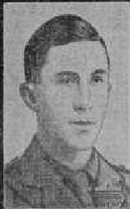
Lt Esson Thomas J. Rule
Photo sourced from Aust.
War Memorial
Redruth, South Australia was the birthplace of Esson Thomas James Rule on 4 January, 1895 the son of William James and Ita Juliana (nee Topperwein) Rule. He was educated at the Burra Model School and became a blacksmith in his father’s business at Aberdeen serving a five-year apprenticeship. His military training commenced with the Junior Cadets for three years, Senior Cadets of the 82nd Battalion Cadets for two years and 81st Battalion at Wakefield and was still serving when war was declared.

News of his military achievements was published in the:
Chronicle (Adelaide) Saturday September 27, 1913:
RIFLE NOTES
With reference to the musketry year ended June 30, 1913, the undermentioned are the names of the best shot of the Battalions in the 10th Brigade Area (Senior Cadets)
Sergeant E.T.J. Rule, E. Company, Burra, 137 points. Article abridged

The following appointment was announced in the:
Commonwealth of Australia Gazette Saturday August 8, 1914:
78th Infantry / Adelaide Rifles
Esson Thomas James Rule to be 2nd Lieutenant (provisional). Dated 1 July, 1914
At the recruiting depot in Morphettville, South Australia on 19 August, 1914 the single nineteen-year-old blacksmith applied to enlist for active service abroad and passed the medical examination. Forms of Attestation describe him as 173cms (5ft 8ins) tall, weighing 66kgs (145lbs) with a chest expansion of 85-97cms (33½-38ins) with a dark complexion, brown eyes and dark brown hair. Distinctive marks were vaccination scars on his left arm. Church of England was his religious faith. Next-of-kin nominated was his father W.J. Rule of Aberdeen. Burra, S.A. The Oath of Enlistment was taken and signed the next day.

Basic training commenced with G Coy, 10th Infantry Brigade the same day and was promoted to Acting Sergeant on August 28 then became Corporal on September 1, 1914. His regimental number was 188.

G Company, 10th Infantry Battalion embarked on 20 October, 1914 from Adelaide (4th Military District) on the transport HMAT A11 Ascanius, a twin-screw steamer, of which no trip sheet of their voyage has survived.
A stopover at Columbo and Aden took place where an Inquiry was held on 25 November, 1914 in connection with the collision between them and the transport Shropshire on 21 November, 1914 at about 4.35 a.m. when the Shropshire was struck on their starboard side, as it suddenly lost weigh, by Ascanius’ port bow.

A Board of Inquiry found that although the consequences of the collision were slight the Ascanius was blamed for the collision due to the evidence presented. The voyage would have terminated at the Suez.

They proceeded on the transport Ionian from Alexandria to join the M.E.F. at Gallipoli on 2 March, 1915 and in 6 May was promoted Sergeant.

A list of volunteers from Burra was published in the:
Kapunda Herald Friday June 18, 1915:
BURRA VOLUNTEERS
Burra, June 14.
We by request published a list, so far as is ascertainable, of volunteers from this district:
E.T.J. Rule Article abridged

Influenza invalided him to the 1st Aust Casualty Clearing Station on 3 August, 1915 then conveyed on the minesweeper Claxton to Mudros and for further treatment at Lemnos and re-joined his unit on August 13.

On 29 December, 1915 he disembarked the transport at Alexandria and on 26 February, 1916 was transferred to the 50th Battalion at Serapeum and taken on strength at Tel-el-kebir a day later. On 1 March, 1916 was promoted to be Company-Sergeant Major until March 27 when he was to be 2nd Lieutenant.

On the transport Arcadian they proceeded to France from Alexandria on 5 June, 1916 to join the British Expeditionary Forces disembarking at Marseilles on June 12.

He was promoted to Lieutenant in the field on 10 July, 1916.

His appointment as 2nd Lieutenant was announced in the:
Commonwealth of Australia Gazette Thursday July 20, 1916:
50TH BATTALION
To be 2nd Lieutenant
Company-Sergeant Major Esson Thomas James Rule Dated 27 March, 1916

He was recommended for a Military Cross on 19 August, 1916 for the following:

15th Aust. Infantry Brigade, 4th Australian Division, 50th Battalion, 19/8/16 date of recommendation.

50th Battalion, A.I.F. Lieut. RULE, Esson Thomas James
Near MOQUET FARM between 12th and 15th August, coolness and bravery under fire and great devotion to duty.
Captain Armitage
Major R.B. Jacob

Lieutenant Rule was killed in action of 3 April, 1917 at just twenty-two years of age.

Burial took place in Noreuil Australia Cemetery 5½ miles north east of Bapaume and struck off strength.

The 4th Military district was advised on 16 April, 1917 of his demise and notified his parents.

An Obituary was published in the
Journal (Adelaide) Thursday April 19, 1917:
LATE LIEUT. E.T.J. RULE
News was received on Monday by Mr and Mrs W.J. Rule, of Aberdeen, that their son, Lieut. Essen T.J. Rule, had been killed in action on April 3, (writes our Burra correspondent). Lieut. Rule always took a keen interest in military matters, and was in the Citizen Forces when war broke out. He left for Egypt on October 20, 1914, and being attached to the famous 10th Battalion was in the landing at Gallipoli. He went through the campaign, and was with the first detachment to proceed to France. He received his commission several months ago. The deceased was a general favourite. All flags were immediately flown at half-mast when the news of his death was received. Lieut. Rule was a prominent member of the Foresters’ Lodge, and at the time of enlistment he had gone through nearly all of the offices. The members of the lodge granted him leave while on service and presented him with a gold medal. He was formerly engaged in his father’s blacksmithing business. He was 22 years of age.
His name was among those listed in the Casualty List published in the:
Chronicle (Adelaide) Saturday April 25, 1917:
289 LIST – KILLED IN ACTION
Lieut. E.T.J. RULE, Burra, Article abridged

A copy of his service was made for the War Pension Department.

His Will in which he left his estate to his mother Ita Juliana Rule was received by Base Records on 27 September, 1917.

His personal effects were returned to his father from the Aust Imperial Force Kit Store in London by the transport Euripides of a green sealed canvas trunk containing the following articles:
2 S.D. Tunics, 1 pair gloves, 1 “Sam Browne” belt, 1 cap, letters, compass, I knife, stars, 1 medallion, 2 coins, 1 identity disc, 1 metal soap box, 1 revolver, 1 key, 2 clasp knives, 5 handkerchiefs, 1 forage cup, 1 testament, 4 prs socks, 1 photo, 3 face towels.

Base Records advised the 81st Infantry Battalion of his death on 19 January, 1918.

Letters of administration of his estate were received on 9 May, 1918 and requests for copies of the Certificate of Death came from the Oddfellows Lodge and J.E. Winnall.
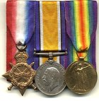
Medals of Esson Rule sourced from Virtual War Memorial Australia website
The Circular and Booklet re Graves was dispatched to his parents on 12 December, 1919 and return was acknowledged by printed card on 9 September, 1920. Photographs in triplicate of his grave were sent on 4 April, 1921 to his family. The Memorial Plaque (356416) and the Memorial Scroll (356416) were issued to his father on 5 December, 1923.

For his supreme sacrifice Lieutenant Esson Thomas James Rule, 50th Battalion was issued with the 1914-15 Star (2910), British War Medal (4747) and the Victory Medal (4746) for serving his country.

His name is commemorated on the Australian War Memorial, Canberra, ACT in the commemorative area on panel 151. The Adelaide National War Memorial also bears his name.
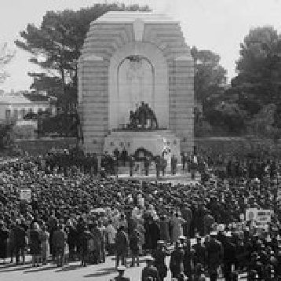
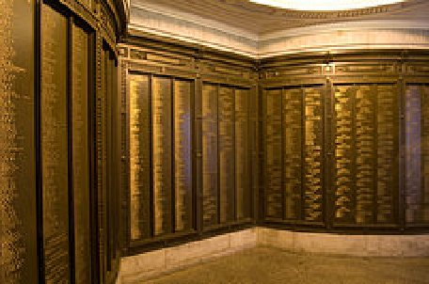
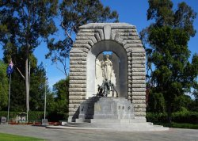
Adelaide National War Memorial - Photos sourced from S.A.History Hub’s website and Flickr
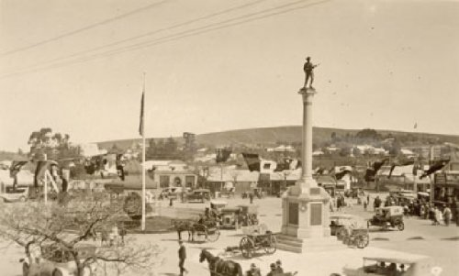
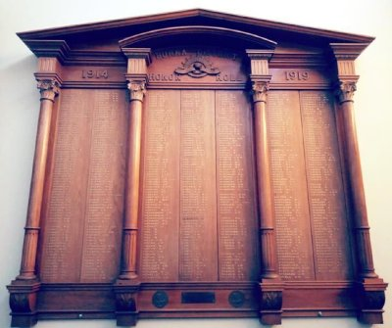
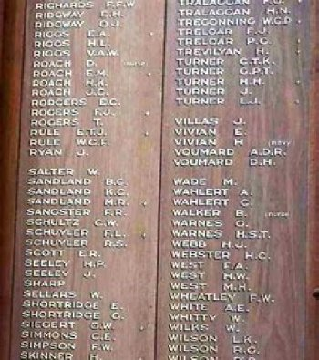
Burra and District War Memorial
He is commemorated on the Burra War Memorial and on his Lodges’ Rolls of Honour.

His and his brother’s names are also commemorated and the Burra and District Roll of Honour.
Burra District Honour Roll
Photo taken by Michael Pinkerton 11/2/2021

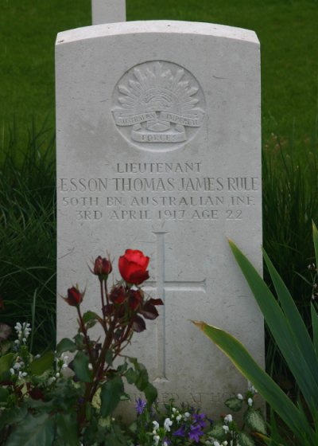
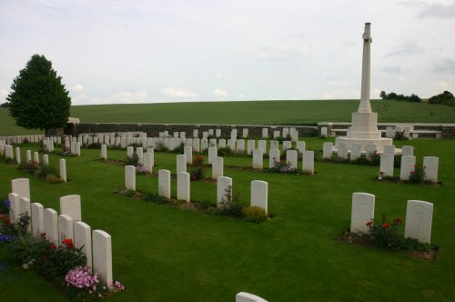
His grave is located in the Noreuil Australian Cemetery, du Pas-de-Calais, Nord, France within Row A in grave no. 24.
Photo of headstone & Noreuil Cemetery
by kind permission of
The War Graves Photographic Project - www.twgpp.org

LEST WE FORGET

© Donna Baldey 2021
www.tunnellers.net

