SAPPER ALEXANDER ROBINSON ROSS
6053 – 1st Tunnelling Company

Gympie, Queensland was the birthplace of Alexander Robinson Ross on 10 August, 1874 the son of William (died 1910) and Ellen (nee Robinson, died 1892) Ross. From 1903 to 1905 he is listed as a timber-getter at Tewantin and from 1908 to 1913 worked at Pomona with the same occupation. In 1916 he was a teamster at Kareewa, Pomona.

At the recruiting depot in Brisbane (1st Military District) on 4 July, 1916 the forty-one-year-old teamster applied to enlist for active service abroad and passed the medical examination. Attestation forms were completed and describe him as 170cms (5ft 7ins) tall, weighing 73.6kgs (162lbs) with a chest expansion of 92-98cms (36-38½ins) and had a medium complexion with his blue eyes testing to good vision and brown hair. Religion was Presbyterian. Next-of-kin nominated was his sister Mrs Ellen Richards of Ringtail, Pomona. The Oath of Allegiance was taken and signed the same day.
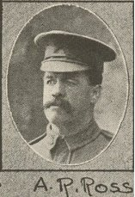
Spr. A.R. Ross
Of Reinforcements.
Photo Queenslander supplement issue 3/3/17 - State Library of Qld
Basic training commenced with the 11th Depot Battalion at Enoggera Barracks from 12 July until 28 August when allotted to the Miners depot (1st Military District) and he signed a statutory declaration the next day that he wanted his occupation to be that of a miner. On 9 September was transferred to their training camp at Seymour, Victoria for further instruction and placed with the December, 1916 Reinforcements to the Tunnelling Companies. His rank was Sapper with the regimental number 6053.

The 516 Reinforcements departed Melbourne, Victoria on October 25, 1916 at 1.30pm aboard the transport HMAT A38 Ulysses. The Australian coastline disappeared from view on October 30, 1916 with the port of Durban reached at 11.30am on November 13, 1916. Windy weather was experienced going around the Cape and arrived at Cape Town at 7am on November 19. Sierra Leone was the next port of call but their departure was delayed until December 14, 1916 as it was not safe to proceed further. Arrived at Plymouth, England on December 28, 1916 after 65 days at sea, with the troops disembarking at 1.30pm. Trains took them to Tidworth station marching in to Perham Downs the following day for further training for the front at the Aust. Details Camp.

The Reinforcements proceeded to France on 28 January, 1917 on board S.S. Onward from Folkstone arriving at the Aust General Base Depot in Rouelles the next day.

On 8 February, 1917 was attached to the 1st Anzac Entrenching Battalion which was an advanced section of the Base Depot that organised works near the lines and through duties, usually of ten days duration, would accustom the reinforcements to war conditions before being assigned to a company in the field.

He was attached to the 1st Tunnelling Company on 26 February, 1917.

Service continued until 7 September, 1917 when he went sick with Scabies (a skin irritation caused by Itch Mite whose eggs are laid under the skin’s outer layer) to the 97th Field Ambulance for seven days then returned to his unit on September 14.

On 6 October, 1917 went to the 97th Field Ambulance with haemorrhoids progressing to the 53rd Casualty Clearing Station the following day. Conveyed on Ambulance Train no.24 to Rouen was admitted to the 8th General Hospital for Haemorrhoid treatment. On October 14 was invalided to England on the hospital ship St George entering the Reading War Hospital with piles on October 16.
Sapper was transferred on 17 December, 1917 to the 3rd Aust Auxiliary Hospital in Dartford then discharged to furlough a day later and report to the No. 1 Command Depot in Dartford on 1 January, 1918.

He did not report and was apprehended on January 5 resulting in the following:
Offence: Sutton Veny 1/1/18 AWL from 3.30 p.m. till 6.30 p.m. 5/1/18
Award: 5 days Field Punishment No. 2 by Lt-Col W.O. Hansbridge 8/1/18
Total forfeiture: 12 days’ pay
In custody awaiting trial 2 days.

On 9 February, 1918 marched out to the No. 2 Command Depot at Weymouth.

Sapper Ross embarked for Australia on 10 March, 1918 on board H.T. Durham Castle due to premature senility (decline or deterioration of physical strength or mental functioning). Base Records advised his sister that he was returning home.

The returning invalid soldiers were transhipped to the transport Orontes at Capetown departing on 19 April, 1918.

His name was among those listed as returning in the:
Daily Standard Friday May 3, 1918:
INVALID SOLDIERS
LIST M. The following additional names to List M:
6053. Spr. A.R. Ross, Tun Rfts. Article abridged

The troopship docked in Sydney (2nd M.D.) on 12 May and the Queenslanders left by special train to Brisbane arriving on 14 May, 1918.

Military Discharge was issued in Brisbane (1st M.D.) on 14 June, 1918 as medically unfit.

In 1919 he is listed as a teamster at Kareewa, Pomona where he remained until 1930.

Sapper 5093 Alexander Robinson Ross, 1st Tunnelling Company was issued to wear the British War Medal (246721) and the Victory Medal (23784) for serving his country.
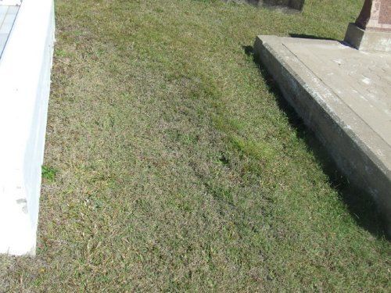
© Donna Baldey 2023
www.tunnellers.net
His unmarked grave in Gympie Cemetery, Q
Photo sourced from Gympie Cemetery Trust website
The Brisbane branch of the Repatriation Commission requested a copy of his service records from Base Records which were forwarded on 22 June, 1936.

Alexander R. Ross passed away on 15 June, 1942 aged 68 years. Interment took place in the Presbyterian Private B portion of Gympie Cemetery within section 2 in grave no. 283 the following day. There is no headstone

