SERGEANT FRANCIS XAVIER ROBINSON
3940 – 2nd Tunnelling Company / 3940A – 3rd Pioneer Battalion

Francis Xavier Robinson was born in Hobart, Tasmania on 20 January, 1876 the son of Henry and Louisa (nee Hammett) Robinson. He married in 1916 to Jessie Collins in Victoria.

At the recruiting depot on 3 March, 1916 in Melbourne, Victoria (3rd Military District) the forty-year-old married miner applied to enlist for active service abroad and passed the medical examination. Attestation forms describe him as 176cms (5ft 9¼ins) weighing 58.6kgs (129lbs) with a chest expansion of 84-92cms (33-36ins) and had a medium complexion with blue eyes and dark brown hair. Roman Catholic was his religious faith. Distinctive marks were two vaccination scars on his left arm and one on the right one and a scald scar on his head. Next-of-kin nominated was his wife Mrs Jessie Robinson of Brompton Road, Box Hill, Vic and allotted three-fifths of his pay in support of her and their children. He took and signed the Oath of Allegiance the same day.

Basic training commenced with No. 5 Tunnelling Company in the rank of Sapper at Broadmeadows camp, near Melbourne. The No. 5 Company was recruited from Victoria, South Aust. & Tasmania and made up of Headquarters and 2 Sections (8 officers & 173 men) (3 M.D.). 1 Section from Tasmania (3 officers & 76 O.Rs); also 1st Reinforcements for No. 5 Company (17 men from Vic. & 8 men Tas.)

Early in May 1916 No. 4 Tunnelling company recruits embarked from Brisbane, Qld aboard HMAT A69 Warilda for Sydney, NSW. Six officers and 152 other ranks together with the 1st Reinforcements of fifteen other ranks made up the two sections. At Rosebery Park, Sydney, NSW they joined their Headquarters and two sections (8 officers & 153 O.Rs.) plus 1st Reinforcements consisting of one officer and seventeen other ranks for final training.

The 7713-ton transport Warilda sailed from Sydney, NSW on May 22, 1916 to Melbourne, Vic where on 25 May Sapper Robinsons was promoted to Corporal. The No. 5 company departed the same day for Adelaide, S.A. to collect one Section of 3 officers & 76 O.Rs with 1st Reinforcements of 8 O.Rs.

Docking at Fremantle, W.A. on June 1, 1916 added No. 6 Company recruited from W.A. of 14 officers and 325 O.Rs along with 1st Reinforcements of 1 Officer & 32 O.Rs, set forth on their voyage the same day.

Durban, South Africa was reached on June 16, 1916 and Cape Town on June 21, 1916 while St Vincent completed the African ports of call on July 7, 1916. Discipline was fairly good except at intermediate ports where Away without Leave caused concern. The fifty-eight-day voyage experienced remarkably pleasant weather terminating at Plymouth, England on July 18, 1916. Four, Five and Six Companies comprising of 1064 officers and other ranks were detrained to Amesbury and Tidworth to begin training for the front at Perham Downs.

The Reinforcements proceeded to France on 28 August, 1916 arriving at the 2nd Aust Divisional Base Depot on August 30. Corporal marched out on 25 September for the 2nd Tunnelling Company in the field and taken on strength on 30 September.

On 6 April, 1917 Corporal was transferred to the 3rd Pioneer Battalion and taken on strength six days later. He was re-allotted the regimental number 3940A and was to be Temporary Sergeant due to Sgt Crowther being evacuated.

Proceeded on leave on 5 October, 1917 re-joining on October 17. During his leave was promoted to be Sergeant as Sergeant Hudson left sick on 9 July, 1917.

Sergeant was attached for temporary duty with the 2nd Aust Casualty Clearing Station on 26 November, 1917 and re-joined his unit from detachment on 13 December.
Two Blue Chevrons were issued to wear on his uniform for serving twelve months abroad.

On 26 May, 1918 Sergeant was wounded in action by a mustard gas attack and taken to the 11th Aust Field Ambulance then moved to the 49th Casualty Clearing Station a day later. Was admitted on 4 June to the 2nd Stationary Hospital in Abbeville but two days later conveyed on Ambulance Train no.17 and invalided to England on 7 June on the hospital ship Jan Breydal entering the Norfolk War Hospital, Thorpe, Norwich for further treatment for mustard gas poisoning.

Base Records regretfully advised his wife on 12 June, 1918 that it was reported her husband had been wounded due to gas poisoning. His address would have been included for correspondence. She was again notified her husband had been transferred to England on June 23 actual condition not stated.

His name was among those soldiers appearing in the Casualty List published in the:

Weekly Times (Melbourne) Saturday June 29, 1918:
WOUNDED
Sgt F.X. Robinson, Box Hill (gas) Article abridged
Was transferred to the 1st Aust Auxiliary Hospital on 3 July and two days later discharged to furlough and report to the No. 4 Command Depot at Hurdcott on July 17. He was granted the balance of leave to July 22 and marched in from Administration Headquarters, London. Was moved to the Overseas Training Brigade at Longbridge, Deverill on 3 September and proceeded to France on 29 September, 1918. Arrived at the Aust Infantry Base Depot in Rouelles and marched out to his unit arriving on 7 October.

He was with his unit when Peace was declared and they remained on the front as part of the Army of Occupation assisting with rehabilitation of their district.

On 16 February, 1919 marched out for return to Australia joining the Quota No.12 at the Aust General Base Depot departing on February 28 and arrived at Weymouth, England on 1 March, 1919 the marched in to the Overseas Training Brigade.

After demobilisation Sergeant Robinson embarked for discharge in Australia on 30 April, 1919 on board H.T. Karagola. Base Records advised his wife on 21 May he was returning home.

His name appeared in the list of soldiers returning appearing in the:
Age (Melbourne) Tuesday May 27, 1919:
VICTORIANS OF KARAGOLA
The following Victorian members of the A.I.F. are returning per transport Karagola, which left England on 30th April:
Sergt F.X. Robinson Article abridged

The troopship docked in Melbourne (3rd M.D.) on 12 June, 1919 with news of their arrival published in the:
Argus Friday June 13, 1919:
RETURNING TROOPS – ARRIVAL OF S.S. KARAGOLA
Despite the frequency with which transports have lately been arriving, there has been no indication of waning interest on the part of members of the public. The welcome given to the troops who arrived yesterday by the s.s. Karagola was extremely cordial, and was greatly appreciated by the men. The State commandant (Brigadier-General Brand) was on the pier when the vessel arrived, and briefly addressed the soldiers, who were afterwards conveyed by the usual route to the A.I.F. Depot in Sturt-street, where relatives and friends gave them a rousing reception. The military arrangements were satisfactory and the final examination of the men was carried out without avoidable delay.
Military Discharge was issued in Melbourne (3rd M.D.) on 27 July, 1919 on termination of his period of enlistment. For serving his country Sergeant 3940A Francis Xavier Robinson, 2nd Tunnelling Company / 3rd Pioneer Battalion was issued with the British War Medal (45501) and the Victory Medal (44728).

He returned home to Brompton Road, Box Hill to work as a labourer where they remained.

Base Records received a request from the Melbourne branch of the Repatriation Commission for a copy of his hospital admissions which was prepared on 10 December, 1921.

He receipted delivery of the Victory Medal on 7 July, 1922 from Victoria Barracks, Melbourne.

The Melbourne branch of the Repatriation Commission requested copies of his service records from Base Records which were sent on 12 January, 1927.

Mrs Jessie Robinson died on 23 August, 1953 and buried in Box Hill Cemetery in the same grave as daughter Eva Robinson who had died on 15 March, 1915.

Francis Xavier Robinson passed away on 13 March, 1954 aged 78 years in the Repatriation Hospital, Heidelberg. Arrangements were published in the:
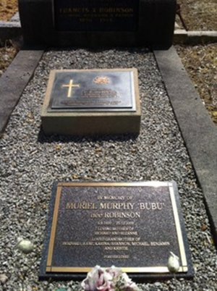
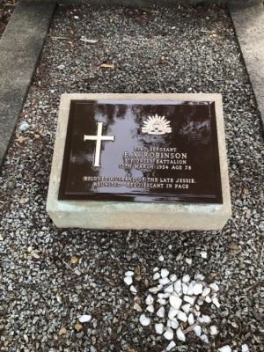
Argus (Melbourne) Monday March 15, 1954:
DEATHS
ROBINSON, Francis Xavier, of 9 Barcelona-street, Box Hill—On March 13, at Heidelberg Repatriation Hospital, dearly loved husband of the late Jessie and loved father of Eva (deceased), Josie, Bill, Muriel and Grace. R.I.P.
FUNERAL NOTICES
ROBINSON—The Funeral of the late Mr FRANCIS XAVIER ROBINSON will leave Padbury’s chapel, 959 White Horse Road, Box Hill THIS DAY(Monday), at 1.15 p.m. for the Box Hill Cemetery.
A.W. PADBURY & CO. PTY LTD
Robinson Family Plot in Box Hill Cemetery, Melbourne - Photo of War Grave plaque supplied by DVA
overall grave photo sourced from Find-a-Grave website
Interment took place in the family plot in the Church of England portion of Box Hill cemetery with in grave no. 0828. He has a Commonwealth War Grave.
Their daughter, Muriel ‘Bubu’ Murphy, nee Robinson, is also buried in the family plot.

Business in connection with his Estate was advertised in the:
Argus Monday March 29, 1954:
LAW NOTICES
FRANCIS XAVIER ROBINSON. Also known as Frank Robinson, of 9 Barcelona Street, Box Hill, Gentleman, Deceased. —After fourteen clear days Francis Henry David Robinson of Hume-street, Greensborough, METTALURGIST AND John Bernard Murphy, of 24 Sweetland-road, Box Hill, printer, the executors appointed to the deceased’s will, dated the third day of November, 1953 will APPLY to the Supreme Court of Victoria for a grant of PRIBATE of the said WILL.
MAURICE BLACKBURN & Co. Solicitors of 431 Bourke-street Melbourne.

His name is commemorated on the Shire of Nunawading Roll of Honour Board, Melbourne.

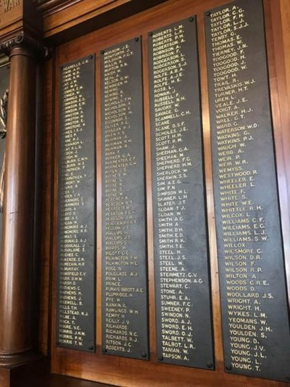
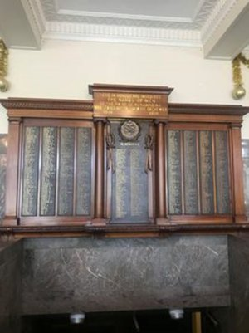
Shire of Nunawading Roll of Honour Board
Photo sourced through Virtual Anzacs website

© Donna Baldey 2024
www.tunnellers.net

