SAPPER ERNEST VICTOR ROBINS
6051 – 2nd Tunnelling Company

Alstonville, New South Wales was the birthplace of Ernest Victor Robins in 1884 the son of Henry Alexander and Catherine Hannah (nee McDonald) Robins.

There is an entry in the New Zealand Electoral Roll of 1906 for him residing at Dalziel Road, Te Roti, Hawera and would have been twenty-two-years of age. He went to the district of Cooroy, Queensland and with his brother Angus Bruce Robins were early farmers in the area. In 1911 he was a trustee for the Recreation Reserve Crown Land in Cooroy which was announced in the:
Brisbane Courier Friday September 1, 1911:
CROWN LANDS
The following areas have been reserved: 1 rood 2 perches at Cooroy for recreation (trustees) C. Livingstone, E.V. Robins, J.L. Bolem, A.S. Douglas and C.J. Reed: Article abridged

In 1912 and 1913 the Robins brothers Ernest and Bruce Robins were listed at Cooroy with Ernest as a farmer and Bruce, a selector.

He married on 12 March, 1913 to Clara Lister and they continued to reside at Cooroy.

He is mentioned in an article on the annual ball in the:
Gympie Times and Mary River Mining Gazette Thursday June 26, 1913:
DANCE AT COOROY
A correspondent at Cooroy writes that the second annual ball arranged by the Benedicts of that town and district eventuated on Friday night last 20th inst. in the Coronation Hall, and as was anticipated proved a distinct success. The weather conditions during the day were not promising, but happily no rain fell until after the guests had assembled. The proceedings opened with the conventional Grand March. Afterwards a programme of 24 dances was put through, Messrs E.V. Robins and Alf. Cooper being the joint MMC.

In the Noosa Shire election he co-nominated the local candidate and published in the:
Gympie Times and Mary River Mining Gazette Tuesday February 10, 1914:
NOOSA SHIRE ELECTION
Nominations closed yesterday at 4 p.m. for the vacancies caused by the annual retirement of one member from each division of the Noosa Shire. The returning officer received the following nominations:
No. 3 Division. George Thomas Whelan, nominated by— [13 others] and E.V. Robins Article abridged

Problems with alcohol occurred and the Police and Licensing Court ordered the following:
Gympie Times and Mary River Mining Gazette Thursday April 29, 1915:
POLICE COURT
At the Police Court on Tuesday before Mr T.H. Boddington, P.M. By consent a prohibition order was granted against Ernest V. Robins for twelve calendar months.

Gympie Times and Mary River Mining Gazette Tuesday May 4, 1915:
THE LIQUOR ACT OF 1912
In the Licensing Court of Licensing District of Gympie, in the State of Queensland.
TO WHOM IT MAY CONCERN
WHEREAS it has been made to me, the undersigned, constituting the Licensing Court in the Licensing District of Gympie acting under “The Liquor Act of 1912” that ERNEST VICTOR ROBINS, by extensive drinking of liquor, greatly injures his health, I do by this my Order forbid any licensed person to sell to the said Ernest Victor Robins any liquor for the period of one year from the date hereof.
Given under my hand at Gympie, this 29th day of April, 1915.T.H. BODDINGTON, Police Magistrate
Around the same time he placed the following advertisement in the:
Gympie Times and Mary River Mining Gazette Thursday May 13, 1915:
WANTED KNOWN
I WILL not be responsible for debts incurred by my wife or any other person after the date of this issue without written authority from me. —E.V. Robins.

Towards the end of 1915 he had decided to enlist for active service abroad and in preparation resigned as trustee on the Cooroy Recreation Reserve as reported in the:
Times and Mary River Mining Gazette Tuesday November 30, 1915:
NOTES AND NEWS
Trustees—In last Saturday’s “Government Gazette” it is notified that James Duke has been appointed trustee of the Cooroy Recreation Reserve, vice E.V. Robins, resigned.

At the recruiting depot in Brisbane (1st Military District) on 17 May, 1916 the thirty-two-year-old farmer / miner applied to enlist for active service abroad and passed the medical examination. Previous military experience was gained with the NSW Lancers until he left the district. Attestation forms describe him as 173cms (5ft 8ins) tall, weighing 69.5kgs (153lbs) with a chest expansion of 88-90cms (34-35½ins) and had a dark complexion with fair eyesight in both brown eyes and dark brown hair. Religion was Presbyterian. Next-of-kin nominated was his wife Mrs Clara Robins of Cooroy, Qld and allotted three-fifths of his pay in support of her.

The Oath of Allegiance was signed and taken the same day.

An auction was held selling all his furniture, house and farm items and advertised in the:
Gympie Times and Mary River Mining Gazette Tuesday June 20, 1916:
V.C. MARK’S AUCTION SALE
HORSES and FURNITURE
Saturday, 24th June,
ON ACCOUNT OF MR E.V. ROBINS
(who has enlisted)
HOUSEHOLD FURNITURE AT HIS RESIDENCE COOROY
AT 3 O’CLOCK
Double Bed, Three-Quarter Bed, Duchess Chests, Wash Stands, Sideboard, Couch, Chairs, Tables, Crockery, Kitchen Utensils, Spray Pump, 40 Fowls, Saddle and Bridle, Tools of all sorts, Saddle Hack and Sheep Dog.
V.C. MARKS, Auctioneer, COOROY

He was a witness in the City Police Court, Brisbane on 7 July, 1916 for an incident on 29 June, 1916 at the Clarence Hotel, South Brisbane. Details of the robbery were published in the:
Telegraph (Brisbane) Saturday July 8, 1916:
A VISITOR’S MONEY – THEFT FROM PERSON ALLEGED
A charge of having stolen £2 from the person of William Henry Harris, was laid against a man named Albert James Smith in the City Police Court yesterday, before Mr E. Eglinton, P.M.
Constable P. Murphy stated that on 29th June, he saw accused and another man in company with Harris, at the Clarence Hotel, South Brisbane. They went along a passage leading to the back yard. A few minutes afterwards, witness heard the third man Robins, say something. In consequence, witness went to the stable at the rear of the hotel, and saw Harris lying on the straw. His right-hand hip pocket was turned inside out.
Ernest Victor Robins, a farmer, stated that accused asked him to take Harris, who was drunk, to the stable. Witness lent his assistance. A few minutes later, when Harris was lying on the straw, accused rifle his pockets. Witness reported the matter to Constable Murphy.
Accused reserved his defence, and was committed for trial at the criminal sittings of the Supreme Court, to be held on 7th August.
Basic training commenced with the 11th Depot Battalion at Enoggera Barracks from 12 July, 1916 to 15 August then to the 6th Reinforcements to the 49th Battalion until September 1 when allotted to the Miners Depot (1st Military District). He then signed a Statutory Declaration that he wanted his occupation to be stated that of a miner.
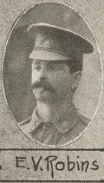
Spr. E.V. Robins
Photo sourced from supplement to The Queenslander issue
3 March, 1917
State Library of Qld

On 14 October, 1916 was transferred to their training camp at Seymour, Victoria and later placed with the December, 1916 Reinforcements to the Tunnelling Companies. His rank was Sapper with the regimental number 6051.

The 516 Reinforcements departed Melbourne, Victoria on October 25, 1916 at 1.30pm aboard the transport HMAT A38 Ulysses. The Australian coastline disappeared from view on October 30, 1916 with the port of Durban reached at 11.30am on November 13, 1916. Windy weather was experienced going around the Cape and arrived at Cape Town at 7am on November 19. Sierra Leone was the next port of call but their departure was delayed until December 14, 1916 as it was not safe to proceed further. Arrived at Plymouth, England on December 28, 1916 after 65 days at sea, with the troops disembarking at 1.30pm and detrained to the station at Tidworth and marched in to Perham Downs the following day for further training for the front at the Aust. Details Camp. The Reinforcements proceeded to France on 29 January, 1917 from Folkstone on the transport S.S. Onward arriving at the Aust General Base Depot the next day.

On 8 February Sapper was attached to the 1st Anzac Entrenching Battalion which was an advanced section of the Base Depot that organised works near the lines and through duties, usually of ten days duration, would accustom the reinforcements to war conditions before being assigned to a company in the field.

Sapper proceeded to join the 2nd Tunnelling Company in the field on 28 March, 1917 and was taken on strength on April 1.

During July, 1917 the 2nd Tunnelling Company had its Headquarters at Coxyde Bains on the South Coast of Belgium with the company camped on the outside of town and working in the Nieuport Bains sector to the extreme left of the British Line. Sections of the company were undertaking offensive mining against enemy strongpoints, sinking wells between Coxyde Bains and Oost Dunkerque Bains and building underground subway and quarters for a Battalion Headquarters.

On 10 July, 1917 the extreme left of the British front line was at this time about 600 yards in advance of the River Yser, and consisted of a series of posts in the Dunes, and on the beach. The Reserve line, Battalion Head Quarters, and the billets of this unit were on the Western side of the river, and connected to the front-line system, by three pontoon bridges.

About 8 a.m. the enemy opened up a heavy bombardment on these bridges and by 2 p.m. they were destroyed, the result being that all men on the Eastern side of the river were cut off. These included 2/Lt W.M. Mortensen and 2/Lt E.P. Hargraves, 47 Tunnellers and 47 attached infantry, 1 Battalion Kings Royal Rifles Corps, and 1 Battalion 1st Gloucester Regiment, with technical arms.

Throughout the day the enemy kept up an intense and destructive bombardment on Nieuport Bains.

As nearly as can be estimated, at about 7 p.m. the enemy attacked and killed or took prisoner all on that side of the river, with the exception of a few officers and men who swam across.

Sapper Robins was initially reported wounded in action on 10 July, 1917 and sent to hospital sick but returned the same day.
Wounded in action later was crossed out on his service card and marked remaining on duty and (not yet diagnosed). Later shell shock was crossed out and neurasthenia (nervous condition, constantly worried to point of exhaustion) left penned in. Verification was written for on 20 August by Headquarters and the Unit replied “remained on duty N.Y.D.”

Service continued without incident and the Company returned to France and were mining in hard chalk on a Brigade Headquarters with additions during the first two weeks of March, 1918. Billets were at Trescault.

The Unit Diary of the 2nd Tunnelling Company reported the following:

“11 March, 1918
Tactical situation on the whole of the Corps front very critical. It is expected that enemy will attack here any day, for some time past with work on the Corps and Army lines and wiring has been pushed forward as fast as possible and the defences are now remarkably good. The “Battle” or Corps Line on which a decisive stand would probably be made is where the majority of the work of the Unit is now being done.

“12 March, 1918
O.C. visited new camp site, and conferred with C.E. regarding action in case of enemy attacks.
Tactical situation still more critical. Enemy artillery activity intense, shells being used extensively, mixed with a proportion of H.E.
The area around No. 3 Section Forward Billets at Trescault heavily shelled with gas resulting in 2 officers (Lieut. L.G. Wilkins and Lieut. S. Halford) 74 sappers of the Coy being gassed, besides 58 attached infantry. The bombardment lasted from 7 p.m. to 3 a.m. [number cut off] night of 12/13th and was spread over quite a large area, which retained a dangerous concentration of gas for over 24 hours. It is estimated that the enemy fired 40,000 shells on the Corps front during the 24 hours. The majority of these fell in and around Trescault. The enemy also shelled various points in back areas with H.E. These included Metz, Ytres Station and Royaucourt. Owing to the tactical situation Labour Corps ordered not to have any men on detachment after evening of the 12th. “

Sapper Robins was wounded in action on 12 March, 1918 in a mustard gas shell attack and taken to the 149th Field Ambulance then on to the 3rd Casualty Clearing Station. The next day was conveyed on Ambulance Train no.9 to the 3rd Aust General Hospital at Abbeville for two days then invalided to England on the hospital ship Cambria on March 15 being admitted to the County of London Hospital at Epsom with shell gas poisoning the next day.

Hospital report on his condition stated:
Gassed 12/3/18 with mustard gas. Comparative laryngitis, severe vomiting & cough, abundant
sputum, frothy, pocketed with blood on admittance here T101.
Lungs – rhonchi (harsh wheezing) and rales (rattling sounds) both bases, later all over. Tubular
breathing & patches of collapsed lung.
Heart – right ventricle and intermittent pulse
Condition of acute broncho-pneumonia. Cyanosis (blue-purple discolouration) of face.
He got progressively worse & died at midnight 28/3/18.

He was 33 years of age when he died of wounds on 28 March, 1918. The Epsom War Hospital telegrammed London Headquarters at 9.24 a.m. on March 29 advising of the soldier’s death, next-of-kin with details. The 1st Military District was advised by cable on 2 April, 1918 and next-of-kin notified. Confirmation of cable received was confirmed.

His body was put on a train for interment in Brookwood Military Cemetery in Surrey, England where Thomas Vigers of 3 Eccleston Street, London took care of the arrangements providing a good coffin of polished elm to be interred in the Australian Military Burial Ground of consecrated earth in a single grave Plot XI. A. 16 (no.180766) with a military funeral.

The Funeral commenced at 1.30 p.m. on 2 April, 1918 with Chaplain Rev. Shannon of A.I.F. Headquarters conducting the ceremony with the coffin draped in the Australian flag and a beautiful wreath placed on the coffin by several Australian comrades from the County of London Hospital, Epsom who attended the funeral.
A friend, Miss Nellie Wordleworth of 4 Dunkerley Street, Oldham also was present. Firing party, bugler and pallbearers were supplied by A.I.F. Headquarters in London and representatives from there also attended.

The grave was immediately to be turfed and an oak cross erected by A.I.F. London.

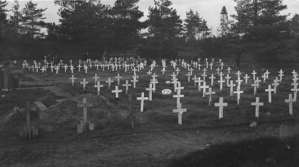
AWM Image ID: D00190

Brookwood Military Cemetery AIF section - January 1919

Base Records had advised his wife by Telegram care of Mrs Rowe, Cooroy on 28 March, 1918 of his admittance to the Horton County War Hospital on 16/3/18 suffering from gas poisoning. His postal address was given. This news was shared in the:
Gympie Times and Mary River Mining Gazette Thursday April 4, 1918:
PERSONAL
Mrs E.V. Robins (Cooroy), has received a message from Base Records, Melbourne, stating that her husband, Sapper E.V. Robins is seriously ill and suffering from shall gas poisoning, received on the 19th March.

A copy of his service records was made on 5 April, 1918 for the Pension Department in London.

News of his demise was announced in the:
Gympie Times and Mary River Mining Gazette Saturday April 6, 1918:
COOROY – PERSONAL
Word was received here that Private E.V. Robins, who was recently reported to have been gassed whilst at the front in France, has since died. He leaves a wife, but no family. He is also a brother of Mrs E.J. Sneesby, of Cooroy. The deceased soldier was one of the pioneer settlers here and was well thought of. His brother Bruce was also killed in action some time ago.

This was also published in the:

Chronicle and North Coast Advertiser Friday April 19, 1918:
IN THE BIG DEFENSIVE
Pte E.V. Robins, of Cooroy, was fatally gassed.
A Memorial Service was held in his home town of Alstonville, NSW and a report published in the:
Northern Star (Lismore) Wednesday May 1, 1918:
THE LATE SAPPER E.V. ROBINS – MEMORIAL SERVICE
On Sunday night last in the Alstonville Agricultural Hall, the Rev. Gordon W. McAlpine, Alstonville, conducted a memorial service to the late Sapper E.V. Robins, second son of Mr H.A. Robins “Lochiel,” Rous, who had given his life for his King and country. The attendance was very large indeed, all classes and creeds attending to pay their respect to the memory of a brave soldier and to his father and brothers and sisters. The stage was appropriately arranged for the occasion. The background consisted of a large Union Jack, while the pulpit was draped in black, relieved by the Australian flag, in front of which was a large wreath of white chrysanthemums. On the organ was a large vase of white flowers.
The service, which was a very solemn one, opened with the National Anthem, followed by a prayer, after which the hymn “O God Our Help is Ages Past” was sung. The first lesson was taken from Ecclesiastics 12th chapter. After prayer Psalm 20 was sung.
The second lesson was from 1st Corinthians, 15th Chapter. After prayer Kipling’s famous Recessional Hymn was sung. The other hymns were: “O God of Love, O King of Peace.” And “For Ever with the Lord.” The Rev. Mr McAlpine preached an eloquent and highly instructive sermon from Hebrews 9th chapter, 27th verse: “It is appointed unto men once to die.” In his discourse the reverend preacher referred to the significance of Anzac Day, a day, he said, Australia would demand to be placed in history. He also dealt with the theme of life beyond the grave, and in conclusion paid a high tribute to the many fine qualities of the deceased soldier, who was a son of one of the most respected citizens in the district. At the conclusion of the sermon a prayer was offered, after which Mr G. Hampton, of Lismore, sang in fine voice “He Wipes a Tear From Every Eye.” After the Benediction the Dead march in “Saul” was played by Miss Abernethy, who presided at the organ throughout the service.

The following bereavement notice was placed in the:
Gympie Times and Mary River Mining Gazette Saturday April 20, 1918:
ROLL OF HONOUR
ROBINS—Private E.V. Robins, dearly beloved Husband of Clara Robins (Cooroy), died on 28th instant, at County Hospital, Epsom from the effects of being gassed in France.
“Greater love hath no man than that he lays down his life for his friends.”

His name was amongst those casualties published in the:

Chronicle and North Coast Advertiser Friday May 3, 1918:
OUR HONOUR LIST – APRIL’S ADDITIONS
April unfortunately made up for the welcome deficiencies of March in the supply of casualties amongst the lads from our district
List 389 (April 16) reported Sapper Ernest Victor Robins, of Cooroy, as having died of wounds on 28th March 1918 (gas, previously reported wounded, gas).
Article abridged
Messrs Crouch and Eden, Solicitors of Fitzroy Chambers. Brisbane wrote to Base Records who replied on 16 May, 1918 to their communication of the 9th instant stating that sufficient time had not elapsed for his personal effects to have filtered through the usual channels from France and Australia but any coming to hand would be forwarded promptly to his wife Mrs Robins or in accordance with other testamentary instructions. There was no record of a Will at their office to date.

If Sapper Robins had prepared a Will on the Will form provided in the Pay Book or if such document was discovered amongst his personal belongings, the Authorities at the Front would dispatch it to their branch for distribution to the District Paymaster, Victoria Barracks, Brisbane, to the legatee.

Certificate of Report of Death will be forwarded to them on receipt of necessary official information confirming documents from abroad.

At the Red Cross Society meeting in Alstonville minutes were published with the following mentioned in the:

Northern Star (Lismore) Wednesday May 22, 1918:
ALSTONVILLE RED CROSS SOCIETY
A meeting of the Alstonville Red Cross Society was held on Wednesday, the 15th inst.
Inward correspondence was as follows—From Mr H.A. Robins and family, expressing thanks for sympathy extended them in their recent bereavement, in the death of Sapper E.V. Robins—Received.
Article abridged
His personal effects were sent from the County of London War Hospital, Epsom to the Kit Store at Hammersmith, London for return Mrs Robins. Their inventory showed:

1 belt, 1 hair brush, 2 badges, 1 Testament, 2 pipes, 2 razors, 1 cigarette holder, 6 coins, 1 case
containing photos, 1 paybook cover containing letters, 1 diary, 1 watch (glass broken), P.O. &
stamps for 3/7 pence passed to Chief Paymaster A.I.F. Headquarters, London.

These items were packed in a case No.1112 and dispatched on the transport Barunga on 21 June, 1918 to Base Records for distribution.

Messrs Crouch and Eden, Solicitors of Brisbane previous request for a Certificate of Report of Death from Base Records was prepared and the form sent to them on 22 June, 1918.

The same day Base Records wrote to his widow care of Mrs Rowe, Cooroy, Qld with reference to the report on the regrettable loss of her late husband and now were receipt of advice from abroad which showed he died at Horton County of London Hospital, Epson, England on 28/3/18 of gas poisoning, acute broncho-pneumonia. Burial took place in Brookwood Military Burial Ground. They repeated the (above) information on his military service and those in attendance and stated that these additional details were furnished by direction, it being the policy of the Department to forward all information received in connection with deaths of members of the Australian Imperial Force.

Photographs of his grave were transmitted in triplicate to next-of-kin on 24 July, 1918.

Base Records prepared the Certificate of Report of Death on 26 July, 1918 as requested by urgent telegram as evidence from Solicitor Mr Sykes, Gympie, Qld and sent the copy to him for probate.

Mrs C. Robins wrote to Base Records on 8 August, 1918 from Sydney asking if anything should come belonging to her husband would they kindly forward to her present address G.P.O. Sydney and thanked them for their kindness.

Cooroy commemorated Anzac Day, 1919 with an evening service of prayers held for the local members of the district with proceedings published in the:
Gympie Times and Mary River Mining Gazette Saturday May 3, 1919:
COOROY – ANZAC DAY
Anzac Day at Cooroy was fittingly celebrated last Friday. In the morning Chaplain Rev. A. Maxwell held a service in the Church of England. In the evening an un-denominational service was held in the Coronation Hall which was filled. The service was conducted by Rev. J. Gunders, Mrs Ross acting as accompanist on the organ. With prayers and singing of hymns and the scripture lessons from psalm and Revelations were read.
Mr Gunders then delivered an address and concluded by reading a list of Cooroy district boys who had made the supreme sacrifice. They were as follows: A.B. Robins, E.V. Robins.
At 9 o’clock all stood in silence the “Dead March’ being played. The hymn “Abide with Me” was sung. The benediction and the singing of the National Anthem closed the proceedings.
A collection was taken up for the memorial fund and £2 15s was obtained.
Article abridged

A memorandum from the 1st Military District dated 8 September, 1919 to Base Records advised that Probate of the Will of the deceased soldier has been granted to the executor Mr Ephraim Joseph Sneesby of Cooroy (farmer.)
A Circular and Booklet re Graves was dispatched on 12 December, 1919 to his widow with a chaser forwarded on 29 July, 1921 and final notice issued on 14 February, 1922. She was then advised that if no reply was received from her by 31 March work upon her husband’s grave will be proceeded to at once and requests for personal inscriptions would no longer be considered from that date.

Base Records wrote on 6 August, 1920 to Mrs E.J. Sneesby, Cooroy asking if she could supply the address of Mrs Clara Robins, widow and next-of-kin of the late soldier Sapper Robins. Their address to her care of General Post Office, Sydney, NSW had been returned. Mrs Sneesby replied on August 18 that as near as she knew her present address was care of Mr V.C. Marks, Samford Hotel, Samford, via Brisbane, Qld. Her letter was acknowledged by Base Records on 27 August and thanked her for the information it contained.

For his supreme sacrifice Sapper 6051 Ernest Victor Robins was issued with the British War Medal (51672) and the Victory Medal (50992) for serving his country,

The War Medal was issued to the Commandant, 1st Military District on 29 April, 1921 for forward to his widow at a suitable time.

The Pamphlet Where the Australians’ Rest was sent to Mrs Robins on 7 May, 1921.

The Memorial Committee for the Royal Engineers who gave their lives would have their names inscribed of a Roll of Honour to be placed in St Paul’s Cathedral, London and announced in the:
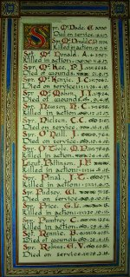
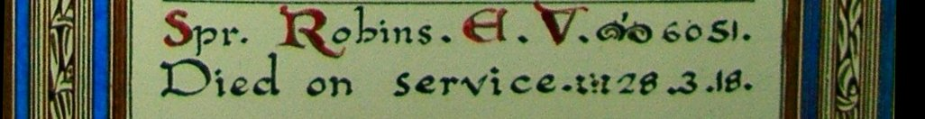
The Sydney Morning Herald - Saturday 23 July 1921:
ENGINEERS' ROLL OF HONOUR
The Royal Engineer War Memorial Committee are arranging to deposit a roll of honour of all ranks of the Royal Engineers whose names were officially published as killed in action or died of wounds or disease in the war in the chapel of St. Paul's Cathedral, and the Engineer corps of the dominions, colonial, and Indian armies have been invited to deposit similar rolls of honour in St. Paul's, to be attached to that of the Royal Engineers. This invitation has been accepted in Australia. The roll will be inscribed on vellum and enclosed in a casket of Australian timbers to rest on a slab of Australian marble.
This extract from Tunnellers Roll of Honour included in profile with the kind permission of the
Dean and Chapter of St Paul’s Cathedral, London
Photos courtesy of Robin Sanderson, Paris

The Memorial Scroll (341518) was issued to Mrs Robins on 16 December, 1921. Delivery was receipted by her dated 5 January, 1922.

The District Finance Officer requested the address of next-of-kin from Base Records on 2 May, 1922.

Also sent to Mrs Robins was the Memorial Plaque (341518) posted on 24 October, 1922 and received delivery signing the slip on 20 November, 1922.

Imperial War Graves, London wrote on 14 December, 1922 enclosing an order form to purchase the Register containing his name in the Brookwood Cemetery. A small sample was attached to the letter.

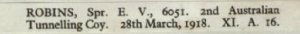
Image sourced from WWI Documents – Robins, E.V. 6051
National Archives of Australia

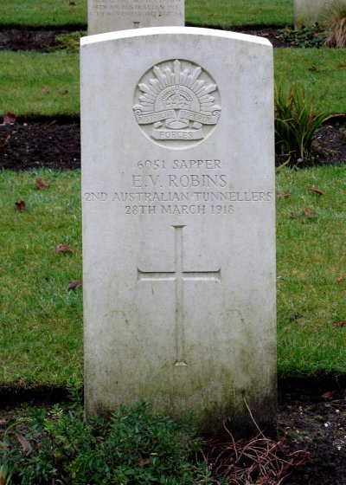
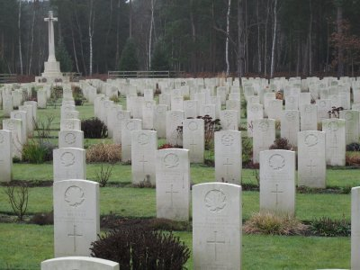
addressed to Mrs C. Robins, Samford, Queensland and containing the Victory Medal for her late husband. He begged to inform that advice received from the Deputy Postmaster-General, Brisbane that this packet was redirected to the G.P.O., Brisbane and was delivered to the addressee on 25/5/23. The “A.R.” card was duly completed and returned herewith. The present address of Mrs Robins was stated as “Holyrood” Redcliffe, Queensland.
The Victory Medal was packaged for his widow on 12 April, 1923 and sent on April 16.

The Postmaster-General’s Office, Melbourne wrote to Base Records on 24 July, 1923 replying to their inquiry of the 15th June, 1923, relative to the disposal of a registered packet No.7379, posted 16/4/23,
Photo of headstone and Brookwood Cemetery by kind permission of
The War Graves Photographic Project - www.twgpp.org

At the Australian War Memorial, Canberra, ACT his name is commemorated on panel 27 in the Commemorative area.

His brother also served.

PRIVATE ANGUS BRUCE ROBINS
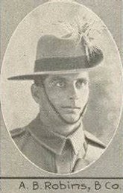
249 – 5th Light Horse Regiment
Pte A.B. Robins
Photo from supplement to The Queenslander 19 Dec., 1914
2nd Aust. Expeditionary Force
State Library of Qld
Rous Mill, Ballina Shire, New South Wales was the birthplace of Angus Bruce Robins in 1890 the son of Henry Alexander and Catherine Hannah (nee McDonald) Robins.

In 1912 he was listed as a selector at Cooroy, Queensland.

On 21 September, 1914 the twenty-four-year-old single farmer applied to enlist for active service abroad and passed the medical examination at the recruiting depot in Gympie.
Forms of Attestation were completed and describe him as 169cms (5ft 6½ins) tall, weighing 63.6kgs (140lbs) with a chest expansion of 81-88cms (32-34½ins) and had a dark complexion with brown eyes and brown hair. Distinctive mark was a scar of the left eye. Presbyterian was his religion.

Next-of-kin nominated was his father Alexander Robins of Rous, Richmond River, NSW. The Oath of Enlistment was taken and signed the same day.

Acknowledgement to the new recruit was published in the:
Gympie Times and Mary River Gazette Thursday September 24, 1914:
MILITARY NOTES
The following have enrolled in the second Australia Expeditionary Force and have joined the concentration camp at the Exhibition Grounds, Brisbane: Angus Bruce Robins (Cooroy):
Article abridged

His send-off to Brisbane was also reported in the:
Gympie Times and Mary River Gazette Saturday September 26, 1914:
COOROY
TO THE WAR—Mr Bruce Robins, the first Cooroyite to volunteer for the front, took his departure from here on Thursday morning to join the second expeditionary force of infantry. A large number of friends saw him off at the railway station, and wished him good luck in his mission.

Basic training commenced in Brisbane (1st Military District) and on 8 December was allotted to A. Squadron, 5th Light Horse Regiment at Enoggera Barracks.
His rank was Private with the regimental number 249.

On his final home leave returned to Cooroy where the following occurred and reported in the:
Chronicle and North Coast Advertiser Friday November 6, 1914:
TO THE WAR
Our only volunteer to the war, Bruce Robins, paid a hurried visit to the town on Friday and Saturday last. As a member of the light horse he looked gallant and should be able to give a good account of himself at the front. He was not allowed to depart without a token of his fellow residents’ regard, and a goodly number met at Kelly’ Hotel Victory to give him a send-off and to wish him “Bon Voyage.” Several small presentations suitable to his need at the front, and several cheers were made.

The Regiment embarked from Sydney (2nd Military District) on HMAT A34 Persic on 21 December, 1914 for Alexandria, Egypt. On 16 May, 1915 the Regiment proceeded to join the M.E.F. at Gallipoli.

Private Robins was killed in action of 14 November, 1915 aged 25 years. Burial took place the same day at Shell Green Cemetery by Chaplain Rev. Mullins in plot 1 within row E in grave no. 4. It was recorded about 1180 yards south of Anzac Cove at the time.
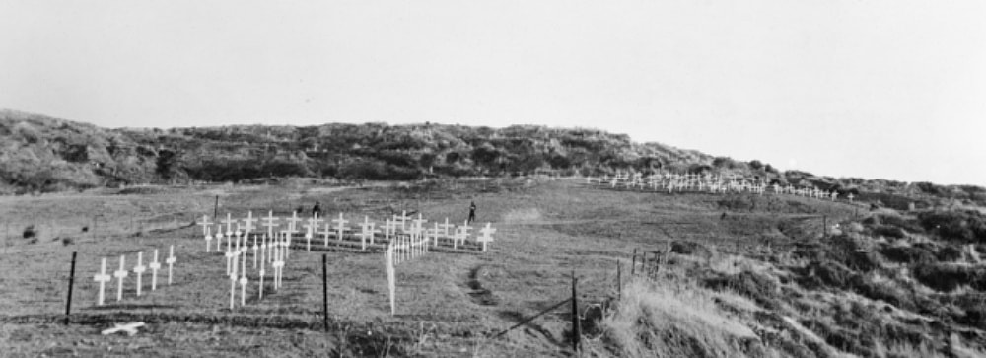
Gallipoli, Turkey. 25 April 1923. The Shell Green Cemetery in the Anzac area. (Donor Miss M. Berkeley) - www.ww1cemeteries.com
News of his death was sent by cable to the 2nd Military District on 10 December, 1915 and confirmation of receipt returned on December 14.

Next-of-kin was advised and news followed to Cooroy of the young soldier’s demise and announced in.
Gympie Times and Mary River Mining Gazette Saturday December 18, 1915:
COOROY
FOR HIS COUNTRY—On Tuesday last Mr F.J. Sneesby received word that his brother-in-law, Private Bruce Robins, who enlisted from Cooroy, was killed in action at the Dardanelles on the 11th November. He was well thought of here, being one of the first selectors to take up land at the same of the Cooroy re-purchased estate. He has a sister, Mrs F.J. Sneesby, and brother Eric Robins, in Cooroy, but his parents live on the Richmond River (N.S.W.). It was only a few days before his death being known that he had written to his friends of his good luck in escaping injury.

Chronicle and North Coast Advertiser Friday December 24, 1915:
COOROY – KILLED ON GALLIPOLI
News was received here that one of our townsmen at the front had “gone West.” We refer to Bruce Robins, who was one of the first selectors of the Cooroy Estate, and who when war broke out was one of the first to enlist. He took part in the Gallipoli fight and has been over 12 months at the front. This is our first casualty and brings very close the horrors of the war. General sympathy is expressed for the bereaved relatives, the deceased having been very popular among the residents of the district.

A memorial service was held in Cooroy about six weeks after his death and reported in the:

Brisbane Courier Thursday December 30, 1915:
A MEMORIAL SERVICE
COOROY, December, 29.
A memorial service was conducted on Sunday evening for the late Private Bruce Robins, who was recently kill at the Dardanelles. Members of the M.U.I.O.O.F. and the L.O.L. Lodge were present in regalia, the deceased having been a member of both lodges. The Rev. W.C.R. Moore (Presbyterian minister) conducted the service, and made reference to the sacrifice make by the fallen soldier and his comrades. The large congregation included the relatives of the deceased, who was one of the first settlers on the Cooroy Estate, and who was practically the first volunteer from Cooroy. The secretary of the Grange Lodge offered the prayer. Miss Bertha Krohn presided at the organ. The “Dead march” concluded the service and Mr Rowe, of Gympie played the “Last Post.”
His personal effects were returned to his father on 18 July, 1916 on the transport Itonus.

For his supreme sacrifice Private 249 Angus Bruce Robins, 5th Light Horse Regiment was issued with the 1914-15 Star (15022), the British War Medal (5377) and the Victory Medal (5365). Other Memorabilia issued were the Memorial Scroll (319363) and the Memorial Plaque (319363) sent to his father.
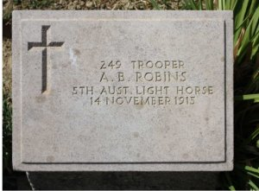
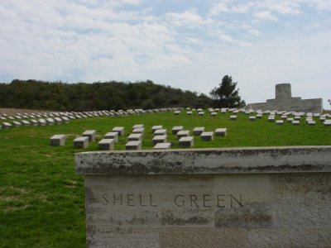
Plaque in Shell Green Cemetery, Turkey
Photo sourced from Ancestry.com.au
Shell Green Cemetery
Image sourced from www.cwgc.org
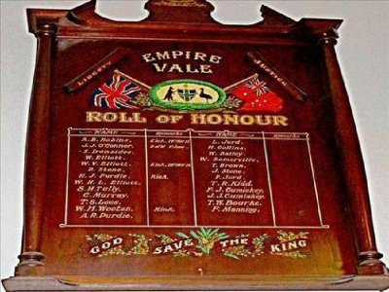
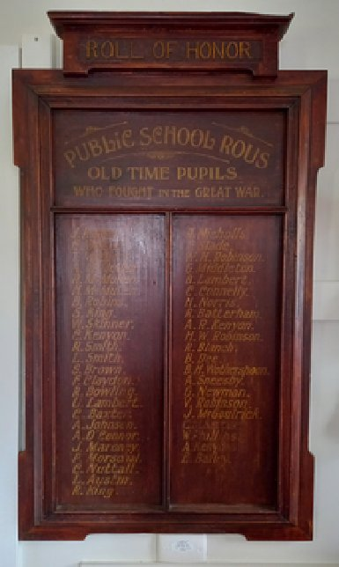
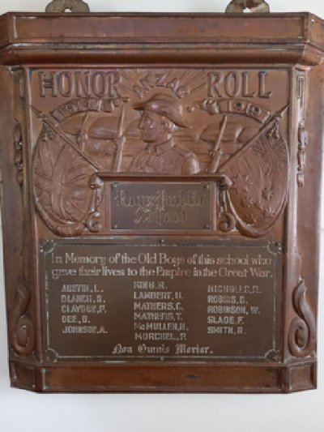
He is commemorated at his old schools.
Empire Vale Public School Roll of Honour
Photo sourced from Monument Australia website
Great War Roll of HonourOld Time Pupils Roll of Honour
Rous Public School
Photos Monument Australia

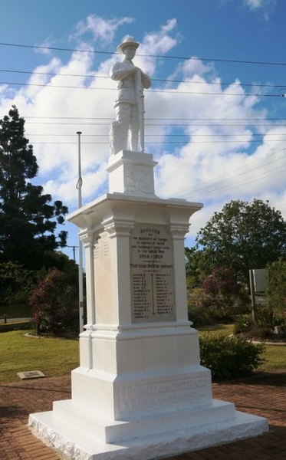
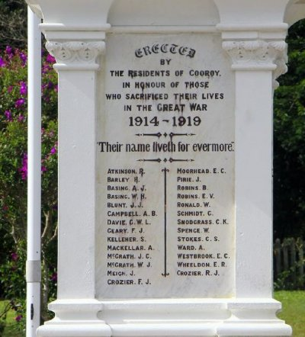
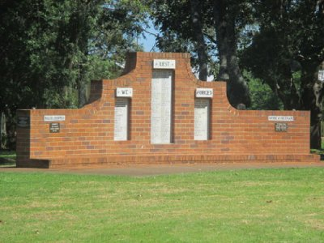
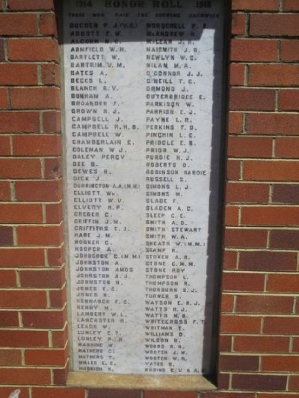
His name is commemorated on panel 5 at the Australian War Memorial, Canberra ACT.
Cooroy, Qld War Memorial - Photos sourced from Monument Australia website
The brothers are commemorated on the War Memorial, Cooroy.
The Alstonville War Memorial, NSW, also bears the brothers’ names.
Alstonville, NSW War Memorial
Photos sourced from Monument Australia website
© Donna Baldey 2023
www.tunnellers.net

