SERGEANT HAROLD ROY PROCTOR
358 – 3rd Tunnelling Company

Norwood, South Australia was the birthplace of John Harold Roy Proctor on 6 March, 1890 the son of Alfred George and Isabella (nee Fox) Proctor. He studied Dentistry for four years to become a qualified dentist. Married on 4 January, 1910 in Adelaide to Emmeline Adelaide Davenport with the announcement published in the:

Quiz (Adelaide) Friday December 17, 1909:
SOCIALITIES
The marriage of Mr Harold Roy Proctor, now of Melbourne, son of Mr Alfred Proctor, of Angas Park, to Miss Emily Davenport, eldest daughter of Mr W.H. Davenport, of Hutt Street, Adelaide, will be celebrated in St Paul’s Church, Pulteney Street, on Tuesday, January 4, 1910.
He was residing at 24 McKenzie Street, Melbourne in 1909 and in 1912 at Vine Street, Albert Park and later moved to Sydney, New South Wales.

At the recruiting depot at the Sydney Town Hall on 4 December, 1915 the twenty-five-year-old married dentist applied to enlist for active service abroad and passed the medical examination. Attestation forms were completed and describe him further as 172cms (5ft 7½ins) tall, weighing 85.9kgs (189lbs) with a chest expansion of 94-105cms (37-41½ins) and had a dark complexion with good vision in his hazel eyes and brown hair. Religion was Church of England. Next-of-kin nominated was his wife Mrs H.R. Proctor of Francis Street, Bondi, Sydney, NSW allotting three-fifths of his pay in support of his wife and child and later care of Mrs Davenport, East Parade, New Kensington, S.A. On 10 December he signed and took the Oath of Allegiance at Casula camp, near Liverpool, NSW.

Basic training commenced with H Coy, 17th Depot Battalion then placed with the Mining Corps who were in their establishment phase. His rank was Sapper with the regimental number 358.

At a civic parade in the Domain, Sydney on Saturday February 19, 1916, a large crowd of relations and friends of the departing Miners lined the four sides of the parade ground. Sixty police and 100 Garrison Military Police were on hand to keep the crowds within bounds. The scene was an inspiriting one. On the extreme right flank, facing the saluting base, were companies of the Rifle Club School; next came a detachment of the 4th King’s Shropshire Light Infantry, then the bands of the Light Horse, Liverpool Depot, and the Miners’ on the left, rank upon rank, the Miners’ Battalion.

The Corps boarded HMAT A38 Ulysses in Sydney, NSW on February 20 and sailed for the European theatre. Arriving in Melbourne, Victoria on February 22 the Miners camped at Broadmeadows for a stay of 7 days while further cargo was loaded.

Another parade was held at the Broadmeadows camp on March 1, the Miners’ Corps being inspected by the Governor-General, as Commander-in-Chief of the Commonwealth military forces.

Leaving Melbourne on March 1, Ulysses arrived at Fremantle, Western Australia on March 7 where a further 53 members were taken on board.

On Wednesday March 8, 1916 the whole force, with their band and equipment, paraded at Fremantle prior to leaving Victoria Quay at 9.30 o’clock.

The ship hit a reef when leaving Fremantle harbour, stripping the plates for 40 feet and, although there was a gap in the outside plate, the inner bilge plates were not punctured. The men on board nicknamed her ‘Useless’. The Miners were off-loaded and sent to the Blackboy Hill Camp where further training was conducted.

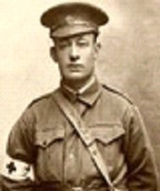
The Mining Corps comprised 1303 members at the time they embarked with a Headquarters of 40; No.1 Company – 390; No.2 Company – 380; No.3 Company – 392, and 101 members of the 1st Reinforcements.
Spr. H.R. Proctor
Photo sourced from Virtual Anzacs

Finally departing Fremantle on April 1, Ulysses voyaged via Suez, Port Said and Alexandria in Egypt. The captain of the ship was reluctant to take Ulysses out of the Suez Canal because he felt the weight of the ship made it impossible to manoeuvre in the situation of a submarine attack. The troops were transhipped to HM Transport B.1 Ansonia, then on to Valetta, Malta before disembarking at Marseilles, France on May 5, 1916. As a unit they entrained at Marseilles on May 7 and detrained on May 11 at Hazebrouck.

A ‘Mining Corps’ did not fit in the British Expeditionary Force, and the Corps was disbanded and three Australian Tunnelling Companies were formed. The Technical Staff of the Corps Headquarters, plus some technically qualified men from the individual companies, was formed into the entirely new Australian Electrical and Mechanical Mining and Boring Company (AEMMBC), better known as the ‘Alphabetical Company’.

On 5 May, 1916 he was admitted to No. 2 Aust General Hospital at Moussot with Influenza from the transport Ansonia until May 23 when discharged to the Aust General Base Depot at Etaples and sent to the 3rd Tunnelling Company on 3 July, 1916 and taken on strength.

He went sick on 11 September, 1917 to the 11th Aust Field Ambulance moving to the 58th Casualty Clearing Station with a social disease. The next day conveyed on Ambulance Train no.27 to Havre entering the 39th General Hospital for further treatment until discharged to the Aust General Base Depot in Rouelles on 1 October. He left for his unit on 1 January and re-joined on January 8, 1918.

He was photographed in the Mess Hall of 3rd Tunnelling Company on 30 January, 1918 at Noeux-les-mines.
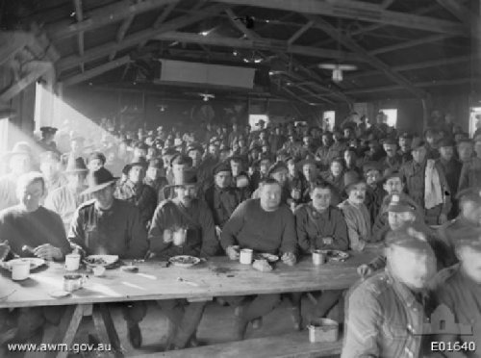
Spr. Proctor identified as circled
Three Blue Chevrons were issued to wear on his uniform for service abroad on 20 February, 1918.

He was a recipient of comfort gifts from the Goldfields Women’s Club and a letter signed by all was returned and reprinted in the:
Western Argus Tuesday March 19, 1918
GOLDFIELDS WOMEN’S CLUB
Miss O’Connor has received a letter from Sergeant Michael J. Murphy in France, thanking the Goldfields Women’s Club for a parcel of gifts forwarded to the No. 6 Tunnellers Co., and the following are the names of the men who benefited: Spr. H.R. Proctor Article abridged

On 17 March was appointed Temporary 2nd Corporal due to promotion of Corporal Bocksette and then to be Acting Sergeant. On 14 May was promoted to 2nd Corporal as Temporary Corporal Bocksette was to be Corporal and he retained the rank of Acting Sergeant.

Leave from France was granted on 9 August and returned to duty on 23 August, 1918. Further promotion took place on 26 October, 1918 as to rise in rank of Sergeant Forsyth to Company Quartermaster Sergeant.

Went sick with tonsillitis on 3 November, 1918 and re-joined his unit three days later and was there when Peace was declared five days later. The Tunnelling Companies remained on the front as part of the Army of Occupation assisting with rehabilitation of their area by clearing roads and bridges of booby traps and delayed action mines left by the enemy.

Orders were received on 10 March, 1919 to prepare for demobilisation and return to the Aust Infantry Base Depot at Havre where they departed on March 17 arriving in England at the 2nd Training Brigade camp at Codford a day later.

After demobilisation Sergeant Proctor embarked for Australia on 27 April, 1919 on board H.T. Runic. Base Records advised his wife on 17 May he was returning home. The transport docked Adelaide (4th Military District) on 8 June, 1919. News of their arrival was reported in the:
Register (Adelaide) Monday June 9, 1919:
SOLDIERS AND TROOPSHIPS
The troopship Runic arrived from Liverpool late on Saturday night, with 118 troops for this State. The vessel was boarded on Sunday morning by the quarantine authorities, and shortly before midday was declared to be “clean.” The men were brought off from the steamer on the launch Vigilant, and were landed at the wharf shortly before 2 p.m. Many relatives and friends were gathered on the wharf to meet the men. Mr “Sammy” Lunn was, as usual, busy delivering messages to home-comers and locating soldiers for their friends. Major J.K. Paul D.S.O., welcomed the troops on behalf of the State Military Commandant (Brig-Gen. Antill, C.B., C.M.G.) and the Mayor of Port Adelaide (Mr R.H. Smith) spoke for the public.
Refreshments were provided for the soldiers in No. 1 shed at the wharf by the Y.M.C.A., assisted by the V.A.D.
Additional home-comers (to those previously announced) were: 358—Sgt H.F. Proctor Article abridged

Military Discharge was issued in Adelaide (4th M.D.) on 24 July, 1919 on termination of his period of enlistment.

His Will was returned to the 4th Military District on 31 October, 1919.

The British War Medal (10094) and the Victory Medal (10030) were issued to Sergeant 358 Harold Roy Proctor, 3rd Tunnelling Company for serving his country.

The following purchase was recorded in the:

Observer (Adelaide) Saturday December 20, 1919:
The Cheney Motor Company, Limited has sold a large number of cars.
REGISTRATIONS
The following are the latest registrations issued by the South Australian Registrar of Motor Vehicles:
Cars and Lorries
04820.—H.R. Proctor, Danby Street, Mile-End, 22.5 Ford. Article abridged
Accompanied by his wife, he embarked on a holiday around the world and was interviewed on his return to Adelaide and published in the:
Register (Adelaide) Saturday August 30, 1924:
SOUTH AUSTRALIAN’S IMPRESSIONS ABROAD
Mr Harold R. Proctor, of Henley Beach Road, Underdale, accompanied by his wife, has just returned from an extended trip around the world. Mr and Mrs Proctor motored through many parts of England, Scotland and Wales, and then visited Germany, Holland, Belgium, France, Switzerland and Italy.
During his stay in London Mr Proctor saw much of the Empire Exhibition at Wembley. He remarked to a reporter on Friday that the display there was wonderful, but the Australian Pavilion was not advertised sufficiently. Most of the attendants at that pavilion appeared to be mainly devoted to selling apples, and even then they could not tell visitors the variety of the fruit, or where they were grown. The Canadian Pavilion was a remarkable place, and was well advertised. Continuing, Mr Proctor said food was dearer in England than in Australia, but clothing and boots were much cheaper. There was practically no poverty on the Continent, and comparatively few people appeared to be out of work. France had been built up again, and the present visitor hardly recognised it. Many French people appeared almost to have forgotten the Australian soldier, and a large section of the population seemed to have little time for England. The Italians, in their turn, apparently had no time for the French. The soldiers’ graves in the war cemeteries in France were a credit to those who looked after them, and relatives of war heroes resting there could be assured that all was being done to make the burial places beautiful. After leaving Europe Mr Proctor proceeded to America and Canada. He remarked that prohibition in the United States was a failure. One could get a drink anywhere, and millions of cases of liquor were being smuggled into the United States monthly. When he was in Canada there was a great need of rain, and the crops looked very bad. So far as the liquor traffic was concerned in Canada, he said most of the former prohibition areas in the Dominion were now becoming “wet.” Considerable unemployment existed throughout Canada, especially in Vancouver. After their departure from America, Mr and Mrs Proctor travelled to Honolulu and New Zealand. They have returned convinced that Australia is the best country on the earth, but should be advertised more.

Represented his ward South Australia mentioned in the:
Chronicle (Adelaide) Saturday June 20, 1925:
WEST TORRENS
Underdale ward—Harold Roy Proctor, Gordon James Rowell.
Article abridged

His wife filed for divorce which was reported in the:
News (Adelaide) Friday March 8, 1929:
MARRIAGE BONDS BROKEN
Sir George Murray (Chief Justice) heard petitions for the dissolution of marriages in the Divorce Court when decrees nisi were granted in the following cases:
Emily Adelaide Proctor (petitioner) against Harold Roy Proctor, of Underdale. Petitioner alleged misconduct on the part of respondent with Violet L. Stalley, of Kent Town, on diverse dates between November, 1928 and February, 1929, at various places. His Honor found the allegations proved.
Mr J.F. McCarthy represented petitioners Hambly, Stephens and Proctor.
Article abridged

Was injured in a car accident in North Adelaide and reported in the:

Register-News Pictorial Monday October 27, 1930:
DENTIST AND WIFE INJURED IN CAR SMASH
John Harold Proctor, 30, Dentist of Buxton Street, North Adelaide, sustained a lacerated face, a fractured elbow and fractured ribs and his wife head injuries, fractured jaw and a fractured leg when Mr Proctor’s motor car, which he was driving, along the Lower North Road at Dudley Park, ran into a deep gutter and smashed against the joint of a footpath and a culvert.
The accident was caused by a fault in the steering gear.
He remarried on 29 December, 1931 to Violet Lillian Hann in South Australia.

Another car accident occurred with events reported in the:
Leader (Angaston) Thursday August 15, 1935:
MOTOR LORRY AND CAR COLLIDE
Diane Proctor, aged 3 years, sustained a fractured jaw and her father, Mr Harold R. Proctor, Nuriootpa, received a cut on the head when necessitated three stitches, when the car he was driving came into collision with Messrs Taylor Bros. lorry, driven by Mr Roy Messner. Mrs Messer was accompanying her husband, and both escaped injury; although the lorry, laden with 79 cans of cream, capsized. The accident occurred about a mile south of Tanunda on the main Tanunda to Lyndoch Road, and about 6.30 last evening. M.C. Maher, Tanunda investigated the accident.

Chronicle (Adelaide) Thursday September 26, 1935:
Before Mr G.W. Halcombe, S.M. on September 19, Harold Roy Proctor, surgeon dentist, of Nuriootpa, pleaded guilty, through his solicitor, Mr A.S. Blackburn, to a charge that on August 14, near Tanunda, he drove a motor car recklessly. He was fined £10 with £1 costs. He was allowed 14 days in which to pay. Superintendent P.A. Giles prosecuted.

Early in 1936 he returned to Sydney and took over the licence of the City View Hotel in Redfern giving his address as 34 Abercrombie Street, Redfern and the occupation of hotelkeeper with the transfer recorded in the:
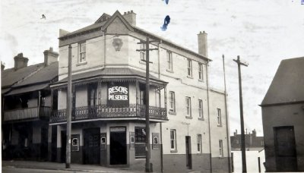
Sydney Morning Herald Tuesday March 17, 1936:
LICENCES TRANSFERRED
Transfers of the following hotel licences were granted at the sitting of the Metropolitan Licensing Bench yesterday:
City View Hotel, Redfern, from Daniel Sweeney to Harold Roy Proctor. Article abridged
City View Hotel at Vine & Abercrombie Streets, Redfern 1930. Traded for 88 years until closed in 1965
Photo sourced from Noel Butlin Archives, Aust National University
John Harold Roy Proctor died at the Royal Prince Alfred Hospital on 13 July, 1936 aged 46 years.

Announcements were published in the:
Sydney Morning Herald Tuesday July 14, 1936:
DEATHS
PROCTOR. –July 13, 1936, at Prince Alfred Hospital, John Harold Proctor, late of 42 Lamrock-avenue Bondi, husband of Violet and loving son of Mrs Isabella Proctor, and brother of Miss Olive and Leonie Proctor, aged 46 years. For further particulars see Thursday’s Herald.
PROCTOR. –July 13, 1936, at Prince Alfred Hospital, John Harold Proctor, late of 42 Lamrock-avenue, Bondi, dearly loved brother of Clifford Proctor, of Bondi, aged 46 years. See funeral notices Thursday’s Herald.

Sydney Morning Herald Thursday July 16, 1936:
FUNERALS
PROCTOR. –The funeral of the late JOHN HAROLD PROCTOR (formerly of City View Hotel) will leave the Kinsela Chapels, Oxford Street, Taylor Square, Darlinghurst, THIS THURSDAY after service, which will commence at 9.30 a.m. for the Church of England Cemetery, Waverley
CHARLES KINSELA

Interment took place in Anglican Special Section 20 of Waverley Cemetery within row 22 in grave no.6209A.

Further tributes were published in South Australia in the:

Leader Thursday July 16, 1936:
PERSONAL
Mr Harold R. Proctor, 46, recently dentist at Nuriootpa, died on Saturday. Among other relatives he leaves a sister, Mrs B. Knispel, Seppeltsfield. Mrs Aug. Linke, Loxton, formerly of Nuriootpa, is another sister.
An inquest was held and with the finding he died of failure of heart and respiratory failure whilst under sedation administered by surgical operator.

Legal notices in connection of his Estate were published in the:
Advertiser (Adelaide) Thursday April 29, 1937:
LEGAL NOTICES
SOUTH AUSTRALIA IN THE SUPREME COURT TESTAMENTARY CAUSES JURISDICTION
IN THE ESTATE OF JOHN HAROLD ROY PROCTOR DECEASED
NOTICE is hereby given that after the expiration of EIGHT DAYS APPLICATION will be made in the Registers of the Supreme Court of South Australia in the Testamentary Causes Jurisdiction for the SEALING of the LETTERS of Administration of the ESTATE of JOHN HAROLD ROY PROCTOR, late of City View Hotel, Abercrombie Street, Redfern in the State of New South Wales deceased granter by the Supreme Court of New South Wales at Sydney on the 24th day of September, 1936.
GUN & TRUSTEES
Adelaide – Solicitors for the Administratrix

Base Records received a request from the Sydney Branch of the Repatriation Commission requesting a copy of his service records which were forwarded on 23 December, 1937.

Published part of his inscription reads:
Harold Proctor
Aged 46
Erected by his son Harold and daughter Diane

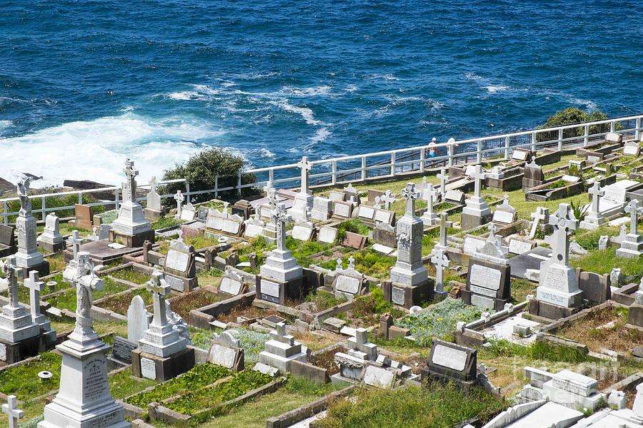
Section of Waverley Cemetery, Bronte, Sydney, NSW
Photo taken by Martin Berry 2017 sourced from Images of Waverley Cemetery

© Donna Baldey 2022
www.tunnellers.net

