SAPPER JAMES GEORGE PARSONS
5800 – 3rd Tunnelling Company

James George Parsons was born on 25 September, 1870 the son of John (died 1920) and Angelina (nee Durrant died 1934) Parsons at Eastbourne, Sussex, England and was baptised in St Nicholas’ Church of England.

In 1881 the family were living at 7 Roseland Terrace, Eastbourne and residents were John (30) contractor’s labourer, Angelina (29), James G. (10), Rosannah (6), Clera (2) and John (4mths).

The marriage of James George Parsons took place in the Church of the Holy Innocents in Dalling Road, Hammersmith, London on 3 June, 1900 by banns to Jane Acton.

A year later in 1901 the couple were residing at 79 Lilian Road, Barnes, Surrey and were James G (30) general labourer and wife Jane (26). A decade later in 1911 they were living in a two-roomed house at 52 Conington Road, Sheperd’s Bush, Hammersmith and citizens of the household were James G. (40) general labourer, Jane (37) with Edith (9), Albert (6), Ada (4) and Ruth (18mths).

The family consisting of James (39) lamerman, Jane (38) and children Edith (11) Albert (5) Ada (3) and Ruth (1) came to South Australia in 1912 on the steamer Beltana.

At the recruiting depot in Adelaide (4th Military District) on 5 August, 1916 the married miner reduced his age to thirty-nine years (actual age 46) when applying to enlist for active service abroad and passed the medical examination. Attestation forms were completed and describe him as 164cms (5ft 4½ins) tall, weighing 55.4kgs (122lbs) with a chest expansion of 87-92cms (34-36½ins) and had a medium complexion, dark hair and his brown eyes tested to fair eyesight in his right eye and poorer vision in the left one. Distinctive marks were four vaccination scars on his left arm. Religion was Church of England. He stated military experience was gained from 7 years-service with West Surrey Military until his time expires. Next-of-kin nominated was his wife Mrs Jane Parsons of 200 Gover Street, North Adelaide and allotted three-fifths of his pay in support of her and their five children. The Oath of Enlistment was signed and taken in Adelaide on 12 August, 1916.

Acknowledgment to the new recruits was published in the:
Chronicle (Adelaide) Saturday August 19, 1916:
THE CALL TO ARMS – GONE INTO CAMP
The following men went into camp on Saturday:
J. Greaves, F.F. Morris, M.D. Healey, F.W Hill and J.G. Parsons Article abridged

Basic training commenced with B Coy, 2nd Depot Battalion on 18 August, 1916 moving to the 21st Reinforcements to the Tenth Battalion for further instruction on 11 September. Was allotted to the Base Miners Depot on September 16 until 2 October then moved to the Miners Reinforcements and later joined the October, 1916 Reinforcements to the Tunnelling Companies. His rank was Sapper with the regimental number 5800.

The 516 Reinforcements departed Melbourne, Victoria on October 25, 1916 at 1.30pm aboard the transport HMAT A38 Ulysses. The Australian coastline disappeared from view on October 30, 1916 with the port of Durban reached at 11.30am on November 13, 1916. Windy weather was experienced going around the Cape and arrived at Cape Town at 7am on November 19. Sierra Leone was the next port of call but their departure was delayed until December 14, 1916 as it was not safe to proceed further.

Arrived at Plymouth, England on December 28, 1916 after 65 days at sea, with the troops disembarking at 1.30pm and detrained to the station at Tidworth and marched in to Perham Downs the following day for further training for the front at the Aust. Details Camp at Perham Downs.
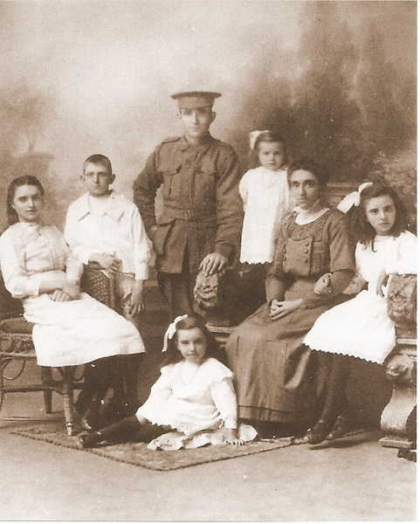
Sapper J.G. Parsons and family before departure
Edith Emma, Albert James, James George, Mabel Adelaide, Jane, Ada Agnes and Ruth Elizabeth Parsons
Photo sourced from Ancestry Public Member Tree submitted by Tony Humphries 6/12/2021

Military discipline was issued for the following:
Offence: Aust Details camp 8/1/17 overstaying leave from 2400hrs till 1800hrs
9/1/17
Award: 7 days confined to barracks by Capt. G.C. Woods
Forfeits: 1 day’s pay RW

The Reinforcements left Folkstone on board the transport S.S. Onward for France on 28 January, 1917 arriving at the Aust General Base Depot the following day.

Sapper was taken on strength with the 3rd Tunnelling Company on 6 February, 1917 who were driving galleries in hard chalk averaging 82 feet per day.

Their arrival was recorded in the After War Report of the 3rd Tunnelling Company as follows:

“On 6/2/17 2/Lt Trebilcock reported with a draft of 95 O.R. as reinforcements.”

The Company was raided by the enemy and a small report appeared in their After War Report:

“On the 18/3/17 our Lines opposite Scots Alley at Hill 70 were raided by the enemy, apparently without meeting the slightest opposition from the Infantry “holding the line”. 2 mobile charges were placed in Scots Incline Shaft, the entrance of which was near the support line. One only exploded, doing some damage. Small gas cylinders were brought over & 3 of our listening galleries were filled with gas.
There were 15 miners underground at the time.
At least 4 of the raiders penetrated our lines past the support line to a distance of 400 yds from the front line, investigated our covered way, and dummy trenches behind the line.”
Sapper reported sick on 19 March, 1917 to the 73rd Field Ambulance with his service card marked gas poisoning from a shell attack and transferred to the 1st Casualty Clearing Station the following day with debility and discharged to duty on March 30.

With no other members who had been working underground suffering ill effects from gas poisoning by the enemy raid, Major L.J. Coulter wrote the following letter on 29 March, 1917 in regards to a query on Sapper Parsons.

Unit Diary of 3rd Tunnelling Company for March, 1917 – Appendix 23 shows:
Appendix 23, 356
G.S. 1st Corps
I submit herewith copy of the actual report sent to me by one of my Officers “Lt Cranshaw” from the line, and on which my report regarding the gas was based.
An examination of the listening galleries has shown that two are very badly damaged and are inaccessible. The third gallery has been examined by an Officer (25/3/17) who took a mouse with him to test the air. The report of gas was made by the Listening N.C.O. who reported it to the Officer of his Section – namely Lt Cranshaw.
Regarding your last query No.5800 Sapper Parsons, J.G. paraded “sick” on 19/3/17 (on coming from trenches. He stated he was “gassed.” He was retained by 73rd Field Ambulance and was subsequently sent to No. 1 C.C.S. To the inquiry from the Field Ambulance as to this Man’s condition, I stated in effect that I had no knowledge of his suffering from gas, that he was underground with his respirator on for about one and a quarter hours.
I have no report of him since.
29/3/17
Major
O.C. 3rd Australian Tunnelling Company

Also in the March, 1917 Unit Diary Appendix is another letter written by Major Coulter on 19 April, 1917:
Appendix 30, 356.
3rd AUSTRALIAN TUNNELLING COMPANY
PRECIS
Re No.5800 Sapper PARSONS, J.G.
This sapper came in with his relief on the night of the 18th March, 1917, that is the evening of the day of the enemy raid.
On the following morning he paraded “Sick”. At this period the sick parade was inspected at the 73rd Field Ambulance.
Following this parade, the C.O., 73rd Field Ambulance submitted A.F.B.117 to be filled in, as Sapper Parsons had stated he had been “gassed”. The particulars as given by the sergeant in charge of that relief are that, when an explosion occurred at the mouth of the shaft, all the men below were collected and ordered to put on their respirators. The length of time the respirators were worn was—between 1 ¼ to 1 ½ hours.
No one reported any ill effects at the time. The first intimation we had was, the report from the Field Ambulance.
19/4/17 L.J. Coulter, Major
O.C. 3rd Australian Tunnelling Company

Further letters submitted regarding the query continued in the April, 1917 Unit Diary of the 3rd Tunnelling Company:
Appendix 10, 356
Re No. 5800 Sapper PARSONS, J.G
On the morning of March 20th, 1917, the Orderly Officer informed me that Sapper Parsons reported sick stating he had been gassed. By chance Capt. R.A. PETERS, att. H.Q. Special Coy, R.E., 1st Army, the Medical gas expert of the First Army happened to be at this Ambulance at the time, and I asked him to see the case with me. He examined him carefully, and it was decided that though there were no apparent symptoms of the man being gassed, to give him the benefit of the doubt, as it is well known that serious symptoms often do not appear until a few days afterwards.
Capt. Peters advised that he should be kept quiet and evacuated to C.C.S. when the reports came from the 3rd Australian Tunnelling Coy, if there was any doubt at all. Later I showed him the papers, and he considered it advisable to send him to C.C.S. for further observation, though no further symptoms had developed while he was in this unit. He was evacuated to No. 1 C.C.A. 20/3/17
[Signature unreadable]
Lt.-Col RAMC
15/4/17 Commanding 73rd Fld Amb.

Appendix 10, 356
I CORPS
Hand written letter
This man was admitted on 20th March and discharged to duty on 30th March.
On admission no symptoms which could justify a diagnosis of gas poisoning were observed and no such symptoms subsequently developed.
19/4/17 Dr Hyde, Lt.-Col
R.A.M.C.
O.C. No. 1 C.C.S.
Appendix 10, 356
O.C.R.E. I Corps Troops
Reference attached.
It would appear from the Statements of the Medical Authorities that this man was not gassed on the occasion mentioned.
Please inform O.C. 3rd Australian (T) Coy, Engineers accordingly.
Major
D.A.A.G. I Corps
20/4/17

The Red Cross Society in London was contacted by Sapper Parsons in response to letters to France were not received by him. It appears the Society wrote to the soldier and his reply was as follows in their records:

3rd Aust Tunnlg Coy Parsons, J.G. 5800
A.I.F. NOT RECEIVING LETTERS
Yours of 31.9.17 to hand in reference to my correspondence.
I am sorry to say that my letters from wife do not come to hand very regularly in fact I have only received three letters from my wife since May last and no parcels since coming to France. I have also had letters written to me from London which, I have not received and I would be extremely grateful to you if you could do anything to expediate matters in reference to them.
Letter from:
J.G. Parsons,
3rd Aust Tunnlg Coy 11.9.17

N.B. We have written to G.P.O. Mount Pleasant to try to improve matters.
London
24.9.17

The Military Pay Office, North Terrace, Adelaide wrote to Base Records on 16 October, 1917 advising that Mrs Jane Parsons of 200 Gover Street, North Adelaide called at their office and stated that letters addressed to her husband for the past few months have been returned to her as per enclosure.

She was very anxious to know of her husband’s whereabouts as she had received no letters from him for some considerable time. The writer required full particulars as to correct number and unit of soldier in order the he could communicate with her.

Base Records replied on 22 October, 1917 that no enclosure was attached to their communication when received at their office, but if the envelopes returned were the same as the address given therewith, the matter will be referred to the A.I.F. Headquarters, London with a view to ensuring safe delivery of his mails in the future. His address was included.
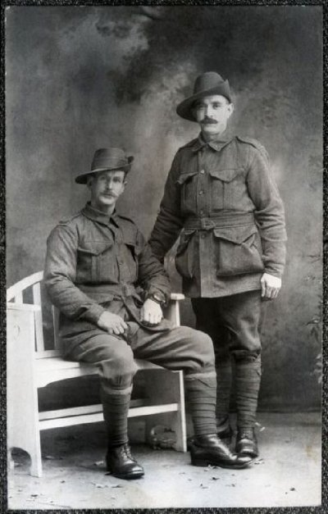
Sapper J.G. Parsons with his mate Sapper 5845 Humphrey Terrell
also of the 3rd Tunnelling Company.
Photo sourced from Virtual Anzacs website - Submitted by Florence Drummond
On 24 December, 1917 Sapper was admitted to the 1st Casualty Clearing Station with rheumatic fever and conveyed two days later on Ambulance Train no.36 entering the 13th United States General Hospital in Boulogne with myalgia (muscular pain.)

He was invalided to England on the hospital ship Jan Breydal with sub-acute rheumatism on December 30 and admitted to the Chester War Hospital, Chester the same day with myalgia.

Transferred on 22 February, 1918 to the 1st Aust Auxiliary Hospital at Harefield with rheumatism then discharged to furlough on February 28 and report to the No.2 Command Depot at Weymouth on March 14.

Reported from A.I.F. Headquarters, London as ordered.
Sapper appeared before the Medical Board on 8 April, 1918 and his Statement of Case reads:

Disability: Sub-acute rheumatism. Overage.
Date of disability: 2 October, 1917
Place of disability: France
Essential facts: Had an attack of Rheumatism in Australia 10 years ago. In England was
2 months in bed. Onset this attack October following burns by mustard gas
When scrotum was blistered, followed by pain & swelling in both hips & knees which has continued slight glandular enlargement. With rales (wheezing) at both bases, no dullness, heart nil & tenderness in both knees. No swelling, no oedema, temp normal. (Sgd.) J.G. Parsons.
Attributed to: Active service
On service: exposure
Present condition: complains of pains in leg joints, in groin & testicles. Breathless on exertion
Pains in shoulders. Heart & lungs normal. Pains in hips & across back worse on walking – can get about slowly. Pains worse on lifting & in dull weather.
Has been in hospitals since October–improvement is very slow. Temp 98.4
Pulse 88. Radials not thickened.
Recommendation: Discharge permanently unfit 26/2/18
Board finding: Attributed to pre-existing – aggravated by active service
Degree of disablement: 100%
Finding: Ciii. Permanently unfit for general service and home service
Approved: 9/4/18

Sapper Parsons was transferred to Devonport, England and embarked for discharge in Australia on 12 May, 1918 on board H.T. Ruahine. His berth for the voyage was a hammock.

Base Records advised his wife on 10 June that he was returning home.

Medical note during the voyage on his condition – stationary.

His name was among those listed as returning in the:

Chronicle (Adelaide) Saturday June 22, 1918:
RETURNING SOLDIERS – LIST “K”
The following have been listed for return to Australia, and are actually en route from abroad.
5800 Spr. J.G. Parsons, 3rd Tun. Coy. Article abridged
The troopship docked in Sydney (2nd Military District) on 5 July, 1918 and the South Australian soldiers completed their journey to Adelaide by troop train. News of their arrival in Adelaide on July 7 was reported in the:
Daily Herald (Adelaide) Monday July 8, 1918:
RETURNING SOLDIERS
Yesterday morning about 75 returning soldiers comprising list K which had been published during the week arrived at the Keswick Railway Station. There was a large number of friends and relatives at Keswick to meet them. Military Officials also met the men there.
A bus service from the Adelaide G.P.O. to Keswick to meet the convenience of relatives and friends to the servicemen was partaken freely.

Sapper was examined at No. 7 Aust General Hospital on 7 July, 1918 and his medical notes were:
Urine – no sugar, no albumin. Scrotal burn by mustard gas, pain & swelling in testicles
ever since; otherwise well. O.E. general condition, good. Heart √, Lungs √. Left varicocele
large – right inguinal hernia to surgeon.
Later: Refuses operation for hernia. To Medical Board.

The Permanent Referee Medical Board at Keswick Barracks saw him and medical notes were:
Recovered from mustard gas poisoning & rheumatism. States feels pain on lifting.
Dentally fit. Incapacity ¼ for six months.

Military Discharge was issued in Adelaide (4th M.D.) on 22 July, 1918 as medically unfit due to (1) Rheumatism (2) Overage.

The 4th Military District sent medical, dental and hernia operation refusal proceedings to Base Records on 30 July, 1918 advising that this soldier returned on 5 July, 1918 and discharged on 22 July, 1917 as medically unfit and not due to misconduct, after serving 1 year and 345 days service of which 1 year and 254 days were served abroad.

Three months later his wife Jane died on 30 October, 1918 aged 43 years with news and arrangements published in the:
Express and Telegraph (Adelaide) Thursday October 31, 1918:
DEATHS
Parsons—On the 30th October, at her residence, 200, Gover-street, North Adelaide, Jane, dearly beloved wife of James George Parsons, aged 43 years.
FUNERAL NOTICES
PARSONS—THE FRIENDS of MR JAMES GEORGE PARSONS are respectfully informed that the Remains of his late WIFE (Jane) will be removed from his residence, 200 Gover-street, North Adelaide, on FRIDAY, at 11a.m, for interment in the West-terrace Cemetery.
GEO J. McLEOD, Undertaker.

Her grave is located on Road 5, path 23, aspect W, in site no. 42 of West Terrace Cemetery. Three others were buried in this grave from 1884 to 1960.

A letter from Base Records dated 15 January, 1919 acknowledged receipt of his communication of the 6th instant, concerning his Kit Bag and in reply stated the matter had been referred to the Adjutant General, Victoria Barracks, Paddington, N.S.W. for enquiry and reply to him direct.
The British War Medal (17780) and the Victory Medal (17599) were issued to wear for serving his country to Sapper 5800 James George Parsons, 3rd Tunnelling Company.

He was living in Gilbert Street, Bowden-on-the Hill, Adelaide when the following was reported in the:
Advertiser Friday December 10, 1926:
THROWN OUT OF A CART
Mr James George Parsons (56) of Gilbert-street, Bowden-on-the Hill, was admitted to the Adelaide Hospital on Thursday night, suffering from a fracture of the skull. He was riding in a cart when the horse took fright, and he was thrown out.

James George Parsons passed away on 2 March, 1934 aged 62 years from throat cancer. Announcement was placed in the:
Advertiser Saturday March 3, 1934:
DEATHS
PARSONS—On the 2nd March, at Adelaide Hospital, James George Parsons of 12 Tayler-Street, Croydon, aged 62 years.

Advertiser Saturday March 10, 1934:
FUNERAL NOTICES
PARSONS—THE FRIENDS of Mr JAMES GEORGE PARSONS (late 3rd Australian Tunnelling Corps) are respectfully informed that his Funeral will leave the residence of Mr A. Brighton [blurred] No. 12 Taylor-street, Croydon on SATURDAY, at 11 a.m. for the Soldiers’ Cemetery, West Terrace.
F.T. ELLIOTT & SON, Undertakers

His grave is located in the Light Oval of West Terrace Cemetery within row S, aspect E in site no. 27.
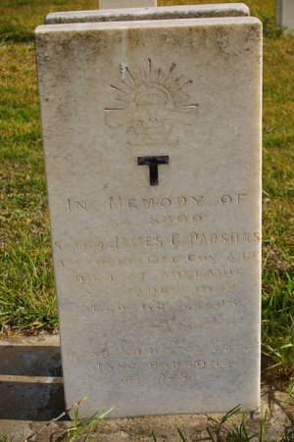
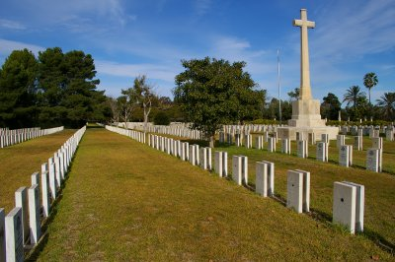
Adelaide War Cemetery,
South Australia
Photos courtesy Heather Pearce

He is commemorated on the Christ Church Honour Board, Jeffcott Street, North Adelaide, S.A.

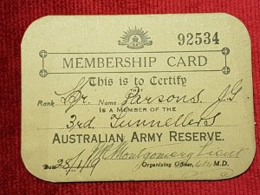
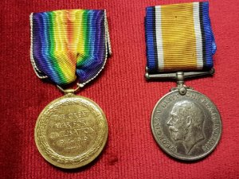
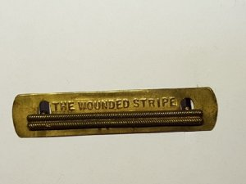
Australian Army Reserve Membership Card dated 28/1/19
Photos sourced from Virtual Anzacs website and submitted by Florence Drummond
War Medals and wounded stripe badge belonging to Sapper J.G. Parsons
His war memorabilia:

© Donna Baldey 2023
www.tunnellers.net

