SAPPER CARL FREDERICK OLSSON
4437 – 3rd Tunnelling Company

Carl Frederick Olsson stated he was born in Dormaying, Sweden in 1887 and did not name his parents. He was a sailor who got off the ship in Western Australia and went to work at Carnarvon. He became a naturalised Australian about 1915.

At the recruiting depot in Carnarvon on 17 December, 1915 the twenty-eight-year-old single sailor applied to enlist for active service abroad and passed the medical examination and was noted to be unvaccinated. Attestation forms were completed and describe him as 172cms (5ft 7½ins) tall, weighing 64kgs (141lbs) with a chest measurement of 97cms (38ins) and a fair complexion, bluey eyes and fair hair. Distinctive marks were tattoos of bear on forearm, girl dancing in centre of left forearm, two crossed flags external surface of left forearm and two crossed flags upper left arm. Religion was Presbyterian.

Next-of-kin nominated was his father Mr C. Olsson of Dormaying, Sweden.

Basic training commenced at Blackboy Hill, near Perth on 3 January, 1916 with the 40th Depot Battalion for two days then moved to the Engineer Reinforcements on January 5.

His naturalization papers were in order and signed and took the Oath of Allegiance on 12 February, 1916 at Blackboy Hill camp. On 10 March was allotted to the No. 6 Tunnelling Company in the rank of Sapper with the regimental number 4437.

Recruiting for the No. 6 Tunnelling Company had commenced on March 7, 1916 by Captain Lawson and his four officers. Instruction classes were formed of officers and N.C.O.’s as there was insufficient time to attend the Engineer’s School in Sydney. Recruits were forthcoming in abundant numbers and the aim was to have good physical types of skilled W.A. Miners.

At Blackboy Hill camp the new company paraded daily with sister companies until March 27 when the Company moved camp to Belmont camp. Sapper Olsson arrived at the camp where four sections were created and training continued through April and May.

The remainder of May was occupied in the usual training: musketry, trench work and night work while equipment and clothing issue was also in progress. Here a difficulty was met in that the general size of the men was considerably above the average and some little trouble was experienced in getting all accurately fitted.

Across the country early in May, 1916 the No. 4 Tunnelling Company consisting of six officers and 152 other ranks together with the 1st Reinforcements of fifteen other ranks making up two sections, embarked from Brisbane, Qld aboard HMAT A69 Warilda for Sydney, NSW.

At Rosebery Park, Sydney, NSW they joined their Headquarters and two sections (8 officers & 153 O.Rs.) plus 1st Reinforcements consisting of one officer and seventeen other ranks for final training.

The 7713-ton transport Warilda departed Sydney, NSW on May 22, 1916 and collected in Melbourne, Victoria the No. 5 Company recruited from Victoria, South Aust. & Tasmania made up of Headquarters and 2 Sections (8 officers & 173 men) (3 M.D.).

One Section from Tasmania (3 officers & 76 O.Rs); also 1st Reinforcements for No. 5 Company (17 men from Vic. & 8 men Tas.) The ship departed on May 25, 1916 for Adelaide, S.A. to collect one Section of 3 officers & 76 O.Rs with 1st Reinforcements of 8 O.Rs.

The public were kept up with their progress with regular articles appearing in the:
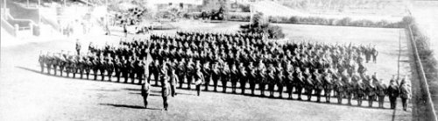
The West Australian Wednesday May 31, 1916:
THE TUNNELLING COMPANY - PARADE THROUGH CITY STREETS
Although the numerical strength of the troops which paraded the city streets yesterday morning was considerably less than that of previous parades, and despite the fact that citizens have become accustomed to the sight of khaki-clad warriors, the men of the No.6 Tunnelling Company and the Claremont N.C.O. school met with a hearty reception as they swung along to the inspiriting music of the Blackboy Hill band. The line of route was freely bedecked with flags, whilst the large crowds, if somewhat undemonstrated denoted none the less by their presence their keen appreciation of that sense of patriotism which found its highest expression in the long line of soldiers answering to the call of Empire. In physique and general bearing the men were equal to their comrades who have gone before. Leaving James-street well on appointed time, the column swung into Beaufort-street and over the bridge in to Barrack-street. The members of the N.C.O. school, about 113 strong, under Captain Thompson, followed the band, the No.6 Tunnelling Company, with its first reinforcements, totalling nearly 400 men, under Captain Lawson, bringing up the rear. At the head of the Tunnellers was borne the flag recently presented to the company.
After traversing Barrack and Hay streets the column entered St George’s-terrace via Victoria-avenue. Opposite Government House his Excellency (Sir Harry Barron), with whom were the State Commandant (Colonel J.H. Bruche), Major P.H. Meeks and Major Wilkinson, A.D.C., took the salute. Passing along the Terrace the route was via William and Wellington streets to the station. The men paraded in full fighting equipment.
The No.6 Tunnelling Company - - Photograph taken at the W.A.T.C. Course, Belmont, where the men have been in training
The No. 6 Company paraded through the city of Perth where the fine physique of the men, who marched with arms bare to the elbow excited universal admiration.
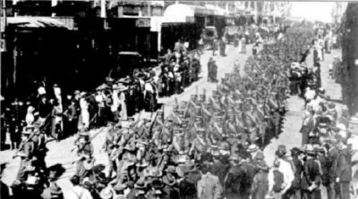
Tuesday’s parade of troops. The No.6 Tunnelling Company and the members of the N.C.O. School,
Claremont, marching through the city.

The transport arrived in port at Fremantle, W.A. on June 1, 1916. The whole company consisting of 14 officers and 325 O.Rs along with 1st Reinforcements of 1 officer and 32 O.Rs entrained at Belmont at 2 p.m., every man physically fit being present and boarded Warilda which left the harbour the same evening.

Durban, South Africa was reached on June 16, 1916 and Cape Town on June 21, 1916 while St Vincent completed the African ports of call on July 7, 1916. Discipline was fairly good except at intermediate ports where Away without Leave caused concern.

The fifty-eight-day voyage experienced remarkable pleasant weather terminating at Plymouth, England on July 18, 1916. Four, Five and Six Companies comprising of 1064 officers and other ranks were detrained to Amesbury and Tidworth to begin training for the front at Perham Downs.

The Reinforcements proceeded to France on 28 August, 1916 arriving a day later at the 2nd Aust Divisional Base Depot two days later. In the After War Report of the 3rd Tunnelling Company the following was recorded:

“On September 23rd instructions were received that the Company was to be used to reinforce No.3 Company already at work at the Front, to the extent of 8 officers and 206 men, while the remainder were to stay at Etaples awaiting further orders with the exception of Captain Lawson, Officer Commanding, and Captain Hillman, who were also to proceed to the Front temporarily without command. The Company accordingly to that strength only left Etaples on the morning of September 25th arriving at Le Drumez the same evening. The next morning Captain Lawson formally handed over the whole party to Major Coulter, officer Commanding No.3 Company, who immediately proceeded to allot them to duty.
The existence of No.6 Tunnelling Company as such was thus terminated.
In the first days of October mining was vigorously carried out in the Red Lamp, Tillaloy, Fauquissart & Chapigny Sectors.”

Sapper was taken on strength with the 3rd Tunnelling Company in the field on 30 September, 1916 and assigned to No. 3 Section.

By 10 November, 1916 he was training as a ‘listener’ through a course at the Listening School lasting about ten days where they learnt to distinguish between any normal sounds created during mining operations.

The listener would be on duty at any specified post underground for a fixed period, usually a six-hour shift silently listening for sounds of underground mining by the enemy. Detailed reports were provided of sounds heard to superiors on return to the surface. So these sounds could be credited solely to the enemy all company work would cease while intensive listening could be carried out. Listening posts were many and numbered to gauge from these positions the location of enemy mining activity which was accurately recorded on the Mine Plan.

During March, 1917 he also was instructed in underground mine rescue using the “Proto-equipment” – a life-saving breathing apparatus worn to rescue or retrieve men from underground when nitrous gases permeate the air in the tunnels.

Service continued without incident until he went sick on 8 June, 1917 to the 1st Corps Scabies Station at the 16th Field Ambulance for treatment of Scabies (a skin irritation caused by Itch Mite whose eggs are laid under the skin’s outer layer). A day later was moved to the 1st Corps Rest Station and discharged to duty on 12 June re-joining his unit the following day.

He was a recipient of comfort gifts from the Kalgoorlie Ladies Club and sent a letter of thanks in return which was reprinted in the:
Western Argus (Kalgoorlie) Tuesday February 13, 1917:
GIFTS FOR THE SOLDIERS
Sapper J. Back, writing from France on Nov 5 to Mrs R.M. Jordan, secretary of the Goldfields Women’s Club, says—
“I have much pleasure in writing you a few lines on behalf of the men in my section, for the kindness bestowed on us by yourself, and the Women’s Club of Kalgoorlie and Boulder, in sending us a packet containing cigarettes, tobacco, socks, mittens, etc. We all enjoy a good smoke, coming as it does all the way from the West and we give great credit to you one and all. Our company has been very lucky up to the present, and I hope it will continue so, that we may be able to come back and thank you personally. Excuse this short note of thanks; I am a poor one with the pencil or pen, for this is not in a soldier’s line. But for all that, our hearts are all back there with you. So now I will conclude by sending our best of wishes and the compliments of the season to you all.”
The undersigned signatures of soldiers who received gifts were attached — C.F. Olsson,
Article abridged
Two Blue Chevrons were issued to wear on his uniform for serving twelve months abroad.

He returned to the 16th Field Ambulance on 3 October, 1917 for treatment of scabies moving to the 18th Field Ambulance Scabies Station the next day until 10 October when sent to the 57th Casualty Clearing Station and discharged to duty on October 20 re-joining his unit a day later.

Sapper was counted to be still serving in an audit of the company on 1 October, 1918.

He was granted and took leave from France on 5 October, 1918 and re-joined on October 22.

When Peace was declared he was with his unit and the Tunnelling Companies remained on the front as part of the Army of Occupation assisting with rehabilitation of their district by clearing roads and bridges of booby traps and delayed action mines left by the enemy.

Was sent to the 18th Field Ambulance on 10 February, 1919 with a social disease and admitted to the 51st General Hospital on March 8 then spent a couple of days in the 39th General Hospital until 10 March, 1919.

Sapper was invalided to England per the transport Goorkha entering the 1st Aust Dermatological Hospital at Bulford for further treatment and discharged to the Convalescent Training Depot at Parkhouse on March 13, 1919 after a total period of 32 days curative care.

His name was listed in the Nor’West Heroes Roll published and updated continuously in the:
Northern Times (Carnarvon) Saturday May 3, 1919:
NOR’WEST HEROES
The following are the names of the gallant men from the Gascoyne, Onslow and Roebourne Districts, who have undertaken to assist on the battlefield in defending the honor of the Empire and the safety and freedom of the small nations of the world. ONSLOW: C.F. Olsson
Article abridged

Sapper was discharged in England in consequence of being demobilised on 26 August, 1919 after three years and 226 days of which 3 years and 87 days were served abroad.

He had received four Blue Chevrons for his overseas service with deferred pay of £37 issued on 12 July, 1919 and his parchment Certificate of Discharge no.236. He gave his intended place of abode to be Domnarfbet, Sweden.

He applied for passage to Australia for his wife from Military authorities in London and departed on January 22, 1920 on the transport Friedrichsruh.
His name was on the list of returning soldiers published in the:
Advertiser (South Australia) Wednesday February 18, 1920:
RETURNING TROOPS – THE FRIEDRICHSRUH
The following members of the Australian Imperial Force are returning to Australia by the transport Friedrichsruh, which left England on January 22:
C.F. Olsson
Article abridged

The transport docked in Fremantle (5th M.D.) on 22 February, 1920 and reported in the:

For serving his country Sapper 4437 Carl Frederick Olsson, 3rd Tunnelling Company was issued with the British War Medal (22505) and the Victory Medal (20850).
Sunday Times Sunday February 29, 1920:
ANOTHER TROOPSHIP SCANDAL – THE FILTHY FRIEDRICHSRUHE
The troops Friedrichsruhe arrived at Fremantle yesterday shortly after 2.30, and immediately the men got shore they made bitter complaints of the conditions under which they were returned to Australia. There were 1160 on board all told, including 70 A.I.F. Officers, six nurses and 693 other ranks. Two officers, 15 N.C.O.’s, 45 A.I.F. men, 7 soldier’s wives, 12 ex-A.I.F. men and four children were disembarked for Western Australia.
We have seen an official copy of the collective statement signed by all the N.C.O.’s and many of the men (there are no dissentients) which reveals a horrible state of affairs, and of the Federal authorities whitewash this scandal they are prepared to condone anything.
Article abridged

These were not collected at the designated barracks and were returned to Base Records on 30 September, 1924 where they remained.

A letter dated 18 September, 1928 was written to Base Records by H.A. Morine of U.S.C. G293, Base 21, St Petersburg, Florida, U.S.A. on behalf of his mother who was sister to Sapper Olsson and asked if they could tell them if he was killed or what in the war. He enclosed the last letter he wrote to this sister dated 5 June, 1916 at Belmont, West Australia. Although the letter was written in Swedish it gave the name of the place, they had last heard from him. He himself was in service of the United States of America and thanked them kindly if they could let them know of him as his mother was anxious to know as he was her only brother.

Base Records replied on 29 October, 1928 to his communication advising that the ex-soldier of the A.I.F. was demobilised in England on 26 August, 1919 and returned to Australia early in 1920. The writer regretted they had no knowledge of his present whereabouts.

The Perth Branch of the Repatriation Commission requested a copy of his service records from Base Records which were forwarded on 4 February, 1938.

Carl Frederick Olsson, late of Perth, passed away on 22 February, 1938 aged 51 years. Arrangements were published in the:
West Australian Friday February 25, 1938:
FUNERALS
OLSSON—The Friends of the late Mr. Carl Frederick Olsson, of Perth, and formerly No. 4437, Sapper of the 3rd Tunnellers, A.I.F., are respectfully informed that his remains will be interred in the Church of England portion of the Karrakatta Cemetery, at 10 o’clock THIS (Friday) MORNING. The Cortege will move from Messrs Donald J. Chipper and Son’s service Chapel, Hay-street, Perth at 9.40 o’clock.
DONALD J. CHIPPER and SON
Funeral Directors, Perth and Mt Lawley
His grave is located in the Church of England portion of Karrakatta Cemetery within section WB in gravesite no. 73.

In the military column his demise was published in the:
Western Mail Thursday March 10, 1938:
THE WESTERN FRONT
Carl Frederick Olsson, on February 24; late Third Tunnellers, A.I.F. Article abridged

On 28 February, 1940 his Returned Serviceman’s Badge No. 265450 and original Discharge Certificate were returned to Base Records from the 5th Military District, W.A. and placed in their store.
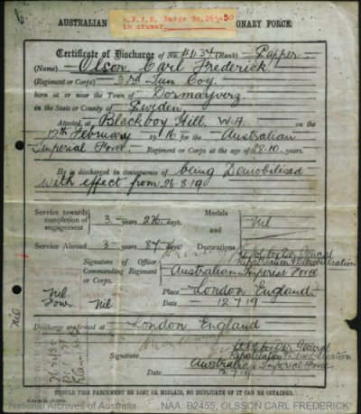
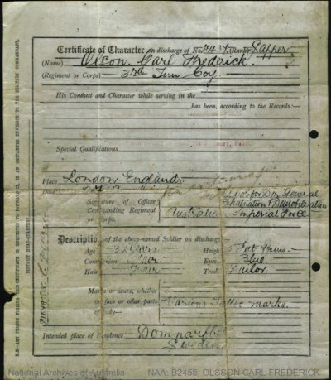
His Original Parchment Discharge Certificate
Photo sourced from his military papers National Archives of Australia

© Donna Baldey 2022
www.tunnellers.net

