CORPORAL CHARLES ARTHUR PELHAM MYERS
3645 – 2nd Tunnelling Company / 3rd Pioneers

Charles (Charley) Arthur Pelham Myers was born in Majorca, near Maryborough, Victoria on 20 May, 1867 the son of Henry (Harry) and Jane (nee Austin) Myers. He became a bootmaker by trade and had his shop in Cecil Street, South Melbourne. He married at Moor Street, Fitzroy, Melbourne on 10 June, 1889 to Isabella Jane Blue (dressmaker) according to the rites of the Free Church of England. They had three daughters.

It was in 1896 he became secretary of the Albert Park Football Club and was honoured with the following article on his successes with this club:
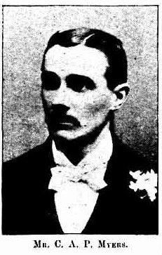
Record (Emerald Hill) Saturday 3 June, 1899:
AN ENTERPRISING TOWNSMAN
One of the best-known men in South Melbourne is Mr C.A.P. Myers, whose boot-making establishment at 163 Cecil Street is a popular rendezvous of sport. It is principally in connection with the prevailing popular pastime of football that Mr Myers came prominently before the public, for it was he who, in 1896, took in hand the secretarial duties of the Albert Park Football Club. At that time the Club was practically defunct in every sense of the term. It had only three members, Messrs F. O’Hara, Ryan and Allen, but by the exercise of that indomitable energy which characterises everything Mr Myers identifies himself with, he succeeded in galvanizing the Club into practical action and a season of brilliant successes was crowned with the possession the Junior Premiership, an honor that was retained the following year, and last year the record of success was added to by the Club being runners up to the victorious West Melbourne. That work this self-imposed honorary task meant to Mr Myers can only be realized by those who have intimate acquaintance with the inner workings of a suburban Football Club, but no such word as failure was known in the lexicon out of which Mr Myers worked, and his arduous efforts ere recompensated in a manner that was gratifying to himself and highly creditable to the Club.
This season his business affairs compelled him to relinquish the secretarial duties, but he is none the less still a warm supporter of the Park, and he proved his usefulness on its behalf by the prominent part he played in helping to defeat the opposition that was put forward from certain quarters to withhold the use of the South Melbourne Cricket Ground from the Albert Park Club, Mr Myers, it was, who organised the Annual Ball in connection with the Club, an event that is now looked forward to with considerable interest, and this year’s celebration, which is fixed for 27th July, promises to be fully as successful as any of its predecessors. Mr Myers is now a Vice-President of the Club, as well as being a delegate of the Victorian Junior Football Association, and so long as the destinies of a Club are in the hands of such enthusiastic supporters’ members are encouraged in a manner which make the hope of success sweeten their labors. I social affairs the Albert Park Assembly is an institution with which Mr Myers’ name is most intimately associated. With several other gentlemen he started the Assembly last year, was unanimously appointed hon-secretary, as well as master of ceremonies. The success of the assembly this season has been so thoroughly established that the fortnightly dances are now being held in the main hall instead of the supper-room of the town hall. The Albert Park Assembly is the only body of its kind that has ever attempted such an ambitious undertaking, but the success of the venture is established beyond all doubt, and very great credit is due to Mr Myers for the manner in which he has retained the continued support of old members, as well as enrolled quite a number of new associated. On Thursday 15th inst., the assembly are holding an apron party and ladies’ pound night, and there is every likelihood of the evening proving one of the most successful social gatherings ever held in South Melbourne.
And while Mr Myers finds time, in the conduct of his business, to give so much valuable support to the several institutions with which he is associated, he also conducts a class for dancing, in the teaching of which useful accomplishment his efficiency is best proved by rapidly increasing number of pupils he has enrolled since the class was established about a month ago.
From his private residence, where a commencement was made, he went to the Nelson Hall, but the accommodation which that building provides is altogether inadequate, and now Mr Myers has completed arrangements for the use of the lecture hall in the Mechanics Institute, where a start will be made on Tuesday, 13th inst.
Mr Myers has proved, by his dancing class, that “nothing succeeds like success,” and we sincerely trust that his ability and energy will continue to be rewarded with the success they deserve. Those desirous of joining Mr Myers’ dancing class may do so any anytime. The night of meeting is Tuesday, and while the cost if trifling, everything is connection with the classes is strictly select. Enquiries left at Mr Myers’ shop, in Cecil-street will be promptly attended to.

The following year was re-elected as secretary to the club as reported in the:
Record (Emerald Hill) Saturday February 17, 1900:
ALBERT PARK ASSEMBLY
The second annual meeting of the Albert Park Assembly was held at Rimmer’s George Hotel, on Thursday evening last. The president (Mr George Lister) presided, and there was a large attendance of members present. The minutes of the last annual meeting were read and confirmed and the hon. Secretary (Mr C.A.P. Myers) submitted a very satisfactory report, which, among other things, set out that the record attendance at last season’s assemblies was 111 couples, while the lowest was 74 couples.
Election of office-bearers: C.A.P. Myers Secretary.
Hearty votes of thank were passed to the retiring committees and all office bearers. In response to calls Messrs Lister and Myers suitably responded.
At the conclusion of the business the company were entertained with some harmony to which Messrs Marks, Rimmer, Orme, Myers, Naughton and Castelbow and Pence contributed.

He was publicly thanked for his donation of time for a benefit concert in the:
Record Saturday July 19, 1902:
BACON BENEFIT CONCERT
Dear Sir, I take this opportunity of tendering my sincere thanks to the committee and all those who worked so assiduously to make my benefit a great success, also to Mr C.A.P. Myers (who gave his services and time gratuitously), for his untiring efforts on my behalf. —Yours etc., A. BACON
Merton-street, Albert Park, July 15th, 1902.

A Lodge member also with his name mentioned at the meeting in the:
Record Saturday December 26, 1903:
U.A.O.D. – HARMONY LODRE, No. 162
The above, lodge held a most enjoyable evening on Friday, the 18th inst, in the Temperance Hall, Napier-street, the occasion being the presentations of a P.A. diploma to Bro. S. Dunn and the prizes won in connection with the recent Druids’ walking contest.
Bros. C.A.P. Myers and E.J. Matlock officiating as Ms.C., while Pro. Myers supplied the music.
Article abridged

He became insolvent with the announcement placed in the:
Age (Melbourne) Tuesday October 9, 1906:
NEW INSOLVENTS
Charles Arthur Pelham Myers, of 207 Cecil-street, South Melbourne, boot maker. [Next line cut off] Article abridged

In November, 1909 his wife said he walked out of his Prahran shop leaving it to the man he employed. In January, 1910 he left their home and wrote to his daughters three weeks later he was off to America.

In March, 1910 one of his girls received a letter saying he got off the boat in Adelaide, South Australia with Port Augusta the last place his wife heard of his whereabouts.

Three months later he attended a meeting for the formation of the Boy Scouts’ movement with the following reported in the:
Kangaroo Island Courier (S.A.) Saturday June 4, 1910:
BOY SCOUTS’ MOVEMENT
A public meeting, call by the chairman of the district Council of Kingscote, was held in the Council Hall on Monday last, for the purpose of discussing the formation of a Boy Scouts’ Patrol. Those present were appointed to add to the number Messrs C.A.P. Myers.
Mr Myers to act as Scoutmaster.
[Later in the column]
Mr Myers (Scout-master) reports that the first parade of the Island Boy Scouts was held on Thursday night when the following boys attended. [not reproduced here]
Article abridged

He continued with his entertainment work with the following reported in the:
Port Augusta Dispatch, Newcastle and Flinders Chronicle Friday January 23, 1914:
MARINERS ENTERTAINED
A social and dance, organised by Mr C.A.P. Myers, was tendered to the officers and crew of the steamer Kooyong at the Town Hall on Monday evening last. The general public did not muster to the event in large numbers, but nevertheless the social was a great success. During the course of the evening an excellent musical programme was successfully carried out.
Mr J. Love’s Orchestra supplied the music. During the evening light refreshments were supplied.

Mrs Isabel Myers petitioned for a divorce which was granted in June, 1915 and reported in the:
Express and Telegraph (Adelaide) Tuesday June 1, 1915:
DIVORCE CASES – BOOTMAKER GRANTED A DECREE
Melbourne, May 31
Desertion was the grounds upon which Isabel Jane Myers (45), of Glover-street, South Melbourne, applied for a divorce from Charles Arthur Pelham Myers (47), of Port Augusta, bootmaker. The marriage took place on June 10, 1889. A divorce nisi was granted.

At the recruiting depot in Adelaide, S.A. (4th Military District) on 31 December, 1915 he applied to enlist for active service abroad and passed the medical examination saying he was a widower with the occupation of railway ganger. He deleted a number of birthdays to give his age at forty-two-years and was described in Attestation Forms as (5ft 6¾ins) tall, weighing (139lbs) with a chest expansion of (35-37ins) and had a medium complexion with fair eyesight in his hazel eyes and grey hair. Military experience was served with the No. 1 Battery A.F.A. for 4½ years in Victoria until his time expired and had previously been reject for service due to defective teeth. Distinctive marks were three vaccination scars on his left arm and tattoos on his chest and both upper arms. Religion was Church of England. Next-of-kin nominated was his mother Jane Manning of Gas Works Yard, Graham Street, Port Melbourne, Vic. The Oath of Allegiance was signed and taken the same day.

Basic training commenced with E Coy, 2nd Depot Battalion at the Exhibition showground from December 31, 1915 to 15 February, 1916 when sent to the Non-Commissioned Officers’ shed at Mitcham and returned three days later and re-joined E Company. On February 26 was allotted to the Mining Corps at Mitcham. On 1 March, 1916 was to be Lance Corporal. The recruits were transferred to Sydney (2nd Military District) to the No. 4 Tunnelling Company training at Rosebery Park on 11 May, 1916 and four days later his rank of Corporal was confirmed. His regimental number was 3645.

The recruits forming part of the No. 4 Company embarked from Brisbane, Qld early in May, 1916 aboard HMAT A69 Warilda for Sydney, NSW. Six officers and 152 other ranks together with the 1st Reinforcements of fifteen other ranks made up the two sections.

At Rosebery Park, Sydney, NSW they joined their Headquarters and two sections (8 officers & 153 O.Rs.) plus 1st Reinforcements consisting of one officer and seventeen other ranks for final training.
He participated in the Inspection of Troops at Moore Park which was reported in the:
Sydney Morning Herald Monday May 22, 1916:

THE TROOPS – INSPECTION AT MOORE PARK
“In the presence of a crowd of 10,000 people the District Commandant, Brigadier-General Ramaciotti, V.D., held an inspection of troops at Moore Park, on Saturday afternoon. The troops consisted of Field Artillery, Tunnelling Section (including Queenslanders), under Major Vincent; Infantry, under Lieutenant Owen Gibbs, under Captain Brosnan, the whole parade being under the command of Major Holman, D.S.O.
Prior to arrival of the commandant and his staff, the men were drawn up in columns of companies on the Dowling-street side of the ground, facing the tramline. The bands of Liverpool Headquarters and the Engineers played selections of music.
Brigadier-General Ramaciotti, V.D. made a close inspection of the lines. Returning to the saluting base the Commandant took the salute as the various units marched past in columns of companies, and again as they returned headed by the band in columns of fours.
One company had with it a small kangaroo as a mascot. The animal was held on a ribbon, but when it drew level with the saluting base it bobbed up and down as if anxious to do its share in the saluting lines as its male friends were doing. Its antics were so ludicrous that the crowd roared.
At the conclusion of the inspection the men were marched across to the Royal Agricultural Ground, where they were provided with temporary quarters.” Article abridged

The 7713-ton transport departed Sydney, NSW on May 22, 1916 and collected in Melbourne, Victoria the No. 5 Company recruited from Victoria, South Aust. & Tasmania made up of Headquarters and 2 Sections (8 officers & 173 men) (3 M.D.). 1 Section from Tasmania (3 officers & 76 O.Rs.); also 1st Reinforcements for No. 5 Company (17 men from Vic. & 8 men Tas.)

Corporal was photographed with the Non-Commissioned Officers before embarkation and published in the:
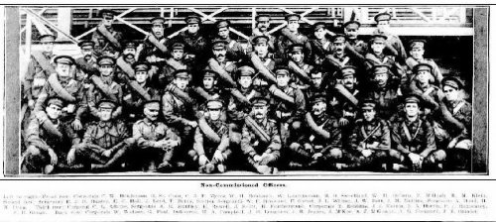
Corporal C.A.P. Myers is identified as circled
Town and Country Journal (Sydney) Wednesday May 24, 1916:

The ship departed on May 25, 1916 for Adelaide, S.A. to collect one Section of 3 officers & 76 O.Rs. with 1st Reinforcements of 8 O.Rs.

In Perth the No. 6 Tunnelling Company was in their final stages of preparation for departure giving a regimental show of their strength in parades.

Docking at Fremantle, W.A. on June 1, 1916 added No. 6 Company recruited from W.A. of 14 officers and 325 O.Rs. along with 1st Reinforcements of 1 Officer & 32 O.Rs. departing the same day.
Durban, South Africa was reached on June 16, 1916 and Cape Town on June 21, 1916 while St Vincent completed the African ports of call on July 7, 1916. Discipline was fairly good except at intermediate ports where Away without Leave caused concern. The fifty-eight-day voyage experienced remarkable pleasant weather terminating at Plymouth, England on July 18, 1916. Four, Five and Six Companies comprising of 1064 officers and other ranks were detrained to Amesbury and Tidworth to begin training for the front at Perham Downs’ camp.

Lt-Col J.S. Knox at Bhurtpore Barracks sent a memo to the Officer Commanding “A” Group, at Perham Downs that the Court Martial held on board HMAT Warilda during the voyage from Australia was improperly constituted and therefore illegal. In the case of this soldier 3645 Corporal C.A.P. Myers, 4 Tunnelling Company, the consequences of the trial are therefore expunged from the record of this man.

The Reinforcements proceeded to France on 15 October, 1916 arriving at the Aust General Base Depot. On 5 January, 1917 was taken on strength supernumerary with the 2nd Tunnelling Company until 6 April when transferred to the 3rd Pioneer Battalion and taken on strength six days later and re-allotted the regimental number 3645A.

On 5 June, 1917 was admitted to the 9th Aust Field Ambulance as mental moving to the 2nd Aust Casualty Clearing Station classed as shell shock and two days later entered the 4th Stationary Hospital in Arques suffering acute mania (frenzied state) and transferred to the 7th General Hospital at St Omer.

The next day was moved to the 8th Stationary Hospital at Wimereux as mental and seven days later on June 13 was transferred to England on the hospital ship St Andrew being admitted as mental to the Royal Victoria Hospital, Netley. On June 21 was transferred to the Murtley War Hospital, Perthshire.

Base Records advised his mother on 5 July, 1917 that he had been admitted to hospital on 14 June, 1917 suffering mental sickness. He was among the soldiers appearing in the Casualty List published in the:
Advertiser (Adelaide) Tuesday July 17, 1917:
THE ROLL OF HONOUR – 324TH CASUALTY LIST
3645. Cpl C.A. MYERS, South Melbourne Article abridged

Corporal Myers embarked for Australia on 10 September, 1917 for discharged in Australia due to mania on board H.T. Ulysses. Base Records notified his mother on 26 September that he was returning home.

In the list of soldiers returning home his name was among those appearing in the:

Barrier Miner NSW Wednesday November 7, 1917:
RETURNING SOLDIERS
Advice has been received by the South Australian military authorities that the undermentioned sick and wounded soldiers are due to arrive in Adelaide at an early date (list No. 21).
All the men must proceed in the procession by motor-car to Keswick Headquarters where they will be detained for a short period in order to undergo medical examinations. The date and time of arrival in Adelaide will be published as soon as possible. 2-Corporal C.A. Myers, 3rd Pioneers. Article abridged
The transport docked in Adelaide (4th M.D.) on 9 November, 1917 with news of their arrival published in the:
The Daily Telegraph (Sydney) Saturday November 10, 1917:
HOME-COMING SOLDIERS – ARRIVAL AT ADELAIDE
ADELAIDE, Friday—About 1200 soldiers returned to Adelaide to-day. A hundred and thirteen belonged to South Australia and were welcomed warmly. With 800 interstate men they were entertained at the “Cheer-Up Hut”. Hotels were closed during the day.

Military Discharge was issued in Adelaide (4th M.D.) on 28 December, 1917 as medically unfit. His Will was returned to the 4th Military District on 10 July, 1918.

For serving his country Sapper 3645 & 3645A Charles Arthur Pelham Myers, 2nd Tunnelling Company / 3rd Pioneer Battalion was issued with the British War Medal (13014) and the Victory Medal (12844).

He remarried in 1923 in Adelaide to Elsie Lillian (Lilly) Seiler/Saler formerly Golding, the widow of Louis William Seiler who died in 1919.

The following article appeared in the:

Sport (Adelaide) Friday February 18, 1927:
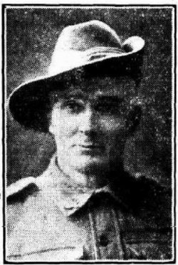
MR C.A.P. MYERS
Nobody would guess that the typical Digger looking down at you from above dated back to the long ago—to the days when at South Melbourne he was a shining light of the Sunflowers’ Minstrels, a troupe of entertainers that brought to light the famous old die-hard, Will Whitburn. If further proof of Charley’s antiquity is needed, we have only to mention that he made riding boots for Tommy Corrigan, the tophole steeplechase rider. How many of the present-daysters can recall to mind the daring needs of Tommy?
Yet, in spite of being of the heyday of a bright and sunshiny youth so long ago, Charles Myers was one of the first to hop in and get his cut when the bugle called, instead of the recruiting officer when the war became an established institution, so to write. How Charley deceived the doctor about his age can be explained that his hardy physique made him look under the standard age of 45 while he could have easily have put many years on to that score. Anyway, he got in, and a good soldier he made every time and all the time. He joined up with the Pioneers, a unit of the A.I.F. that had to go ahead and explore new ground for the troops to advance or camp on, and to the credit be it said, he wound up at the death-nock with his discharge marked “Very good.” When the notorious Hill 60 was blown up, Charley also went with a remnant of that lump of earth, and though much worse for that experience, packed up his troubles in his old kit bag and smiled—and smiled.
He has been for seven years bootmaker for the Commonwealth Military Forces, besides making a specialty of jockey’s, hunting, football, running and surgical boots. Just now you will find him in a natty shop on Bull’s Creek Road, Mitcham, not far from the site of the camp where he first learned to form fours, and do everything else an exacting drill sergeant ordered.
Anyway, if you want to be well and truly shod, you cannot do better than look up this good Digger and first-class shoer of bipeds’ pedal extremities.
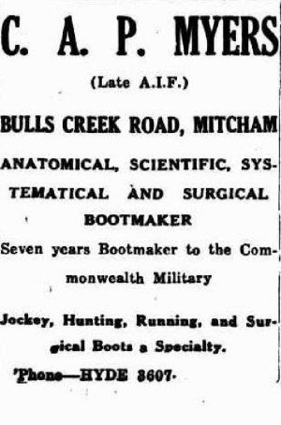
Police Gazettes South Australia
DESERTED WIVES, FAMILIES ETC.
ADELAIDE—a Warrant has been issued for the arrest of CHARLES ARTHUR PELHAM MYERS, described as a native of Victoria, 61 years of age, about 5ft 9ins high, thin build, grey hair, greyish-blue eyes, clean shaven, long nose, a bootmaker; charged that (1) he has been guilty of deserting his wife Elsie Lilly Myers, on and since the 8th June, 1928; (2) wilful neglect to provide reasonable maintenance for her; (3) cruelty to her about the beginning of May and on the 7th June, 1928; and (4) he is a person who, by reason of the habitual intemperate drinking of intoxicating liquor, is at times incapable of managing himself.
Warrant filed at C.I. Branch, Adelaide.
The following was placed in the Police Gazettes of S.A. on 11 July, 1928:
This advertisement appeared many times in the Sport newspaper.
The Adelaide branch of the Repatriation Commission requested a copy of his service records from Base Records which were forwarded on 4 April, 1932.

In 1938 he was a contestant in the garden competition with competitors names published in the:
Mail (Adelaide) Saturday March 19, 1938:
WHO HAS BEST AUTUMN SHOW? 46 GARDENS IN “THE MAIL’S” £30 CONTEST
SECTION THREE
Mr C.A.P. Myers, 366 Sea View Road, Henley Beach. Article abridged

In the Electoral Roll for 1939 he is listed at 366 Sea View Road, Henley, with the occupation of bootmaker.

Charles (Charley) Arthur Pelham Myers passed away on 2 December, 1940 aged 74 years. Announcements were placed in the:
Advertiser (Adelaide) Wednesday December 4, 1940:
FUNERAL NOTICES
MYERS—THE FRIENDS of the late CORPORAL CHARLES ARTHUR PELHAM MYERS (bootmaker) late of Mitcham and 2nd Tunn. Corps and 3rd Pioneers, A.I.F. and respectfully informed that the Funeral will leave the residence of Mrs M.J. Donnolly, 366 Seaview-road, Henley Beach, on WEDNESDAY, at 4 p.m. for the A.I.F. Cemetery, West Terrace.
ALFRED JAMES & SON A.F.D.A. Funeral Directors
R.A.O.B.
THE MEMBERS of the above Order and Mile End Lodge, in particular, are requested to follow the Remains of our late BROTHER CHARLES A. P. MYERS.
The funeral will leave the residence of Mrs M.J. Donnolly, 366 Seaview-road, Henley Beach on WEDNESDAY, the 4th of December at 4 p.m. for the A.I.F. Cemetery, West terrace.
HERBERT CARTER, Grand Secretary.

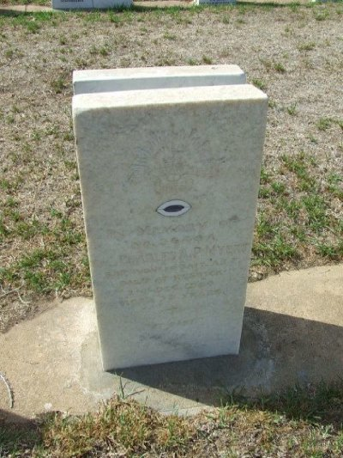
Interment took place in the Light Oval portion of West Terrace Cemetery within Row 2N, Aspect C in site no. 14.
His grave in West Terrace Cemetery, Adelaide S.A.
Photo sourced from Find-a-Grave website

His second wife Elsie Myers died on 12 November, 1980 at 98 years of age at Norwood, S.A. She was buried with her first husband Louis Seiler in West Terrace Cemetery.
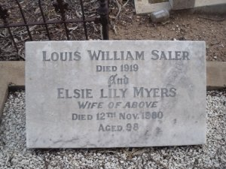
Photo sourced from Ancestry Public Tree submitted by
W. Hunters 3/10/2018

© Donna Baldey 2022
www.tunnellers.net

