SAPPER JOHN THOMAS MUNSTER
1085 – 3rd Tunnelling Company

John Thomas Munster stated he was born in Auckland, New Zealand and there is a name matching him born in 1872 the son of Thomas and Ellen Munster. He came to the goldfields of Western Australia and at thirty-years of age was a partner in a gold mining lease advertised in the:

Mount Magnet Miner and Lennonville Leader Saturday August 30, 1902:
NOTICE OF APPLICATION FOR A GOLD MINING LEASE
NOTICE is hereby given that we, Hugh Campbell, William Curran, James Curran, Samuel John Cash, John Thomas Munster, of Lennonville, the undersigned, have made application this day for a gold mining lease under the provisions of “The Goldfields Act, 1895,” and its amendments, and the Regulations made thereunder, of ground to be known as “The Golden Maid.” Containing five acres, commencing about five chains north-east of the north-east corner peg of G.M. Lease, 622M, thence one chain N.E. to the south-east corner peg of G.M.L. 613m, thence three and a half chains north-west, along boundary line of G.M.L. 613M, thence five and a half chains east, thence eight and a half chains south-east, thence six and a half chains west to datum peg.
As witness our hands at Mt Magnet this 25th day of August, 1902.
HUGH CAMPBELL JAMES CURRAN WILLIAM CURRAN JOHN THOMAS MUNSTER
SAMUEL JOHN CASH By their agent Hugh Campbell
Objections against the application above referred to must lodged at the Warden’s Office on or before the 26th day of September, 1902.
GERARD HORGAN, Acting Mining Registrar Mt Magnet, Murchison Goldfield
In 1906 he was listed as a prospector at Wiluna, W.A.

He was before the Police Court in 1911 with the following reported in the:
Black Range Courier and Sandstone Observer Thursday July 27, 1911:
GENERAL NEWS
At the local police last week J.T. Munster, for using abusive language to W.F.S.E. Buchan, Secretary of the Black Range Road Board, was fined £2 and 14s costs. He had to pay £1 6s, with 4s 6d costs for sanitary fees, and 102 with 4s 6d for being the owner of an unregistered dog, three charges costing the defendant £4 18s.

A year later listed his residence at Boogardie and was prospecting. Further application for a mining lease was placed in the:
Murchison Times and Day Dawn Gazette Thursday April 11, 1912:
MINING NOTES
Samuel John Cash and John Thomas Munster are applying for a one-acre lease to be known as The Sunshine, and situate at Boogardie.

At the recruiting depot at Mount Magnet on 9 October, 1915 the forty-year-old married miner applied to enlist for active service abroad and passed the medical examination. Forms of Attestation were completed and describe him as 183cms (5ft 8ins) tall, weighing 65kgs (143½lbs) with a chest expansion 87-95cms (34-37½ins) with a fresh complexion with brown eyes and brown hair. Distinctive marks listed were vaccination mark on right arm and various round crealties? on shoulder, chest and arm. Also, a large scar on right groin. A medical notation stated slight varicocele of left testicle and varicosity of right leg. Roman Catholic was his religion.

Next-of-kin nominated was his wife Mrs Mary Munster of G.P.O. Perth. Allotment of two-fifths of his pay was in support of his wife. He signed and took the Oath of Allegiance on October 15 at Blackboy Hill camp, near Perth.

Basic training commenced with the 33rd Depot Battalion at Blackboy Hill from October 15 and allotted to the No. 3 Company of the Miners’ Corps on 3 December, 1915.
Recruiting for the Miners’ Corps officially began on December 1st, 1915 therefore Sapper Munster was placed for basic training at the Helena Vale camp at Blackboy Hill, W.A. with the newly forming Corps. The Unit’s title was the No. 3 Company with a major portion of No. 3 Company recruited by 2nd Lt. L.J. Coulter, A.I.F. who was sent from N.S.W. to W.A. for that purpose. They were made up to strength with 1 Officer and 274 Other Ranks and embarked from Fremantle, W.A.

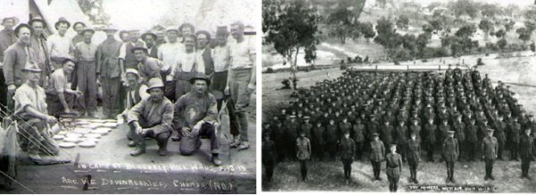
No.3 Company recruits at Blackboy Hill, 3 December 1915 & on Parade - 16 December 1915
Photos courtesy Graeme Williams, grandson of 1202 Spr. Charles Williams – 3ATC
On December 18, 1915 the company sailed for Sydney, NSW on board the troopship SS Indarra. His name appears on the passenger list which was published in:
The West Australian Saturday December 18, 1915:
INDARRA’S PASSENGERS
The following passengers are booked to leave by the Indarra to-day: Messrs: J.T. Master [Munster]
Article abridged

On Boxing Day (Dec 26th), 1915 the Unit arrived in Sydney and marched into Casula Camp, near Liverpool, NSW. They were joined by the 4th Section of the Tasmanian Miners, bringing the establishment strength up to 15 officers and 349 Other Ranks under the command of 2nd Lieutenant L.J. Coulter.

Mining Corps Units from all Military districts came together at Casula camp, near Liverpool, NSW to complete training as a Corps. Sapper Munster was assigned the regimental number 1045 and remained in No. 3 Company.

At a civic parade in the Domain, Sydney on Saturday February 19, 1916, a large crowd of relations and friends of the departing Miners lined the four sides of the parade ground. Sixty police and 100 Garrison Military Police were on hand to keep the crowds within bounds. The scene was an inspiriting one. On the extreme right flank, facing the saluting base, were companies of the Rifle Club School; next came a detachment of the 4th King’s Shropshire Light Infantry, then the bands of the Light Horse, Liverpool Depot, and the Miners’ on the left, rank upon rank, the Miners’ Battalion.

The Corps boarded HMAT A38 Ulysses in Sydney, NSW on February 20 and sailed for the European theatre. Arriving in Melbourne, Victoria on February 22 the Miners camped at Broadmeadows for a stay of 7 days while further cargo was loaded.

Another parade was held at the Broadmeadows camp on March 1, the Miners’ Corps being inspected by the Governor-General, as Commander-in-Chief of the Commonwealth military forces. Leaving Melbourne on March 1, Ulysses arrived at Fremantle, Western Australia on March 7 where a further 53 members were taken on board.
On Wednesday March 8, 1916 the whole force, with their band and equipment, paraded at Fremantle prior to leaving Victoria Quay at 9.30 o’clock.

The ship hit a reef when leaving Fremantle harbour, stripping the plates for 40 feet and, although there was a gap in the outside plate, the inner bilge plates were not punctured. The men on board nicknamed her ‘Useless’. The Miners were off-loaded and sent to the Blackboy Hill Camp where further training was conducted.

The Mining Corps comprised 1303 members at the time they embarked with a Headquarters of 40; No.1 Company – 390; No.2 Company – 380; No.3 Company – 392, and 101 members of the 1st Reinforcements.

Finally departing Fremantle on April 1, Ulysses voyaged via Suez, Port Said and Alexandria in Egypt. The captain of the ship was reluctant to take Ulysses out of the Suez Canal because he felt the weight of the ship made it impossible to manoeuvre in the situation of a submarine attack. The troops were transhipped to HM Transport B.1 Ansonia, then on to Valetta, Malta before disembarking at Marseilles, France on May 5, 1916. As a unit they entrained at Marseilles on May 7 and detrained on May 11 at Hazebrouck.

A ‘Mining Corps’ did not fit in the British Expeditionary Force, and the Corps was disbanded and three Australian Tunnelling Companies were formed. The Technical Staff of the Corps Headquarters, plus some technically qualified men from the individual companies, was formed into the entirely new Australian Electrical and Mechanical Mining and Boring Company (AEMMBC), better known as the ‘Alphabetical Company’.

On 5 June, 1916 went with varicose to the 17th Aust Field Ambulance and returned to duty three days later on June 8.

Went sick again on 12 June, 1916 to the 2 /1 South African Field Ambulance suffering pleurisy and sent to the 25th General Hospital at Camiers and to recuperate at the No. 1 Convalescent Depot. Then reported to the 1st Aust Divisional Base at Etaples on June 29 and re-joined his unit on 9 July, 1916.

Sapper been trained as a ‘listener’ through a course at the Listening School lasting about ten days from 12 December, 1916 where they learnt to distinguish between any normal sounds created during mining operations. The listener would be on duty at any specified post underground for a fixed period, usually a six-hour shift silently listening for sounds of underground mining by the enemy. Detailed reports were provided of sounds heard to superiors on return to the surface. So these sounds could be credited solely to the enemy all company work would cease while intensive listening could be carried out. Listening posts were many and numbered to gauge from these positions the location of enemy mining activity which was accurately recorded on the Mine Plan. A certificate was issued on completion of the course.

During March, 1917 he also was instructed in underground mine rescue using the “Proto-equipment” – a life-saving breathing apparatus worn to rescue or retrieve men from underground when nitrous gases permeate the air in the tunnels.

Mrs J.T. Munster wrote to Base Records care of Post Office, Wagga Wagga, NSW on 9 July, 1917 asking if they would kindly reply and let her know what happened to her husband who enlisted from Mt Magnet. She has not had any word from him since February 12, 1917. He used to write regularly and she feared that something had happened to him.

Records replied on 13 July, 1917 to her letter and stated that no report of casualty had been received regarding her husband, consequently it may be assumed he is with his unit. His address was included for correspondence. Her change of address had been noted.

On 18 August, 1917 a group of tunnellers were overcome by gas while working at Hill 70, Loos.
In the After War Report of the 3rd Tunnelling Company the following was recorded:

“On 18.8.17 the following were wounded at Hill 70, Loos:
1425 Spr. Martin, A.
1192 “ Turnbull, J.G.
5019 “ Waterhouse, R.G.
5027 “ Jones, T.G.
1085 Spr. Munster, J.T. was gassed and died on 24.8.17 and
4496 Spr. Truman, H.P. was gassed and died on 21.8.17.”

Sapper was taken to the 18th Casualty Clearing Station but died of gas poisoning on 24 August, 1917 aged 42 years.

Burial took place on Lapugnoy Military Cemetery situated three and a half miles south, south east of Lillers in plot 5 row D.

Base Records regretted to advise his wife on 27 August, 1917 that it had been reported that her husband had been reported suffering from gas poisoning. His address for correspondence was included.

Mrs J.T. Munster replied to Base Records on 5 September, 1917 that she had received their communication stating that Sapper J.T. Munster was suffering from gas poisoning. Could they please tell her what hospital he was in at present as she was very anxious and would like to Cable to see if he was still living, if so, she shall send him some money to purchase necessary nourishment while in hospital.

In reply to her Wagga Wagga address from Base Records dated 12 September, 1917 concerning her husband, the writer said I have to state, ere this, be aware, that his soldier is reported having died of gas poisoning, on the 24th August, 1917. No particulars are yet available, but later official advice coming to hand by mail should contain further details, and these, on receipt, will promptly communicated to you.

The Anzac Section, 3rd Echelon, G.H.Q. had received the hospital report and other relevant information and the Field Service Report was compiled on 12 September, 1917 and a copy of his service records were prepared for the Pension Department.

The following appeared in the:
Daily Advertiser (Wagga Wagga) Tuesday September 18, 1917:
WAGGA SOLDIERS’ COMFORTS FUND
A meeting of the Wagga Soldiers’ Comforts Fund committee was held at the Town Hall yesterday afternoon.
Votes of sympathy were passed to the relatives of Gunner F. Mate and Gunner H. Turner, Sapper J.T. Munster and Mr C.H. King.

He was mentioned in the Casualty List published in the:
Sun (Kalgoorlie) Sunday September 23, 1917:
THE TOLL OF WAR AND ROLL OF HONOUR
The 338th list of casualties among West Australians serving with the A.I.F. in various theatres of war.
OTHER CAUSES
Spr. John Thomas Munster, Wagga Wagga (N.S.W.), gas poisoning: Article abridged

Mrs J.T. Munster wrote to Base Records from her address care of the Post Office, Sydney, NSW on 25 October, 1917 asking if there was any further information to hand concerning her husband who died of gas poisoning 24 August, 1917. Could they tell her what hospital he died in as she would like to write to the matron for particulars? Could they give her the address of his commanding officer of No.3 Company, Miners Corps? She was so anxious to hear something about her husband’s death but nothing to hand, only a cable say that he died of gas poisoning.
Do please reply. Her former address was Wagga Wagga, NSW.

The following small obituary announcing his demise appeared in the Perth newspaper:
Daily News (Perth) Saturday October 27, 1917:
MAINLY ABOUT PEOPLE “Franziska”
Mrs Munster, of N.S.W., formerly of Mt Magnet, has been notified of the death of her husband, Sapper J.T. Munster, in France on August 24. He enlisted from Magnet and left Australia with the 3rd Tunnelling Co in April, 1916. He was well-known, and had many friends in the Magnet district.

Base Records replied on 8 November, 1917 to Mrs Munster in Sydney, NSW in reference to the report of the regrettable loss of her husband the writer could state only the information available to date had already been transmitted, to the effect that he died of gas poisoning on the 24th August, 1917. Further particulars that come to hand by mail, on receipt, will be promptly transmitted to her. It is customary, when the stress of operations permit, for the Commanding Officer, Chaplain or Nurse to communicate with next-of-kin of deceased members of the Australian Imperial Force, giving them, at first hand, such information as is available. Should you have not received any letters from the front the address you require would be Commanding Officer 3rd Tunnelling Company, Aust Imperial Force, Abroad. Her change of address was noted.

Mrs Munster who revealed her correct name was Mary Bradley and noted as reputed wife, was granted a widow’s pension of £2 per fortnight to her address at 271 Forbes Street, Darlinghurst from 4 November, 1917.

The Kit Store, Hammersmith, London prepared an Inventory of his personal effects on 26 November, 1917 which contained the following:
3 Discs, Pipe, 2 books, religious medallion and Mine Rescue Certificate.
These were placed in a sealed package and consigned on the transport Boonah to Base Records who forwarded them on to his widow care of the G.P.O. Sydney on 6 May, 1918.

His widow wrote to Base Records on 9 May, 1918 care of G.P.O. Sydney saying parcel to hand today which I thank you. It almost broke my heart when I received the parcel and saw his pipe, just as he last used it. But I am pleased to get those trifles and will treasure them always. This terrible war has given a great many of us a cruel burden to bear, but what cannot be avoided must be endured. I must console myself with the thought I am one of the many left to grieve. My husband had other articles that he treasured in his kitbag, a photo of myself, shaving bag he always carried. I don’t suppose I shall ever get them, anyhow I am pleased to get even those articles.

A tribute notice was placed by his widow on the first anniversary of his death in the:
Mount Magnet Miner and Lennonville Leader Saturday August 31, 1918:
IN MEMORIAM
Munster—In loving memory of my dear husband, Sapper J.T. Munster (Jack), 3rd Company Mining Corps, died gas poisoning, August 24, 1917, somewhere in France.
No one knows what the parting cost;
Heaven had gained what I have lost.
No loved ones stood around him,
To catch his last faint sighs,
Or whisper just one loving word
Before he closed his eyes
—Inserted by his loving wife, May Munster

The Commanding Officer of the 3rd Tunnelling Company forwarded to Mrs Munster care of G.P.O. Perth on 26 April, 1919 photographs of the resting place of her late husband who gave his life so faithfully for his country and hoped that they would be of some comfort to her.
The following bereavement notice was placed on the second anniversary of his death in the:
West Australian (Perth) Monday August 25, 1919:
IN MEMORIAM – ANZAC HEROES
Munster—In loving memory of my dear husband, Sapper John T. Munster, 3rd Tunnelling Co., died of gas poisoning, August 26, 1917, somewhere in France.
Though death dividing fond memories cling
Inserted by his loving wife, May Munster.

Base Records forwarded to his widow on 1 March, 1920 two photographs and description of the locality of the grave of her husband. Any discrepancy appearing on the memorial will be rectified when the permanent headstone is erected.

The 5th Military District was asked for the next-of-kin on 19 March, 1920 for Mrs Mary Munster of G.P.O. Sydney. They replied on 8 April, 1920 informing that the widow of abovenamed was at present in the Perth Public Hospital. Her postal address was Mrs Mary Munster, 365 Stirling Street, Perth, W.A.

A letter posted on 30 November, 1921 to the Perth address was returned “unknown by letter carrier” and contained a forwarding letter about the Memorial Scroll and King’s Message.

Mrs Munster receipted delivery of three photographs of the grave of her husband on 3 February, 1922.

On 15 February, 1922 the 5th Military District advised Base Records that the address of the widow of the late soldier was now residing care of Mrs Inglis, Darlow Street, Wagga Wagga, NSW.

The Memorial Scroll was signed for by Mrs Munster on 20 March, 1922 and on the 16th October, 1922 the Memorial Plaque was received by her.

The Victory Medal was issued to his widow who signed its delivery on 23 February, 1923.

On 17 September, 1923 Base Records advised his widow that the official site of his grave was registered in Lapugnoy Military Cemetery in plot 5 row D in grave no. 13.

A Roll of Honour for the Engineers was made known in the:
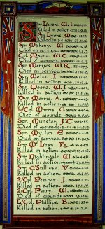
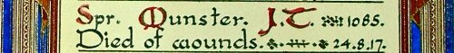
The Sydney Morning Herald - Saturday 23 July 1921:
ENGINEERS' ROLL OF HONOUR
The Royal Engineer War Memorial Committee are arranging to deposit a roll of honour of all ranks of the Royal Engineers whose names were officially published as killed in action or died of wounds or disease in the war in the chapel of St. Paul's Cathedral, and the Engineer corps of the dominions, colonial, and Indian armies have been invited to deposit similar rolls of honour in St. Paul's, to be attached to that of the Royal Engineers. This invitation has been accepted in Australia. The roll will be inscribed on vellum and enclosed in a casket of Australian timbers to rest on a slab of Australian marble.

This extract from Tunnellers Roll of Honour included in profile with the kind permission of the
Dean and Chapter of St Paul’s Cathedral, London
Photos courtesy of Robin Sanderson, Paris

His name was published in the List being placed on the Memorial Tablets at Kings Park, Perth in the:
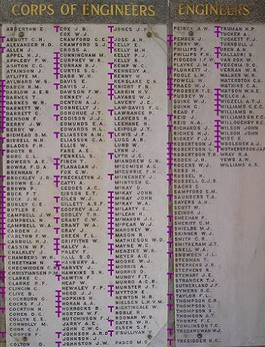
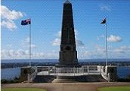
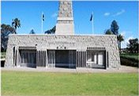
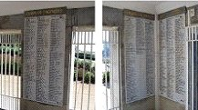
The West Australian Thursday August 7, 1930:
STATE WAR MEMORIAL – NAMES FOR TABLETS
The names of all West Australian soldiers who gave their lives during the Great War are to be handed down to posterity by means of a series of tablets bearing their names on the walls of a section of the State War Memorial on Mount Eliza.
Spr. MUNSTER, J.T. 3rd T. Coy Article abridged
Purple T by Tunnellers.net
Kings Park, Perth – Great War Memorial Honour Boards
His name is commemorated on the Commemorative Panel of the Australia War Memorial on Panel 27.

His grave can be located in plot five of Lapugnoy Military Cemetery, Bethune, France within row D in grave no. 13.
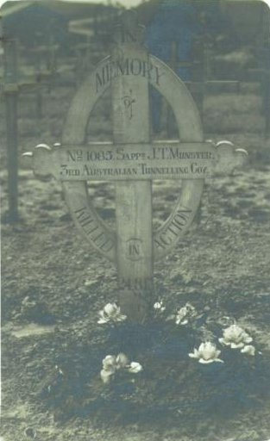
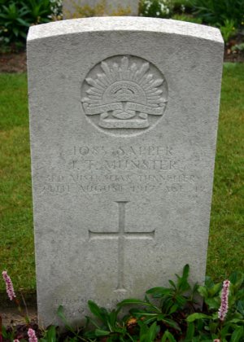
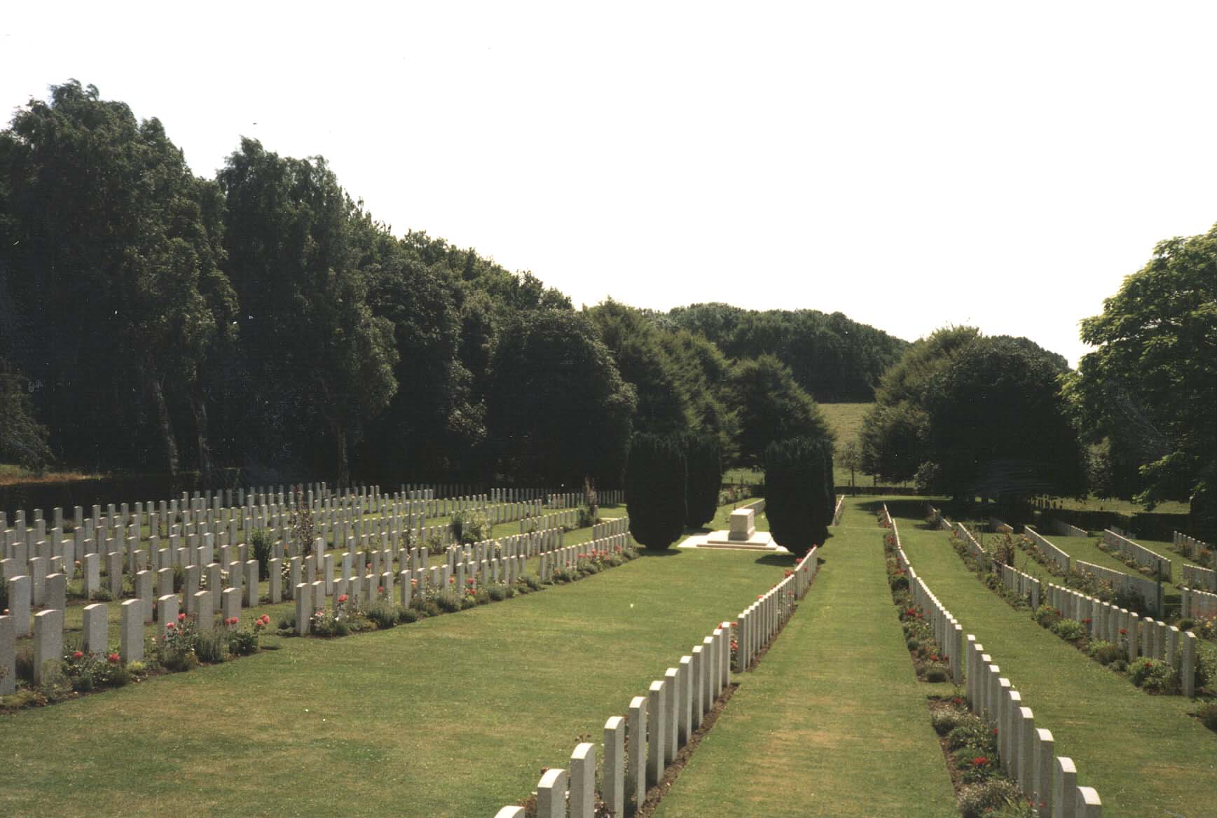
Photo of cemetery & headstone by kind permission of
The War Graves Photographic Project - www.twgpp.org

© Donna Baldey 2022
www.tunnellers.net

