CAPTAIN LEONARD GRAEME MUIRHEAD
A.A.M.C. - 1st Tunnelling Company

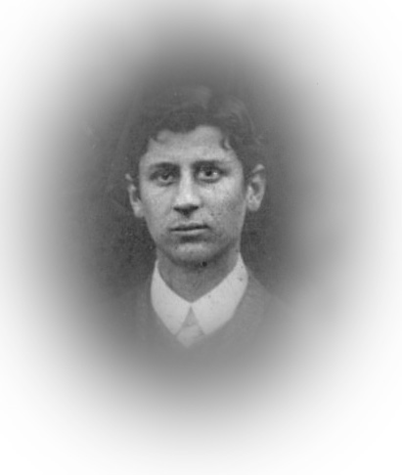
Leonard Graeme Muirhead was born in Adelaide, South Australia on April 19, 1887 the son of David Graham and Eliza Helen (nee Hogg) Muirhead.
Captain Leonard G. Muirhead MB BS
1887-1964
Photo courtesy:
Army Health Services Research Group Adelaide

He gained degrees from Adelaide University as a Bachelor of Medicine (MB) and a Bachelor of Surgery (BS). Experience as House Surgeon and Physician at the Adelaide Hospital in 1911-1912 followed and military medical knowledge was gained as Captain with the A.A.M.C. Reserve. A slight knowledge of French was known.

One month before his 30th birthday the Medical Practitioner enlisted for general overseas service on April 15, 1917. The following day applied for a Commission in the Australian Imperial Forces for which the rank of Captain was recommended the same day and Gazetted No. 73 on May 24, 1917.

A medical examination took place at Mitcham Camp, S.A. on April 16 which describes his height as 174cms (5ft 8¼ins), weight 65.5kgs (144lbs) with a chest measurement of 84-92cms (33-36ins). Eyesight was recorded as 6/6 nearly in each eye and Presbyterian his faith. His father David Graham Muirhead of The Grange, S.A. was recorded as next-of-kin and his Will had been lodged with the Executor, Trustees & Agency Company, Adelaide.

Captain Muirhead departed Melbourne, Victoria on the troopship HMAT A11 Ascanius on May 11, 1917. The ship docked at Fremantle on May 25 and arrived at Durban, South Africa on June 12. It departed on June 15 visited Cape Town on June 19. Left on June 22 and entered Sierra Leone on July 5 departing two days later. After a voyage of 71 days the ship docked at Devonport, England on July 19, 1917 and the troops were detrained to Amesbury, Eng.

Marched in to the A.M.C. Training Depot at No. 2 Camp at Parkhouse for several weeks training remaining until August 9, 1917. The following day was attached to the Convalescence Training Depot at Bulford, England as Medical Officer. He proceeded overseas to France via Folkstone on October 14, 1917.

Three days later Captain Muirhead was attached to the 1st Tunnelling Company as Medical Officer and continued service with the Company until February 22, 1918 when he went to Nice on leave, rejoining the unit on March 10, 1918.

His second leave began on October 22, 1918 to England going before the Medical Board on October 24, which declared him unfit for General Service during winter months but was fit for Home Service only.

Captain Muirhead was attached for duty to the 3 Aust. Auxiliary Hospital at Dartford, Eng on November 7, 1918. He was there when Peace was declared several days later.

On November 19 marched in to the 1 Training Depot, Weymouth in preparation for the next day to embark for Australia while serving duty as M.O. on board H.T. D33 Suevic. His next-of-kin was notified of his return on December 19, 1918.

A list of returning soldiers was published in the:
Barrier Miner Friday December 27, 1918:
RETURNING SOLDIERS
LIST “Z”
The South Australian Military authorities advise that the following have been listed (list “Z”) for return to Australia and are actually en route.
RETURNING TO DUTY
Captain L.G. Muirhead A.A.M.C.
Article abridged

Captain disembarked in Melbourne, (Vic) (3rd M.D.) on January 5, 1919 then proceeded to Adelaide, (S.A.) (4th M.D.) where his appointment was terminated on January 19, 1919 owing to cessation of hostilities.

For serving his country Captain Leonard Graeme Muirhead of A.A.M.C (including 1st Tunnelling Company) received the British War Medal (20341) and the Victory Medal (19914).

In 1923 he married in Adelaide, S.A. to Freda Mary Chinner.

During WWII enlisted again with the Australian Army on February 12, 1942 at Torrensville, SA and issued with the number S45193. Residence was at Wayville SA and his wife Freda M. Muirhead was named as next-of-kin. Mrs Muirhead wrote that her husband had placed his name on the reserve list and was called up for further service at Loveday Prisoner of War Camp.

On March 2, 1959 Dr Muirhead living at 9 Sturt Place, Beaumont, S.A. requested an official certificate of recognition of his service as Captain attached to 1st Aust. Tunnelling Company during WWI for business purposes. After a Statutory Declaration had been filed a Statement of Service was issued in mid March, 1959 to replace his Discharge Certificate which he stated that in the passing of time had gone.

Dr L.G. Muirhead died on January 2, 1964 aged 76 years. Cremation took place at Centennial Park Crematorium, Adelaide, South Australia.

The War Service Homes Division, Adelaide, S.A. requested information on service on March 8, 1963 and a Statement of Service was forwarded on March 18, 1963.

Mrs Freda M. Muirhead wrote from 1 Crombie Street, Brighton, S.A. on February 27, 1964 requesting service information on her late husband. A Statement of Service was sent to her dated March 4, 1964.

Freda Mary Muirhead passed away aged 88 years on February 3, 1988. Ashes are at Centennial Park Cemetery.

© Donna Baldey 2009/2012
www.tunnellers.net
with the assistance of Professor Annette Summers AO RFD, a member of the Army Health Services Research Group Adelaide, a group of serving and ex-serving military health officers in South Australia who are undertaking a project for the centenary of WW1.

