SAPPER DONALD McKAY MATHESON
354 – 1st Tunnelling Company
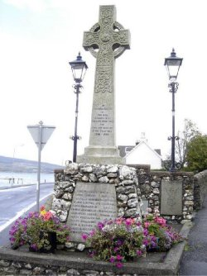
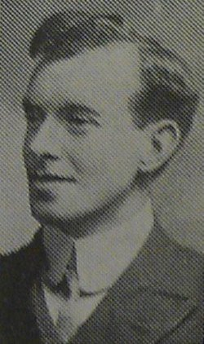
http://scottishmilitaryresearch.weebly.com

DONALD MCKAY MATHESON
Donald Matheson was born in Glasgow in 1884, the son of Margaret Matheson, latterly of 6 Victoria Place, Port Bannatyne, Bute. He had been employed as an apprentice with R & J Gray, Glasgow before finding employment as a Master Mariner in Australia. He enlisted at Casula, New South Wales, Australia, on 20th December 1915. He gave his age as 31 years, 5 months, and his religion as Presbyterian. He disembarked at Marseilles on the 5th May 1916 and then detrained at Hazebrouck on the 8th May of the same year. On the 24th June 1916 he was found guilty of being drunk on duty while in the field and was sentenced to 28 days Field Punishment No.1 – this consisted of the convicted man being placed in fetters and handcuffs or similar restraints and attached to a fixed object, such as a gun wheel or a fence post, for up to two hours per day. He was killed in action on the 10th November, 1916, while serving in the 1st Company Australian Tunnelling Corps, Australian Expeditionary Force. He is buried at Railway Dugouts Burial Ground (Transport Farm), and is commemorated on the war memorial in Port Bannatyne, Bute.
On 9 October 1903 he was granted a Certificate of Competency as ‘Second Mate of a Foreign-Going Ship’ in the Merchant Service, issued by the Lords of the Committee of the Privy Council for Trade under the Merchant Shipping Act, 1894.

On 29 September 1905, and again on 27 February 1906, he was granted a Certificate of Competency as ‘First Mate of a Foreign-Going Ship’ and on 29 May 1908 he was granted a Certificate of Competency as ‘Master of a Foreign-Going Ship’.

He signed the ‘Attestation Paper of Persons Enlisted for Service Overseas’, and the Oath to ‘well and truly serve’, at Casula Camp, NSW, on 20 December 1915, naming as his Next-of-Kin his friend Mr. John Morrison of 7 Spring Street, Balmain, NSW. He was appointed to No.1 Company of the Miners Corps and embarked on 20 February 1916 on board Ulysses.

At a civic parade in the Domain, Sydney on Saturday February 19, 1916, a large crowd of relations and friends of the departing Miners lined the four sides of the parade ground. Sixty police and 100 Garrison Military Police were on hand to keep the crowds within bounds.

The scene was an inspiriting one. On the extreme right flank, facing the saluting base, were companies of the Rifle Club School; next came a detachment of the 4th King’s Shropshire Light Infantry, then the bands of the Light Horse, Liverpool Depot, and the Miners’ on the left, rank upon rank, the Miners’ Battalion.

Following the farewell parade in the Domain, Sydney, the Australian Mining Corps embarked from Sydney, New South Wales on 20 February 1916 on board HMAT A38 Ulysses.

The Mining Corps comprised 1303 members at the time they embarked with a Headquarters of 40; No.1 Company – 390; No.2 Company – 380; No.3 Company – 392, and 101 members of the 1st Reinforcements.

Ulysses arrived in Melbourne, Victoria on 22 February and the Miners were camped at Broadmeadows while additional stores and equipment were loaded onto Ulysses.

Another parade was held at the Broadmeadows camp on March 1, the Miners’ Corps being inspected by the Governor-General, as Commander-in-Chief of the Commonwealth military forces.
Departing Melbourne on 1 March, Ulysses sailed to Fremantle, Western Australia where a further 53 members of the Corps were embarked. The ship hit a reef when leaving Fremantle harbour, stripping the plates for 40 feet and, although there was a gap in the outside plate, the inner bilge plates were not punctured. The men on board nicknamed her ‘Useless’. The Miners were off-loaded and sent to the Blackboy Hill Camp where further training was conducted. After a delay of about a month for repairs, The Mining Corps sailed for the European Theatre on 1 April 1916.
‘On the arrival of our troop ship in Alexandria in April 16, a party of some 120 out of our 1200 miners, with the wanderlust strong upon them, broke loose suddenly from our troop ship (Ulysses) as she lay at the wharf, rushed the sentries, and went careering like a lot of released school boys up the main street of Alexandria, making for the heart of the city.
Some bad sport, perhaps one should rather say, one sound disciplinarian, telephoned to the military police. And in due course the sappers were met by some charabancs driven by genial gentlemen, who offered them a lift.
The offer was of course accepted, and presently the vehicle swung into a courtyard, the gates of which were promptly closed, and the sappers then realised that they were prisoners. One hundred and twenty of them were locked up in a building designed for a maximum of 60. The sappers called it the ‘boob”. The night was very hot and the “boob” threatened to become a veritable Black Hole of Calcutta.
In the early dawn, an agonized SOS came from the military police to our ship to say that the sappers were tunnelling under the walls of the boob, and that it was tottering to its foundations, and would we send up a strong-armed party at once to hold and remove the prisoners.’
Major T.W. Edgeworth David

The ship arrived at Suez, Egypt on 22 April, departing for Port Said the next day; then on to Alexandria.

The Captain of the ship was reluctant to take Ulysses out of the Suez Canal because he felt the weight of the ship made it impossible to manoeuvre in the situation of a submarine attack. The Mining Corps was transhipped to B1 Ansonia for the final legs to Marseilles, France via Valetta, Malta. Arriving at Marseilles on 5 May, most of the men entrained for Hazebrouck where they arrived to set up their first camp on 8 May 1916.

A ‘Mining Corps’ did not fit in the British Expeditionary Force, and the Corps was disbanded and three Australian Tunnelling Companies were formed. The Technical Staff of the Corps Headquarters, plus some technically qualified men from the individual companies, was formed into the entirely new Australian Electrical and Mechanical Mining and Boring Company (AEMMBC), better known as the ‘Alphabetical Company’.
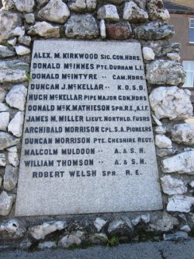

No.1 Company was re-designated the 1st Australian Tunnelling Company (1ATC) and from their arrival in France, 1ATC worked on the Hill 60 system involving the 2 great mines at Hill 60 and Caterpillar.

https://vwma.org.au/
He was a Sapper with the 1st Company, Australian Tunnelling Corps.
He was the son of Mrs. M. Matheson of 6 Victoria Place, Port Bannatyne, Bute.
He is commemorated on the North Bute War Memorial-North Bute is the northernmost parish of Bute island, Buteshire, bounded SE by Rothesay parish. Its church stands in the dingle between Kames and Etterick Bays, 1 mile W of Port Bannatyne, and 3½ miles NW of Rothesay; and its post-town is Port Bannatyne.
He is also commemorated on the Port Bannatyne war memorial but there his name is spelled Mathieson
The War Story of Oliver Holmes Woodward, Capt., 1ATC:
On November 9th 1916, our Company officially took over from the 3rd Canadian Tunnelling Company and from then on the care of the Hill 60 Mining System rested on our shoulders.
At 4.30 p.m. on the 10th, word was received that the enemy had crumped one of our dugouts, killing two men and badly gassing three officers. Contd.
Red Cross File – sourced from AWM:
Havre20th Nov. 1917
Tunnelling Companies Mathieson. Daniel
A.I.F.1st Co.
RE ENQUIRY
I knew Sapper D. Mathieson well. He had been a ship’s Officer in Burns, Phillips & Co’s Line, Sydney, before the war, on the Coastal Service. He had followed the sea all his life. He was about 5’6”, fair complexion, cleanshaven, aged about 35, blue eyes. He joined up in Sydney in Nov. 1915. He had not kept up with his people for a number of years and never told them he had joined the army. I saw him killed by a minenwerfer at Hill 60 in Jan. 1917. He was in a dugout and was and was brought out dead, killed outright by concussion. He is buried near Zillebeke in the Military Cemetery. I never saw the grave, but I know where it is well enough. We buried half a dozen of more of our fellows at the same time. It had a cross with his name &c. on it. His mother and sisters live at Rothesay, Glasgow, but I don’t know the exact address. The reason he had not communicated with them was owing to some woman in Sydney that he got mixed up with. He made a will in favour of her, but I don’t know if it was a legal one. He regretted having made over his property to her, and I am sure he would have liked his people to know he had been killed.
Informant: Sapper D. Murray, 333; 1st Tunnelling Co, A.I.F.; Australian Camp
Continues
With Lieut. Justice I was ordered to report to the Hill and after a quiet trip up we arrived there at 10 p.m. On this tour of duty I was detailed for service in the Intermediate or “D” Galleries. In this Section Listening was infinitely more exciting than in the Front Line Saps. According to the Canadians, and later confirmed by ourselves, the enemy’s Gallery was within 6 ft to 10 ft. from Listening Posts “A”, “B” and “C”, in “D” Right Gallery. Getting into these Posts was in itself a task as the utmost caution was necessary and one in it was a case of sitting immovable. In this respect we outdid the Royal Horse Guards at Whitehall. With them tradition demanded that they should not move, with us it was more a case of fear preventing any movement. I have Listened in “D” Right Gallery as immovable as a piece of statuary and have been equally as cold, from fear.
Donald McKay Matheson was buried at Railway Dugouts Burial Ground (Transport Farm) at Sect IV, Row O, grave 25.

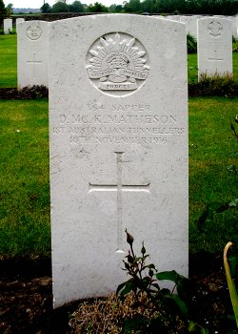
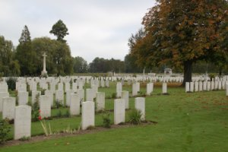
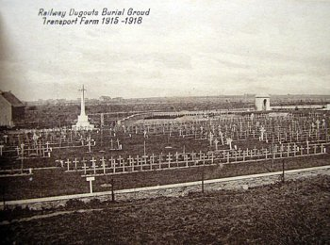
Photo of cemetery above & headstone by kind permission of
The War Graves Photographic Project - www.twgpp.org

372 Sapper William James Heathcote Brook was the man killed in the same incident and he was buried beside Donald in grave 26.
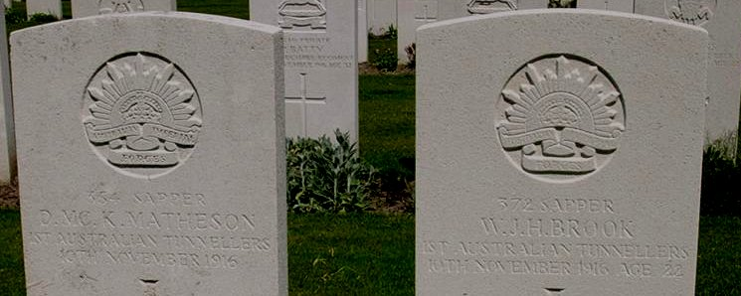

Donald McKay Matheson's name is located at panel 27 in the Commemorative Area at the Australian War Memorial.

In 1919 the veterans of the 1st Australian Tunnelling Company erected a memorial on Hill 60, honouring the 29 comrades who had died there in 1916-1917. The memorial and its stove enamelled plaques weathered badly, and in 1923 a new and more robust monument, which stands on the site today, was constructed. The three original plaques, bearing the dedication and the names of the company’s dead, were returned to Australia.
Donald and William’s names were both included on the original (1919) 1st Australian Tunnelling Company Memorial at Hill 60, near Ypres, Belgium. (Australian War Memorial Images ID P00735.017 & RELAWM05099.001 below)
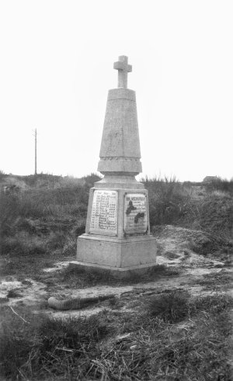
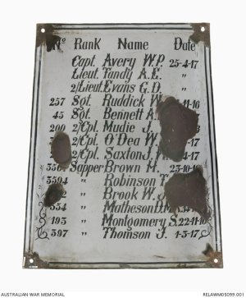
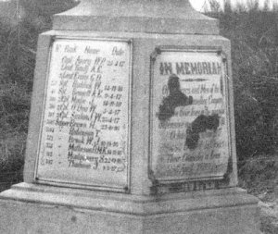


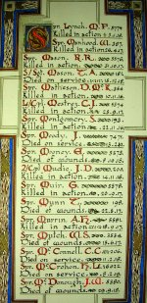
The Sydney Morning Herald - Saturday 23 July 1921:

ENGINEERS' ROLL OF HONOUR
The Royal Engineer War Memorial Committee are arranging to deposit a roll of honour of all ranks of the Royal Engineers whose names were officially published as killed in action or died of wounds or disease in the war in the chapel of St. Paul's Cathedral, and the Engineer corps of the dominions, colonial, and Indian armies have been invited to deposit similar rolls of honour in St. Paul's, to be attached to that of the Royal Engineers. This invitation has been accepted in Australia. The roll will be inscribed on vellum and enclosed in a casket of Australian timbers to rest on a slab of Australian marble.

This extract from Tunnellers Roll of Honour included in profile with the kind permission of the
Dean and Chapter of St Paul’s Cathedral, London
Photos courtesy of Robin Sanderson, Paris

The Mercury - Hobart, Tasmania : Thursday 18 December 1924
VANDALISM.
WAR MONUMENT DAMAGED.
(Australian Press Association.)
LONDON. December 16.
The War Graves Commission has advised the authorities at Australia House that the inscription on the tablet of the Australian Tunnelling Company monument at Hill 60 in Flanders has been considerably damaged, many of the letters having been broken, and some entirely removed, evidently by a hammer and chisel. Inquiries into the outrage are now proceeding, and the matter has been referred to the Anglo-French Mixed Committee.

Correspondence in Donald’s file:
9th March, 1917
Dear Sir,
With reference to the report of the regrettable loss of the late No.354 Sapper D. McK. Matheson, 1st Tunnelling Company, I am now in receipt of advice which shows that he was killed in action, In the Field, France, on the 10th November 1916, and was buried at Railwau Dug-outs Burial Ground, 1½ miles S.S.E. of Ypres.
These additional details are furnished by direction, it being the policy of the Department to forward all information received in connection with deaths of members of the Australian Imperial Force.
Yours faithfully,
Mr J. Morrison Major
7 Spring Street, Officer i/c Base Records
Balmain, N.S.W.
The Public Trust Office, Sydney, requested a copy of his death certificate on 5 June 1918.
14th June, 1918.
Dear Sir,
I have to acknowledge receipt of your communication of 7th inst. And enclose herewith, as requested, Certificate, in duplicate, of report of death of the late, No.354, Sapper D. McK. Matheson, 1st Tunnelling Company.
The address of the Deceased, prior to enlistment, is not recorded. Next-of-kin is shown as :-
(Friend) Mr John Morrison,
98 Phillips Street, Balmain, NSW.
Yours faithfully,
The Public Trustee, Captain
Box 7 G.P.O. for Officer i/c Base Records
Sydney, N.S.W.
6th May, 1919
Dear Madam,
I have to acknowledge receipt of your communication of 28th ultimo, with reference to the late No. 354 Sapper D. McK. Matheson, 1st Tunnelling Company, and to state on his Attestation Sheet he nominated as his next-of-kin, Mr. J. Morrison (friend), 7 Spring Street, Balmain, N.S.W. later of 28 Phillips Street, Balmain, but subsequently the deceased soldier’s mother – resident in Scotland, was recorded in that relationship.
The only information available regarding this soldier’s death is to the effect that he was killed in action in France on 10/11/16, and was buried at Railway Dug-outs burial ground, 1½ miles south south-east of Ypres.
Yours faithfully
(signed) Major
Officer i/c Base Records.
Mrs. W.J. McMullen
13 Congdon Street,
Osborne,
West Australia
13 Congdon St, Osborne
28 Apr 1919
O.C.
Base Records, Melbourne
Sir
Would you kindly supply any records re Pt Donald McKay Matheson No 354, No.1 Coy Mining Corps the only information that I know is that he gave his address as Balmain. If you have his full address in Balmain I may be able to get some information for his mother who is in Scotland & does not know anything about her son who was killed in France about 17 Nov 1916 thanking you in anticipation
Yours
Mrs. W.J. McMullen
5th October, 1918
Dear Madam,
I have to acknowledge receipt of your communication of 20th ultimo, regarding the late No. 354 Sapper D. McK. Matheson, 1st Tunnelling Company, and to state next-of-kin is recorded as :-
Mrs M. Matheson, (Mother)
6 Victoria Place,
Port Bannatyne,
Bute, Scotland.
Yours faithfully,
Major
Officer i/c Base Records
Mrs. L. McMullen,
13 Congdon Street,
Osborne,
W. Aust.
The Officer in Charge 13 Congdon St,
Base Records Office, Osborne
Defence Department West Aust
Melbourne September 20th 1918
Sir
No 354 Sapper Donald McKay Matheson Deceased.
No.1 Company 1st Australian Tunnling Corps, A.I.F.
The above deceased soldier was a personal friend of mine, and as I am desirious of communicating with his parents as regards certain matters in connection with his death.
I shall be glad if you will kindly supply me with the address of his parents whom I presume reside in Scotland.
Thanking you in anticipation
Yours faithfully,
Mrs. L. McMullen

By August 1922, war memorabilia in respect of Donald’s service had been issued to his mother in Scotland. Memorabilia included the British War Medal and the Victory Medal; the pamphlet ‘Where The Australians Rest’; the Memorial Plaque and the Memorial Scroll with the King’s message.

LEST WE FORGET

© Donna Baldey 2022
www.tunnellers.net

Note: letter writer ‘L. McMullen’ believed to be Elizabeth (Lizzie) nee Collins, wife of Walter John McMullen.

