SAPPER WILLIAM BUTLER MARSON
178 – Mining Corps / 1904 4th Pioneer Battalion

William Butler Marson was born in Beverly, Yorkshire, England, the son of Lowson and Jane (nee Danby) Marson. Based on his age given in 1915, his year of birth would be 1867 but in 1917 his age was revealed to be 53 years making 1864 closer to his birth date. He gave his previous military training as twelve months with the 5th East Yorkshire Voluntary Rifles.

William arrived in Queensland on the ship Scottish Hero on August 3, 1886 as a twenty-one-year-old. On the same ship were the Mayall brothers Arthur (22) and Walter (19). Walter Mayall would become a miner at Mount Morgan, Q and also join the Mining Corps in October, 1915.

William married Annie Tolson and they had three sons and two daughters. They lived at Taroom about 1895 and Clermont in 1898.

His wife Annie died in 1902 and his residence in 1903 was near Cemetery, Mount Morgan remaining there until after 1913. Occupation was a labourer then changed to Engine Driver and Winding Engine Driver. He was at D’Arcy Street, Mount Morgan when the war began.

At the Rockhampton Recruiting Depot on November 6, 1915 the widower enlisted and passed the medical examination and was sworn in the same day. Forms of Attestation show he was 168cms (5ft 6ins) tall and weighed 76.3kgs (168lbs) with a chest expansion of 102-107cms (40-42ins). Complexion was fair with blue eyes and fair coloured hair. Distinguishing mark was the second joint of his third finger on his right hand was missing.

His religion was Methodist and his youngest daughter Martha Jane Marson of D’Arcy Street, Mount Morgan was named as next-of-kin.

He was sent to training camp at Casula near Liverpool, NSW commencing on November 21, 1915 and assigned the regimental number 178 with the No 1 Company, Mining Corp in the rank of Sapper.

The Corps boarded HMAT A38 Ulysses in Sydney, NSW on February 20, 1916 and sailed for the European theatre. But Sapper Marson did not embark. There is no record of desertion, discharge or military closure on his term with the Mining Corps.

At the Rifle Range Camp, Enoggera, Brisbane on April 8, 1916 he Re-Attested and took the medical examination again. His details were the same as his original Form of Attestation except his age was given as 48 years and 8 months and his occupation became Winding Engine Driver.

Immediate placement was with the 2nd Reinforcements to the Pioneer Battalion. He was re-assigned a regimental number 1904 and the rank of Private.

On April 12, 1916 Private Marson and the Reinforcements embarked on RMS Mooltan from Sydney NSW arriving at the Suez on May 18, 1916. On June 6, 1916 he proceeded to join the British Expeditionary Force and embarked on the transport Ionian for Marseilles and disembarked on June 16, 1916.

He went to the 4th Aust. Divisional Base Depot at Etaples and was still recorded serving there on December 27, 1916.

Detached by authority from Headquarters London for Temporary duty with the 4th Training Battalion from June 23, 1917 he proceeded overseas to France via Southampton, Eng returning from Escort Duty on July 16, 1917 to the 4th A.D.B.D.

The following news was published in The Rockhampton Morning Bulletin on Tuesday July 31, 1917:
MOUNT MORGAN
(From our local correspondent)
UNVEILING AN HONOUR BOARD
At the services in the Methodist Church last night an honour board bearing the names of members who have enlisted in the Australian Imperial Forces was unveiled.
The Rev. J.H. Heaton said that for a final memorial it was, perhaps, best to wait, but they wanted something in the meantime. He expressed the hope that in the final memorial more particulars would be recorded.
Mr F.H. McCarthy, in an appropriate address, said that, as a member of the church, a Britisher, and an Australian, he felt it an honour to be asked to unveil the board. It was not permanent. They were taking part in the ceremony knowing in their own minds that the British Empire was waging a just and righteous war—a war that had been thrust upon them. They had had no alternative but to take up the sword for right against wrong. Had Britain not done her duty in this war she would not have been able to hold her head again among the nations. Many from that church had gone, including the minister, the Rev H.P. Hare—a soul amongst giants, a man amongst men. Wherever a kindly act could be performed Mr Hare was there to do it. Mr Hare’s photograph was in the centre of the board.
As a tribute to the dead and the living, Mr McCarthy unveiled the honour board by removing the Union Jack. He then read the names which were on the board.
Mount Morgan 30th July, 1917. Article abridged.

The names of W.B. Marson and P. Marson were read out as they appeared on the board of seventy enlistees from the Church.

Private Marson went before a Medical Board and on September 4, 1917 was sent to Havre for return to England classed as “PB”. The following day he arrived at the No 2 Depot at Weymouth with the debility classification CIII from France. The following day he was assessed at Westham, Weymouth where it was established that he was 53 years old and had attacks of Pleurisy since last week. On September 11, 1917 he was approved as permanently unfit for general service and temporarily unfit for home service caused by conditions on active service and to return home for a change and Overage.

Private Marson embarked from England on the H.T. A30 Borda on September 26, 1917. His daughter was notified of his return on November 2, 1917. The transport arrived in Melbourne, Vic (3rd Military District) and he disembarked on November 21, 1917. The next day he re-embarked on the ship Suevic to return to Brisbane, Qld (1st M.D.)

On November 26, 1917 he entered the 6th Aust. General Hospital at Kangaroo Point, Brisbane and remained until discharged from hospital on December 17, 1917. He was sent to the S.O.I. & R.S. Section.

On December 5, 1917 the Honour Board of employees who enlisted from the Mount Morgan Gold Mining Company Ltd was publicly displayed. The name W.B. Marson appears on the Board as he was an employee of the Company when he enlisted.

Private Marson received his Military Discharge due to being medically unfit and Overage in Brisbane (1st M.D.) on January 1, 1918.

As he did not serve overseas Sapper 178 William Butler Marson, Mining Corps was not entitled to any service medals but as Private 1904 William Butler Marson, 4th Pioneer Battalion he received the British War Medal (12173) and the Victory Medal (12014) for his sixteen months of duty.

Around 1925 he was living on Rockhampton Road, Mount Morgan and his occupation was Winding Engine Driver. In the 1930’s he was at Pocket Creek, Wowan and a farmer.
Salamanca Street, Rockhampton was his residence in 1937.

William Butler Marson passed away on July 31, 1939 aged 76 years. In the Rockhampton Morning Bulletin on Tuesday August 1, 1939 these notices appeared:
FUNERAL NOTICES
THE Relatives and Friends of the late Mr WILLIAM BUTLER MARSON are respectfully invited to attend his Funeral, to leave the residence of his Son-in-law and Daughter, Mr and Mrs George Perkins, Robinson Street, North Rockhampton, THIS (Tuesday) AFTERNOON, at 4 o’clock, for the North Rockhampton Cemetery.
LUTTON BROS.
Funeral Directors.
R.S.S.A.I.L.A.
Rockhampton Sub-Branch.
THE Members of the above League are requested to attend the Funeral of their late Comrade, WILLIAM BUTLER MARSON—See Family Notice.
By Order,
N. RICHARDSON, Secretary

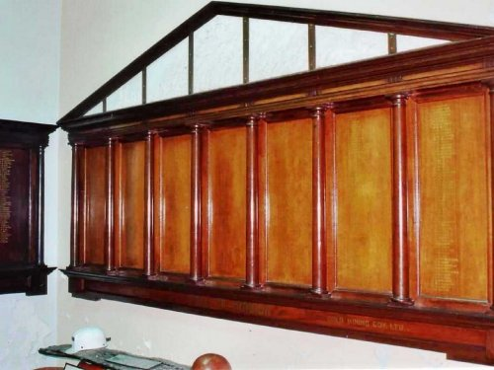
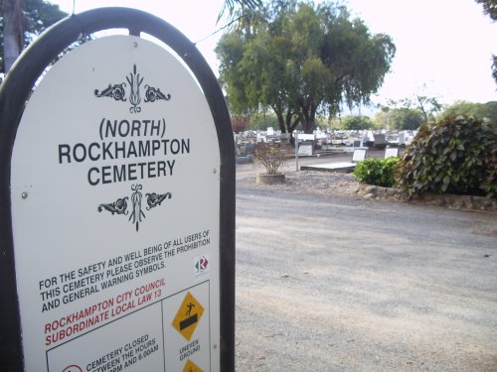
Mount Morgan Gold Mining Company Employees’ Roll of Honour
held at Mt Morgan Mine Office
Photo sourced from Qld Memorials Register website – photo Dennis Stocks & Doug Tanner
His grave and monument are located in Compartment 11, Section 2, Graves 60 & 61 of the North Rockhampton Cemetery.

There is no headstone.
Employees of the Mount Morgan Gold Mining Company were inscribed on their Roll of Honour Board.

Two of William Marson’s sons also enlisted.

PRIVATE PARKER MARSON
23 – 2nd Light Horse Regiment
Parker Marson was born June 26, 1895 at Palm Tree Creek, Queensland. He was a platelayer working at Mount Morgan when at the age of 19 years and 2 months he enlisted for service abroad on August 20, 1914.

He suffered slight wounding at the Dardanelles in 1915 and a slight scalp wound in April, 1918. Also contracted Malaria and was treated in Abassia. All of his service was on the Eastern front except when sent to England for medical treatment. He returned to Australia on November 15, 1918.

In World War II he enlisted at Rockhampton, Qld on February 22, 1942 in the Australian Army. His service number was Q213522. He served with the 13 Battalion VDC Q, PTD as a Lieutenant. He was discharged on October 22, 1945.

PRIVATE JOSEPH WILLIAM MARSON
2053 – 2nd Reserve Regiment 5th Light Horse / 13th Field Artillery Battalion
Joseph William Marson was born on February 11, 1989 at Clermont, Qld. A student aged 18 years and 2 months when he enlisted in Brisbane on September 13, 1915. He served with the 2nd Reserve Regiment 5th Light Horse, 13th Field Artillery Battalion, 25th Field Artillery Battalion and the 49th Battalion on the Eastern and Western fronts. He returned to Australia on March 23, 1919 and was discharged on September 14, 1919.

He also enlisted for duty in World War II at Wooloowin, Qld. His service number was Q64224 and was a Captain and worked in the 1st Military District Accounts Office. He was discharged on December 17, 1946.

© Donna Baldey 2010 / 2023
www.tunnellers.net

