SAPPER OSCAR WILHELM BLIXT MALLING
7117 – 3rd Tunnelling Company

Axvall is an urban area in the municipality of Skara, Västergötland near the West Coast of Sweden and was named as the birthplace of Oscar Wilhelm Blixt Malling on 27 November, 1886. He arrived at Geraldton, Western Australia on the 25 December, 1912 from South America on the Norwegian 1071-ton barque Hebe under Master of the Ship, Captain Stephensen, from Bueno Ayres.

After three years in Western Australia, he applied for Naturalization completing a Statutory Declaration on 14 February, 1916 at Laverton and his application three days later with the postmaster at Beria, W.A. Allegiance was sworn to King George V on 22 February before the Stipendiary Magistrate. His Certificate (23346) issued from the Department of External Affairs was dated 17 March, 1916 and he signed the receipt of delivery on April 19.

His name appears in the electoral roll of 1916 at Day Dawn with the occupation of miner and later that year it changed to Meekatharra and a fireman.

At the recruiting depot at Cue on 31 October, 1916 the twenty-nine-year-old single fireman applied to enlist for active service abroad and passed the medical examination. Attestation forms describe him as 173cms 5ft 8½ins) tall weighing (160lbs) with a chest expansion of 88-97cms (35-38ins) and had a fresh complexion with good vision in his grey eyes and brown hair. Religion was Roman Catholic. Distinctive marks were numerous large tattoos on chest and both arms and a small varicose vein in right calf.

He said he had no relatives and later changed to his friend Mrs Grace Jackson of Grand Hotel, Day Dawn, W.A. His Naturalization papers were noted to be in order by the recruiting officer. The Oath of Enlistment was taken the same day.

On 7 November was re-examined at Geraldton and placed the next day with the No. 1 Depot Company at Geraldton and on November 11 moved to No. 2 Depot Company at Northam.

At Blackboy Hill camp, near Perth on 17 November, 1916 signed and took the Oath of Enlistment again and sent to the 94th Depot Battalion for basic training. On 1 December, 1916 was allotted to the Tunnellers Reinforcements until 11 January, 1917 when transferred to their training camp at Seymour, Victoria joining the February, 1917 Reinforcements to the Tunnelling Companies. His rank was Sapper with the regimental number 7117. Military authorities noted his Will had been lodged with them.

The transport HMAT A9 Shropshire embarked from Melbourne, Vic on May 11, 1917 with 168 members of the February Reinforcements on board. Sapper Malling left Australian waters from Fremantle harbour and after crossing the Indian Ocean the ship docked at Durban, South Africa. Next Port-of-call was Capetown to refuel about June 21, followed by another stopover at an unrecorded harbour would have completed the trip-sheet. After being at sea for 70 days the voyage terminated at Plymouth, England on July 19, 1917. The three officers and 165 other ranks were detrained to Tidworth while two were hospitalised at Plymouth then marched into the Nos 1 and 3 camps at Parkhouse for further training for the front.

The Reinforcement proceeded to France from Southampton on 18 August, 1917 arriving at the Aust General Base Depot in Rouelles the following day. On 31 August Sapper marched out to join the 3rd Tunnelling Company and taken on strength on 3 September, 1917.

At the end of August, 1917, the 3rd Tunnelling Company were liberated from operations on road construction and maintenance in the Loos, Maroc and St Pierre location completing several months of important reconstruction work in advanced areas. They started on preliminary work in construction with reconnaissance of Advanced unconsolidated trench areas at Lens and Hill 70.
In the After War Report of the 3rd Tunnelling Company the following was recorded at the beginning of September, 1917:

“Reinforcements marched in at intervals and were taken on strength.

Blue Chevrons were issued to wear on his uniform for serving twelve months abroad on 11 May, 1918.

Leave was due to be taken on 24 March, 1918 but was cancelled.

Disciplinary action was taken for the following:
Crime: 15/7/18 Absent from working parade at 8 a.m.
Award: 14 days F.P. No.2 [field punishment] by C.O.

Sapper proceeded on leave on 26 August, 1918 and returned to duty on 10 September, 1918.

Members of the Company were working on 4 October, 1918 on the Lens to La Bassee Road.

On 8 October, 1918 Sapper was wounded in action suffering gas poisoning and taken to the 45th Field Ambulance and transferred to the 47th Field Ambulance then returned to duty on October 10 (under 7 days).

Base Records advised his friend on 14 October, 1918 that he had been admitted to hospital suffering the effects of gas poisoning.

His name appeared in the Roll of Honour in the:
Sunday Times (Perth) December 1, 1918:
THE ROLL OF HONOR - INJURED
Spr O.W.B. Malling Article abridged

He was with his unit when Peace was declared and the Tunnelling Companies remained on the front as part of the Army of Occupation assisting with rehabilitation of their district by clearing roads and bridges of booby traps and delayed action mines left by the enemy.

On 17 March, 1919 Sapper was taken to the 51st Casualty Clearing Station with a scalp wound and fracture injury to his leg (accidental). The next day was conveyed on Ambulance Train no.5 to the 7th Canadian General Hospital then invalided to England on March 23 on the hospital ship Jan Breydal entering the Emdell Street Military Hospital, London for further treatment of scalp wound head and fracture.

Base Records again notified his friend on 24 April, 1918 that he had been admitted to hospital in England on 23 March, 1919.

Was transferred on 6 May, 1917 to the 3rd Aust Auxiliary Hospital in Dartford then granted furlough on 8 May and report to Headquarters on May 22. Reported as ordered and to be sent to the 2nd Training Brigade at Codford but this changed when he was granted leave to visit Scandinavia until 14 June, 1919.
Argus (Melbourne) Tuesday May 27, 1919:
VICTORIAN WAR CASUALTIES – LIST No 466
INJURED
O.W.B. Malling [word blurred] Article abridged

Marked A.W.L on 14 June, 1919 and reported on 23 June having his lateness excused and was sent to the Command Depot at Sutton Veny marching out from Headquarters.
After demobilisation Sapper Malling embarked for Australia on 23 July, 1919 on board H.T. Main. His friend was notified by Base Records on 14 August that he was returning home. The transport docked at Fremantle (5th Military District) on 27 September, 1919.

Their arrival was published in the:
Western Argus Tuesday October 7, 1919:
ARRIVAL OF TROOPSHIP
Perth, Sept 28.
The Troopship Main, which arrived at Fremantle yesterday, disembarked 223 troops and dependants today.

His Will had been returned to the 5th Military District on 25 August, 1919.

Military Discharge was issued in Perth (5th M.D.) on 5 November, 1919 on termination of his period of enlistment.

The British War Medal (18697) and the Victory Medal (18007) were issued to wear to Sapper 7117 Oscar Wilhelm Brixt Malling, 3rd Tunnelling Company for serving his country.

He wrote to the Department of External Affairs on 15 January, 1922 from Baneygo Gold Mine, via Laverton, W.A. applying for a copy of his Naturalization Certificate having the misfortune to lose it in the trenches in France between Christmas and New Year, 1917 and could not recover the same. He was issued by the Commonwealth with a certified copy on 8 March, 1922.

He was granted a prospecting area which was reported in the:
Western Argus (Kalgoorlie) Tuesday May 2, 1922:
LAVERTON
The following prospecting areas were granted in the Warden’s Court: 959T, Oscar Malling, 24 acres at Erlistoun;
Article abridged

From 1931 onward his address was given as Bardoc with the occupation of prospector.

He appeared before the Kalgoorlie Police Court with proceedings as follows:
Western Argus Tuesday October 2, 1934:
PROSPECTORS’ ALTERCATION – BOUND OVER TO KEEP THE PEACE
In the Kalgoorlie Police Court Tuesday, before Messrs G.H. Rainsford and E.B. Elliott, J’s.P., Carl Isaacson, a prospector at Bardoc, applied to have his mining partner, Oscar Malling, put under a bond to keep the peace as he was going in fear of his life in consequence of Malling allegedly threatening to shoot him at the Eureka gold mining lease on September 22. A second charge of having in his possession a single barrel shotgun and a revolver which had not been licensed was preferred against Malling
Carl Isaacson stated that he owned the Eureka lease at Bardoc, and that towards the end of July, he had entered into a verbal agreement of partnership with Oscar Malling. Accused had never previously worked with witness and it had been at the accused’s suggestion that Isaacson had agreed to the partnership. About a month ago the partners had struck some good ore and from that time accused’s manner towards witness had changed. He appeared to want to quarrel with him. On Saturday, September 22, about 8 a.m., witness approached Malling and asked him when a certain crushing would be put through. Malling threw down his shovel, drew a revolver and told witness the “the -------- thing could stay there for another 12 months.” Malling then said to witness: “You can do the dancing and I’ll pay for the music,” referring to the gun, and ordered Isaacson off the lease.
Lily Fitzgerald stated that she had been employed as a housekeeper to Isaacson at Bardoc for the past two months. On September 22 at about 8 a.m. she heard Malling tell Isaacson that it (meaning the ore) could stay there for another 12 months and she saw that Malling had a revolver in his hand.
Cont’d
Continues:
There was also something said about dancing and paying for the music. She heard Malling tell the complainant to get off the lease.
There had never been any previous altercation but witness was no afraid that the accused would do Isaacson some bodily harm.
Oscar Malling gave evidence that on the morning of September 22 and argument had arisen between himself and the complainant in regard to the crushing of ore and Isaacson had pulled a large bolt out of his pocket and made as if to throw it at him. Witness then drew a revolver and that was all that happened. At the time of the incident the gun was without a cylinder, which witness had lost some years previously.
Constable Sunter, who had arrested the accused on warrant, stated that the time of the arrest the revolver was without a cylinder.
P.M. Crudace gave evidence of the accused’s good character, and stated that he was a most mild tempered man.
On the first charge, to which accused pleaded not guilty, Malling was released on a bond of £10, under his own recognisance to keep the peace for six months, and was ordered to pay 36/ costs. Accused pleaded guilty to the second of having unlicensed firearms in his possession and was fined the minimum penalty of £1. The confiscation of the weapons was ordered.
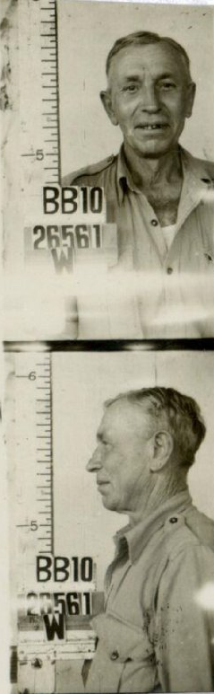
He re-enlisted during World War II at Claremont on 11 June, 1941 with the A.C.M.F. Infantry Battalion aged 58 years and 10 months. Medical notation was he had flat feet.

Next-of-kin nominated was his sister Jardot Blomgren of 25 School Street, Chicago, USA.

After demobilisation Private W26561 Malling was discharged on 20 January, 1947 at Karrakatta camp, Perth from the 10th Aust Garrison Battalion after serving 2050 days of which 1743 were active days service.

The Perth Branch of the Repatriation Commission requested for a copy of his service records from Base Records which were forwarded on 2 June, 1947.

Photos sourced from his WWII Service Documents – National Archives of Australia

Oscar Wilhelm Brixt Malling died in the Kalgoorlie District Hospital on 16 March, 1951 aged 64 years. Announcement of his demise was recorded in the:
Kalgoorlie Miner Saturday March 17, 1951:
DEATHS
MALLING—At Kalgoorlie District Hospital, on March 16, Oscar, sincere friend of the Hayter family, Phil, Rene and Robin.
Vale old friend.

Interment took place in the Anglican B 2 portion of Kalgoorlie Cemetery within section 5 in row 210/14 in grave no. 10972.

Notices in connection with his Estate were advertised in the:

West Australian Friday September 21, 1951:
NOTICE TO CREDITORS AND CLAIMANTS
Notice is hereby given that all persons having claims or demands against the estates of the undermentioned deceased persons are hereby required to send particulars of such claims or demands to the Public Trustee in writing on or before the undermentioned dates:
MALLING, Oscar Wilhelm Blixt, late of Barboc, War Pensioner, (last date for claims 22nd October, 1951.)
Article abridged
His grave is a Commonwealth War Grave for service in World War II.
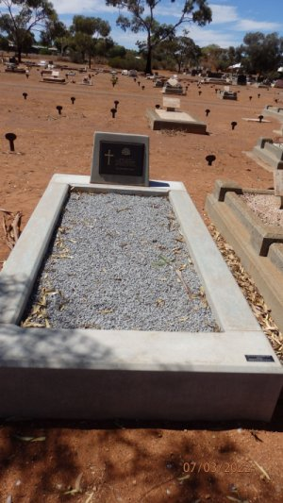
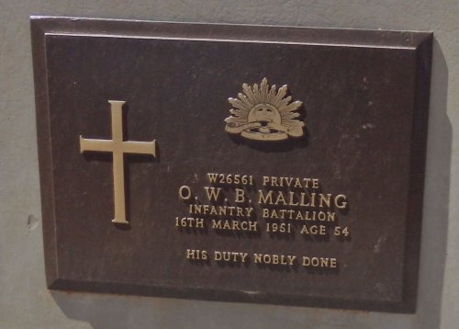
Photo supplied by
Dept. of Veteran’s Affairs
and used with permission.
Headstone photograph from Find-a-Grave website

© Donna Baldey 2022
www.tunnellers.net

