SAPPER DANIEL EDWARD LYNCH
8079 – 1st Tunnelling Company

Daniel Edward Lynch stated he was born in Brisbane, Queensland on 4 July, 1892 the son of Thomas Joseph and Mary Ann (nee Mahoney) Lynch. He is officially registered born on 4 July, 1895.

At the recruiting depot in Adelaide-Street, Brisbane on 16 July, 1917 the single twenty-five-year-old carter, care of Mrs J. Petersen, Golden Estate, Eagle Junction, Brisbane applied to enlist for active service abroad and passed the preliminary medical examination. He had done three months Home Service and was still serving and previously had been rejected due to defective vision. Declared fit his application was accepted by the recruiting officer.

Attestation forms describe him as 170cms (5ft 7ins) tall, weighing 68kgs (150lbs) with a chest expansion of 87-94cms (34-37ins) with a fair complexion with good vision in his right eye and nil marked for the left one. Religion was Roman Catholic. Next-of-kin nominated was his father Thomas Joseph Lynch of Duke Street, Kangaroo Point, Brisbane, Qld. The Oath of Allegiance was taken and signed the same day.

Acknowledgement to the volunteers was published in the:
Daily Standard (Brisbane) Tuesday July 17, 1917:
YESTERDAY’S ENLISTMENTS
Twenty-four men offered their service for the A.I.F. at the Adelaide-street depot yesterday, two of whom were returned soldiers re-enlisting; 16 were declared fit.
The names are: Daniel Edward Lynch Article abridged

Basic training commenced on July 20 with the No. 1 Depot Battalion to the 3 September, 1917 then allotted to the Miners Corps (1st Military District). Final home leave was granted from 20 August for two days from Rifle Range Camp at Enoggera Barracks. On 13 September was transferred to their training camp at Bendigo, Victoria and was to be Acting Lance Corporal from September 20 with the June, 1917 Reinforcements to the Tunnelling Companies. Military authorities noted his Will was lodged with them. His rank was Acting Lance Corporal with the regimental number 8079.

Acting Lance Corporal Lynch was one of 130 Reinforcements who departed Melbourne, Victoria at noon on November 26, 1917 aboard the SS Indarra. At 10.15 p.m. the ship arrived at Albany, W.A. on November 30 and left at 2.10 p.m. on December 1, 1917. Colombo was reached by December 13 at 10.30 a.m. and departed two days later at 8.30 a.m. on December 15. Christmas Day was specially provided for by the ship and religious services were held on board. The soldiers disembarked at the Suez at 7 a.m. December 27, 1917. Amusements such as sports and cricket between various troop decks took place with some competitive teams made up of officers. Occasionally a religious service was held during the week. Weather was excellent and warm in the tropics.

The troops were then transhipped to HMT Kashgar on January 9, 1918 and arrived at Taranto, Italy on January 20, 1918. They were entrained at Bordighira, Italy about January 27 entering Cherbourg, France on January 31, 1918 where they boarded H.M.T. Mona’s Queen and disembarked at Southampton on February 2, 1918. The men were entrained to Parkhouse camp and marched into No. 3 Details camp the same day. He reverted to the rank of Sapper on 17 February, 1918.

The reinforcements proceeded to France from Southampton on 8 April, 1918 arriving at the Aust General Base Depot in Rouelles the next day. On 18 April they moved to the Aust Corps Depot in Caestre. Left from there to join the 1st Tunnelling Company in the field at Saulty where all sections were digging trenches and wiring outside the Saulty sector. It was showery and wet all day when he arrived.

Sapper was taken on strength with the company on 19 April, 1918.
He attended the School of Musketry for the fortnight ending 23 June, 1918 and his scores were as follows:
NO 1 SECTION
Squad Sergeant: Sergt. J. Yeats
Squad No. 2. Second School: MUSKETRY
Fortnight ending 23-6-18

No. Rank. Name Grouping Rapid Vanishing Target Total
8079 Spr. Lynch 25 14 25 64
Average per man 22.1 13.3 21.0
Total average 56.3
Possible 70

He went sick on 8 July, 1918 to the 9th Aust Field Ambulance suffering P.U.O. (Pyrexia (fever) uncertain origin) and two days later moved to the 5th Casualty Clearing Station. On 12 July was transferred on Ambulance Train No.36 to the 1st Aust General Hospital in Rouen. Was invalided to England on July 27 on the hospital ship Panama being admitted to the 1st Birmingham War Hospital, Rednal with trench fever.

On 6 August, 1918 was transferred to the 3rd Aust Auxiliary Hospital in Dartford and ten days later was moved to the 1st Aust Auxiliary Hospital in Harefield. Was discharged to furlough on 20 August and to report to the No. 4 Command Depot on 4 September.

Base Records advised his father on 13 August, 1918 that it was reported his son was in hospital in England.

His name was listed in the Casualty List published in the:
Week (Brisbane) Friday September 6, 1918:
ROLL OF HONOUR – QUEENSLAND CASUALTIES
Casualty List No. 426 was issued from the Censor’s office last week and contained the names of 179 Queenslanders.
ILL
Spr. D.E. Lynch, Kangaroo Point Article abridged

He did not report as ordered but his lateness was excused and marched into the No. 4 Command Depot at Hurdcott a day later.

He was there when Peace was declared and marched out on 12 November, 1918 to the Overseas Training Brigade in Deverill.

Sapper Lynch embarked for Australia on 25 January, 1919 on board the hospital ship Ceramic. Base Records advised his father on 11 February, 1919 that he was returning home.

His name was among the soldiers listed as returning in the:

Telegraph Thursday February 27, 1919:
SOLDIERS RETURNING – TWO MORE PARTIES
The following have been listed for return to Australia and are actually en route from abroad.
8079. Spr. D.E. Lynch, 1st Tnlrs, B’bane Article abridged
The troopship docked in Melbourne (3rd Military District) on 14 April, 1919. News of their arrival and quarantine was reported in the:
Argus (Melbourne) Thursday March 20, 1919:
RETURNING TROOPS – SOLDIERS FROM THE CERAMIC
Troops who returned to Australia a few days ago on the transport Ceramic and are now in quarantine will disembark at the New Pier, Port Melbourne, at 10 o’clock on Sunday morning, subject to pratique being granted.
The Queensland soldiers continued to Brisbane and were also quarantined with their welcome home published in the:
Brisbane Courier Thursday March 27, 1919:
THE CERAMIC CONTINGENT – A HEARTY WELCOME HOME
The returned soldiers from the Ceramic, who were released from quarantine yesterday afternoon, had a particularly hearty reception. As the Koopa turned into the New Farm reach it seemed as if the cords of every hooter, whistle, or siren of all the vessels in the vicinity of the city were pulled simultaneously. The din continued until the last soldier stepped ashore to receive the warmest of welcomes from the large crowd of relatives, friends and soldier patients who had gathered at the Kangaroo Point Hospital jetty.
The soldiers, who numbered 245, were under the command of Lieut. French. They had no complaints to make concerning their treatment either on the voyage or in the quarantine camp, where the unavoidable tedium was made more bearable by the untiring efforts of the Red Cross and the other institutions which attend to the welfare of the troops. Article abridged

Military Discharge was issued in Brisbane (1st M.D.) on 18 April, 1919 on termination of his period of enlistment.

He was a carter in 1919 and living at McNab Street, Rosalie. A marriage took place between he and Elsie Gorman in Brisbane on 17 December, 1921 and continued to reside at the McNab Street address.

For serving his country Sapper 8079 Daniel Edward Lynch, 1st Tunnelling Company was issued with the British War Medal (32509) and the Victory Medal (30551).

In 1925 the couple were at 76 Menzies Street, Paddington with the same occupation.

The following was reported from the Magistrate’s Court in the:

Daily Standard Saturday February 28, 1925:
DAMAGES IN COLLISON – CLAIM FOR £120
The case was continued in the Magistrate’s Court this morning, in which Justin Edwin Carr, of Hillside Crescent, Hamilton and William Bertram Carr carrying on s business as H.E. and W.B. Carr contractors, are being sued by Eva Christina Cook, of Ipswich-road, Annerley for £120 damages to her car.
Plaintiff alleged that the damage was caused through Daniel Lynch, an employee of the firm driving the cart so negligently and unskilfully as to cause a collision between the wagon and plaintiff’s motor-car.
Daniel E. Lynch stated that he was driving the sanitary wagon on June 12 along Melbourne-street. When near Cordelia-street he felt a bump. He was thrown two or three feet in the air off his seat then on to the street. The wheels of the wagon passed over his arm, breaking it. He lit his lamps before starting out and they were still alight on Victoria Bridge. Article abridged
In 1929 their address was Victor Street, Holland Park working as a carter.

His tender for a War Service Home was accepted and reported in the;
Brisbane Courier Tuesday June 10, 1930:
WAR SERVICE HOMES – TENDERS CLOSED
The following were the lowest tenders received:
D.E. Lynch, Hollard Park; W. Barlow, builder
Article abridged
He was a witness at the Coroner’s Inquest with proceedings published in the:

Daily Standard Monday January 11, 1932:
MILKMAN’ STORY OF FATAL SMASH – CORONER’S INQUEST
A milkman driving along Tank-street early on the morning of December 11 saw a motor cycle, out of control, swerve towards the river and then turn a somersault. He rushed to it, and saw his brother-in-law, in a dazed condition, halfway down the river bank. Two other men were also injured and one of them died.
Daniel Edward Lynch, carter, of Contay-street, Holland Park, and employed by the General Contracting Company, who was near the scene of the accident, also gave evidence. Article abridged
Their residence from 1937 was 18 Contay Street, Holland Park and his job remained as a carter.

The Melbourne branch of the Repatriation Commission requested a copy of his service records from Base Records which were forwarded on 26 January, 1943.

Daniel Edward Lynch passed away on 10 July, 1965 aged 70 years. Interment took place in the monumental portion of Mount Gravatt Cemetery with in section 4F in row 25 in gravesite no. 27A.

His grave is marked with a Commonwealth War Grave.

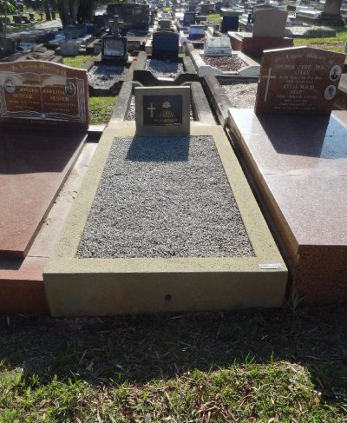
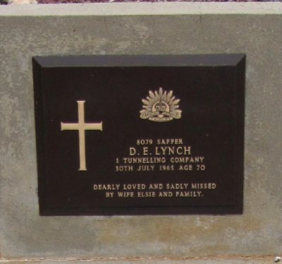
. His grave at Mt Gravatt Cemetery
Photo supplied by Dept. of Veteran’s Affairs and used with permission

© Donna Baldey 2023
www.tunnellers.net

