SAPPER KARL LOUNE
400 – 1st Tunnelling Company

Narva, Estonia is a municipality located at the Eastern extreme part of Estonia at the Russian border on the Narva River. During the middle of the 19th Century, it developed into a major industrial town. Powerful waterfalls gave cheap energy and by the end of the century had thousands of industrial workers including a large cotton mill.

Karl Loune stated he was born in Nearve, Russia (Narva) and served an apprenticeship of five years as a boilermaker. With his trade it appears that he became a sailor and travelled the world finally settling in Sydney, New South Wales about 1912.

At the Town Hall Recruiting Depot, Sydney on 12 January, 1916 the single thirty-seven-year-old boilermaker applied to enlist for active service abroad and passed the preliminary medical examination. Personal particulars taken reveal he was 176cms (5ft 9ins) tall, weighed 70.4kgs (155lbs) with a chest expansion of 87-97cms (34-38ins) and resided at 10 Napoleon Street, Sydney. Declared fit his application was accepted by the recruiting officer.

At Casula camp, near Liverpool, NSW on 24 January, 1916 completed Attestation Forms which describe him further having a fair complexion, hazel eyes and brown hair. Distinctive marks were tattoos of a ship on his chest, initials C.L., right upper arm an eagle - forearm girl, bird, flag, heart and dagger; hand – geometric figure, anchor. Left upper arm – Russian flag, ship, faith, hope and charity, eagle; hand – figure and anchor. Religion was Russian Roman Catholic. In lieu of next-of-kin he nominated his friend Mary Ann Ives (Jares on his form) of 10 Napoleon Street, Sydney. He signed and took the Oath of Enlistment as a Russian subject the same day.

Basic training commenced the same day with C. Coy Depot Battalion until 12 February when allotted to the 1st Reinforcements to the Mining Corps and later changed to the No. 1 Company. His rank was Sapper with the regimental number 400.

At a civic parade in the Domain, Sydney on Saturday February 19, 1916, a large crowd of relations and friends of the departing Miners lined the four sides of the parade ground. Sixty police and 100 Garrison Military Police were on hand to keep the crowds within bounds. The scene was an inspiriting one. On the extreme right flank, facing the saluting base, were companies of the Rifle Club School; next came a detachment of the 4th King’s Shropshire Light Infantry, then the bands of the Light Horse, Liverpool Depot, and the Miners’ on the left, rank upon rank, the Miners’ Battalion.

The Corps boarded HMAT A38 Ulysses in Sydney, NSW on February 20 and sailed for the European theatre. Arriving in Melbourne, Victoria on February 22 the Miners camped at Broadmeadows for a stay of 7 days while further cargo was loaded.

Another parade was held at the Broadmeadows camp on March 1, the Miners’ Corps being inspected by the Governor-General, as Commander-in-Chief of the Commonwealth military forces.

Leaving Melbourne on March 1, Ulysses arrived at Fremantle, Western Australia on March 7 where a further 53 members were taken on board.

On Wednesday March 8, 1916 the whole force, with their band and equipment, paraded at Fremantle prior to leaving Victoria Quay at 9.30 o’clock.

The ship hit a reef when leaving Fremantle harbour, stripping the plates for 40 feet and, although there was a gap in the outside plate, the inner bilge plates were not punctured. The men on board nicknamed her ‘Useless’. The Miners were off-loaded and sent to the Blackboy Hill Camp where further training was conducted.
The Mining Corps comprised 1303 members at the time they embarked with a Headquarters of 40; No.1 Company – 390; No.2 Company – 380; No.3 Company – 392, and 101 members of the 1st Reinforcements.

Finally departing Fremantle on April 1, Ulysses voyaged via Suez, Port Said and Alexandria in Egypt. The captain of the ship was reluctant to take Ulysses out of the Suez Canal because he felt the weight of the ship made it impossible to manoeuvre in the situation of a submarine attack. The troops were transhipped to HM Transport B.1 Ansonia, then on to Valetta, Malta before disembarking at Marseilles, France on May 5, 1916. As a unit they entrained at Marseilles on May 7 and detrained on May 11 at Hazebrouck.

A ‘Mining Corps’ did not fit in the British Expeditionary Force, and the Corps was disbanded and three Australian Tunnelling Companies were formed. The Technical Staff of the Corps Headquarters, plus some technically qualified men from the individual companies, was formed into the entirely new Australian Electrical and Mechanical Mining and Boring Company (AEMMBC), better known as the ‘Alphabetical Company’.

Disciplinary action was taken for the following:
Crime: While on Active Service 30/9/16 (1) Drunk (2) Absent from 8.30 to 9.15
p.m. on 23/9/16 (3) resisting arrest
Award: 28 days F.P. No. 1 [field punishment] by Major J.D. Henry 27/9/16

The No. 1 Company was officially transferred on 24 December, 1916 to the 1st Tunnelling Company in the field.

Leave from France was taken from 1st to 11th August, 1917 and again from 3rd to 18th February, 1918.

Sapper went sick on 8 July, 1918 to the 9th Aust Field Ambulance with P.U.O. (Pyrexia (fever) uncertain origin and discharged to duty on July 10 re-join his unit the following day.

He was sent to the Second School of Musketry ending the fortnight of 23 June, 1918 with his results as listed in the Unit Diary of the 1st Tunnelling Company:

During September the 1st Tunnelling Company moved its Headquarters to Cartigny which was recorded in their Unit Diary as follows:
NO 1 SECTION
Squad Sergeant: Sergt. J. Yeats
Squad No. 2. Second School: MUSKETRY
Fortnight ending 23-6-18

No. Rank. Name Grouping Rapid Vanishing Target Total
400 Spr Loune K. 25 14 25 59

Average per man 22.1 13.3 21
Total average 56.3
Possible 70

“September
12th Wet. Headquarters Camp moved forward to position in Lenhen Road, West of Cartigny”

Sapper Loune was wounded in action on 29 September, 1918 receiving gunshot wounds and taken to the 11 Aust Field Ambulance where he died of wounds received in action, aged 37 years. Interment took place in St Emelie Valley British Cemetery, Plot 2, Row H, Grave 4.

The Company was engaged in clearing and repairing forward roads as part of the Offensive attack of the Hindenburg line and the Unit Diary reports the following extract for that day:
“September
29th Fine – misty morning. Offensive started. Sections carry on in accordance with instructions. Appendices 2 & 8. Lt Johnson severely wounded. 18 sappers wounded 1 sapper died of wounds”

Further information of their work comes from Captain O.H. Woodward, also of the 1st Tunnelling Company in his unpublished book My War Story of the Great War:

“I was advised on the 27th [September] that “B” Company, 102nd United States Engineers, would be attached to my Section. That day we worked on the repair of the Southern-road from St. Emilie to a point just beyond Ronnsoy, and next day under heavy shelling we carried the road forward as far as Benjamin Post in the support line.

On the afternoon of 28th September, I received my orders for the attack, which was to be launched next morning. If the attack permitted, we were to carry the Southern Road from Benjamin Post through Bony to Mt. Saint Martin. In addition, we were to repair the Northern Road known as Gillemont Road, running from Ronnsoy past Gillemont Farm to North of Bony, and then to Le Catalet. I was also to make a personal inspection of all forward roads in the Corps Sector.

The attack by the Americans on September 28th was intended to advance our Front line sufficiently to give a good jumping-off position for the main attack on the Hindenburg Line. It was a failure, and from the impression prevalent among the troops in the area, this unsatisfactory position arose by the failure of the Americans to “Mop up”. In the excitement of their first battle, the Americans failed to attend to this important task. “Mopping up” consisted of cleaning all dugouts and machine gun emplacements of enemy troops. It must be remembered that in this area the German Trench System was wonderfully fortified by deep dugouts and concrete machine gun emplacements, and that as far as bravery was concerned the German Machine Gunners were equal to any troops. When the Artillery barrage fell on their Front lines the German troops sheltered in these dugouts, and unless captured by the first wave of attacking Infantry, they came out and attacked in the rear. This state of affairs was allowed to exist after the attack on the 27th September so that, in effect, there was the main German Army, then a line of Americans, and another line of German Machine Gunners between the Americans and the Australians who were to carry out the main attack on 29th. It became essential to hold to the original plans and the Artillery fire could not be directed over the same area as was the case on the 27th, since failing accurate knowledge of the whereabouts of the Americans, to do so would have resulted in enormous casualties to them.

At 5 a.m. on the 29th September, I arrived at Benjamin Post with 82 men of No. 4 Section and 65 men of the 102nd “B” Company U.S. Engineers. The attack was launched at 5.50 a.m. and shortly after we commenced work on repairs to the road. When we approached Quennet Copse and Guennemont Farm we were held up by machine gun fire, owing to the failure of the Americans to “mop up” these positions. Before we realised what had happened, we lost one officer and one sapper killed and twenty others wounded. At 9 a.m. I received an order from the C.R.E. Australian Corps to report immediately on the condition of the road leading to Hargicourt, and then as far as possible toward Bellicourt. I took Sapper Mooney with me and left the Section with instructions to proceed with the repairs to the road to Bony as early as possible. We had a particularly exciting task inspecting these forward roads since they were subjected to heavy artillery and machine gun fire. It was not until 6 p.m. that I completed the inspection and again returned to Benjamin Post.”

At 6 a.m. next morning, we were again on the road work and got up to the outskirts of Bony, and from the crest of the hill witnessed Australians “mopping up” the village; but it was not until 6 a.m. next morning that the position had been cleared up and by noon we had the forward road repaired to a point just beyond Bony. When we ceased work that night we had carried the road forward to a point about a quarter of a mile beyond the town.”

The 2nd Military District was advised on 10 October, 1918 of his demise on 29 September and a copy of his service records was made for the Pension Department on October 22.

His name was listed in the Casualty List published in the:
Sun (Sydney) Thursday November 21, 1918:
DIED OF WOUNDS
Spr K. LOUNE, Sydney Article abridged

On 13 December, 1918 the Circulars and Booklet re Graves of the Fallen was sent to his friend and a final notice on 7 February, 1919.

His personal effects contained in one parcel from the Aust. Kit Store in London which returned to Australia by the transport Bulla to Base Records were forwarded to Mrs M.A. Ives, Sydney on 19 August, 1919. Their inventory stated:
1 Wallet, 1 YMCA wallet, Souvenir, Badges and Buttons, Letters, Photos, Cards, 3 Certificates
of Discharge, 2 foreign coins.

On the first anniversary of his death the following notice was placed by Mrs Ives and family in the:
Sydney Morning Herald Monday September 29, 1919:
ON ACTIVE SERVICE
LOUNE—Sacred to the memory of Sapper Karl Loune, died of wounds, France September 29, 1918. Not forgotten. Inserted by his friend Mary Ann Ives, also Charlie, Will and Fred.

Base Records advised Mrs M.A. Ives of 10 Napoleon Street, Sydney on 24 April, 1920 that Sapper K. Loune was buried in Saint Emelie British Cemetery, 8¼ miles north east of Peronne.

Photographs of his grave in triplicate were transmitted to Mrs Ives on 6 September, 1920.

The British War Medal (32091) and the Victory Medal (31871) were issued to Sapper 400 Karl Loune, 1st Tunnelling Company for his supreme sacrifice.

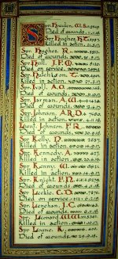

An Honour Roll of the Engineers’ who gave their lives during the war was to be inscribed and details of this were published in the:
Sydney Morning Herald - Saturday 23 July 1921:
ENGINEERS' ROLL OF HONOUR
The Royal Engineer War Memorial Committee are arranging to deposit a roll of honour of all ranks of the Royal Engineers whose names were officially published as killed in action or died of wounds or disease in the war in the chapel of St. Paul's Cathedral, and the Engineer corps of the dominions, colonial, and Indian armies have been invited to deposit similar rolls of honour in St. Paul's, to be attached to that of the Royal Engineers. This invitation has been accepted in Australia. The roll will be inscribed on vellum and enclosed in a casket of Australian timbers to rest on a slab of Australian marble.

This extract from Tunnellers Roll of Honour included in profile with the kind permission of the
Dean and Chapter of St Paul’s Cathedral, London
Photos courtesy of Robin Sanderson, Paris

A letter dated 10 November, 1921 was sent to Mrs Ives from the Medals Section of Base Records looking for blood relatives of the late soldier.
Mrs Ives replied with the following:
10 Napoleon Street, Sydney, NSW
Dear Sir,
In answer to your questions on the other side I beg to state that the late Sapper K. Loune lived with me for four (4) years previous to enlisting for the war and told me that he would make his Will in my favour, as he had not any living relatives in the world, all having died since he left Russia for Australia.

On 9 December, 1921 Base Records thanked in their reply to Mrs Ives for her remarks to their letter of 10 November concerning the affairs of the late soldier and have to advise that in the circumstances it was proposed to place the deceased soldier’s war medals etc upon the “Untraceables” list which will be advertised throughout the world with a view to sons of his blood relatives submitting a claim. As to the balance of his estate, deferred pay and war gratuity etc., it was suggested to communicate with the District Finance Officer, Victoria Barracks, Paddington, New South Wales on the subject.

Mrs J. Lynette Matheson, President of the Meredith Red Cross Society, Moranghurk, Lethebridge wrote to Base Records on 10 December, 1922 requesting of possible to be put in touch with the next-of-kin of the deceased soldier as her sister had been visiting the battlefields and among other the cemetery of St Emelie where she saw this grave. She took a photograph and particularly made enquiries as to the details and sent them to her. There was a man similar but spelt Lowne not the initial from her district who was killed and where people never heard details of where he was buried. So thinking this useful, she sent the photographs and particulars. It is not the man from this district, if you could let me know where the relatives are of this man whose grave it is she would only be glad to let them have the photographs and the description her sister wrote her. She hoped she was not causing too much trouble.

Base Records replied on 19 December, 1922 to her communication and furnished the name of the nominated next-of-kin of the late Sapper Loune as Mrs Ives and her Sydney address.

A memorial to the 1st Tunnelling Company was erected in 1918 at Hill 60, Belgium for members who lost their lives.

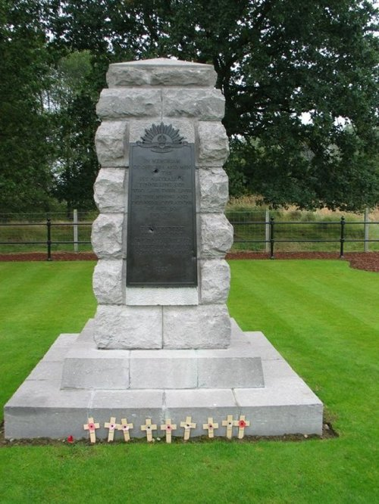
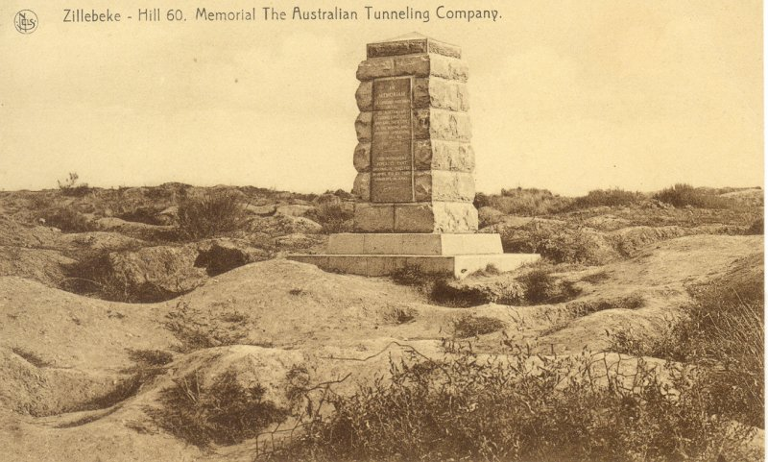
Hill 60 Memorial – 1918 Hill 60 Memorial – 2004
Photo sourced from Aust War Memorial Photo courtesy of Ignatius Park College
On 1 July, 1930 Base Records advised Mrs Ives that the Imperial War Graves Commission had been unable to acquire the site of Ste. Emilie British Cemetery in France and in the circumstances, it was necessary to remove these graves to Templeux-le-Guerard British Cemetery which was an established military burial ground in the vicinity of Ste Emelie. They further advised that instructions had accordingly been issued for this work to be carried out with all due care and reverence and full particulars of the location of the new graves would be advised as soon as available.

The Department extended sympathy and profound regret at arising of these distressing circumstances.

Base Records wrote to Mrs Ives on 31 October, 1930 further to their communication of 1 July, 1930 and were now in receipt of advice from the Imperial War Graves Commission that the remains of this soldier had been exhumed and re-interred in Plot 2, Row F, Grave no. 32 of Templeux-le-Guerard British Cemetery, France.

In the commemorative area of the Australian War Memorial, Canberra, ACT on panel 27 his name is commemorated.

His grave can be located in plot 2 of Templeux-le-Guerard British Cemetery within row F in grave no. 32.
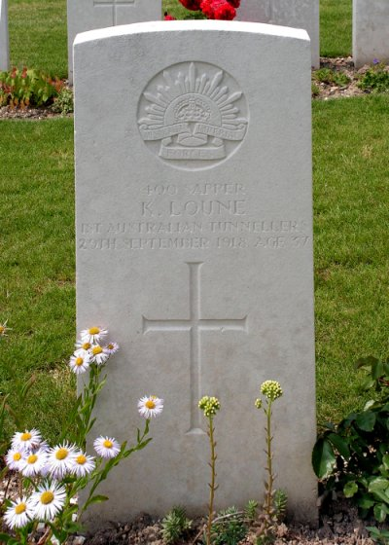
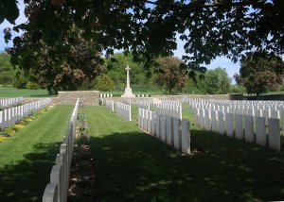
Photo of headstone and cemetery by kind permission of
The War Graves Photographic Project www.twgpp.org

LEST WE FORGET

© Donna Baldey 2022
www.tunnellers.net

