SAPPER ALFRED LEATCH
3322 – 1st Tunnelling Company

Hotham Hill, Melbourne, Victoria was the birthplace of Alfred Leatch in 1878 the son of Thomas and Emily Rosanna (nee Blay) Leatch. He married in a Presbyterian Church, Melbourne on 25 February, 1897 to Elizabeth Ada Andrews. His occupation was a tanner. Early in 1905 purchased a small grocery business at 17 Melrose Street, North Melbourne and continued to trade until about 1910 when he began drinking, keeping late hours and neglected the business and bills which was then purchased by his father. He took his wife and five children to Queensland and became a selector of land at Tara named The Gums to become a farmer. Unable to find work they suffered great hardship living in a tent and very little income to live on for five months and he told his wife to go back to Melbourne. Her Aunt was able to give her enough money for fares for herself and 3 youngest children leaving the eldest two boys with a friend until she saved for their fares. Mrs Leatch secured work immediately as a machinist to support themselves. She learnt that work had been obtained by her eldest son and then joined the Army after the outbreak of the war.

Their son Albert Thomas Leatch (almost 19 years) enlisted on 24 February, 1915 in Brisbane (1st Military District). He was allotted to the 8th Reinforcements to the 2nd Light Horse Regiment training at Chermside and embarked from Brisbane on the troopship HMAT A55 Kyarra on 16 August, 1915. On arrival in Egypt the regiment was absorbed at Heliopolis on 9 January, 1916. His rank was Trooper with the regimental no. 1175

About the same time at the Darling Downs Recruiting Depot in Toowoomba on 13 January, 1916 his father, now a thirty-eight-year-old farmer, applied to enlist for active service abroad and passed the medical examination. Attestation forms were completed and describe him as 170cms (5ft 7¼ins), weighing 65.9kgs (145lbs) with a chest measurement of 86cms (34ins) and a dark complexion with blue eyes and black hair. Church of England was his religion. Next-of-kin nominated was his wife Mrs Ada Leitch of 33 Melrose Street, North Melbourne, Vic and was eventually allotted three shillings of his pay in support of her and their three children under 16 years. The Oath of Enlistment was signed and taken the same day.

Acknowledgment to the volunteers was published in the:
Brisbane Courier Friday January 14, 1916:
COUNTRY VOLUNTEERS
TOOWOOMBA January 13.
During the 24 hours ended 1 p.m. today 21 men presented themselves to the Toowoomba recruiting office, and 13 were accepted. They included Messrs. George W. Cole (Mount Whitestone), Ernest J. Walter (Helidon), William Milton (Clifton), Alfred Leatch (Tara), James Simpson (Warra), Richard A. Davis (Tara), Hector M’Innie (Clifton), William Toy (Toowoomba), Andrew C. Glover (Clifton), Patrick Harran (Westbrook), Bertie T. Barlow (Clifton.)

Meanwhile in Egypt on 3 March, 1916 his son and a number of men from B Squadron, Light Horse were crossing the Bahn Yusef canal, Tukum-El-Kneil over a small bridge at night above Minia when Trooper Leatch’s horse swerved and reared with him and both rider and horse fell into the water and were drowned. He was reported as missing but his body was recovered on March 7 at Ezbet Bidnoum and buried in the Greek Cemetery, Minia the following day.

His name appeared in the Casualty List published in the:
Examiner (Launceston) Thursday March 23, 1916:
MISSING
QUEENSLAND—Pte A.T. Leatch (believed to be drowned).

Basic training for his father began at Enoggera Barracks, Brisbane from 18 January to 20 March, 1916 then allotted to the No. 4 Tunnelling Company.

The recruits forming part of the No. 4 Tunnelling Company embarked from Brisbane, Qld early in May, 1916 aboard HMAT A69 Warilda for Sydney, NSW. Six officers and 152 other ranks together with the 1st Reinforcements of fifteen other ranks made up the two sections.

At Rosebery Park, Sydney, NSW on 10 May they joined their Headquarters and two sections (8 officers & 153 O.Rs.) plus 1st Reinforcements consisting of one officer and seventeen other ranks for final training. The rank of Sapper and the Regimental number 3322 in No. 4 Company was assigned to him.

He participated in the Inspection of Troops at Moore Park which was reported in the:
Sydney Morning Herald Monday May 22, 1916:

THE TROOPS – INSPECTION AT MOORE PARK
“In the presence of a crowd of 10,000 people the District Commandant, Brigadier-General Ramaciotti, V.D., held an inspection of troops at Moore Park, on Saturday afternoon. The troops consisted of Field Artillery, Tunnelling Section (including Queenslanders), under Major Vincent; Infantry, under Lieutenant Owen Gibbs, under Captain Brosnan, the whole parade being under the command of Major Holman, D.S.O.

Prior to arrival of the commandant and his staff, the men were drawn up in columns of companies on the Dowling-street side of the ground, facing the tramline. The bands of Liverpool Headquarters and the Engineers played selections of music.

Brigadier-General Ramaciotti, V.D. made a close inspection of the lines. Returning to the saluting base the Commandant took the salute as the various units marched past in columns of companies, and again as they returned headed by the band in columns of fours.

One company had with it a small kangaroo as a mascot. The animal was held on a ribbon, but when it drew level with the saluting base it bobbed up and down as if anxious to do its share in the saluting lines as its male friends were doing. Its antics were so ludicrous that the crowd roared.

At the conclusion of the inspection the men were marched across to the Royal Agricultural Ground, where they were provided with temporary quarters.” Article abridged

The 7713-ton transport departed Sydney, NSW on May 22, 1916 and collected in Melbourne, Victoria the No. 5 Company recruited from Victoria, South Aust. & Tasmania made up of Headquarters and 2 Sections (8 officers & 173 men) (3 M.D.). 1 Section from Tasmania (3 officers & 76 O.Rs.); also 1st Reinforcements for No. 5 Company (17 men from Vic. & 8 men Tas.) The ship departed on May 25, 1916 for Adelaide, S.A. to collect one Section of 3 officers & 76 O.Rs. with 1st Reinforcements of 8 O.Rs.

In Perth the No. 6 Tunnelling Company was in their final stages of preparation for departure giving a regimental show of their strength in parades.

Docking at Fremantle, W.A. on June 1, 1916 added No. 6 Company recruited from W.A. of 14 officers and 325 O.Rs. along with 1st Reinforcements of 1 Officer & 32 O.Rs. departing the same day.

Durban, South Africa was reached on June 16, 1916 and Cape Town on June 21, 1916 while St Vincent completed the African ports of call on July 7, 1916. Discipline was fairly good except at intermediate ports where Away without Leave caused concern. The fifty-eight-day voyage experienced remarkable pleasant weather terminating at Plymouth, England on July 18, 1916. Four, Five and Six Companies comprising of 1064 officers and other ranks were detrained to Amesbury and Tidworth to begin training for the front at Perham Downs camp.

Military Discipline was issued for the following:
Offence: AWL 4/8/18 to 5/8/16
Award: 14 days confined to barracks
Total forfeiture: 3 day’s pay RW

The reinforcement proceeded to France on 29 August, 1916 marching into the 2nd Divisional Base Depot on August 30. He was taken on strength with the 1st Tunnelling Company on 30 September who were situated at Bailleul, Belgium working on dugouts for Infantry at Hill 63 and Trench 121.

Sapper was wounded in action from mine gas poisoning (severe) on 12 November, 1916 and taken to the 4th London Field Ambulance.

The Unit Diary for the 1st Tunnelling Company recorded the following for that day:

POPERINGHE
12th November
Berlin Shaft “B” Left Gallery “D” left Gallery Gallery to Anzac driven.
2 men wounded; Installed pumps; enemy quiet in mining system but very active on
Surface destroyed 21st Battalion Headquarters which delayed communication

Was transferred to the 10th Casualty Clearing Station then three days later moved to the 3rd Canadian General Hospital in Boulogne for further treatment of mine gas poisoning.

On Christmas Eve, 1916 was transferred to the 7th Convalescent Depot being admitted with enteritis (inflammation of intestine). On 11 February, 1917 progressing to the Rest Camp after mine gas poisoning and laryngitis and the next day sent to the Aust General Base Depot at Etaples.

He left there on 29 March for the II Anzac Headquarters for permanent base duties from March 30 remaining until 28 October, 1917 and returned to the A.G.B.D. in Rouelles the next day.

On 12 November, 1917 was returned to England for permanent base duty due to D.A.H. (disordered action of heart) from Harve arriving a day later to the No. 2 Command Depot at Weymouth.

His name appeared in the Casualty List published in the:
Morning Bulletin (Rockhampton) Tuesday December12, 1916:
AUSTRALIAN CASUALTIES – LISTS NOS 248 and 249
Casualty lists Nos. 248 and 249 were issued last night.
WOUNDED
Sapper A. Leatch (North Melbourne) Article abridged

Sapper Leatch embarked for discharge in Australia due to being overage and shell shock on 11 January, 1918 on board H.T. Port Darwin. Base Records notified his next-of-kin on 24 January that he was returning home.

His name published in the list of soldiers returning in the:
Toowoomba Chronicle Wednesday February 13, 1918:
INVALIDED SOLDIERS RETURNING – BATCH DUE SHORTLY
The following Dows and Western soldiers (list “J”) have been listed for return to Australia, and are actually en route from abroad.
LIST “J”
3322 Sapper A. Leatch, 1st Tun. Co., Toowoomba Article abridged

News of their impending arrival in Melbourne (3rd M.D.) was published in the:
The Age (Melbourne) 1 March, 1918:
TWO TRANSPORTS ARRIVING
A transport containing returning wounded and invalid Australian soldiers, whose names were recently published in list “F”, will arrive at Port Melbourne on Sunday at 3 p.m.
The soldiers for New South Wales and Queensland returned to Sydney (2nd M.D.) by train changing for Brisbane which briefly stopped in Toowoomba and he was interviewed on his service for the:
Toowoomba Chronicle Saturday March 9, 1918:
BOYS THAT ARE BACK – YESTERDAY’S CONTINGENTS
Two troop trains arrived in Toowoomba yesterday, with their precious burdens of returned heroes.
Sapper A. LEATCH, Dalby, enlisted in December, 1915, and was in most of the fighting, particularly at Hill 60, where he was wounded. After recuperating, however, he returned to the fighting line, but the effects of the previous “gassing” were unfavourable enough to force his return home.

The soldiers continued their journey to Brisbane for their disembarkation medical examinations.

Military discharge was issued in Brisbane (1st M.D.) on 10 April, 1918 as medically unfit.

During 1919 he was living at the Post Office Hotel, Edward Street, Brisbane working as a barman.

For serving his country Sapper 3322 Alfred Leatch, 1st Tunnelling Company was issued with the British War Medal (19222) and the Victory Medal (18747).

In 1925 he was living at 13 Melrose Street, North Melbourne working as a tanner remaining there.

His wife petitioned for a divorce which was granted and reported in the:
Age (Melbourne) Saturday April 18, 1925:
DIVORCE COURT – NEVER TROUBLED ABOUT WIFE
Desertion was the ground on which Elisabeth Ada Leatch 45 years, of Macaulay-road Kensington, asked divorce from Alfred Leatch, 50 years, of Melrose-street, North Melbourne, grocer. Petitioner stated that respondent enlisted in Queensland, and when he returned from the war he was discharged at Brisbane and remained in Queensland. Sometime later he came to Melbourne, but made no effort to see her, nor did he give her any means of support. She worked and supported the four children of the marriage. A decree nisi was granted with costs against Leatch.

It appears he and Mary Ellen (surname unknown) became a couple and in 1928 were living at 476 Drummond Street, North Melbourne.

By 1934 the couple were at 14 Mary Street, North Melbourne with the same occupation where they remained.

The Repatriation Department in Brisbane requested a copy of his service records from Base Records which was forwarded on 27 March, 1934.

He won football tickets which were advertised in the:

Sporting Globe (Melbourne) Saturday May 4, 1935:
LUCKY 100 NAMES
Another 100 free season football tickets are presented today to readers of The Sporting Globe.
A Leatch, 14 Mary St, North Melbourne Article abridged
Alfred Leatch passed away on 24 July, 1937 aged 59 years. Announcement and arrangements were published in the:

Age (Melbourne) Monday July 26, 1937:
DEATHS
LEATCH—On the 24th July, at Caulfield Military Hospital, dearly beloved husband of Mary Ellen Leatch, of 14 Mary-street, North Melbourne; loving father of Alfred (deceased, A.I.F.); Adele, Joe, Will and Reg; fond stepfather of George, Alexander, William and Frank; loving son of the late Thomas and Emma Leatch, fond brother of Tom (A.I.F.), William, Emily, Percy and Ern, aged 59 years, late A.I.F.) Father and son united
FUNERALS
LEATCH—The Friends of the late Mr ALFRED LEATCH are respectfully informed that his funeral with leave Joseph Allison Pty Ltd’s Funeral Parlors, 133 Errol-street, North Melbourne, TO-MORROW (Tuesday) 27th July, at 10.30 a.m. for the place of interment, the Fawkner Cemetery
JOSEPH ALLISON PTY LTD
Burial took place in the Presbyterian portion D of Fawkner Cemetery in grave no. 4578. There is no headstone.

Both father and son’s names are commemorated on the Tara Shire WWI Roll of Honour.

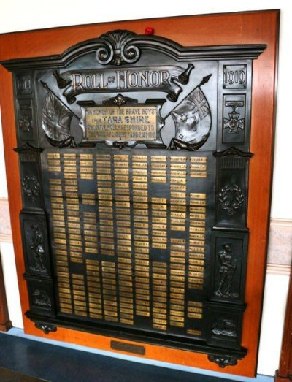
Tara Shire WWI Roll of Honour at Memorial Hall
Photo sourced from Monuments Australia website

Trooper Leatch’s name is also commemorated in the Commemorative area of the Australian War Memorial on panel 3.

He was re-interred after the war at Cairo War Memorial Cemetery, Egypt within section H in grave no. 45.
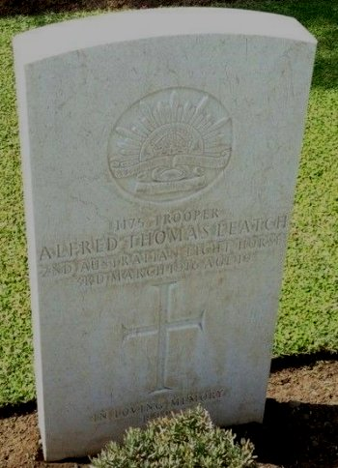
Photo sourced from www.findagrave.com
Photo added by Digger
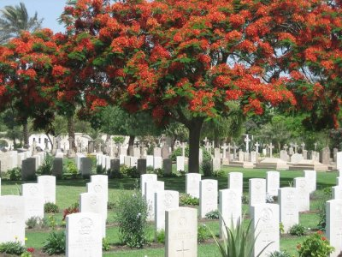
Cairo War Memorial Cemetery, Egypt in 2006
Photo sourced from Commonwealth War Graves Commission website

© Donna Baldey 2023
www.tunnellers.net

