SAPPER JAMES FREDERICK KERSEY
7061 – 3rd Tunnelling Company

James Frederick Kersey stated he was born in Melbourne, Victoria in 1876 and his birth appears to not have been registered. His siblings were born at Emerald Hill, Victoria, to parents Henry Thomas and Martha Rosalina (nee Broderick). His father came to Victoria as a nineteen-year-old leaving England in August, 1852 on the ship Admiral and married in 1863 to Martha. His father died at Moonee Ponds aged 58 in March, 1891 and his mother died in 1918. He married on 7 July, 1897 at North Melbourne to Daisy Naomi Stafford and they went to Broken Hill, New South Wales.

He was a member of the Druid Lodge there who formed a new company to establish a local hall and meeting rooms and their registration was published in the:

Evening News Saturday March 22, 1913:
NEW COMPANIES
Broken Hill Druids’ Hall Company Limited, registered March 17, with a capital of £[blurred] in £1 shares, in acquire lands and [blurred] rooms, hall, shops, etc. The signature to the registration are those of J.C. Byrne, G.M. Aitken, H.C.E. O’Connell, F.W. Weeks, L.V. Benjamin, C. Chester and A. Ross. The first directors are: 9 listed then James F. Kersey, and 2 others.
Registered office, Broken Hill. Article abridged
At the recruiting depot in Broken Hill on 11 September, 1916 the married forty-year-old mine timberman applied to enlist for active service abroad and passed the medical examination. Attestation forms describe him as 178cms (5ft 10ins) tall, weighing 67cms (148lbs) with a chest expansion of 87-95cms (34-37½ins) having a sallow complexion with good vision in his brown eyes and black hair. Church of England was his religion. Distinctive marks were top of small finger left hand missing and his toes slightly hammered.

Next-of-kin nominated was his wife Mrs Daisy Naomi Kersey of Argent Street, South Broken Hill, NSW and later Hawthorn Post Office, Hawthorn then changed to Joffre Street, Burwood, Vic where she remained.

The Oath of Allegiance was signed and taken three days later.

Acknowledgement to the departing volunteer was published in the:
Barrier Miner (Broken Hill) September 18, 1916:
Mr J.F. Kersey was among the A.I.F. volunteers who departed by the express to Adelaide on Thursday night last.

New recruits from country areas for training in the 4th Military District were also published in the:
Register (Adelaide) Wednesday September 20, 1916:
ENLISTMENTS IN THE COUNTRY
Following are the names of the men who enlisted at country centres and reported at the Exhibition Camp last week. J.F. Kersey Article abridged

Basic training commenced with A Coy, 2nd Depot Battalion at the Exhibition showground camp on 15 September, 1916 until moved for further instruction with the 7th Reinforcements to the 50th Battalion at Mitcham camp on October 10 but this changed and allotted to the Base Miners until 3 January, 1917.

The next day was transferred to their training camp at Seymour, Victoria joining the February, 1917 Reinforcements to the Tunnelling Companies to February 27 then for final training until May 10, 1917. In preparation for departure military authorities noted his Will had been lodged with his wife Mrs Daisy Naomie Kersey of Joffre Street, Burwood, Vic.

His rank was Sapper with the regimental number 7061.
The transport HMAT A9 Shropshire embarked from Melbourne, Vic on May 11, 1917 with 168 members of the February Reinforcements on board.

Sapper Kersey left Australian waters from Fremantle harbour and after crossing the Indian Ocean the ship docked at Durban, South Africa.

Next Port-of-call was Capetown to refuel about June 21, followed by another stopover at an unrecorded harbour would have completed the trip-sheet.

After being at sea for 70 days the voyage terminated at Plymouth, England on July 19, 1917. The three officers and 165 other ranks were detrained to Tidworth while two were hospitalised at Plymouth and the remainder entrained to No. 3 Details camp at Parkhouse for further training for the front.

The Reinforcements proceeded to France on 18 August, 1917 from Southampton arriving at the Aust General Base Depot in Rouelles the next day. On 3 September, 1917 was taken on strength with the 3rd Tunnelling Company who were working on the permanent tunnel systems of Hulluch – St Elie – Vermelles Sector, continuing to extend the subways and dugout accommodation for garrison troops, maintaining an efficient state of sanitation and repair, and in “Listening” in the mine listening galleries in advance of the Front-Line Trenches.

He is photographed in the Mess Room of the 3rd Tunnelling Company in January, 1918.

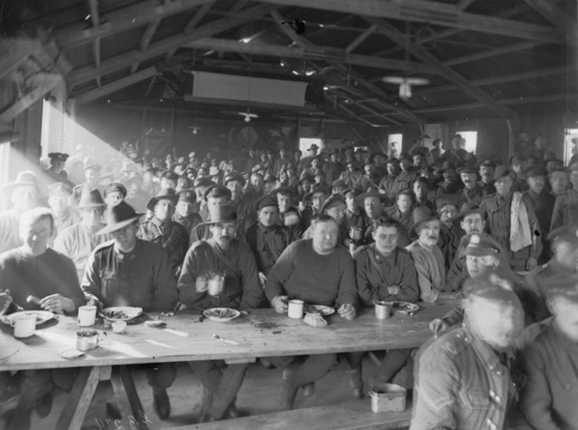
His service continued without incident and was issued with one Blue Chevron to wear on his uniform for serving one year abroad to May, 1918.
The Mess Room of 3rd Tunnelling Company at Noeux-Les-Mines, France – 30 January, 1918
Sapper J.F. Kersey identified as circled.
Photo sourced from Aust. War Memorial – copyright expired
He was a recipient of Comfort Gifts from the Kalgoorlie Ladies Committee and signed a letter of Thanks which was reprinted in the:
Kalgoorlie Miner Tuesday April 16, 1918:
TUNNELLERS’ COMFORTS – MEN WHO RECEIVED THEM
Sometime ago gifts were despatched to the front by the No. 1 Tunnelling, Pioneers and Engineers committee, and a list of recipients has now been received by the secretary, Mrs R.M. Jordan as follows—No. 7061 J.F. Kersey Article abridged

Leave was granted and taken from 21 September and re-joined his unit on 9 October, 1918.

He was with his unit when Peace was declared and the Tunnelling Companies remained on the front as part of the Army of Occupation assisting with rehabilitation of their district by clearing roads and bridges of booby traps and delayed action mines left by the enemy.

Orders were received to prepare for return to England on 10 March, 1919 and left the Aust Infantry Base Depot at Havre on March 17 arriving at the 2nd Training Brigade the following day to await their voyage home.

Sapper J.F. Kersey died on 8 May, 1919 in No. 3 New Zealand Hospital, Codford from a cerebral haemorrhage caused by being accidentally knocked down by an Australian Motor Ambulance on Wylie Road, Codford. He was forty-three years of age.

The 3rd Tunnelling Company forwarded the following Telegram to Administration Headquarters, London on 13 May, 1919 which read:
10.40AM CODFORD ST MARY
ADMINAUST LDN
B2511 13TH AAA NO 7061 PTE KERSEY JF 3RD TUN COY NEW ZEALAND HOSPL CODFORD
ON NIGHT OF 8TH INST AAA ADDSD SALAUSTRA REPTD ADMINAUST
THREEAUST CODFORD

Interment took place with a military funeral in consecrated ground of the Military Cemetery, Tidworth within section C in grave no. 386 in an elm coffin with brass mounts. Officiating clergyman was Church of England Chaplain J.F. Webb from Garrison Headquarters, Tidworth and funeral arrangements were made by Butcher and Son, Warminster.

On May 16, 1919 the 4th and 3rd Military Districts were advised of his demise with next-of-kin notified and on 31 May a copy of his service was made for the Pension Department. Confirmation of receipt of Cable from London was returned on May 19.

The Australian Mutual Provident Society, 459-463 Collins Street, Melbourne wrote to Base Records on 6 June, 1919 kindly requesting a Certificate of the late member’s movements while on active service from Base Records. A Statement of his Service was prepared on June 13 for the A.M.P. Society.

At the fortnightly meeting of the Triumph Lodge in Broken Hill the following took place and reported in the:
Barrier Miner (Broken Hill) Wednesday June 11, 1919:
DRUIDISM
The fortnightly meeting of the Triumph Lodge, I.A.O.D., was held in the lodge room on Monday evening, June 9, A.D. Bro. R.J. Tonkin presiding.
Correspondence from various sources was received and dealt with. Secretary Gray announced the death of P.A. Bro. J.F. Kersey (on active service). The brother had died in hospital in England on the eve of returning home. A letter of condolence was sent to the widow and the lodge rose out of respect for the late member.

The cable from London on June 30 was acknowledged giving his Cause of Death to the 4th and 3rd Military districts on 1 July, 1919 and three days later the Pension Department was advised also.

Location of his Will was reported.

The A.M.P. Society again wrote to Base Records on 7 July, 1919 stating that the widow received advice of the A.A.G., Melbourne that her husband had died on 8 May as a result of an accident being knocked down by a motor car. The writer presumed that the usual Certificate of Death was now available and would be glad if they could forward one to their office as early as possible.

Base Records also replied to Mrs D. Kersey to her requests on 8th and 11th July advising that necessary official documents covering the report of her husband had not yet been received from abroad but it was noted for completion at the earliest possible date. This was completed and forwarded to her on 4 August, 1919 and another delivered to her on 28 August, 1919.

His name appeared in the Casualty List published in the:
Advertiser (Adelaide) Saturday July 12, 1919:
CASUALTY LIST No. 468
Died-Other Causes
7061. Spr. J.F. KERSEY, Burwood, 8/5/19, injuries, rep died c. not stated Article abridged

His Will had been made out on 3 May, 1917 while at the Salvation Army Institute, Military Camp, Seymour giving the whole of his property and effects to his wife Daisy Naomie Kersey at Joffre Street, Burwood and a copy was sent on 4 September, 1919 from the 4th Military District to Base Records.

The Red Cross Society wrote to the No. 3 New Zealand General Hospital, Wiltshire for any information concerning the death of Sapper J.F. Kersey. The Officer Commanding replied on 5 August, 1919 to their letter of inquiry of 24th ultimo stating that he was unable to give any particulars as he was not admitted to the hospital.

Details given he was accidentally killed by an Australian Motor Ambulance on the Wylie Road and permission was given for the body to be placed in the morgue attached to the hospital and all funeral arrangements were carried out by the Australian authorities and understood he was buried at Tidworth. The officer advised the society to write to the A.D.M.S. at Tidworth for his burial particulars.

A Court of Inquiry was held at the hospital and the finding was - no blame attachable to the driver of the Ambulance.

He apologised for the delay in answering their letter as it was just received, owing to the hospital being closed and the Matron to whom it was addressed being away on leave.

Base Records advised Mrs Daisy Kersey on 15 October, 1919 referring to the regrettable loss of her husband they were now in receipt of advice which showed he died on 8 May, 1919 at 3rd New Zealand Hospital, Codford, England, from cerebral haemorrhage, being the result of injuries accidentally received by being knocked down by a motor car. He was buried in Military Cemetery, Tidworth, separate single grave in Virgin Soil, Consecrated Ground.

Full Military honours, the coffin with brass mounts being draped with the Australian Flag and conveyed to the graveside on a gun-carriage preceded by a Firing Party. Six of the deceased’s late Unit Comrades acted as pallbearers. Chaplain Rev. J.F. Webb (Church of England) conducted the burial service, at the close of which the “Last Post” was sounded and volleys sounded over the grave.

A number of Australians followed the remains and were present at the graveside ceremony. A.I.F. Headquarters, London was represented.
The upmost care and attention were being devoted to the graves of our soldiers and photographs were being taken as soon as possible for transmission to next-of-kin.

These additional details were furnished by direction, being the policy of the Department to forward all information received in connection with deaths of members of the Australian Imperial Force.

The A.I.F. Kit Store, Hammersmith, London forwarded one sealed parcel with their inventory stating:
Effects from 3rd New Zealand Hospital, Codford contained: 16 coins (foreign), souvenir badges, numerals, Titles, 4 Wallets, 1 comb, photos, Postcards, 1 pencil, 2 discs, 1 clasp knife.

£5.0.11 had been passed to the Chief Paymaster, A.I.F. Headquarters, London to be combined with monies due and credited to Pte Kersey’s Ledger Account.

The parcel was dispatched on the transport Barambah. On 5 December, 1919 Base Records advised Mr Kersey that the personal effects had been sent under separate cover to her. Mrs Kersey replied on 9 December that she received the parcel alright and it contained all stated and signed their delivery receipt.

A circular and booklet re Graves was despatched to his wife on 5 January, 1920.

Photographs of his grave in duplicate was transmitted to his wife on 4 February, 1920.

The District Finance Officer of the 2nd Military District, Sydney wrote to Base Records on 6 February, 1920 asking if they could kindly furnish the district of enlistment of this soldier. Records replied on February 10 that the soldier enlisted in the 4th Military District (Broken Hill, NSW 14/9/16).

A presentation of Certificates to returned soldiers and relatives was held during a banquet held by the Druid Lodge of Broken Hill and his name was listed as having a certificate and published in the:
Barrier Miner Wednesday March 17, 1920:
DRUIDISM – VISIT OF THE GRAND PRESIDENT – BANQUET HELD LAST NIGHT
PRESENTATION OF CERTIFICATES TO RETURNED SOLDIERS
A Druidical banquet to celebrate the visit to Broken Hill of Grand President Bro. F.J. Alcock was held in the Druids’ Hall last night. Occasion was also taken to present the Grand Lodge certificate to members of the order who enlisted for active service. There was an attendance of about 150 Druids, representing both the male and female branched of the order.
Grand President Alcock then presented certificates to a number of returned soldiers and relatives. Those absent from the district will have their certificates forwarded. The certificates are the work of a Sydney artist and are a of a neat design. On top the wording “Honor the Brave” is inscribed. Just beneath there is a picture of a number of Light Horsemen. On one of the bottom corners there is a picture of field artillery in action and on the other a scene in France. There are two types of certificates, one being for returned men, and the other a memorial for the relatives of deceased men. The certificates presented to returned men read: --“United Ancient Order of Druids, Grand Lodge of New South Wales: --Presented to Bro…………by the board of directors as a mark of appreciation of services rendered in the cause of liberty and justice whilst serving with the Australian Imperial forces in the great European war, 1914-1919.” The certificates bear the signatures of Grand President F.J. Alcock and Grand Secretary R.A. Barry.
Certificates were issued for the following: * Denotes killed on service.
J.F. Kersey
Article abridged

For his sacrifice Sapper 7061 James Frederick Kersey was issued with the British War Medal (56940) and the Victory Medal (55982) in serving his country.

The War Medal was forwarded to the Commandant 3rd Military District on 10 June, 1921 for issue to his widow and collected on 18 November, 1922 at Victoria Barracks, Melbourne by her. The Victory Medal was issued on 18 December, 1922 and her delivery receipt was signed but not dated.

The pamphlet “Where the Australian’s Rest” was sent out to his widow on 16 June, 1921.
The Memorial Scroll (342849) was issued over the counter from Base Records to Mrs Kersey on 18 December, 1922. The Memorial Plaque (342849) was sent direct to her on 27 October, 1922.

Mrs Daisy Kersey died on 17 April, 1923 with announcement published in the:
Argus Friday April 20, 1923:
DEATHS
KERSEY. —On the 17th April, at Portland Private Hospital, Daisy Naomi, relict of James F. Kersey, eldest daughter of John and Mary Ann Stafford, mother of Henry, Herbert, Roland and Earl, beloved sister of Thomas, Daphne (Mrs Christensen), Myrtle (Mrs Linfoot), Olive (Mrs Puckey), Joseph and Reginald.
A patient sufferer gone to rest.

Burial took place in Melbourne General Cemetery.

James Frederick Kersey is commemorated on the Adelaide National War Memorial, Adelaide, S.A. and the list of names to be inscribed was published in the:
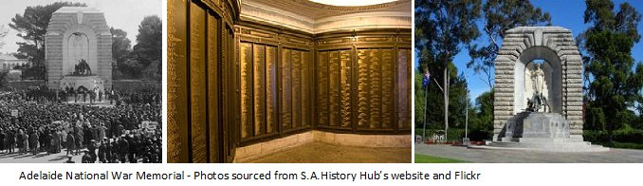
Register (Adelaide) Friday May 8, 1925:
THEIR NAME LIVETH FOR EVERMORE
KERSEY. —Spr. J.F. Kersey, of 3rd Tunnel Coy, died on 8th May, 1919.Article abridged
Adelaide National War Memorial, Adelaide S.A. - Photo sourced from State Library of S.A.

His name can also be located at the Aust. War Memorial in the commemorative area on panel 27.

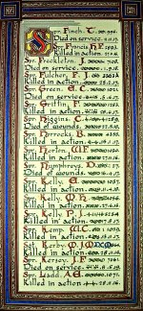

A Roll of Honour for all in the Engineers Corps who lost their lives in the Great War would be inscribed and placed in the chapel of St Paul’s Cathedral, London. Details of this was announced in the:
The Sydney Morning Herald - Saturday 23 July 1921:
ENGINEERS' ROLL OF HONOUR
The Royal Engineer War Memorial Committee are arranging to deposit a roll of honour of all ranks of the Royal Engineers whose names were officially published as killed in action or died of wounds or disease in the war in the chapel of St. Paul's Cathedral, and the Engineer corps of the dominions, colonial, and Indian armies have been invited to deposit similar rolls of honour in St. Paul's, to be attached to that of the Royal Engineers. This invitation has been accepted in Australia. The roll will be inscribed on vellum and enclosed in a casket of Australian timbers to rest on a slab of Australian marble.

This extract from Tunnellers Roll of Honour included in profile with the kind permission of the
Dean and Chapter of St Paul’s Cathedral, London
Photos courtesy of Robin Sanderson, Paris

His grave is in the Tidworth Military Cemetery, Wiltshire, England in section in grave site no. 386.
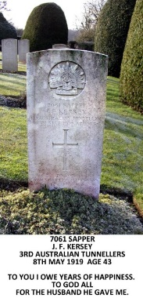
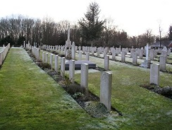
7061 Sapper
J F Kersey 3rd Australian Tunnellers
8th May 1919 age 43

To You I Owe Years Of Happiness
To God All
For The Husband He Gave Me.
Tidworth Military Cemetery – January 2013
Grave of Sapper J F Kersey 2nd in the row nearest camera
Photos & transcription courtesy Phillip Robinson, Durand Group, England
LEST WE FORGET

© Donna Baldey 2021
www.tunnellers.net

