ALEXANDER LORIMER KENNEDY
Lieutenant – 3rd Tunnelling Company

Alexander Lorimer Kennedy was born on 23 April, 1889 in Woodside, South Australia the son of Joseph Arthur and Elizabeth Isabella (nee Lorimer) Kennedy. His father was a school teacher.

At about thirteen years of age his school results were published in the:
Advertiser (Adelaide) Monday December 22, 1902:
STATE EXHIBITIONS AND BURSARIES
Considerable interest is manifested every year in the examinations held by the Educational Department for exhibitions and bursaries. Public exhibitions (tenable at Prince Alfred College):
2. Alexander Lorimer Kennedy (Sturt-street school) Article abridged

He was a member of St Peter’s College rowing team in 1905 with their win reported in the:
Register (Adelaide) Wednesday April 26, 1905:
INTERCOLLEGIATE ROWING
The annual four-oar race between St Peter’s College and the Geelong Grammar School was rowed on the Port River on Tuesday afternoon and resulted in the Adelaide boys wresting the laurels from their opponents, who had five successive wins to their credit. The crews were:
J. Forrest (bow) 10st 8lbs), A.L. Kennedy (2) 9st 3lbs; W.L. Strachan (3) 10.5; C. Hamilton (str) 10.1 and J. Mayo (cox) 7.3 Article abridged

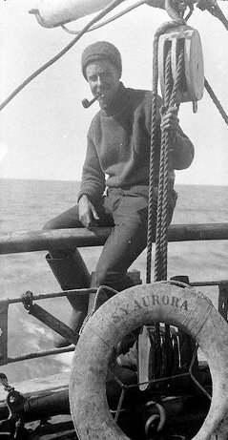
A year later his art work was judged and results published in the:
A.L. Kennedy aboard SY Aurora during Antarctic
Expedition –
photo from Aust Gov website on Mawson’s Hut
Evening Journal (Adelaide) Thursday December 20, 1906:
ART EXAMINATION – INTERMEDIATE PERSPECTIVE (Maximum 50 marks)
School of Design—Alexander Lorimer Kennedy, 45; Article abridged

While still a scientific student at the University of Adelaide was selected as a member for Dr Douglas Mawson’s Australasian Antarctica Expedition (AAE), planning to explore and conduct scientific studies of that continent, sailing from Hobart, Tasmania on December 2, 1911 on the ship SY Aurora. The ship would chart 2900 kms of unexplored coastline and the men of science based in various camps quietly advanced knowledge in polar geology, biology, meteorology, oceanography and began young Kennedy’s interest in magnetism for which he received special tuition to assist while there.

During 1912 he was part of the Western Base Party (Queen Mary Land) acting as Magnetician and was a member of several sledging parties and accompanied Frank Wild on his main eastern journey as Cartographer.

Cape Kennedy was named after him situated on the point of the East side of Melba Peninsula, 4 miles South-West of David Island during an expedition by members of the Western Base Party.

He returned to Adelaide early in 1913.
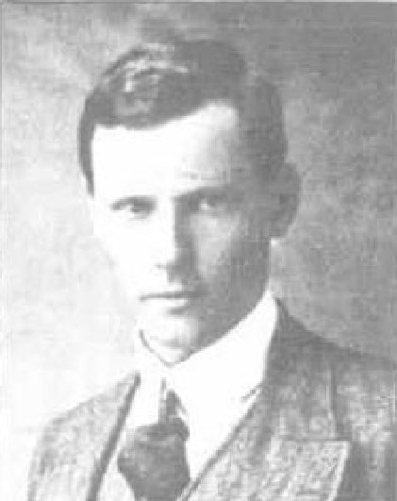
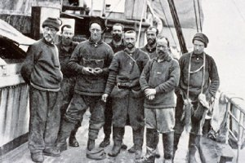
Mr A.L. Kennedy
Back from the Antarctic last week in Adelaide – Photo Chronicle Sat 29/3/13
Staff of Queen Mary Land Station returning to Australia 1913
A.L. Kennedy last on right – photo from Cool Antarctica
Further newspaper reports after Dr Mawson returned in 1914 appeared in the:
Observer (Adelaide) Saturday February 28, 1914:

PERSONNEL OF THE PARTY
Apart from the officers and crew of the Aurora, who numbered about 25, there was a land staff of 32 men including Dr Mawson.
The men selected by Dr Mawson were: From South Australia—Messrs C.T. Madigan (Rhodes Scholar for 1910, who was granted permission by the Oxford University to accompany the expedition, M.H. Moyes, A.L. Kennedy, P.E. Correll and A.J. Hodgeman.
Article abridged

By April, 1914 he had joined the Department of Terrestrial Magnetism of the Carnegie Institution of Washington, D.C. as a magnetic observer and left by camel for inland South Australia and adjoining Western Queensland for a series of observations and on completion would conduct an expedition along the Transcontinental railway line from Port Augusta to Kalgoorlie in Western Australia.

News of his appointment was reported in the:
Advertiser (Adelaide) Saturday April 4, 1914:

AN INTERESTING VISITOR TO ADELAIDE – APPOINTMENT FOR MR A.L. KENNEDY
The Department of Terrestrial Magnetism of the Carnegie Institution, of Washington, D.C., Mr E. Kidson, who with the various members of his party, has been engaged in magnetic work in and around Adelaide during the past three weeks, will be a passenger for Western Australia by the Indarra today.

Mr A.L. Kennedy, who was in charge of the magnetic work at the second base of Dr Mawson’s Australasian Antarctic expedition has recently joined the department as a magnetic observer and has been entrusted with the remaining work in South Australia. Mr Kennedy will leave on Monday for Farina, whence he will secure a series of observations on a trip by camel from Farina to Innamincka, Haddon Station, Birdsville and Hergott Springs. On returning he will organise an expedition along the transcontinental railway line from Port Augusta to Kalgoorlie.
Messrs Kennedy and Parkinson have both joined recently were also instructed in methods of field work.
Article abridged

He married on 19 March, 1915 at Wayville, S.A. to Rosa Beatrix (Trixie) Stevens.
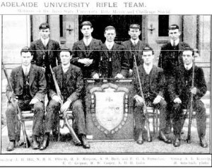
University of Adelaide Rifle Team – Kennedy seated left
Chronicle Sat 30 March, 1911

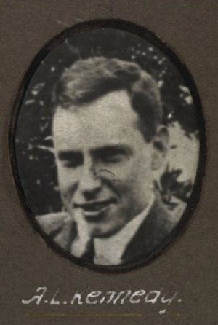
He graduated from the Adelaide University with a Bachelor of Engineering (BE) degree in 1915 with presentation reported in the:
Aust War Memorial photo
Copyright expired
Express and Telegraph (Adelaide) Tuesday April 13, 1915:

PERSONAL NEWS
At the Adelaide University on Wednesday afternoon a special congregation will be held in the Prince of Wales Theatre for the purpose of conferring degrees on the following candidates: Degree of Batchelor of Engineering—Alexander Lorimer Kennedy.
The Chancellor of the University will preside, and the members of the senate and council who attend are requested to wear the academic costume proper to their respective degrees and offices.
Article abridged
He was employed by the South Australian Railway as a draughtsman.

At the recruiting depot in Adelaide (4th Military District) on 16 August, 1915 the twenty-six-year-old married draughtsman with S.A. Railways applied to enlist for active service abroad and passed the medical examination. Attestation forms describe him as 176cms (5ft 9¼ins) tall, weighing 73.6kgs (162lbs) with a chest expansion of 88-94cms (34½-37ins) and a fair complexion with good vision in his brown eyes and had brown hair. Distinctive marks were one vaccination scar on his left arm. Religion was Church of England.

Next-of-kin nominated was his wife Mrs Beatrix Kennedy of 11 Davenport Terrace, Wayville, Adelaide, S.A. and allotted two-fifths of his pay in support of her.

The Oath of Allegiance was taken and signed on 30 August, 1915.

Acknowledgement to the new recruits was published in the:
Advertiser (Adelaide) Tuesday August 31, 1915:
THE WAR – GONE INTO CAMP
The following men went into camp on Wednesday: A.L. Kennedy
Article abridged
Basic Training commenced with C. Coy, 2nd Depot Battalion at the Exhibition ground, Adelaide until 30 September, 1915 then promoted to be Provisional Corporal from 16 September to September 30. Sent to Mitcham camp attending the school for Non-Commissioned Officers from 1 to 31 October. On 1 November trained with the 7th Reinforcements to the 27th Battalion then moved to “A” Group from 16 November for ten days.

On 2 November, 1915 applied for a Commission with the Mining Corps giving educational qualifications at St Peter’s College and attained a Bachelor of Engineering from Adelaide University and a Diploma in Mining. He was at present at the N.C.O. School at Mitcham.

Next-of-kin was his wife Mrs A.L. Kennedy of 247 King William Road, Hyde Park, Adelaide.

By 3 December, 1915 had attained Sergeant’s certificate.

His commission as Second Lieutenant was announced in the Commonwealth of Australia Gazette No. 158 of 23 December, 1915. The next day the following was revealed on Officers with the Mining Corps in the:
The Age Friday December 24, 1915:
THE AUSTRALIAN FORCE – PROMOTIONS AT THE FRONT
The following appointments, promotions &c., made in the Australian Imperial Force by the general officer commanding the Australian and New Zealand Army Corps, were gazetted yesterday.
AUSTRALIAN ENGINEERS
To be Second Lieutenants (Provisionally) Sergeant H.E. Trousselot, Corporal V.B. West, A.E. Tandy, R.A. Clinton, Sergeant R.Y. Langdon, Sergeant W.J. McBride, Private A.L. Kennedy, A.C. Morris, O.R. Howie, E.F. Brind, Sergeant B. Priestman, Sapper G.L. Smith, Corporals J.D. Henry, H.W. Brown, D. Brigstock, P.J. Day, H.V. Seale, C.W. Whyte, O.H. Woodward, R.B. Hinder, D.C. Mackenzie, G.A. Cook Sergeant G.T. Crawshaw. Article abridged

All members of the Mining Corps were sent to Casula camp, near Liverpool, New South Wales for final training for the Corps.

The South Australian members were on final leave to Adelaide and reported in the:
Advertiser Saturday January 1, 1916:
PERSONAL
Lieutenants R.Y. Langdon, A.L. Kennedy, and McBride, who have been spending their long leave in Adelaide, returned to Sydney by Friday’s express to re-join the Mining Corps Battalion.

Announcements of New Appointments to the Corps was published in the:
Sydney Morning Herald Saturday February 19, 1916:
NEW APPOINTMENTS
The following appointments to the Australian Imperial Forces have been made:
To be Captains: James Arthur Pollock, Lieutenant (provisional) R.V. Morse, Senior Cadets.

To be Second Lieutenants: Corporal James Alexander Reid, Corporal William Thomas Anderson.

To be Second Lieutenants (provisionally): Alexander Sanderson, Vyvyan Christopher Bennett.

The provisional appointments of the following second lieutenants are confirmed: H.E. Trousselot, V.B. West, R.Y. Langdon, W.J. McBride, A.L. Kennedy, B. Priestman, G.T. Crawshaw, J.D. Henry, H.W. Brown, D. Brigstock, P.J. Day, H.V. Seale, C.W. Whyte, P. Caro, J. MacD. Royle, L.G. Wilkins, O.H. Woodward, R.B. Hunter.

Promotions to be Lieutenants: Second Lieutenant E.N. Mulligan, L.J. Coulter, W.P. Avery, L. De J. Grut, J.F. Pattinson, H.E. Trousselot, V.P. West, W.J. McBride, J.D. Henry, P.J. Day, C.W. Whyte, and J.M. Reid.

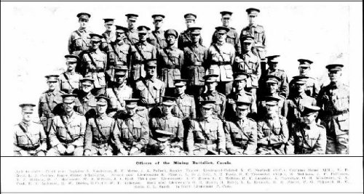
He was allotted to No. 2 Section of No. 3 Company.
The Officers of the Mining Corps, Casula
Photo Australian Town and Country Journal Wednesday 23 February, 1916

Another Attestation Form was completed on 16 January, 1916 with the same details and included he had one child born on 1 December, 1915.

At a civic parade in the Domain, Sydney on Saturday February 19, 1916, a large crowd of relations and friends of the departing Miners lined the four sides of the parade ground. Sixty police and 100 Garrison Military Police were on hand to keep the crowds within bounds. The scene was an inspiriting one. On the extreme right flank, facing the saluting base, were companies of the Rifle Club School; next came a detachment of the 4th King’s Shropshire Light Infantry, then the bands of the Light Horse, Liverpool Depot, and the Miners’ on the left, rank upon rank, the Miners’ Battalion.

The Corps boarded HMAT A38 Ulysses in Sydney, NSW on February 20 and sailed for the European theatre. Arriving in Melbourne, Victoria on February 22 the Miners camped at Broadmeadows for a stay of 7 days while further cargo was loaded.

Another parade was held at the Broadmeadows camp on March 1, the Miners’ Corps being inspected by the Governor-General, as Commander-in-Chief of the Commonwealth military forces.

Leaving Melbourne on March 1, Ulysses arrived at Fremantle, Western Australia on March 7 where a further 53 members were taken on board.

On Wednesday March 8, 1916 the whole force, with their band and equipment, paraded at Fremantle prior to leaving Victoria Quay at 9.30 o’clock.

The ship hit a reef when leaving Fremantle harbour, stripping the plates for 40 feet and, although there was a gap in the outside plate, the inner bilge plates were not punctured. The men on board nicknamed her ‘Useless’. The Miners were off-loaded and sent to the Blackboy Hill Camp where further training was conducted.

The Mining Corps comprised 1303 members at the time they embarked with a Headquarters of 40; No.1 Company – 390; No.2 Company – 380; No.3 Company – 392, and 101 members of the 1st Reinforcements.
Finally departing Fremantle on April 1, Ulysses voyaged via Suez, Port Said and Alexandria in Egypt.
The captain of the ship was reluctant to take Ulysses out of the Suez Canal because he felt the weight of the ship made it impossible to manoeuvre in the situation of a submarine attack. The troops were transhipped to HM Transport B.1 Ansonia, then on to Valetta, Malta before disembarking at Marseilles, France on May 5, 1916. As a unit they entrained at Marseilles on May 7 and detrained on May 11 at Hazebrouck.

A ‘Mining Corps’ did not fit in the British Expeditionary Force, and the Corps was disbanded and three Australian Tunnelling Companies were formed. The Technical Staff of the Corps Headquarters, plus some technically qualified men from the individual companies, was formed into the entirely new Australian Electrical and Mechanical Mining and Boring Company (AEMMBC), better known as the ‘Alphabetical Company’.

The company went to work in the mining sector of existing mine systems of Red Lamp; Winchester; Colvin; Ducks Bill and Sign Post Lane. The No. 3 Company was officially transferred to the 3rd Tunnelling Company.

Was promoted to be Lieutenant on 15 June, 1916. This appeared in the Commonwealth of Australia Gazette No. 124/16.

On 1 July, 1916 Lieutenant was classed as wounded in action suffering an internal derangement of knee joint and taken to the No. 7 General Hospital in Boulogne.

In the After War Report of the 3rd Tunnelling Company the following was recorded:

“On 1/7/16 at Colvin a mine was fired by us and a crater formed. The enemy, after an intensive bombardment, lasting two hours, raided our lines. A Magazine containing 1300lbs of Ammonal, was exploded near No 10 Shaft, which was destroyed. No 11 Shaft was subsequently damaged & the enemy were believed to have destroyed it with a mobile charge.
During the barrage Lt H.V. Seale & Lt A.L. Kennedy succeeded in withdrawing all the miners, but themselves were wounded when remaining to attend to a wounded man in a French shelter. Lt Seale was evacuated & later on medically boarded. The Board found him permanently unfit and he was returned to Australia. Lt Kennedy was evacuated to hospital in England. On being boarded on 5/10/16 he was found medically unfit for G.S. for 6 months but fit for home service.
Lt A.L. Kennedy returned to the Unit at a later date on 2/7/17.”

The hospital ship St Denis invalided him to England on 8 July, 1916 and admitted to the 3rd London General Hospital.

The War Office, London forwarded on 31 July, 1916 to the Director of Medical Services, A.I.F. Horseferry Road, Westminster enclosing proceedings of the Medical Board held at the 3rd London General Hospital, Wandsworth on 29 June for the soldier.

Base Records regretted to advise his wife at 247 King William Road, Hyde Park that Lieut. Kennedy was reported wounded but not stated to be serious. His address for correspondence was included.

Was discharged from hospital on 9 October, 1916 to the No. 1 Command Depot at Perham Downs. On 26 October was taken on strength with the No. 2 Command Depot at Weymouth then by Christmas Day, 1916 was with Headquarters at the Weymouth Command Depot. On 25 May, 1917 was still at the No. 2 Command Depot until the Medical Board declared him fit for general service on 6 June. Left the A.I.F. Depots at Tidworth and proceeded overseas to France on June 26 arriving the next day at the Aust General Base Depot in Rouelles then marched out to re-join his unit on 1 July reported for duty the following day.

The After War Report of the Company recorded his return as:
“On 2/7/17 Lt A.L. Kennedy reported for duty & was allotted to No 2 Section & 2/Lt Dow was transferred from No 2 to No 1 Section.”

News of his wounding was also reported in the:
Register (Adelaide) Thursday July 20, 1916:
CONCERNING PEOPLE
Lieut. Alexander Lorimer Kennedy, a son of Mr J.A. Kennedy, head master of the Norwood School, has been wounded in action. Lieut. Kennedy was a member of Sir Douglas Mawson’s Antarctic expedition, and was at the time of the outbreak of war attached to the Carnegie Institute and engaged in making a magnetic survey of Central Australia. He had the degree of Bachelor of Engineering of the Adelaide University and the diploma of mining engineering of the School of Mines. He was in his student days the crack stroke oarsman of South Australia.
Three Blue Chevrons were issued to wear on his uniform for serving two years abroad on 20 February, 1918.

Lieutenant went sick to the 6th Casualty Clearing Station suffering from Pneumonia on 4 February, 1918.

The After War Report had the following in its Unit Diary:
“On 6/2/18 Lt A.L. Kennedy was admitted to No. 6 C.C.S. suffering from pneumonia contracted at 1st Army Mine School, Houchin. He was evacuated to England & re-joined the Unit 10/5/18.”

Was conveyed on February 14 on Ambulance Train no.28 to Camiers entering the 20th General Hospital with Lobar Pneumonia. Was invalided to England on the hospital ship Newhaven on 22 February being admitted to the 3rd London General Hospital at Wandsworth the same day. Was transferred on 4 March to Cobham Hall where the medical board declared him fit for general service with sedentary employment only on 3 April. Was discharged to the No. 1 Command Depot at Sutton Veny on April 17 marching in from A.I.F. Headquarters, London.

Base Records advised his wife at Main Street, Henley Beach, S.A. on 8 March, 1918 that Lieut. Kennedy was now convalescent. They also said in view that no previous report has been received, A.I.F. Headquarters had been asked the nature of his disability. On receipt she would be promptly notified. His address for correspondence was also given. On 26 March Base Records wrote to Mrs Kennedy that it was reported her husband had been admitted to the 6th Casualty Clearing Station suffering from pneumonia (mild). Further news was issued to her on March 29 it was now reported that he was admitted to the 3rd London General Hospital, Wandsworth S.W. on 22/2/18 suffering pneumonia (severe).

Declared fit for active service two months later by the medical board on 22 April at the Tidworth Depot then marched out from Sutton Veny to the Overseas Training Brigade on 26 April. Proceeded overseas to France on 6 May from Southampton arriving at the Aust General Base Depot and returned to duty on 10 May. Left for Mine School duty on June 16.

On 27 June, 1918 was attached for duty with the 1st Army Mine School and employed as an instructor. In an audit on 6 August, 1918 of the Company he was noted to be still with the Mine School. On 4 October returned from detachment to re-join his unit but re-attached from October 10 to October 19, 1918.

Went sick on 22 October, 1918 to the 54th Casualty Clearing Station with P.U.O. (Pyrexia (fever) uncertain origin) and transferred to Base two days later. The following day admitted to the 13th General Hospital in Boulogne then to the 5th British Red Cross Hospital in Wimereux until 3 November, 1918.

The following was reported in the After War Report:

“On 7/11/18, the A.I.F. Educational Scheme began to take shape so far as it affected the 3rd Aust Tnlg. Coy. Captain Chaplain, W.J. Gray was appointed Education Officer and an Education Committee was formed and detailed consisting of the following :-
President Captain Gray
Secretary Lieut. A.L. Kennedy

COMPANY ORDERS [taken from Unit Diary files]
1158 Appointment of Committee for Educational Scheme Capt. Chaplain Gray President & Lt Kennedy with 5 members.”
Two days later marched out to the 1st Corps Depot at the Aust Base Depot in Havre and was there when Peace was declared on November 11, 1918.

Base Records advised his wife on 8 November, 1918 that it had been reported that her husband was admitted on 25/10/18 to the 5th British Red Cross Hospital suffering from pyrexia uncertain origin, severe. On 14 November, 1918 she was advised he was now convalescent.

On 18 November, 1918 at the Depot was classified to be “A” class.

Leave was taken from 6 December giving his address as 1 Moreton Gardens SW and returned to duty on December 22, 1918.

The following information comes from the After War Report:

“On 6-2-19 Captain A.J. Hillman, Lieut. A.L. Kennedy and Lieut. D. Wentworth with 48 O.Rs. marched out for demobilisation.”

They entered the Aust General Base Depot at Havre and departed on 21 February, 1919 for England arriving at Weymouth the next day and marched into the Reserve Brigade Aust Artillery camp a day later.

Base Records forwarded to his wife at Henley Beach, S.A. on 28 February, 1919 a form of Commission issued by the British War Office covering the appointment of her husband as temporary lieutenant. This referred to his first appointment and not to his present rank. Mrs Kennedy signed their consignment note on 20 March, 1919 accompanied by a letter stating that her address was now Marlborough Street, Henley Beach, S.A.

After demobilisation Lieutenant Kennedy embarked from Devonport, England on 19 April, 1919 on board H.T. Sardinia. Base Records advised his wife on 7 May he was returning home. The transport docked in Adelaide (4th M.D.) on 4 June, 1919. News of their arrival was reported in the:
The Register (Adelaide) Thursday June 5, 1919:
HOME AGAIN - TROOPS FROM THE SARDINIA LANDED
The South Australian troops from the Sardinia were landed from the vessel at Queen’s Wharf, about noon on Wednesday. There was an unusually large number of friends and spectators to witness the arrival and long before the vessel was moored the crowd were out-of-hand and broken through the guard by sheer weight and swarmed the wharf. The best the naval and military men could then do was to join hands and form a ring around the gangway of the ship to allow the men a little freedom in disembarking. Many persons witness the landing from the top of adjacent railway trucks and the roof of the wharf shed. The military officers who went off to the vessel at the anchorage and came in with her were [listed in the article but not reproduced here]. The District Military Band under Warrant Officer Stanley played a number of selections on the wharf, and during the intervals, as the ship drew into the wharf, a fine band on board filled the gaps.
The Y.M.C.A. Army Department assisted by the ladies of the V.A.D., distributed fruit, cake and smokes to the soldiers as they reached the wharf, and they also sent off the usual comforts to the men in quarantine on the Dorset, which arrived at the anchorage early on Wednesday morning. The Semaphore Cheer-up Society distributed “welcome home’ souvenirs. The soldiers were briefly welcomed by Major J.K. Paul, D.S.O., on behalf of the State Commandant and the Mayor of Port Adelaide. Officers landed were:
Lieuts: A.L. Kennedy
Article abridged

The Dept of Defence, Keswick, S.A. sent his service documents to Base Records on 12 June, 1919 advising his arrival and termination dates.

His appointment was terminated in Adelaide (4th M.D.) on 19 July, 1919 on cessation of hostilities.

For serving his country Lieutenant Alexander Lorimer Kennedy, 3rd Tunnelling Company was issued to wear the British War Medal (10071) and the Victory Medal (10007).
He then worked for the Adelaide Observatory as their chief assistant.

In late 1922 he was in charge of the advance party to set up equipment to observe the eclipse of the sun at Cordillo Downs, S.A. A report on this event was published in the:
Observer (Adelaide) Saturday October 7, 1922:
AT CORDILLO DOWNS – PERFECT ECLIPSE OBSERVATIONS – MR DODWELL’S REPORT
The astronomical party which went to Cordillo Downs to see the sun effaced had glorious luck. They saw it all, and saw it well. The sun-gazers were in charge of the Government Astronomer (Mr G.F. Dodwell), who returned to Adelaide on Friday, Sept. 29, armed with voluminous information and many photographs. He submitted to his Minister (Hon. G. Ritchie) a preliminary report. In it he said: --“Our advance party, in charge of Mr A.L. Kennedy, chief assistant at the Adelaide Observatory, went to Cordillo Downs two months before the eclipse with the instruments, and had a very arduous journey of 400 miles, form Lyndhurst Siding to Cordillo Downs, as all the instruments and gear, including some heavy packages, had to be taken through by pack camels, which meant that they had to be loaded and unloaded every day.
AWAITING THE MOMENT
The light gradually failed as the eclipse proceeded and all observers took their posts 10 minutes before totality, in readiness. Shadow bands appeared rippling over the totality, also just after totality. Their appearance and direction of motion were noted down by Mr Wallace Johnson, Mr Kennedy and others.
THE SITE
The Astronomer, Royal of England, said that we should best the accuracy of the theoretical time required for bringing up eighth magnitude stars about half an hour after sunset, when the light of the sky would be approximately the same as during the eclipse. Mr Kennedy’s photographs came out very well and gave us a good guide of exposures, of 20d, 30s., 60s and another of 20s, on four places taken with the Einstein camera lent by the Allegheny Observatory.
RIFT IN THE CORONA
Professor Woolnough and Mr Adamson also took coronial photographs with the Adamson instrument, giving long exposure to bring out the faint extensions of the corona and Mr Adamson also made drawing of the corona. Mr Kennedy took special magnetic observations during totality and also during the three days before and after the eclipse in connection with the programme given by the Carnegie Magnetic Department.Article abridged

Photos of their setting up was published in the Observer on Saturday 16 September, 1922.
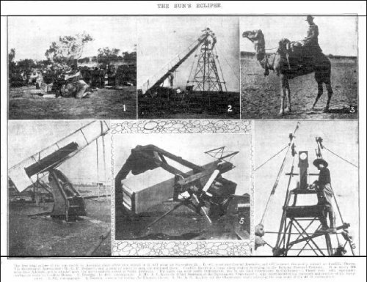

Around 1924 he was attached for a two-year position as an operator at Mt Stromlo Commonwealth Observatory, Canberra, ACT.

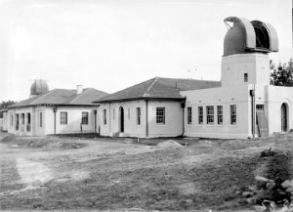
Mt Stromlo Observatory, Canberra, ACT 1921-35
showing the solar tower and observatory with a 6inch Farnham telescope
Photo sourced from National Archives of Aust.

His name appears in the Register of Tunnelling Company Officers, Roll of Honour in 1925 with his entry as follows:
Kennedy, A.L. Lieut. 3 Coy, Observatory, Adelaide, S. Aust.

In the Topographical Index under South Australia is:
Kennedy, A.L.

He was mentioned in an article on neglect of the Adelaide Observatory in the:

He then went to work for the Kandos Cement Company Ltd in New South Wales with a brief mention that could be him in the:
Observer (Adelaide) Saturday April 2, 1927:
THE OBSERVATORY – GREATER INTEREST NECESSARY
Why is it that the Adelaide Observatory occupies so unimportant a place in the public estimation? At one time it was regarded with pride and had a world reputation. It did valuable work in helping solve various problems of astronomers.
There was a good opportunity at the time of the sun’s total eclipse in Central Australia but it was neglected.
Another essential is a proper magnetic survey of the State, more particularly the south coastline of the two gulfs. A partial magnetic survey was made by Mr A. Kennedy, of the observatory staff, some years ago, when funds were provided by the Carnegie Institute, but the State Government has done nothing to continue it. Article abridged
Lithgow Mercury Thursday November 1, 1928:
KANDOS
Mr Dunn, chief draughtsman and Mr Kennedy of the drawing office staff of the Kandos Cement Company have just resigned. They left during the past week to take up positions with a colliery company on the South Coast.

He returned to Adelaide and was interviewed before leaving for Western Australia with the write-up appearing in the:

News (Adelaide) Tuesday October 30, 1928:
VISITED SOUTH POLE – MR ALEX. KENNEDY IN ADELAIDE
Mr Alex Kennedy was a passenger by the East-West express which left for Perth this morning. He is now associated with goldmining in the Pilbara district in the North-West in Western Australia. Mr Kennedy stated that the last time he crossed the Nullarbor Plain was in 1914 before the railway was built. He was a member of the magnetic survey party conducted by the Carnegie Institute and the journey was made by camel at the rate of 15 miles a day. It was a great contrast to speeding across by train at more than 40 miles an hour.
He has had a varied career. He accompanied Sir Douglas Mawson on his expedition to the south polar regions 17 years ago, and saw service at the war with the Tunnelling Corps. He was assistant at Adelaide Observatory for some time, and then became attached to the Commonwealth Observatory on Mount Stromlo near Canberra for two years. Recently he was associated with the Kandos Cement Company Limited, in New South Wales.
Mr Kennedy is a brother of Miss Daisy Kennedy (now Mrs John Drinkwater), the well-known violinist.
He graduated Bachelor of Engineering at the University of Adelaide, and was a member of the eight-oar crew which first won the interstate Varsity race for South Australia in 1910.
With the exception of Mr Fornachon who was killed at Anzac, the members of the crew had a reunion luncheon at South Australian Hotel yesterday.
He returned to become a member of the British, Australian, New Zealand Antarctic Research Expedition (BANZARE) in 1930 on the ship Discovery as a physicist and was able to re-test and compare magnetic measurements he made in 1912.

From 1931 he is listed at Wodgina, via Port Hedland, W.A. as a mining engineer.

A small write up of his work on the expedition was published in the:

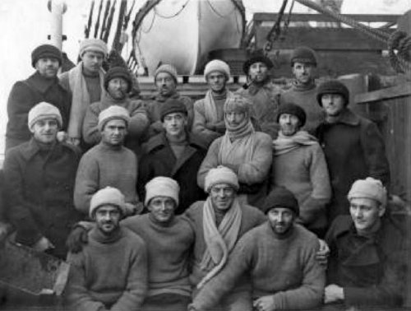
Advertiser and Register (Adelaide) Tuesday May 12, 1931:
NATURAL COOL STORE – 20 YEARS-OLD SOUP FOR MAWSON PARTY
Soup out of natural cold storage in which it had been preserved for 20 years, was an unexpected treat for members of the British, Australian, New Zealand Antarctic Expedition, which returned to Australia in March.
MAGNETIC SOUTH SHIFTS
After six days’ battling against a hurricane a landing was made at Cape Denison where magnetic determinations by Mr A.L. Kennedy (physicist) had steadily moved to the north-west during the last 20 years and now was probably not more than 250 miles away from Cape Denison.Article abridged
Members of the Expedition to Antarctica on their way home on Discovery in 1931- A.L. Kennedy identified as back row second from left
Photo sourced from Cool Antarctica

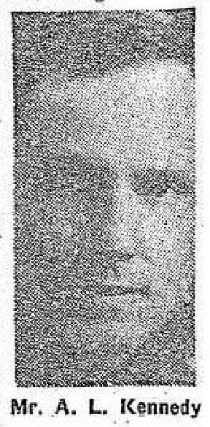
Soon after he was prospecting in Western Australia and gave an interview for the:
News (Adelaide) Thursday January 21, 1932:
HE DOESN’T MIND THE WEATHER – WENT FROM ANTARTIC TO MARBLE BAR – GOT SUNBURNED

ADELAIDE weather holds no terrors for Mr A.L. Kennedy, a North Adelaide engineer. Last year he was in the Antarctic with Sir Douglas Mawson, saw the mercury constantly around zero, and then within a month, was prospecting at Marble Bar, where 100 degrees is a cool change.
He was sunburned through is shirt, but suffered no other ill-effects of the change. For Mr Kennedy has his own way of keeping warm in the snow and cool in the sun. “Anyone can stand it—if only he will try to forget the weather,” says Mr Kennedy. “If you are well-clothed, equipped, have plenty of food, and keep on the move you can nearly always keep warm. But it’s hard to keep cool in the heat of you dress according to convention. I wear, in the heat, only thin shirt and short trousers.”
114 FOR FOUR WEEKS
Mr Kennedy was mining between Port Hedland and Marble Bar, in the north-west of Western Australia. The temperature averaged 114 for 28 consecutive days. The hottest maximum was 120, and the “cool” spell arrived when the mercury sank to 110. Marble Bar is the hottest place in Australia, according to Mr Kennedy. Once it averaged 105.8 for six months.
“The hear is continuous, and there are no sudden changes,” says Mr Kennedy.
“In the Antarctic you feel hot when sledging in the summer. The snow become sticky on the surface, but doesn’t quite melt.”
Twenty years ago on his first Antarctic visit the temperature fell to “fifty below.”
“When you’re going to bed you must hustle. There must be no dawdling while undressing in the Antarctic. I think the extreme cold is healthier than extreme heat—perhaps because there are less germs.
Mr Kennedy was formerly associated with the Adelaide and Canberra observatories.

Those who ventured to the Antarctic were to be issued medals which was mentioned in the:
News (Adelaide) Thursday May 3, 1934:
BRONZE POLAR MEDALS FOR MAWSON’S MEN – ECHO OF ANTARCTIC EXPEDITION
LONDON, May 2—The King has approved the granting of bronze Polar medals to members of Sir Douglas Mawson’s expedition to the Antarctic in 1920-31. There will be 56 recipients, including several residents of Adelaide.
Of the 56 members of the British, Australian, New Zealand Antarctic Research Expedition who will receive the King’s bronze Polar Medal, 15 were members of the special specific and technical staff, seven were ships’ officers and 34 members of the crew of the discovery. The only Adelaide residents are Sir Douglas Mawson, Prof. Harvey Johnston, of the University of Adelaide staff of the Waite Research Institute. The majority of the ship’s officers and staff were Australians and the greater number of the crew comprised of overseas men.
The bronze medal is awarded for ship operations Sir Douglas Mawson has received silver Polar Medals on two previous occasions—the British Antarctic Expedition of 1911-14.
[Sir Douglas Mawson today said that up to the present very little had been published concerning the work of the expedition, but efforts were being made to complete the preparation of details reports, and it was hoped that printing would begin shortly.
It was expected, he added that a large series of volumes would result, for the data and collections were very extensive. When the reports were made available the knowledge of the vast stretch of the Antarctic, extending from the 160th to the 45th degrees of east longitude, in which Australia was now interested would be found to be surprisingly concrete and detailed.]

His wife died while he was working at Port Hedland, W.A. with the notice published in the:
Advertiser (Adelaide) Monday December 17, 1934:
DEATHS
KENNEDY—On the 15th December, at a private hospital, Rosa Beatrix (Trixie) dearly beloved wife of A.L. Kennedy, of Port Hedland, Western Australia. At rest.

He is among the passengers listed on the coastal steamer Katoomba and published in the:

Western Australia Tuesday February 19, 1935:
SHIPPING
Coming from Sydney, Melbourne and Adelaide via Albany, the interstate clipper Katoomba is expected to berth about 6.30 o’clock this morning at D shed, Victoria Quay. Passengers: Messrs: A.L. Kennedy Article abridged
He went to the Northern Territory looking for tantalite deposits with his movements reported in the:
Northern Standard (Darwin) Friday July 17, 1936:
AIRMAILS
The delayed airmail place VH-USD “Brisbane” piloted by Captain Denny and F.O. Ambrose, arrived in Darwin on Wednesday at 10.15 a.m. and left again at 1.45 p.m. When the machine continued its journey Mr A.L. Kennedy was a passenger from Darwin en route to Port Hedland.

A return visit to Adelaide was made known in the:
Advertiser (Adelaide) Friday March 12, 1937:
THE SOCIAL ROUND – Conducted by IDRA
Mr A.L. Kennedy arrived by the Duntroon from Port Hellane, [Hedland] Western Australia, on Wednesday, and is stay at the Hotel Botanie.

He was elected to the Road Board in Port Hedland and investigating prospects in the Northern Territory in 1937 and reported in the:
Northern Times (Carnarvon) Wednesday March 31, 1937:
PORT HEDLAND NEWS
For the two vacancies on the Road Board, the only nominations received were those of the retiring members, Messrs A.E. Richardson and A.L. Kennedy, who were duly declared elected.

West Australian (Perth) Friday June 18, 1937:
TANTALITE INVESTIGATION – TEST IN NORTHERN TERRITORY
DARWIN, June 17—Interest in tantalite prospects in the Northern Territory is still being investigated. Mr A.L. Kennedy, a distinguished geologist who accompanied Sir Douglas Mawson on two expeditions to Antarctica, has been carrying out investigations on behalf of Tantalite, Ltd., of which the chairman of directors is Dr Buller Murphy, formerly Lady Moulden.

Western Mail (Perth) Thursday July 1, 1937:
NORTH-WEST NEWS
PORT HEDLAND: Mr A.L. Kennedy returned from Darwin on Tuesday. Passengers booked to travel south by tomorrow’s place are Messrs Munro, Kennedy, Bridges and McFaull.
Article abridged

Re-married on 25 January, 1938 to Melba More Bruse.

A mining report on the district was published in the:
Yalgoo Observer and Murchison Chronicle (Meekatharra) Friday July 7, 1939:
MINING – NOTES ON INDUSTRY – MARBLE BAR DISTRICT
At Wodgina, Tantalite is being mined by Tantalite Ltd., the mine being managed by Mr A. Kennedy. At present they are employing 10 men working on the surface or only a few feet below it. The lode has been gouged for a length of 2,500 ft., and alluvial Tantalite has been, and still is being worked in some places.

He re-enlisted during World War II from Clarence Park, S.A. at Keswick on 28 July, 1941 giving next-of-kin as Melba Kennedy.

His appointment was published in the:
Commonwealth of Australia Gazette Tuesday October 23, 1941:
4th Military District
ORDNANCE MECHANICAL ENGINEERS
To be Lieutenant (on probation)
And is Seconded
ALEXANDER LORIMER KENNEDY
11 September, 1941

Lieutenant S31419 Kennedy was discharged on 23 October, 1942 from the Recovery Station, A.A.O.C.

His address in 1943 was 13 Mathias Street, Cabra, S.A. with the occupation as militia. They moved to 48 Heytesbury Road, Subiaco later that year with occupation as a mine manager.

His arrival in Perth taking up executive position with the Wodgina mine was announced in the:

West Australian (Perth) Tuesday March 2, 1943:
PERSONAL
Mr A.L. Kennedy has arrived in Perth from Melbourne to take up an executive position on the Wodgina mine in this State. This mine, which is under the control of the Commonwealth Government, will produce tantalite.
Soon after was busy recruiting miners and equipment for the mining venture which was reported in the:
Kalgoorlie Miner Friday March 19, 1943:
STRATEGIC MINERALS – MEN REQUIRED FOR TANTALITE MINING
The controller of minerals of the Department of Supply and Shipping, is reopening the tantalite mines in the Port Hedland district and the superintendent Mr A.L. Kennedy, is at present making arrangements for staff and equipment.
Tantalite has become of outstanding importance owing to the newly discovered use of metal tantalum for radio location and like purposes. United States authorities are pressing the controller of minerals to supply a considerable tonnage of the mineral in the shortest possible time and it is anticipated that mining operations will commence almost immediately so that the tonnage can be produced by the end of 1944.
Thirty men will be required at once to fill the following positions, whilst another 50 can be accommodated within a short time. Article abridged

He enlisted for service again on 12 April, 1943 from Port Hedland, W.A. at Subiaco. His wife Melba Kennedy was nominated as next-of-kin. He was discharged on 2 November, 1943 as a Private with the North West Battalion Volunteer Defence Corps.

They remained at their Subiaco address with his occupation listed as mine manager and later engineer.

Sir Douglas Mawson was mentioned in 1947 unable to participate in the latest expedition to Antarctica which was reported in the:
Northern Times (Carnarvon) Friday March 7, 1947:
PIONEER TELLS OF WARM OASES IN POLAR WASTES
Next summer another Australian Antarctic expedition will sail for the Pole. Regretfully, a great Australian will watch it go—first such venture in which he has not played an active part.
He is Sir Douglas Mawson, great old warhorse of the frozen south.
Now enfeebled by hardships of previous expeditions, Mawson has had to become a back-room boy, planning, advising, guiding the uninitiated.
IMPASSABLE
Unfortunately, at the time of our discovery, Wild’s party, operating by sledge, was unable to cross the Denman Glacier, which extended between them and the bare rocks they could see from camps at David Island and at Mt Barr Smith.
A.L. Kennedy, the surveyor of the party, put the area on the map.
Article abridged
He maintained his interest in mining at Marble Bar and reported in the:
West Australian May 25, 1953:
APPLICATION FOR MINING LEASE TENANT OTHER THAN LEASE
Agent for Tantalum Mineral Claim at Wodgina
A.L. Kennedy
Northern Times Thursday September 3, 1953:
MARBLE BAR WARDEN’S COURT
In the Warden’s Court for the Pilbara Goldfield held at Marble Bar on Wednesday, August 19, before Warden V.P. Leach the following applicants were dealt with:
9. Application by Alexander Lorimer Kennedy for a Mineral Claim for Tantalum, Columbium and Beryllium. No. 308 situated Wodgina and containing 10 acres. Recommended for approval. Article abridged

Alexander Lorimer Kennedy passed away on 24 August, 1972 aged 83 years. Cremation took place at Karrakatta Crematorium with his ashes place in the Garden of Remembrance in garden no. 26 position 147.

Mrs Melba Kennedy died on 2 July, 1991 and her ashes placed in the same position.

His name is on the Pictorial Honour Board of the Adelaide Rowing Club.
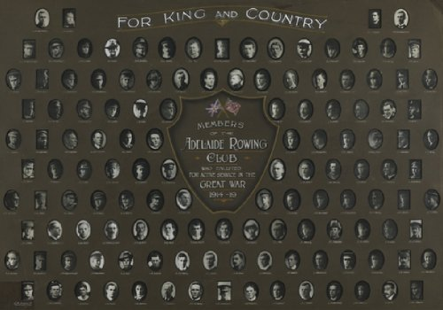
Adelaide Rowing Club’s Honour Board - photo sourced from Aust War Memorial

The South Australia Railway Honour Boards WWI and WWII.

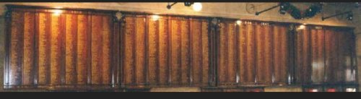
South Australian Railway Employees Honour Board, North Terrace Railway Station, Adelaide, S.A.
Photo sourced from Virtual Memorial website

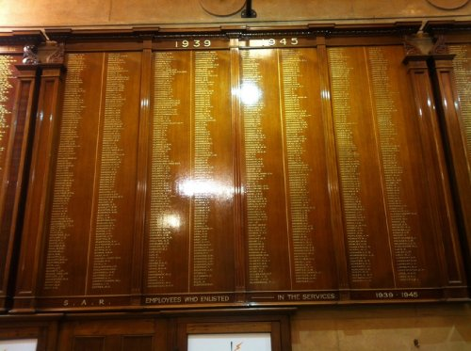
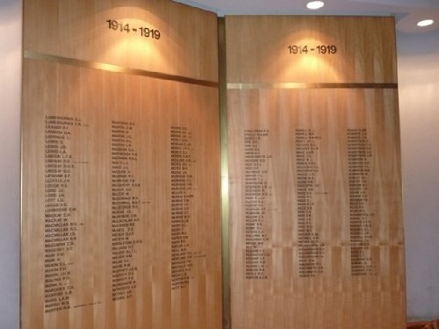
Section of the S.A. Railway Employees Honour Board WWII section - Sourced as above
Hackney Street, St Peter’s College Honour Board, Adelaide - Photo sourced as above
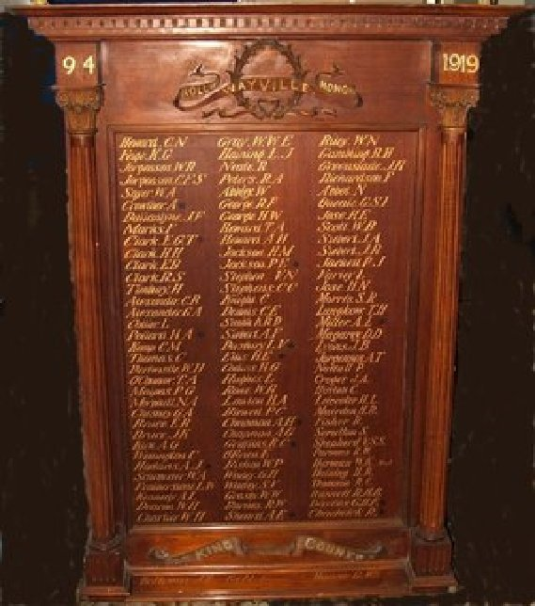
Unley-Wayville Honour Roll bears his name - Photo sourced as above

REUNIONS
Former members of the (Alphabet Company) Aust Electrical & Mechanical Mining & Boring Company and Tunnellers’ in Sydney would meet to march in the Anzac Day parade then attend their annual luncheon. Roll Registers for newsletters of this annual event were kept and his name appears in several circulars that have survived as follows:
12 Castlereagh Street,
SYDNEY.

30th June, 1949.
Dear Tunneller,
Well, since you have all written saying how much you have enjoyed receiving my circulars with news of the old Tunnellers, I will make this a bumper circular and tell you what I can of all the old boys, living and dead.

Well, the dinner was held at the usual place, Sydney Legacy Club, 188 George Street, on one of the foulest nights Sydney has known for years, and I was very despondent as to whether we could get a quorum (we had, I might mention, a jorum). In spite of the weather 39 Tunnellers, near Tunnellers and visitors, arrived, there being only one absentee from the list of those accepting and that was Archie Thomson who was down with the dog’s disease.

…….A telegram from Alex Kennedy at Wodgina –
“Wish could be with you tomorrow. Best wishes to all old Tunnellers. Kindest regards”.

We would all love to see you too, Alex.
With all my thanks and best wishes.
(Sgd) Johnnie Royle. Circular abridged

8 Stanton Road,
MOSMAN
New South Wales

1st September, 1963

Dear Tunneller,

Another year gone past and I am sorry to say I have not had much correspondence with those of our old team still on deck, but I can tell you about some of them.

……I will now tell you something about my trip to Perth at the time of the Commonwealth Games! Did I have a good time!
JOE ALLEN, CAMPBELL SHAW, BERT CARROLL, ALEC KENNEDY and BILL LOGIE together with JACK FOXALL, who joined the No. 1 Company after I left and one of my oldest friends who I had not seen for over 30 years, gave me a magnificent lunch at the Esplanade Hotel in Perth. Campbell Shaw and Logie had travelled hundreds of miles to meet me and they did the thing properly.
After that Logie and his son kidnapped me and took me for a 4 days tour of the South West through Bunbury and Albany and the big timber where we drove right through one of the largest trees. Bill is, or was then, in his ninetieth year but it was nothing to him to carry his heavy port up 2 flights of stairs at the pub we stayed at in Albany, only to find he had forgotten his keys. No trouble to Bill – he ran down the stairs and arrived back on top before I had recovered my wind from the first trip. He gave me a marvellous time and it was the highlight of the trip.

The Games – yes, they were on at the time, but after 1 hour on the opening day, temperature 103 – sun on back of my neck, stripes on my posterior from sitting on lathes, I left.
The next day I went to see the rowing – temperature 104, same stripes on bot. sun in eyes, I left.
After that I thoroughly enjoyed the Games. I went to Foxall’s flat where I laid on a lounge chair with my feet on a stool, with an occasional table on my right and an occasional drink on the table, in front of a good T.V. set.

I also spent a day with Alex Kennedy on a trip to Rottnest Island – also a high light. All the boys wished to be remembered to any of their friends on the mailing list.

All the best to all of you. Let us hear from you!
Yours sincerely,
J. MACD. ROYLE Circular abridged

Also included was a list of Officers
NAMES AND ADDRESSES OF TUNNELLERS AS AT 2ND SEPTEMBER, 1963
A.L. Kennedy
49 Heytesbury Road, Subiaco, W.A
8 Stanton Road,
MOSMAN N.S.W. 2088
30th June, 1967
Dear Tunneller,

Last circular I sent I was going crook about having recurrent ‘flu but I have quite recovered but find my waterworks are giving trouble – but when I read the various replies I have had to my last circular, I feel that many more of you are also finding the years are telling, so I had better stop bellyaching and get on with this year’s news.

I have also a note from Alex Kennedy that de Passey of the 3rd Company had died recently. I had originally had him on the mailing list but lost track of him many years ago.

Most sincerely,
Johnny Royle. Circular abridged
8 Stanton Road,
MOSMAN, N.S.W. 2088

7TH JUNE, 1968

Dear Tunneller,

I am a bit earlier than usual with my circular this year but it is a nice sunny day and I am in a nostalgic mood.
Campbell Shaw writes from Carnarvon on the coast of Western Australia on the 25th parallel which is nearly as far north as Rockhampton is on the Queensland Coast. Cam writes as follows:

“Thank you very much for the copy of your circular letter which was forwarded to me here, we read it with great interest and many regrets as your circular was the first knowledge of poor Bill Logie’s death. We had a very enjoyable dinner with him earlier this year in Bunbury and although he had lost a great deal of weight, he was his same cheery self. With those three bereavements in W.A. I only know of Kennedy and Allen, the only Officers left in W.A.
I have a couple of letters from Alex Kennedy, the first being sent in July before he received my last circular:

“Dear John,
Yesterday, I went to dear old Bill Logie’s funeral. There were many old diggers there, as so many had R.S.L. badges, or 1st A.I.F. “Returned from Active Service” badges, but there were none there that I knew. (I had enlisted in S.A.)

I saw the death and funeral notices in the paper the day before, and on some page of the paper I saw the notices that Roy de Passey had passed away on the 16th June at Busselton and had been cremated there. I had known Roy at the School of Mines in Adelaide early this century and at Kalgoorlie where he had an assay office. Then again in the 3rd Tunnellers in France.”

On the 13th August he wrote –
“Thanks very much indeed for the book, “The Crossing of Antarctica” by Fuchs and Hilary. I appreciate it very much and it goes into my library of polar literature. After my demise my polar books, including this particular one, will go to my grandson in Adelaide, who has shown an interest in the Antarctic. He already has my ice-axe and a few odds and ends from Antarctica, which I gave him years ago. The colour photographs in the book are really marvellous reproductions.

I am “batching” (or is it baching?) at present and have been for about six weeks; my wife has taken a tourist bus trip, Perth, Port Hedland, Darwin, Alice Springs, Adelaide and Melbourne. She will return by air. I find living out of tins again at my age, not the best!

Elsie Carroll rang me a day or two ago, and said she had received your circular and had heard from you, and suggested we might arrange something when you both come to Perth. She told me she had changed her address. It is now Mrs E. Carroll, Flat 117, North Terrace, Rowethorpe, Bentley, W.A. 6102.

If you see Ponty, Col. Morris and Bill Anderson, would you remember me to them, also if you write to Bill McBride tell him I’m still above ground.

I see, on re-reading the last circular you sent that in the P.S. that you and your wife Eadith will be arriving in Perth on September 20th and will stay at the Palace Hotel.

As for myself, I’m well enough except that unaccountably (?) the hills are getting steeper, the ground is further away and print is becoming more indistinct! Kind regards, Alex Kennedy.”

In September, Eadith and I travelled by the Transcontinental to Perth where we spent a pleasant week. Alex Kennedy met us at the railway station and conducted us to the Palace Hotel which is one of the most pleasant and comfortable hotels it has been my lot to stay in. I suppose we are old fashioned but with the large quiet rooms such as the dining room and lounge – no piped music (?) to follow you round the passages and in the lifts and perfect service. It will do us anyhow!

The old reliable Karl Byron Moore writes a long newsy letter and asks me to give his best wishes to Cam Shaw and Alex Kennedy if I see them on my trip to Perth in September. Circular abridged

In Lists as:
Circular Kennedy, A.L. 48 Heytesbury Road, Subiaco
1963 Kennedy, A.L. 48 Heytesbury Road, Subiaco
1969-71 Kennedy, A.L. 48 Heytesbury Road, Subiaco, 6008 Reply’71

© Donna Baldey 2022
www.tunnellers.net

Footnotes:

Alex Kennedy took with him a hockey stick on his first visit to Antarctica. It was auctioned by Christie’s in September 2007 – lot 375 and it sold for GBP 1,500.
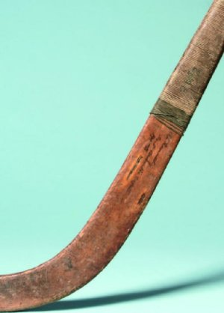
Hockey stick AAE 1911-1913 Alexander L. Kennedy
Photo Christies Auction Sept 2007

Surviving copies of the Circulars between former Tunnelling members are reproduced on this website.

