SAPPER THOMAS GRIFFITH JONES
5027 – 3rd Tunnelling Company

Thomas Griffith Jones stated he was born in Llaberis, Caernarvonshire, Wales about August, 1881. He came to Western Australia and was working at Greenbushes in 1916.

At the recruiting depot at Greenbushes on 15 February, 1916 the thirty-four-year-old single miner applied to enlist for active service abroad and passed the preliminary medical examination. Personal particulars taken show he was 172cms (5ft 8ins) tall, with a chest measurement of 90cms (35½ins) and address was care of Mr Eyles, Greenbushes. Declared fit his application was accepted but referred to the P. Medical Officer and Senior Dental Officer on account of defective teeth – upper and lower dentures required. The recruiting officer in Perth concurred on 19 February, 1916.

Attestation forms were completed and describe him further weighing 56kgs (124lbs) with a brown complexion, his blue eyes testing to good vision and brown hair. Distinctive mark was one big vaccination scar on his left arm. Methodist was his religion. Military experience was with the Volunteers in Wales.

Next-of-kin nominated was his brother Griffith Jones of Gweithy, Llaberis, Wales.

He re-attested at Blackboy Hill camp, near Perth on 25 February, 1916 and the following particulars were given as 173cms (5ft 8½ins) tall, weighing 59kgs (130lbs) with a chest expansion of 84-92cms (33-36ins) and a medium complexion with blue eyes and dark hair. Religion was now non-conformist. Next-of-kin remained the same. He signed and took the Oath of Allegiance the same day. His rank was Sapper with the regimental number 5027.

Acknowledgment to the new recruits was published in the:
Southern Times (Bunbury) Saturday February 26, 1916:
GREENBUSHES
The following have volunteered and gone into camp since the 1st January:
Thomas Griffith Jones Article abridged

Basic training commenced in Area 2 from February 19 until allotted to the No. 6 Tunnelling Company on 10 March, 1916.

Recruiting for the No. 6 Tunnelling Company had commenced on March 7, 1916 by Captain Lawson and his four officers. Instruction classes were formed of officers and N.C.O.’s as there was insufficient time to attend the Engineer’s School in Sydney. Recruits were forthcoming in abundant numbers and the aim was to have good physical types of skilled W.A. Miners.

At Blackboy Hill camp the new company paraded daily with sister companies until March 27 when the Company moved camp to Belmont camp. Jones arrived at the camp on March 10 where four sections were created and training continued through April and May. The remainder of May was occupied in the usual training: musketry, trench work and night work while equipment and clothing issue was also in progress. Here a difficulty was met in that the general size of the men was considerably above the average and some little trouble was experienced in getting all accurately fitted.

Early in May, 1916 the No. 4 Tunnelling Company consisting of six officers and 152 other ranks together with the 1st Reinforcements of fifteen other ranks making up two sections, embarked from Brisbane, Qld aboard HMAT A69 Warilda for Sydney, NSW.

At Rosebery Park, Sydney, NSW they joined their Headquarters and two sections (8 officers & 153 O.Rs.) plus 1st Reinforcements consisting of one officer and seventeen other ranks for final training.
The 7713-ton transport Warilda departed Sydney, NSW on May 22, 1916 and collected in Melbourne, Victoria the No. 5 Company recruited from Victoria, South Aust. & Tasmania made up of Headquarters and 2 Sections (8 officers & 173 men) (3 M.D.). One Section from Tasmania (3 officers & 76 O.Rs); also 1st Reinforcements for No. 5 Company (17 men from Vic. & 8 men Tas.).

The ship departed on May 25, 1916 for Adelaide, S.A. to collect one Section of 3 officers & 76 O.Rs with 1st Reinforcements of 8 O.Rs.

The public were kept aware of the training of the No. 6 Company with the following published as follows:
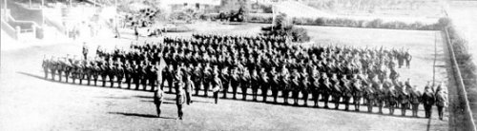
The West Australian Wednesday May 31, 1916:

THE TUNNELLING COMPANY - PARADE THROUGH CITY STREETS
Although the numerical strength of the troops which paraded the city streets yesterday morning was considerably less than that of previous parades, and despite the fact that citizens have become accustomed to the sight of khaki-clad warriors, the men of the No.6 Tunnelling Company and the Claremont N.C.O. school met with a hearty reception as they swung along to the inspiriting music of the Blackboy Hill band. The line of route was freely bedecked with flags, whilst the large crowds, if somewhat undemonstrated denoted none the less by their presence their keen appreciation of that sense of patriotism which found its highest expression in the long line of soldiers answering to the call of Empire. In physique and general bearing the men were equal to their comrades who have gone before. Leaving James-street well on appointed time, the column swung into Beaufort-street and over the bridge in to Barrack-street. The members of the N.C.O. school, about 113 strong, under Captain Thompson, followed the band, the No.6 Tunnelling Company, with its first reinforcements, totalling nearly 400 men, under Captain Lawson, bringing up the rear. At the head of the Tunnellers was borne the flag recently presented to the company.

After traversing Barrack and Hay streets the column entered St George’s-terrace via Victoria-avenue. Opposite Government House his Excellency (Sir Harry Barron), with whom were the State Commandant (Colonel J.H. Bruche), Major P.H. Meeks and Major Wilkinson, A.D.C., took the salute. Passing along the Terrace the route was via William and Wellington streets to the station. The men paraded in full fighting equipment.
The No.6 Tunnelling Company - - Photograph taken at the W.A.T.C. Course, Belmont, where the men have been in training

The No. 6 Company paraded through the city of Perth where the fine physique of the men, who marched with arms bare to the elbow excited universal admiration.
The West Australian June 1, 1916:

THE WESTERN MAIL
The war pictures appearing in this week’s issue of the Western Mail:
In addition, the “Mail” contains a fine photograph of the No 6 Tunnelling Company, as well as an illustration of their march through the streets of the city on Tuesday last, and a photograph of the officers who have been appointed to command the men.

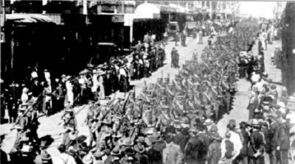
Tuesday’s parade of troops. The No.6 Tunnelling Company and the members of the N.C.O. School,
Claremont, marching through the city.

The transport arrived in port at Fremantle, W.A. on June 1, 1916. The whole company consisting of 14 officers and 325 O.Rs along with 1st Reinforcements of 1 officer and 32 O.Rs entrained at Belmont at 2 p.m., every man physically fit being present and boarded Warilda which left the harbour the same evening.

Durban, South Africa was reached on June 16, 1916 and Cape Town on June 21, 1916 while St Vincent completed the African ports of call on July 7, 1916. Discipline was fairly good except at intermediate ports where Away without Leave caused concern. The fifty-eight-day voyage experienced remarkable pleasant weather terminating at Plymouth, England on July 18, 1916. Four, Five and Six Companies comprising of 1064 officers and other ranks were detrained to Amesbury and Tidworth to begin training for the front at Perham Downs.
On 6 August, 1916 he went sick with a social disease to Military Hospital at Fovant moving to the 1st Aust Dermatological Hospital at Bulford on August 18. Reported to Headquarters on 5 September then was returned to the 1st A.D.H. at Bulford on 29 December, 1916 then to Parkhouse camp. Was classed with B1a debility at the No. 1 Command Depot, Perham Downs on 20 January, 1917 and nine days later sent to the Aust Details Camp. Total curative time totalled 167 days.

Marched in from camps 6 & 7 to the Drafting Depot on 4 April, 1917. He proceeded to France and taken on strength with the 3rd Tunnelling Company on 6 June, 1917.

The After War Report for the 3rd Tunnelling Company recorded the following around the time he arrived in France:
“At the beginning of June following on the advances made in the Hill 70 Sector, work was put to hand to consolidate the new positions and to build Dugout Extensions. The investigation detachment continued the examination of the captured enemy shafts and galleries.
Listening was still carried out at Hill 70.
Extensive system of building, dugouts, dressing stations & M.G. Emplacements was pushed on. The water supply scheme was developed in various directions, adding much to the comfort & convenience of troops occupying the tunnel systems & Front Line areas.”

On 18 August, 17 he was wounded in action receiving a gunshot wound to his left leg and hip and taken to the 23rd Casualty Clearing Station.

The incident was reported in the After War Report as:
“On 18.8.17 the following were wounded at Hill 70, Loos:-
1425 Spr Martin, A.
1192 “ Turnbull, J.G.
5019 “ Waterhouse, R.G.
5027 “ Jones, T.G.
1085 Spr Munster, J.T. was gassed and died on 24.8.17 and
4496 “ Truman, H.P. was gassed and died on 21.8.17.”

The following day was conveyed on Ambulance Train no.24 to the 20th General Hospital at Camiers and was invalided to England on the hospital ship Brighton on 24 August being admitted to the 5th Southern General Hospital at Portsmouth for thirteen days. Medical notes state slight wounds. Both healed. Fit in three months.

His brother changed his address with Base Records on 30 August, 1917 to 53 Victoria Road, Witton, Northwich, Cheshire.

On 8 September was discharged to the 3rd Aust Auxiliary Hospital at Dartford spending eight days a patient there with a medical report stating no disability. Somewhat debilitated.

Was discharged to the Command Depot at Codford on September 22.

His name was among those soldiers published in the casualty list in the:
Sunday Times Sunday September 23, 1917:
THE ROLL OF HONOR - WOUNDED
Spr. T.G. Jones Article abridged

Marched out on 6 December, 1917 to the Overseas Training Brigade at Longbridge Deverill from the No. 4 Command Depot at Hurdcott.

An X-ray was ordered from the Sandhill Depot on 24 January, 1918 at the Sutton Veny Depot and the report stated “Can detect no T.B. in the region of the left ilium.”

Proceeded to France from Southampton on 1 February, 1918 arriving at the Aust General Base Depot at Rouelles the next day. He returned to duty with his unit on February 7.

He was with his unit when Peace was declared and the Tunnelling Companies remained on the front as part of the Army of Occupation assisting with rehabilitation of their district by clearing roads and bridges of booby traps and delayed action mines left by the enemy.

Leave from France was granted from 31 December, 1918 to 14 January, 1919 but did not re-join his unit until 24 January, 1919.

Disciplinary action was taken for the following:

Crime: AWL from 0600hrs 15/1/19 to 0600hrs to 24/1/19
Award: 10 day’s pay by C.O. 3rd Tun Co. on 7/2/19
Total forfeiture: 19 day’s pay

Orders were received on 22 April, 1919 to report to the Aust Base Depot 1 and they left from there on April 28 crossing to England and arrived at camp to await his voyage home.

After demobilisation Sapper Jones embarked for Australia on 1 June, 1919 on board H.T. Somali.

He was on the Roll of members returning to Australia published in the:

Kalgoorlie Miner Friday June 27, 1919:

RETURNING AUSTRALIANS – THE SOMALI LIST
The following nominal roll of members of the Australia Imperial Force returning to Australia by the H.T. Somali was received yesterday from military headquarters, Perth.
Spr. T.G. Jones,
Article abridged
The transport docked at Fremantle (5th Military District) on 8 July, 1919.

News of their arrival was reported in the:
Western Argus Tuesday July 15, 1919:

SOMALI TROOPS LANDED – ENTHUSIASTIC RECEPTION
Perth, July 8.
The transport Somali, with over 1300 W.A. troops on board arrived at Fremantle this morning. This is easily the largest number of home troops that have yet disembarked at a W.A. port, and the coastal residents had resolved to give them a big reception. On Sunday, however, it was announced that owing to the occurrence of several cases of mild influenza and other infectious diseases, the troops would be definitely quarantined for seven days, some at Fremantle and others at Albany. As the result of this notification, not only were the reception ceremonies abandoned, but people from the country put off their proposed trip to meet their soldier relatives.
Then, at the last minute, it was decided to cancel the quarantine decision, and allow the men to land straight away. The news quickly spread, and, despite drizzling rain, several thousand people had gathered on the wharves as the Somali came alongside, shortly before noon, to the accompaniment of great cheering and screeching of whistles. When the men had all been landed, they formed into column, and marched through the streets, headed by the Blackboy Hill Band. The streets were thronged with cheering crowds. The officer commanding was Colonel C.H. Elliott, C.M.G., D.S.O. (Tasmania), who also wears the Legion of Honour, Colonel, H.B. Collet, C.M.G., D.S.O., West Australia, who was the original C.O. of the 28th Battalion, was aboard.

He appeared before the Disembarkation Medical Board on 14 July, 1919 at the No. 8 Aust General Hospital, Fremantle and his Statement of Case reads:

Any wounds or injury? G.S.W. L. hip 18/8/17 Hosp. 2/12 R.T.D.
Any illness on service? No
Soldier’s statement of present condition – Good (Sgd.) Thos. G. Jones
Present condition: Heart, lungs, other organs – clear. Hearing – good. Any abnormality. No.
Recommendation: Fit for duty
Approved: Perth 15/7/19

Military Discharge was issued in Perth (5th M.D.) on 28 August, 1919 on termination of his period of enlistment.

For serving his country Sapper 5027 Thomas Griffith Jones, 3rd Tunnelling Company was issued with the British War Medal (11162) and the Victory Medal (11033).

These medals were not collected at the designated barracks and returned to Base Records on 30 September, 1924. The Medals Section requested information of his address from the District Finance Officer who replied on 24 November, 1924 his address was care of Ben Jones, Bootmaker, 310-312 William Street, Perth, W.A.

A letter was sent to him on 3 July, 1925 care of this address.

His name is commemorated on the Busselton Memorial.
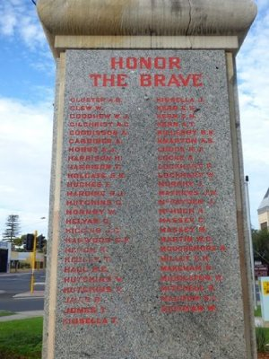
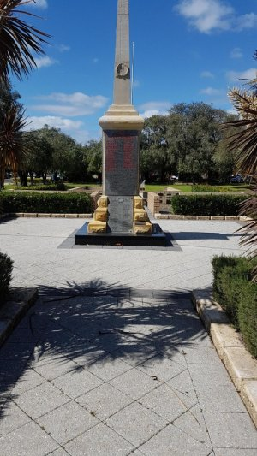
Busselton War Memorial, W.A.
Photos sourced from Places of Pride and Aust War Memorial

© Donna Baldey 2022
www.tunnellers.net

Research:
Our Thomas Griffith Jones appears to have spent most of his life in Australia in Western Australia. It is possible the information below refers to him but we have been unable to positively confirm it is our Thomas Griffith Jones:

1914 Marie Ellen Lloyd living at 1072 Hay Street, West Perth

Thomas G. Jones married Marie Ellen Lloyd in 1915 at Leederville, WA (BDM)

Census:
1916 Jones Marie Ellen 18 York Street, Fremantle
1916 Jones Thomas Griffith 18 York Street, Fremantle, Storeman

1922/1925 Jones Marie Ellen 18 Park Street, Chester Park
1922/1925 Jones Thomas Griffith 18 Park Street, Chester Park Storeman

1931 Jones Marie Ellen 18 Park Street, Chester Park
1931 Jones Thomas Griffith 18 York Street, Chester Park Storeman

1937 Jones Marie Ellen 26 York Street, Fremantle
1937 Jones Thomas Griffith 26 York Street, Fremantle, Storeman

The West Australian, WA – Thursday 29 March 1951:
FUNERALS
LLOYD-JONES: The Funeral Cortege of the late Mrs. Marie Ellen Lloyd-Jones, of Holland-street, Gosnells, is appointed to leave our Service Chapel, 20 Angove-street. North Perth, at 11 o'clock THIS (Thursday) MORNING, arriving at the Welsh Cemetery, Karrakatta, at 11.20 o'clock.
ARTHUR J. PURSLOWE AND CO., B2649.
West Australian Tuesday April 13, 1948:
DEATHS
JONES (Thomas G.) in deep regret at the passing on April 10 of a grand neighbour and friend Mr and Mrs J. Cranston and family.
FUNERALS
JONES: The Friends of the late Mr Thomas Griffith Jones, of Holland-street, Gosnells, the dearly loved husband of Mary Ellen are respectfully invited to follow his remains to the place of interment, the Welsh Free Church Cemetery, Karrakatta. The Cortege is appointed to leave our Private Mortuary 203 Guildford-road. Maylands at 10.25 o’clock THIS (Tuesday) MORNING, arriving at the Cemetery at 11 o’clock.
J.L. WATKINS AND SONS
JONES: Gosnells Lodge No.228 W.A.C.: The Officers and Brethren of the above Lodge are respectfully invited to attend the Funeral of their late Brother. For particulars see main notice. By order of the W.M.
JONES: Welsh Free Church and Cambrian Society: The Members of the above Church and Society are respectfully notified that the remains of their late Honorary Pastor and Member, respectfully will be interred in the Karrakatta Cemetery. For particulars see main notice. D. Davies, Sec.
JONES: Gosnells Methodist Church: Members and Friends are respectfully invited to attend the Funeral of our fellow worker. For particulars see main notice.S. Armstrong, Senior Steward.
West Australian Monday April 12, 1948:
DEATHS
JONES: On April 10, at St John of God Hospital, Belmont, Thomas Griffith, the dearly loved husband of Mary Ellen Jones of Holland-street, Gosnells and formerly of Fremantle.
FUNERALS
JONES: The Friends of the late Mr Thomas Griffith Jones, of Holland-street, Gosnells and formerly of Fremantle are respectfully invited to follow his remains to the place of interment, the Welsh Church Cemetery, Karrakatta. The Cortege is appointed to leave our Private Mortuary, 203 Guildford-road, Maylands, at 10.25 o’clock TOMOTTOW (Tuesday) MORNING, arriving at the Cemetery at 11 o’clock.

From FindaGrave:
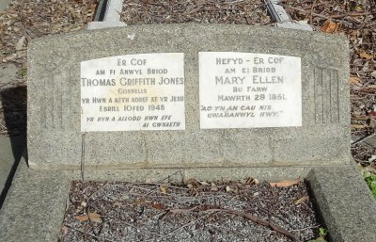
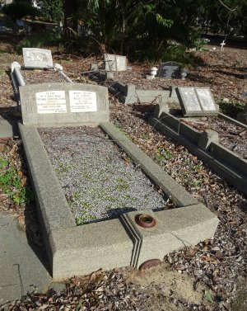
Marie Ellen Lloyd-Jones
BIRTH: 1889
DEATH: 27 Mar 1951 (aged 61–62)
BURIAL: Karrakatta Cemetery and Crematorium Karrakatta, Nedlands City, Western Australia, Australia
PLOT - Welsh Free-Aa-0127
Thomas Griffith Jones
BIRTH: 1885
DEATH: 10 Apr 1948 (aged 62–63)
BURIAL: Karrakatta Cemetery and Crematorium Karrakatta, Nedlands City, Western Australia, Australia
PLOT: Welsh Free-Aa-0127
In Memory of Also in loving memory of
About my dear husbandabout his wife
Who went home to jesudied
What this man could doand close us
Did heseparate them

From VWMA website:

Service Number: | 5027
Enlisted: | 25 February 1916
Last Rank: | Sapper
Last Unit: | 3rd Tunnelling Company (inc. 6th Tunnelling Company)
Born: | Carnarvonshire, Wales, 1882
Home Town: | Greenbushes, Bridgetown-Greenbushes, Western Australia
Occupation: | Miner
Died: | Perth, Western Australia, 10 April 1948, cause of death not yet discovered
Cemetery: | Karrakatta Cemetery & Crematorium Welsh Free - Aa-1027
Memorials: | Busselton War Memorial

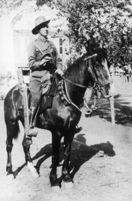
There is:

2786 Thomas Griffith Jones
served with the 2nd Remount Unit and 11th Light Horse Regiment in WW1
Born in Wales - Married to Myrtle Jones.
Previously carpenter & builder – NME Poultry Farming in Kent.
In 1925 he was living in Eumundi, Queensland.

Photo: VWMA per Faithe Jones

