SAPPER GEORGE FRANK JARMAN
7792 – 2nd Tunnelling Company

Frank George Jarman was born 26 February, 1870 in Adelaide, South Australia the son of George and Elizabeth Mary Ann (nee Berridge) Jarman. At St Paul’s parish, Adelaide on 16 January, 1871 he was baptised. He spent most of his life in Lyndoch, Barossa Valley and he married on 9 May, 1892 to Elizabeth Emily Aird at Rosendahl Heights, S.A.

A snippet appears about his in 1910 with the following reported in the:
Bunyip (Gawler) Friday July 29, 1910:
LAW COURTS
Herman Engel was charged by George Frank Jarman with having assaulted him on Monday last. He pleaded guilty.
The informant said that they were working together on the Lyndoch-road. Defendant accused him of telling stories about him and threatened to break his neck. Witness told him not to do that and defendant struck him.
Fined £1 and costs £2 18s in all.

His wife Elizabeth died about 10 April, 1917 with the following arrangements placed in the:

A few months later he is in Brisbane, Queensland and volunteers for active service abroad at the Adelaide Street recruiting depot in Brisbane on 20 July, 1917. Forms of Attestation describe the forty-three-year-old widower as born in Hobart, Tasmania on 22 February, 1874 to lower his age and stood 164cms (5ft 4½ins) tall, weighing 60kgs (132lbs) with a chest expansion of 86-89cms (34-35ins) and had a fresh complexion with very poor sight in his right eye and fair vision in the left. His hair was brown. Distinctive marks were scars on his right leg and stomach. Religion was Church of England. Next-of-kin nominated was his daughter Miss Minnie Louisa Jarman of Lyndoch, S.A. and allotted three-fifths of his pay in support of her and his two children. He signed and took the Oath of Enlistment the same day.
The Advertiser (Adelaide) Wednesday April 11, 1917:
FUNERAL NOTICE
JARMAN—The FRIENDS of Mr GEORGE JARMAN are respectfully invited informed that the Remains of his late WIFE (Elizabeth) will be interred on WEDNESDAY, April 11, in the Lyndoch Church of England Cemetery.
R.T. WALLMAN & SONS Undertakers

Acknowledgement to the new recruits was published in the:

Brisbane Courier Saturday July 21, 1917:
RECRUITS IN BRISBANE – ONLY SEVEN OBTAINED YESTERDAY
Thirteen men offered their service for the A.I.F. at the Adelaide-street depot yesterday. Only seven were fit, five were referred to the P.M.O. and one was unfit.
The names of the volunteers are as follows, their addresses being Brisbane except where otherwise stated:
George Frank Jarman Article abridged
Basic training commenced with the Pioneers Depot at Enoggera Barracks until 1 August when allotted to the Miners Depot (1st Military District). On 10 August was transferred to their training camp at Seymour, Victoria and on August 28 was sent for further training to Bendigo. Final home leave was taken during this time.

Discipline was taken for the following while in Bendigo:

Offence: Bendigo 27/9/17 Improperly dressed on parade
Award: Fined 1 shilling
On November 2 the recruits returned to Seymour and placed with the November, 1917 Reinforcements to the Tunnelling Companies.

In preparation for departure Military Authorities noted his Will had been lodged with his daughter Miss Minnie Jarman at Lyndoch, S.A. His rank was Sapper with the regimental number 7792.

An overnight stay at Broadmeadows camp, near Melbourne, Vic on November 20 ensured the men were ready for departure the following day.

The troopship HMAT A71 Nestor departed Port Melbourne, Vic on November 21, 1917 with 168 Reinforcements on board. The voyage of twenty-five days duration terminated at the Suez on December 15, 1917 and the men disembarked going to the Australian Infantry Camp, Suez the same day. They entrained for Alexandria on January 4, 1918 and marched into the Australian Camp, Gabbary, in Alexandria on January 5.

On January 9, 1918 the Reinforcements left Port Said aboard the H.M.T. B:102 Kashgar arriving at Taranto, Italy on January 20. A week later in Italy were entrained at Bordighira on January 27 and reached Cherbourg, France at the end of the month. On January 31, 1918 the H.M.T. C.O.168 Mona’s Queen conveyed them across the English Channel where they disembarked at Southampton, England on February 2, 1918. A further entrainment completed their journey to Tidworth and they marched into No. 3 Details Camp at Parkhouse.

The Reinforcements proceeded to France from Southampton on 10 March, 1918 arriving at the Aust General Base Depot in Rouelles the next day. On 16 March left the Aust Corps Depot in Caestre for the 2nd Tunnelling Company in the field and was taken on strength three days later where the Company was working in hard chalk at Trescault. Enemy activity was intense with 60,000 gas shells were fired on the Corps front with no further casualties.

The Unit Diary of the 2nd Tunnelling Company recorded the following:

“15/3/18
20 further reinforcements marched in from Aust Corps Depot.”

He was with his unit when Peace was declared and the Tunnelling Companies remained on the front as part of the Army of Occupation assisting with rehabilitation of their district by clearing roads and bridges of booby traps left by the enemy.

On 5 December, 1918 Sapper marched out to the Aust General Base Depot to appear before the Medical Board and four days later returned to the No. 2 Command Depot at Weymouth.

At the Verne Citadel, Portland on 13 December he was assessed by a Medical Board and his statement of case reads:
Disability: Premature senility (decline or deterioration of physical strength or mental functioning)
Origin of disability: March 15 – prior to enlistment
Place of disability: Australia
Essential facts: Age 46. Has not been able to do any marching because of
deformity of right foot from old injury. Otherwise feels well.
Aggravated by: Constitutional
Present condition: Looks a good deal older than 46. Heart: myocardial changes
Arteries: some sclerosis
Disabilities: Deformity (rt) foot, old injury
Degree of disablement: less than 20%
Recommendation: permanently unfit for general service – fit for home service

Sapper Jarman embarked for Australia from Devonport, England on 18 January, 1919 on board H.T. Ulysses. Medical notes during the voyage stated “no change. Urine, normal.” His berth for the voyage was a hammock. Base Records advised his daughter on 6 February that he was on his way home.

The soldiers arrived in Adelaide (4th Military District) on 1 March, 1919 and went into quarantine. News of their impending release was announced in the:
The Journal (Adelaide) Saturday March 8, 1919:
TROOPS RETURNING TOMORROW – ULYSSES AND DELTA
Troops to arrive by the Ulysses and Delta will be released from quarantine tomorrow and will be at the Outer Harbour at 2.30 p.m. The special train to meet the Delta will leave the Adelaide Station at 2.7 and arrive at the Harbour at 2.35 p.m.; leaving again at 4.5 p.m. Both trains will stop at all stations both ways.

He appeared before the Disembarkation Medical Board at Keswick Barracks on 10 March, 1919 and his case reads:

Medical History: Has not been able to do any marching because of deformity of
Right foot from old injury. Otherwise feels well.
Disability: aggravated by service
Present condition: Feels quite well & able to work
Recommendation: Fit for duty. Incapacity nil
Dentally fit
He was sent to the Staff Officer for Invalids and Returned Soldiers for disposal.

Military discharge was issued in Adelaide (4th M.D.) on 25 March, 1919 on termination of his period of enlistment.

Keswick Barracks forwarded on 10 April, 1919 to Base Records his service documents and medical board proceedings stating he returned to Adelaide on 9 March, 1919. Discharge due to cessation of hostilities was issued on 25 March, 1919 after serving 1 year and 248 day of which 1 year and 109 days was served abroad.

For serving his country Sapper 7792 George Frank Jarman, 2nd Tunnelling Company was issued with the British War Medal (22060) and the Victory Medal (21434).

George Frank Jarman passed away in the Adelaide Hospital on 23 July, 1928 aged 59 years. Announcement was made in the:
Advertiser (Adelaide) Wednesday July 25, 1928:
DEATHS
JARMAN—On the 23rd July, at Adelaide Hospital, George Frank, loving father of Minnie, Bert, Vince, Linda and Myra. A cheerful sufferer at rest.

Interment took place in the Light Oval of the War Cemetery, West Terrace Cemetery, Adelaide along road QN at side No. 5.

His family placed the following in the Bereavement Notices of the:
Chronicle (Adelaide) Saturday August 11, 1928:
RETURN THANKS
THE FAMILY of the late GEORGE JARMAN wish to THANK all Friends and Relatives for expressions of sympathy and beautiful floral tributes, also thanking Sister and Nurses of Flinders Ward for kindness and attention given to our Dad.
The Cemetery Trust advised Base Records on 19 September, 1928 that the former soldier had died in Adelaide on 23 July, 1928 and was buried in the A.I.F. Cemetery, West Terrace, Adelaide, S.A.
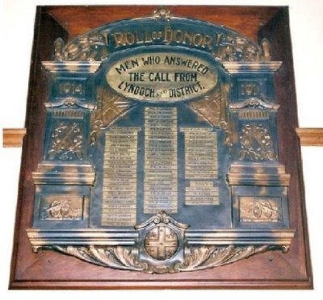
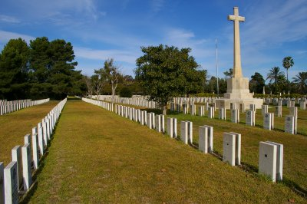
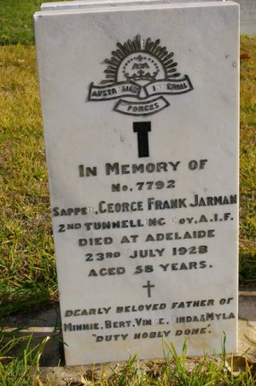
Lyndoch and District Roll of Honour, Lyndoch, S.A.
Photo sourced from Virtual Anzacs website
Adelaide War Cemetery,
South Australia
Photos courtesy Heather Pearce

His service is also commemorated on the Lyndoch and District Roll of Honour, in the Lyndoch Institute, Barossa Valley Way, South Australia.

© Donna Baldey 2023
www.tunnellers.net

