SAPPER FRANCIS JOHNSON HUNT
4361 – 3rd Tunnelling Company

St Arnaud, Victoria was the birthplace of Francis Johnson Hunt in 1878 and the son of Charles Alfred and Hannah Elizabeth (nee Bishop) Hunt. His sister Clementine Alberta Hunt was born in 1887. He moved to Western Australia and worked as a drover on Puree Creek Station, Gascoyne.

At the recruiting depot in Perth, W.A. on 28 January, 1916 the thirty-eight-year-old drover of the Globe Hotel, Perth applied to enlist for active service abroad and passed the medical examination. Attestation forms describe him as 178cms (5ft 10ins) tall, weighing 70.5kgs (155lbs) with a chest expansion of 86-92cms (34-36ins). Fresh was his complexion with grey eyes and brown hair and religious faith was Presbyterian. His parents’ address was unknown and nominated his sister Alberta Hunt of Raglan Street, St Arnaud, Vic as next-of-kin. He signed and took the Oath of Enlistment the same day,

Basic training commenced on 8 February, 1916 with Area 3 at Blackboy Hill Camp, near Perth until 10 March when allotted to the No. 6 Tunnelling Company.

Recruiting for the No. 6 Tunnelling Company had commenced on March 7, 1916 by Captain Lawson and his four officers. Instruction classes were formed of officers and N.C.O.’s as there was insufficient time to attend the Engineer’s School in Sydney. Recruits were forthcoming in abundant numbers and the aim was to have good physical types of skilled W.A. Miners.

At Blackboy Hill camp the new company paraded daily with sister companies until March 27 when the Company moved camp to Belmont camp. Hunt arrived at the camp where four sections were created and training continued through April and May. His rank was Sapper with the regimental number 4361.

The remainder of May was occupied in the usual training: musketry, trench work and night work while equipment and clothing issue was also in progress. Here a difficulty was met in that the general size of the men was considerably above the average and some little trouble was experienced in getting all accurately fitted.

Early in May, 1916 the No. 4 Tunnelling Company consisting of six officers and 152 other ranks together with the 1st Reinforcements of fifteen other ranks making up two sections, embarked from Brisbane, Qld aboard HMAT A69 Warilda for Sydney, NSW.

At Rosebery Park, Sydney, NSW they joined their Headquarters and two sections (8 officers & 153 O.Rs.) plus 1st Reinforcements consisting of one officer and seventeen other ranks for final training.

The 7713-ton transport Warilda departed Sydney, NSW on May 22, 1916 and collected in Melbourne, Victoria the No. 5 Company recruited from Victoria, South Aust. & Tasmania made up of Headquarters and 2 Sections (8 officers & 173 men) (3 M.D.). One Section from Tasmania (3 officers & 76 O.R’s); also 1st Reinforcements for No. 5 Company (17 men from Vic. & 8 men Tas.) The ship departed on May 25, 1916 for Adelaide, S.A. to collect one Section of 3 officers & 76 O.R’s with 1st Reinforcements of 8 O.Rs.

The No. 6 Company paraded through the city of Perth where the fine physique of the men, who marched with arms bare to the elbow excited universal admiration.
The West Australian Wednesday May 31, 1916:
THE TUNNELLING COMPANY - PARADE THROUGH CITY STREETS
Although the numerical strength of the troops which paraded the city streets yesterday morning was considerably less than that of previous parades, and despite the fact that citizens have become accustomed to the sight of khaki-clad warriors, the men of the No.6 Tunnelling Company and the Claremont N.C.O. school met with a hearty reception as they swung along to the inspiriting music of the Blackboy Hill band. The line of route was freely bedecked with flags, whilst the large crowds, if somewhat undemonstrated denoted none the less by their presence their keen appreciation of that sense of patriotism which found its highest expression in the long line of soldiers answering to the call of Empire. Contd.
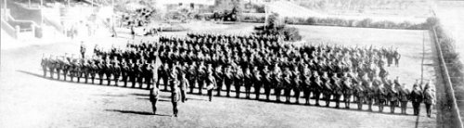
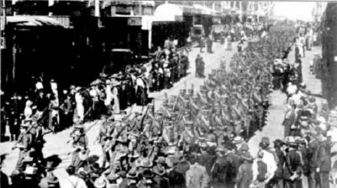
The West Australian June 1, 1916:
THE WESTERN MAIL
The war pictures appearing in this week’s issue of the Western Mail:
In addition, the “Mail” contains a fine photograph of the No.6 Tunnelling Company, as well as an illustration of their march through the streets of the city on Tuesday last, and a photograph of the officers who have been appointed to command the men.
Continues
In physique and general bearing the men were equal to their comrades who have gone before. Leaving James-street well on appointed time, the column swung into Beaufort-street and over the bridge in to Barrack-street. The members of the N.C.O. school, about 113 strong, under Captain Thompson, followed the band, the No.6 Tunnelling Company, with its first reinforcements, totalling nearly 400 men, under Captain Lawson, bringing up the rear. At the head of the Tunnellers was borne the flag recently presented to the company.
After traversing Barrack and Hay streets the column entered St George’s-terrace via Victoria-avenue. Opposite Government House his Excellency (Sir Harry Barron), with whom were the State Commandant (Colonel J.H. Bruche), Major P.H. Meeks and Major Wilkinson, A.D.C., took the salute. Passing along the Terrace the route was via William and Wellington streets to the station. The men paraded in full fighting equipment.
The No.6 Tunnelling Company - Photograph taken at the W.A.T.C. Course, Belmont, where the men have been in training
Tuesday’s parade of troops. The No.6 Tunnelling Company and the members of the N.C.O. School,
Claremont, marching through the city.

The transport arrived in port at Fremantle, W.A. on June 1, 1916. The whole company consisting of 14 officers and 325 O.R’s along with 1st Reinforcements of 1 officer and 32 O.Rs entrained at Belmont at 2 p.m., every man physically fit being present and boarded Warilda which left the harbour the same evening.
Durban, South Africa was reached on June 16, 1916 and Cape Town on June 21, 1916 while St Vincent completed the African ports of call on July 7, 1916. Discipline was fairly good except at intermediate ports where Away without Leave caused concern. The fifty-eight-day voyage experienced remarkable pleasant weather terminating at Plymouth, England on July 18, 1916. Four, Five and Six Companies comprising of 1064 officers and other ranks were detrained to Amesbury and Tidworth to begin training for the front at Perham Downs.

The Reinforcements proceeded overseas to France on 28 August, 1916 arriving at the 2nd Aust Divisional Base Depot on August 30. Sapper proceeded to join the 3rd Tunnelling Company on September 25 and was taken on strength five days later.

In the After War Report of the 3rd Tunnelling Company the following was recorded on their arrival:

“On 25/9/16 took place the absorption of the 6th Aust. Tnlg Coy which marched in from Etaples. It consisted of 10 officers & 209 O.Rs”

His service continued and was issued with two Blue Chevrons to wear on his uniform on 1 June, 1917 for serving twelve months abroad.

He was in the Mess Hall of the 3rd Tunnelling Company when photographed on 30 January, 1918 at Noeux-les-mines:
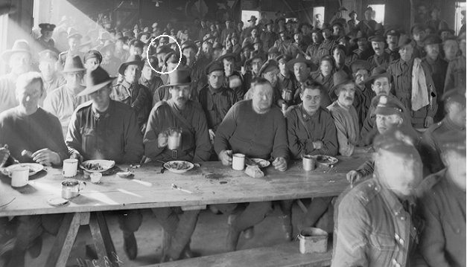
AWM Image Id E01640 - Mess Hall of 3rd Tunnelling Company. Spr. Francis J. Hunt identified as circled

He was a recipient of Comfort Gifts from the Kalgoorlie Women’s Committee and signed the thank-you letter which was re-published in the:
Kalgoorlie Miner Tuesday April 16, 1918:
TUNNELLERS’ COMFORTS
MEN WHO RECEIVED THEM
Sometime ago gifts were despatched to the front by the No. 1 Tunnelling, Pioneers and Engineers committee, and a list of recipients has now been received by the secretary, Mrs R.M. Jordan as follows—No. 4381 F.J. Hunt
Article abridged

In an audit of the company was noted to be still serving on 26 April, 1918.

When Peace was declared he was still with his unit. The Tunnelling Companies remained on the front as part of the Army of Occupation assisting with rehabilitation of their district by clearing roads and bridges of booby traps and delayed action mines left by the enemy.

Leave was granted from the Furlough Department and taken from 7th to 24 December, 1918.

Orders were received on 6 May, 1919 to return to the Base Depot to prepare to return to England but the following day was admitted to the 39th General Hospital (N.Y.D. – not diagnosed yet). On 12 May was transferred from Havre to England and admitted to the 1st Aust Dermatological Hospital at Bulford for treatment of a social disease. Discharged after about six days on 19 May, 1919 to the Convalescent Training Brigade camp.

After demobilisation Sapper Hunt embarked from Liverpool, England on 1 August, 1919 in board H.T. Argyllshire. Base Records advised his sister on 27 August that he was returning home.

His name appeared in the list of returning soldiers published in the:

Western Argus (Kalgoorlie) Tuesday September 9, 1919:
RETURNING AUSTRALIANS – TWO STEAMERS LISTS
The following is a list of West Australian members of the Australian Imperial Force returning per S.S. Argyllshire:
Spr. F.J. Hunt Article abridged

His sister Alberta Hunt wrote to Base Records from Raglan Street, St Arnaud on 1 September, 1919 asking does her mother get a pass from them or Perth? She would like to know as it would not give them much time to write there; as she did not have a father and her mother was up in years could she have the pass in her name? She wondered if needed getting somebody here to sign as her mother had been there 44 years. They could not get two passes, hoping it was not putting them to any trouble and hoped advice comes as soon as possible.

Base Records replied on 5 September, 1919 acknowledging her communication about her brother noting that permission was given to members of the A.I.F. returning to Australia, to proceed to the State where their relatives reside and this soldier will avail himself of this opportunity. On assumption that he does two tickets were forwarded for admission to the finalising depot. As she was registered as next-of-kin she would be entitled to the railway concession should her brother decide to disembark in Melbourne, but it would be necessary to pay her own fare and when in this city apply to the Staff Officer of Invalids, Returned Soldiers, Victoria Barracks for a refund, producing your return ticket and the form attached, filled in.
According to the instructions on the Application form, one pass is only available in her case.
To ensure his proceeding to Melbourne she could, if desired, communicate with the Military Commandant, Keswick Barracks, Adelaide, South Australia (that being his first port of call) requesting that her brother was informed of her wish.

Sapper returned to Perth (5th Military District) and appeared before the Disembarkation Medical Board at No. 8 Aust General Hospital on 25 September, 1919 and his Statement of Case reads:
Any wounds or injury? Nil
Any illness on service? Nil
Soldier’s statement of present condition. Feels quite well. (Sgd.) F.J. Hunt.
Present condition: Heart, Lungs, Other organs – clear.
Hearing – good
Any abnormality? Nil
Dental: refused treatment
Recommendation: FD Approved: 30/9/19

Military Discharge was issued in Perth (5th M.D.) on 10 November, 1919 on termination of his period of enlistment.

He returned to Puree Creek Station, Gascoyne to work as a teamster and continued to be listed there.

The British War Medal (11154) and the Victory Medal (11027) were issued for serving his country to Sapper 4361 Francis Johnson Hunt, 3rd Tunnelling Company.

The Secretary of the Melbourne branch of the Department of Repatriation advised on 4 August, 1923 that no medical board proceedings were available vide their request.

Francis (Frank) Johnson Hunt passed away on 24 February, 1934 aged 56 years. Interment took place in Section C of Roebourne Old Cemetery, W.A.

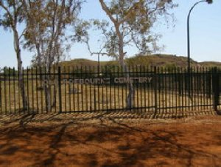
Roebourne Old Cemetery, W.A.
Photo sourced from Find-a-Grave website supplied by Teresa Fairbairn

© Donna Baldey 2021
www.tunnellers.net

