SAPPER GEORGE EDWARD HOPKINS
136 – 1st Tunnelling Company – 10th Field Corps Engineers

George Edward Hopkins stated he was born in Peckham, London, England in 1886 the son of Albert and Mary Ann (nee Eades) Hopkins. In 1901 the family were residing at Camden Square North, Camberwell, London and residents were Albert (58) labourer, Mary Ann (45), Emily (19), George (15) book folder, Joseph W.K. (12) and Maude (10).

George married in 1906 to Minnie Diamond and in 1911 they were living in a three-roomed dwelling at 42 Stafford Street, Peckham and they were George (25) builders’ labourer, Minnie (26) with children Ethel Winifred Ada (4), Doris Louisa (3) and Stanley George Edward (10mths).

The family left London on 1 July, 1914 for Australia on the Aberdeen Liner Euripides and passengers were George (28) road labourer, Minnie (28), Ethel (7), Doris (6), Stan (3) and Oliver (2). The ship docked in Brisbane, Queensland on

He was working as a railway lengthsman at Minerva near Springsure in 1915.

At the Central Recruiting Depot in Rockhampton on 1 November, 1915 the twenty-nine-year-old married lengthsman applied to enlist for active service abroad and passed the medical examination. Attestation forms describe him as (5ft 7ins) tall, weighing 66kgs (146lbs) with a chest measurement of (36ins) and had a fair complexion with blue eyes and auburn hair. Presbyterian was his religious faith. Next-of-kin nominated was his wife Mrs Minnie Hopkins of Minerva Siding, via Springsure, Qld. The Oath of Allegiance was signed and taken the same day.

Acknowledgment to the departing recruits was published in the:
Morning Bulletin (Rockhampton) Wednesday November 3, 1915:
CENTRAL DISTRICT VOLUNTEERS – THIRTY-EIGHT MORE LEAVE
Thirty-eight more recruits accepted at Rockhampton, the headquarters of the Central military district, for service in the Australian expeditionary forces, have left for Brisbane this week. Thirty-eight were:
G.E. Hopkins, Springsure Article abridged

Basic training commenced at Enoggera Barracks, Brisbane until 28 November, 1915 then transferred to the Mining Corps joining other volunteers from across the country for training at Casula camp, near Liverpool, New South Wales. His rank was Sapper with the regimental number 136 in No. 1 Company. On 13 January, 1916 was appointed to be Second Corporal.

At a civic parade in the Domain, Sydney on Saturday February 19, 1916, a large crowd of relations and friends of the departing Miners lined the four sides of the parade ground. Sixty police and 100 Garrison Military Police were on hand to keep the crowds within bounds. The scene was an inspiriting one. On the extreme right flank, facing the saluting base, were companies of the Rifle Club School; next came a detachment of the 4th King’s Shropshire Light Infantry, then the bands of the Light Horse, Liverpool Depot, and the Miners’ on the left, rank upon rank, the Miners’ Battalion.

The Corps boarded HMAT A38 Ulysses in Sydney, NSW on February 20 and sailed for the European theatre. Arriving in Melbourne, Victoria on February 22 the Miners camped at Broadmeadows for a stay of 7 days while further cargo was loaded.

Another parade was held at the Broadmeadows camp on March 1, the Miners’ Corps being inspected by the Governor-General, as Commander-in-Chief of the Commonwealth military forces.

Leaving Melbourne on March 1, Ulysses arrived at Fremantle, Western Australia on March 7 where a further 53 members were taken on board.
On Wednesday March 8, 1916 the whole force, with their band and equipment, paraded at Fremantle prior to leaving Victoria Quay at 9.30 o’clock.

The ship hit a reef when leaving Fremantle harbour, stripping the plates for 40 feet and, although there was a gap in the outside plate, the inner bilge plates were not punctured. The men on board nicknamed her ‘Useless’. The Miners were off-loaded and sent to the Blackboy Hill Camp where further training was conducted.

The Mining Corps comprised 1303 members at the time they embarked with a Headquarters of 40; No.1 Company – 390; No.2 Company – 380; No.3 Company – 392, and 101 members of the 1st Reinforcements.

Finally departing Fremantle on April 1, Ulysses voyaged via Suez, Port Said and Alexandria in Egypt. The captain of the ship was reluctant to take Ulysses out of the Suez Canal because he felt the weight of the ship made it impossible to manoeuvre in the situation of a submarine attack. The troops were transhipped to HM Transport B.1 Ansonia, then on to Valetta, Malta before disembarking at Marseilles, France on May 5, 1916. As a unit they entrained at Marseilles on May 7 and detrained on May 11 at Hazebrouck.

A ‘Mining Corps’ did not fit in the British Expeditionary Force, and the Corps was disbanded and three Australian Tunnelling Companies were formed. The Technical Staff of the Corps Headquarters, plus some technically qualified men from the individual companies, was formed into the entirely new Australian Electrical and Mechanical Mining and Boring Company (AEMMBC), better known as the ‘Alphabetical Company.’

The No. 1 Company was officially transferred to the 1st Tunnelling Company on 24 December, 1916 in the field.

During April, 1917 the company was working on the underground mining system at Hill 60 and Caterpillar (Hill 59) in Belgium and were situated at Poperinghe.

2nd Corporal was transferred on 23 April, 1917 to the 3rd Aust Division Engineers and the following day sent to the 10th Field Company Engineers and placed on the supernumerary list. On 8 June was taken on strength with the company due to 2nd Corporal Woolford being killed in action.

On 2 August, 1917 proceeded overseas on leave and returned to duty on August 16.

At his own request on 31 March, 1918 requested that he revert in ranks due to financial reasons which were approved.

Proceeded to England on leave on 21 September, 1918 and on 8 October returned to duty.

On 5 November, 1918 went sick to the 9th Aust Field Ambulance then transferred to Convalescent camp and two days later went to 108th Company.

Was detached to school on 8 December, 1918 and re-joined his unit on 26 January, 1919.

Sapper marched out for demobilisation with Quota no.12 to the Aust General Base Depot in Havre. As an enlistee of 1915 was eligible for early return to Australia and left on February 28 arriving in England the following day at Weymouth. Marched out to the Overseas Training Brigade on 1 March, 1919 to await his voyage home.

After demobilisation Sapper Hopkins embarked for Australia on 1 May, 1919 on H.T. Karagola. Base Records advised his next-of-kin on 21 May that he was returning home.
His name was among those listed as returning in the:
Queenslander (Brisbane) Saturday June 14, 1919:
PER H.T. KARAGOLA
136. Spr. G.E. Hopkins, 10th F.C.E., R’ton. Article abridged

The troopship docked in Sydney (2nd M.D.) on 14 June, 1919 with news of their arrival reported in the:
Sydney Morning Herald Monday June 16, 1919:
SUNNY WELCOME – SOLDIERS BY THE KARAGOLA
The returned New South Wales and Queensland soldiers who came from England in the troopship Karagola had a morning of sunshine for their landing in Sydney on Saturday last. The contingent was made up of 11 New South Wales men and 23 Queenslanders.
Accommodation was provided by the Red Cross Society for the Queenslanders at Richmond-terrace near the Macquarie-street entrance to the domain.

The Queenslanders boarded the train for Brisbane (1st M.D.) and were welcomed on arrival at Central station on June 16 with their arrival covered in the:
Telegraph (Brisbane) Tuesday June 17, 1919:
SOLDIERS WELCOMED HOME
The soldiers came back from the front by the troopship, Karagola and a hearty public welcome awaited them on arrival in Brisbane last night, by the Sydney mail train, shortly before 8 o’clock. On the platform, amongst others at the Central railway station were the State Commandant (Brigadier-General Irvine), the Minister for Agriculture (Hon. W. Lennon), the mayor (Ald. A.P. Buchanan) and Mayoress (Mrs Buchanan), Major W.P. Brown and Captain Piers Blundell.
Headed by the Army Reserve Band the soldiers were conveyed in motor cars through the city to Kangaroo Point Military Hospital where they were given supper by the ladies of the Red Cross kitchen.
Article abridged

Military Discharge was issued in Brisbane (1st M.D.) on 31 July, 1919 on termination of his period of enlistment. The British War Medal (12134) and the Victory Medal (11995) were issued for serving his country to Sapper 136 George Edward Hopkins, 1st Tunnelling Company / 10th Field Company Engineers.

About a fortnight later he applied for his marriage to be annulled as reported in the:
Gympie Times and Mary River Mining Gazette Tuesday August 12, 1919:
MATRIMONIAL SUITS
George E. Hopkins desires his marriage with Minnie Hopkins of Corinda near Aramac to be annulled.

His application for a divorce from his wife went before the Supreme Court which was granted and custody of the children which was reported in the:
Capricornian (Rockhampton) Saturday December 20, 1919:
DIVORCE ACTIONS
The action instituted by George Edward Hopkins, returned soldier, fencer, Wattlegum, near Bundaberg, for a divorce from Minnie Hopkins (nee Dymond), on the ground of misbehaviour with Patrick Connor, an employee of the Emerald Shure Council, again came before His Honour Mr Justice Lukin in the Supreme Court on Tuesday. Mr J. Pattison appeared for the petitioner and Mr E.R. Larcombe, instructed by Messrs Haber and Powell, for the co-defendant. The action had been adjourned from the 6th of November las because notice of trial on the defendant had not been proved, and it had, therefore, to be posted up in the office of the Supreme Court for sixteen days. His Honour granted a decree nisi, making it returnable in three months, and gave the petitioner the custody of the children which were the issue of the marriage.
Base Records received a request from the Repatriation Commission in Adelaide for a copy of his service records and prepared on 22 March, 1922.

The Melbourne Branch of the Repatriation Commission requested a copy of his service from Base Records which was prepared on 28 November, 1922.

He applied to Base Records for both his medals which were forwarded to him and delivery receipted on 27 June, 1936.

On 1 November, 1948 Base Records sent as per a request from the Sydney branch of the Repatriation Commission for a copy of his service records.

George Edward Hopkins passed away on 13 September, 1965 at Enfield, Sydney and interment took place in the Anglican portion sub-section 15 of Rookwood Cemetery within Zone D in grave no. 2675 the following day. He has a Commonwealth War Grave.

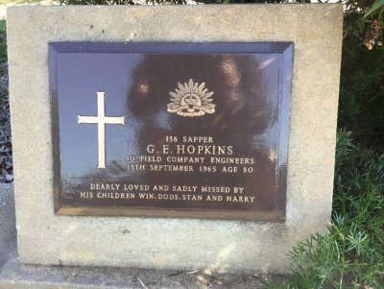
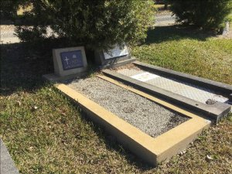
His Commonwealth War Grave in Rookwood Cemetery, Sydney
Photos supplied by Dept. of Veterans’ Affairs and used with permission
The Public Trustee, Sydney wrote to Base Records on 2 February, 1968 advising of his death and inquired if he had made a Will during his service with the First A.I.F.

Base Records replied on February 12 that records from their office did not reveal the final disposal of any Will executed by the late former soldier.
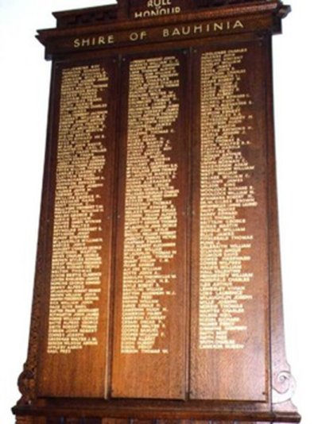
Shire of Bauhinia Roll of Honour
held at Memorial Hall and Shire Chambers, Springsure
photo sourced from Virtual War Memorial Australia
The Pensions Office of the RSL Brisbane wrote on 5 June, 1969 to Base Records requesting a certificate of service relative to the former soldier. This was completed on 14 June, 1969.

His name is commemorated on the Springsure Shire of Bauhinia Roll of Honour.
© Donna Baldey 2024
www.tunnellers.net

