SAPPER JOHN MILLAR HARTLEY
4351 – 3rd Tunnelling Company

Born at Benalla, Victoria in 1890, John Millar Hartley was the son of James and Anne (nee Sumner, formerly Weibye) Hartley.

He married Marion Holt at East Coolgardie, Western Australia in 1916. Marion was the daughter of John and Sarah (nee Quartermaine) Holt.

The 26-year-old toolsmith signed the ‘Attestation Paper of Persons Enlisted for Service Abroad’ on 1 March 1916 at Area 54 – Goldfields Senior Cadets, Kalgoorlie, stating he had previously been rejected due to eyesight. He gave his address as Kookynie Post Office. The 1916 & 1917 Electoral Rolls record John Miller Hartley as a miner living at Kookynie, WA.

Named as his Next-of-Kin his wife, Marion Hartley of 38 St Georges Terrace, Perth, WA and allotted four fifths of his pay for the support of his wife.

A medical examination the same day recorded that he was 26 years and 7 months of age. He stood 5ft 6ins tall and weighed 129 pounds. He had a ruddy complexion and brown hair. His brown eyes were graded as R6/6 & L 6/36. He was of the Church of England faith.

He was appointed to No.6 Tunnelling Company on 1 March and signed the Oath to ‘well and truly serve’ on 14 March at Blackboy Hill, WA

In 1916 thru 1919, Marion is recorded living at 13 York Street, Subiaco, WA, performing home duties,

He embarked at Fremantle on board Warilda.

Two Sections of the Northern recruits to form the No.4 Company had embarked from Brisbane, Queensland early in May, 1916 aboard HMAT A69 Warilda for Sydney, New South Wales (NSW). Six officers and 152 other ranks (O.R.s) together with the 1st Reinforcements of fifteen other ranks made up the two sections.

At Rosebery Park, Sydney, NSW they joined their Headquarters and two sections (8 officers & 153 O.Rs.) plus 1st Reinforcements consisting of one officer and seventeen other ranks for final training.
Sydney Morning Herald - Monday May 22, 1916:

THE TROOPS

INSPECTION AT MOORE PARK
“In the presence of a crowd of 10,000 people the District Commandant, Brigadier-General Ramaciotti, V.D., held an inspection of troops at Moore Park, on Saturday afternoon. The troops consisted of Field Artillery, Tunnelling Section (including Queenslanders), under Major Vincent; Infantry, under Lieutenant Owen Gibbs, under Captain Brosnan, the whole parade being under the command of Major Holman, D.S.O.
Prior to arrival of the commandant and his staff, the men were drawn up in columns of companies on the Dowling-street side of the ground, facing the tramline. The bands of Liverpool Headquarters and the Engineers played selections of music.
Brigadier-General Ramaciotti, V.D. made a close inspection of the lines. Returning to the saluting base the Commandant took the salute as the various units marched past in columns of companies, and again as they returned headed by the band in columns of fours.
One company had with it a small kangaroo as a mascot. The animal was held on a ribbon, but when it drew level with the saluting base it bobbed up and down as if anxious to do its share in the saluting lines as its male friends were doing. Its antics were so ludicrous that the crowd roared.
At the conclusion of the inspection the men were marched across to the Royal Agricultural Ground, where they were provided with temporary quarters.”
Abridged

The 7713 ton transport departed Sydney, NSW on May 22, 1916 bound for Melbourne, Victoria, where the Headquarters and 3 Sections of No.5 Company boarded the transport.

Two of those Sections, 8 Officers and 173 O.R.s, had been recruited in Victoria. The third Section of 3 Officers and 76 O.R.s had been recruited in Tasmania. Also boarding in Melbourne were the 1st Reinforcements for No.5 Company; 17 men from Victoria and 8 from Tasmania.

The ship departed Melbourne on May 25, 1916 for Adelaide, S.A. where one Section of 3 officers and 76 O.Rs with 1st Reinforcements of 8 O.Rs, boarded Warilda to complete No.5 Company.
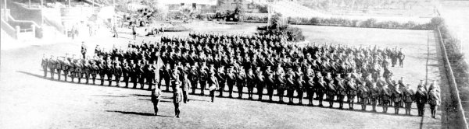
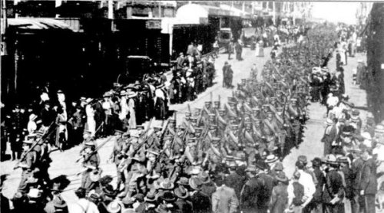
The West Australian June 1, 1916:

THE WESTERN MAIL

The war pictures appearing in this week’s issue of the Western Mail:
In addition, the “Mail” contains a fine photograph of the No.6 Tunnelling Company, as well as an illustration of their march through the streets of the city on Tuesday last, and a photograph of the officers who have been appointed to command the men.
The West Australian Wednesday May 31, 1916:
THE TUNNELLING COMPANY
PARADE THROUGH CITY STREETS
Although the numerical strength of the troops which paraded the city streets yesterday morning was considerably less that that of previous parades, and despite the fact that citizens have become accustomed to the sight of khaki-clad warriors, the men of the No.6 Tunnelling Company and the Claremont N.C.O. school met with a hearty reception as they swung along to the inspiriting music of the Blackboy Hill band. The line of route was freely bedecked with flags, whilst the large crowds, if somewhat undemonstrated denoted none the less by their presence their keen appreciation of that sense of patriotism which found its highest expression in the long line of soldiers answering to the call of Empire. In physique and general bearing the men were equal to their comrades who have gone before. Leaving James-street well on appointed time, the column swung into Beaufort-street and over the bridge in to Barrack-street. The members of the N.C.O. school, about 113 strong, under Captain Thompson, followed the band, the No.6 Tunnelling Company, with its first reinforcements, totalling nearly 400 men, under Captain Lawson, bringing up the rear. At the head of the Tunnellers was borne the flag recently presented to the company.
After traversing Barrack and Hay streets the column entered St George’s-terrace via Victoria-avenue. Opposite Government House his Excellency (Sir Harry Barron), with whom were the State Commandant (Colonel J.H. Bruche), Major P.H. Meeks and Major Wilkinson, A.D.C., took the salute. Passing along the Terrace the route was via William and Wellington streets to the station. The men paraded in full fighting equipment.
The No.6 Tunnelling Company - Photograph taken at the W.A.T.C. Course, Belmont, where the men have been in training
Tuesday’s parade of troops. The No.6 Tunnelling Company and the members of the N.C.O. School, Claremont, marching through the city.
Docking at Fremantle, W.A. on June 1, 1916 No.6 Company had been recruited in W.A. and the 14 Officers and 325 O.R.s, along with their 1st Reinforcements of 1 Officer & 32 O.Rs, were taken on board and Warilda departed the same day for the European theatre. Durban, South Africa was reached on June 16, 1916 and Cape Town on June 21, 1916 while St Vincent completed the African ports of call on July 7, 1916.

Discipline was fairly good except at intermediate ports where soldiers going Absent Without Leave caused concern. The fifty-eight day voyage experienced remarkably pleasant weather and terminated at Plymouth, England on July 18, 1916. Four, Five and Six Companies comprising of 1064 officers and other ranks were detrained to Amesbury and Tidworth to begin training for the front.

John Hartley proceeded overseas to France on 1 June 1916 and marched in to the 2nd Australian Divisional Base Depot on 30 August. On 25 September he marched out to join the 3rd Australian Tunnelling Company (3ATC) and was taken on strength on 30 September.

3ATC first saw action at Boars Head in the lead up to the Fromelles diversion ‘stunt’ of 19 July 1916. The Company was allocated to the First Army and was engaged variously at Laventie-Fauquissart, Givenchy, Loos, Lens, Double Crassiers and Vermelles and other places on the Western Front. On 27 November 1916 at the ‘Black Watch Sap’, Hill 70, an enemy camouflet (or a premature explosion, depending on different accounts) killed 20 members of the company. The next day 2 more members were killed in the same area by an enemy camouflet. The 22 members of 3ATC were buried in 14 adjacent graves at the Hersin Communal Cemetery Extension. The Companies major effort was at Hill 70 where they constructed the extensive Hythe Tunnel system.

John was working underground at Loos when their trenches were raided by the enemy early on 5 January, 1917.

In the Unit Diary of the 3rd Tunnelling Company the following Raid Report was recorded:

Report on Enemy Raid at Loos on 5 January 1917
“The enemy raided our trenches at 5/45 a.m. on 5 January 1917: his apparent course was as follows:
He entered our system by Seaforth Crater, destroyed No.21 Shaft with a mobile charge leaving behind a heavy unexploded charge, he proceeded down Seaforth Alley and turned east along the support line; at the same time sending a party with mobile charges along Pioneer Trench to Seaforth Slant. This latter party was apparently disturbed by two of our Sappers, and did not light the four heavy Mobile charges that they had placed in the Shaft.
The main party proceeded along the support line, took the three Proto men out of Mine Rescue Station and blew up the main entrance with a mobile charge forming a small crater. It is possible, but not probable that the three Proto men were buried.
Thence they proceeded to Gordon Alley bombing dug-outs as they went: they bombed Gordon in a line shaft main entrance, calling on a Sapper to surrender in English, but he went back into the mine. From Gordon the raiding party proceeded along the support line to Old Coy. Headquarters about 15 yards from Cameron Alley, when three of the raiders were killed. It is thought that they then turned back along the support line into Gordon Alley, and there bombed a dug-out causing casualties, and when returning to the Front line intercepted and captured four Listeners who were going back to the Billets in pairs. They were then heard going over the parapet singing at junction of Gordon Alley and front line by a N.C.O. who was in L.G. 13.
A Plan is attached shewing probable route and points attacked.
A.I.F. Casualties = 7 missing.
5/1/1917 – Officer Commanding 3rd Australian Tunnelling Company.”

In the After War Report of the 3rd Tunnelling Company the following was recorded on the incident:
“On 5/1/17 hostile raiding parties entered our lines carrying mobile charges. About 46 prisoners of the 8 Buffs 24th Division and 7 Australian sappers (4 listeners returning through trenches from Front Line Galleries to billets & unconscious of the raid & 3 mine rescue men in proto house) were made prisoners. The Infantry sentries on the shafts were caught napping and made prisoners before they could alarm the Tunnellers down below in the mines. After this raid the Tunnellers seldom trusted the Infantry but usually posted their own sentries when working from front line shafts. No 21 Shaft was destroyed by a mobile charge. The entrance of the mine rescue station was crumped in, and Listening Gallery No 11 in the front line was destroyed. Four mobile charges were placed in Seaforth Shaft, but they did not explode.
The seven sappers taken prisoners were :-
1310 Spr Vick, H. 983 Spr Dickson, F.
4351 “ Hartley, J.M. 4300 “ Clingin, G.
1055 “ Kane, J. 5023 “ McPherson, C.
4412 “ McCracken, A.

“In February, 1918, it was reported that these men were at Gefangenenlager Dulmen in Westphalia. The Aust. Branch of Red Cross Society sent comfort parcels & the Company Canteen Fund supplemented this with 50 francs per month. All these men were sent back to England after the signing of the Armistice on 11/11/18, except Sapper G. Clingin, who died at Chemitz, Germany on 31/10/18 11days before the Armistice.
These prisoners, on their return, gave reports of having received bad treatment in Germany where they were compelled to work in unhealthy mines and under most uncomfortable conditions.
“Also 4300 Spr Clingin, G. died of pneumonia at Chemnitz while a prisoner of War in Germany.
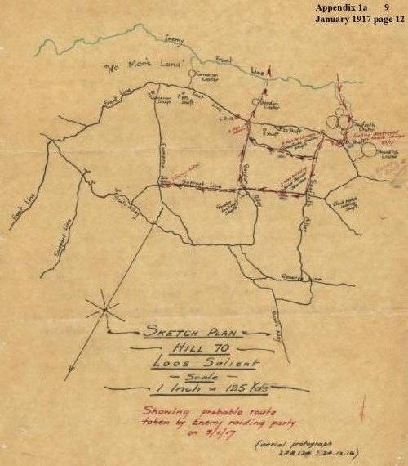
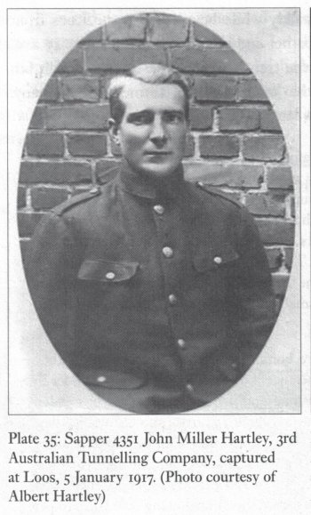
The company’s CO, Major Leslie Coulter, later described the raid:
He [the enemy] entered our system by Seaforth Crater, destroyed No.21 Shaft with a mobile charge. Leaving behind a heavy unexploded charge, he proceeded down Seaforth Alley and turned east along the support line; at which time sending a party with mobile charges along Pioneer Trench to Seaforth Shaft. This latter party was apparently disturbed by two of our sappers, and did not light the four heavy mobile charges that they had placed in the shaft. The main party proceeded along support line, took the three Proto men out of the Rescue Station and blew up the main entrance with a mobile charge forming a small crater. It is possible, but not probable that the three Proto men were buried.
Thence they proceeded to Gordon Alley Bombing dug-outs as they went: they bombed the Gordon Incline shaft main entrance, calling on a sapper to surrender in English, but he went back into the mine. From Gordon the raiding party proceeded along the support line to Old Coy. headquarters about 15 yards from Cameron Alley, when three of the raiders were killed. It is thought that they then turned back along the support line into Gordon Alley and there bombed a dug-out causing casualties, and when returning to the front line interrupted and captured four listeners who were going back to the billets in pairs. They were then heard going over the parapet singing at junction of Gordon Alley and front line by an N.C.O. who was in L.G. 10 [Listening Gallery 13].
Contd

Western Mail, Perth – Friday 30 March 1917:
THE ROLL OF HONOUR,
281st CASUALTY LIST.
5th MILITARY DISTRICT.
PRISONERS OF WAR.
Sapper H. Vick (Harcourt, Victoria), previously reported missing; Sapper F. Dixon, (Moonee Ponds, Victoria), previously reported missing; Sapper G. Clingin, (Bostock's Creek, Victoria), previously reported missing; Sapper J. M. Hartley (Perth), previously reported missing; Sapper A. McCracken (Hines Hill), previously reported missing; Sapper C. McPherson (Kalgoorlie), previously reported missing;
Article abridged to Tunnellers
continues
The Australian Tunnellers taken prisoner by the singing German raiders that morning were Sappers 983 Frederick Dixon, 4351 John Hartley, 4412 Alfred McCracken, 5023 Colin McPherson, 1310 Harry Vick, 1055 John Kane and 4300 George Clingin. John Kane was wounded in the leg by a grenade during the raid and recovered from the wound while in captivity. The men spent most of the war at the Dulman Prisoner-of-War Camp in Westphalia, Germany. With the exception of George Clingin, who succumbed to the Spanish Influenza epidemic two weeks before the Armistice, the Tunnellers were repatriated to Australia at the war’s end.
Crumps and Camouflets – Australian Tunnelling Companies on the Western Front: Damien Finlayson – p.159
Photo of John Hartley above from p.160
The West Australian, Perth – Tuesday 20 March 1917:
War Casualties
Mrs. J. Miller Hartley, 13 York-street, Subisao, has received word from the Military Department that her husband, Sapper J. Miller Hartley, is a prisoner of war in Germany. He was reported missing on January 4.
The West Australian, Perth – Tuesday 23 January 1917:
WESTERN AUSTRALIA.
ROLL OF HONOUR
THE 266th and 267th CASUALTY LISTS.
The 266th and 267th casualty lists were released by the Censor yesterday, and are published below. They contain the
names of Western Australian soldiers, together with those who enlisted elsewhere, but whose relatives reside in this State.
Where not otherwise specified the names are those of privates:

267TH LIST.
5th MILITARY DISTRICT.
MISSING.
Sapper A. McCracken (Hires Hill): Sapper F. Dixon (Moonee Ponds, Victoria); Sapper J. Kane (Perth); Sapper J. M. Hartley (Perth); Sapper G. Clingin (Camperdown, Victoria); Sapper C. McPherson (Kalgoorlie).
Article abridged to missing Tunnellers
Base Records kept Marion informed of the internment camps he was:
24 August 1917 - Dulman - 2 October 1917 and 30 November 1917 - Gefangenenlager

John Millar Hartley was repatriated to England on 22 November 1918.

On 23 November 1918 at No.33 South Camp, Ripon, he made the following statement as a repatriated Prisoner of War:

‘A party of us had been working down a sap in our front line. We knocked off work, and in company with Sapper McPherson, I started to make for our billets in the rear. We emerged from the sap, and after walking a little way along the trench, were surprised to find the Germans in full possession. This would be at about half past 5 o’clock in the morning of 5.1.17.
Of course we could not get away and perforce had to give ourselves up.’

He was granted furlough from 28 November, to report to Headquarters on 28 December 1918.

John returned to Australia, leaving England on 5 March 1919 on board Nevasa, disembarking at Fremantle on 20 April 1919. He was discharged from the A.I.F. on 5 June 1919 entitled to wear the British War Medal and the Victory Medal.

In 1921 the Electoral Roll records John Miller Hartley, farmer, living at Gorge Rock, Corrigin, with Marion.

A son, Donald Hector Hartley was born in Perth, WA in 1922.

The 1925 Electoral Roll records John Miller Hartley, farmer, and Marion Hartley, wife, living at Gorge Rock, Corrigin, WA.

John Millar Hartley died at Gorge Rock, Corrigin Shire, WA on 25 August 1926.
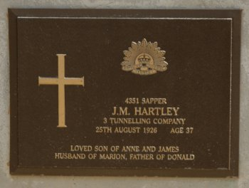
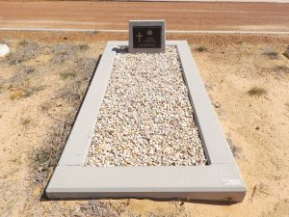
Western Mail, Perth – Thursday 2 September 1926:
DEATH.
HARTLEY.—On August 24, at his farm, "Nethercote," Gorge Rock, John Millar Hartley, loving husband of Marion, and dear daddy to Donald (Bubbles). Aged 37 years. Late A.I.F.
Thy will be done.
Image courtesy of Lorraine’s Cemetery Records Pages
www.ozburials.com

Image sourced from FindaGrave - Photo added by twood
www.findagrave.com
The 1928 / 1931/1934/1949 Electoral Roll records Marion Hartley, farmer, living at ‘Nethercote’ Corrigin, WA.

Marion Hartley (nee Holt) died 21 August 1956 aged 69 years and was buried at Corrigin Cemetery, Corrigin, WA.

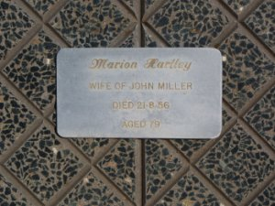
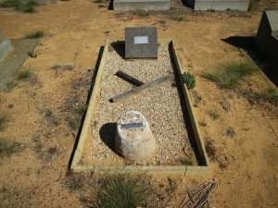
Image sourced from FindaGrave
Photo added by twood
www.findagrave.com
© Donna Baldey 2023
www.tunnellers.net

