SAPPER JAMES DICK GARDINER
3500A – 1st Tunnelling Company

Kirkintilloch, Dunbartonshire, Scotland was the birthplace of James Dick Gardiner on 30 April, 1871 the son of Edward and Euphemia (nee Gilchrist) Gardiner. Ten years later the family were living at 48 Westburn Rows, in the county of Lanarkshire and were Edward (44) coal miner, Euphemia (37) hand loom weaver, John (17) coal miner, James (10) scholar and Edward (8), William (4) and Robert (1).

The family left Glasgow, Scotland on the 2506-ton steamer Waroonga as immigrants to Queensland arriving at Brisbane on 2 October, 1885. Passengers were: Edward (39), Euphemia (37), James (16), Edward (11), William (9) and Robert (5). Brief news of their arrival was reported in the:
Queenslander (Brisbane) Saturday October 3, 1885:
SHIPPING ARRIVALS
OCT 1—WAROONGA, B.I.S.N. Company’s 2506-tons. Captain A.A. Fyfe, from Glasgow, via ports with 321 immigrants and a general cargo.

They went to the coal mining district of Ipswich. His father died in 1887 and the family continued to reside at Stafford Street, Booval. James is listed living there with his mother from 1912 to 1915.

He was declared provisionally fit for service at the recruiting depot in Ipswich and sent to Brisbane.

Acknowledgement to the new recruits was published in the:
Queensland Times (Ipswich) Friday December 3, 1915:
LOCAL RECRUITING
The local recruiting office (Dr M. Patterson) reports that yesterday seven men applied for enrolment in the Expeditionary Forces, of whom Edward Marsh, James Dick Gardiner, James Nugent and Whittaker P. Prince were accepted.

At the recruiting depot in Brisbane (1st Military District) on 3 December, 1915 the single miner deleted a couple of birthdays to give his age as 42 years when applying to enlist for active service abroad and passed the medical examination. Attestation forms describe him as 168cms (5ft 6ins) tall, weighing 66.3kgs (146lbs) with a chest expansion of 93-98cms (36½-38½ins) and a dark complexion with good vision in his grey eyes and grey hair. Distinctive marks were one vaccination scar on his left arm and scars above his right eye and scalp. Religion was Presbyterian. Next-of-kin nominated was his mother Mrs Euphemia Gardiner of Stafford Street, Booval, Ipswich, Q. The Oath of Enlistment was signed and taken the same day.

Basic training commenced with D. Coy, 9th Depot Battalion then moved for further instruction to the 17th Reinforcements to the 18th Battalion until 24 March, 1916 when allotted to the No. 4 Tunnelling Company. On 28 July was transferred to their training camp at Seymour, Victoria and placed with the Miners’ Reinforcements for further training. His rank was Sapper with the regimental number 3500 and placed with the 4th Reinforcements to the Tunnelling Companies.

The 81 Reinforcements embarked on the transport RMS Orontes on August 16, 1916 from Melbourne, Vic. The mail ship sailed to Adelaide, S.A. then Fremantle, W.A departing on August 23, 1916. After leaving the stormy Australian coast the vessel docked at the African ports of Durban, Capetown and St Vincent and after fifty-two days at sea of generally fine and mild weather arrived at Plymouth, England on October 2, 1916. They were detrained to Tidworth and marched in to No 3 Details Camp for further training for the front.

The Reinforcements proceeded overseas to France on 15 October, 1916 arriving at the Aust General Base Depot. On 9 November he was sent to the Segregation camp arriving back on December 4, 1916.
On 11 December was attached to the 1st Anzac Entrenching Battalion which was an advanced section of the Base Depot that organised works near the lines and through duties, usually of ten days duration, would accustom the reinforcements to war conditions before being assigned to a company in the field.

A memo from Headquarters in London had re-allotted his regimental number to 3500A from 10 January, 1917.

On 27 January, 1917 was taken on strength with the 1st Tunnelling Company who were situated at Poperinghe, Belgium and working on the underground mining system of Hill 60 and Caterpillar (Hill 59).

Sapper was wounded in action on 24 April, 1917 suffering a gunshot wound to his hip and arms and taken to the 71 Field Ambulance.

The Unit Diary of the 1st Tunnelling Company recorded the following:
“Poperinghe
April, 1917 23rd Shallows entered by Protomen: air good; crumped from 10 L.P. (Anzac) right
Shaft sounds & face work at A. D is quiet.
24th Some noises in A.: surface normal. 1 man wounded.”

Sapper was then moved to the 2nd Canadian Casualty Clearing Station until April 28 and conveyed on Ambulance Train no. 8 to Wimereux and admitted to the 14th General Hospital with a severe gunshot wound to his left hip.

On 30 April was invalided to England from Boulogne on the hospital ship St Andrew entering the Central Military Hospital, Chatham with a shell wound to left hip. He spent 52 days at Parkhouse V.A.D. Southborough under treatment for the shell wound.

The following Telegram was sent as follows:
3500/1TC BOOVAL Q
MRS GARDINER
STAFFORD STREET
REPORTED SAPPER JAMES GARDINER WOUNDED WILL ADVISE ANYTHING FURTHER RECEIVED
BASE RECORDS
7/5/17

Base Records notified her again on 19 May, 1917 that it was now reported that Sapper Gardiner was admitted to the Chatham Military Hospital on 30/4/17 suffering from gunshot wound hip. His address was given for correspondence.

His name appeared in the Casualty List published in the:
Northern Miner (Charters Towers) Wednesday May 23, 1917:
ROLL OF HONOUR – 301ST CASUALTY LIST
Casualty list 301 was issued this morning: The summary reads:
Sapper J.D. Gardiner, Booval Article abridged

Was discharged on 22 June to the 4th Scottish General Hospital, Stoliff until transferred to the No. 3 Command Depot at Hurdcott. Was noted to be absent without leave on 6 July, 1917. A transfer to the No. 2 Command Depot at Weymouth followed and marched in from Headquarters on 21 July, 1917.

He appeared before the Medical Board there on 22 July, 1917 and his Statement of Case reads:
Disability: Senility (decline or deterioration of physical strength or mental functioning)
Date of disability: prior to enlistment
Place of disability: Brisbane
Essential facts: Had old injury to right ankle now painful and cannot walk.
Unable to stand training. Was wounded 24 Apr, 17 on left
buttock but causes no difficulty
Causation: prior to enlistment
Present condition: Is 47 years of age and looks his age. Has painful right ankle.
Thinks he couldn’t stand training – doesn’t look if he could
stand the coming winter. B Part – heart enlarged
Recommendation: discharge permanently unfit with change to Australia
Aggravated by: Active service
Effect livelihood: Not at all
Board recommends: Permanently unfit for general service and temporarily unfit for
Home service
Approved: Headquarters 1/8/1917

Sapper was again noted Absent without Leave on 27 July, 1917.

Sapper Gardiner embarked for home service in Australia due to senility on 25 August, 1917 on board H.T. Benalla. His berth for the voyage was a hammock. Base Records advised his next-of-kin on 10 September, 1917 that he was returning home. The transport docked in Melbourne (3rd M.D.) on 26 October, 1917 with the soldiers for Sydney and Brisbane continuing overland to these destinations.

Their imminent arrival to Sydney (2nd Military District) was announced in the:
Daily Telegraph Saturday October 27, 1917:
RETURNING INVALIDS
Invalid soldiers will disembark at Sydney this morning. Friends and relatives who have received tickets marked “F” from the Staff Officer for Invalids will be admitted to the Anzac Buffet at 9 a.m. to meet the men. The names of cot cases (if any) will be posted at the buffet as soon as disembarkation commences, and their relations will be able to go to meet them at the Randwick Hospital or Broughton Hall.
Queenslanders will be taken direct to the Railway Station, where they will be given tea, and will leave for the north by a special train at 11.15 a.m. Relations may meet them at the station at 10 a.m. The Gordon Voluntary Aid Detachment (Men’s) will accompany the train.
Red Cross cars numbering from 443 to 476 and from 1 to 51 are requested to be at the No. 1 Wharf, Woolloomooloo, at 8.55 a.m.
Voluntary Aids on duty will be—Wharf; Penrith; Anzac Buffet; St George St John (under Miss Evans), with Mosman; Railway Station. Tea for Queenslanders, Strathfield.

Their welcome home to Brisbane on 28 October, 1917 was reported in the:

Brisbane Courier Monday October 29, 1917:
SOLDIERS RETURN – 185 COME HOME INVALIDED
A special train with 154 soldiers, who have been invalided home, and one cot case aboard, arrived at the Central Railway Station from Sydney yesterday afternoon. A large crowd had assembled at the station, and gave the soldiers a rousing welcome home. Major Bingsfield was the medical officer on the train, and the officer in command was Lieut. Robinson. Major Harte, A.S.C. also returned by the train. The men had a good journey from Sydney, and were supplied with refreshments at various stations. Colonel Luxcombe (representing the Commandant) and Major Jackson went as far as Ipswich to meet them.
The soldiers were driven by motor cars from the railway station to the Military Hospital, Kangaroo Point where the Premier and Mrs Ryan and the Deputy Mayor (Alderman Doggett) met them.
The list of men who returned is as follows:
Spr. J.D. Gardiner, 1st Tun. Co.; Article abridged

He went before the Disembarkation Medical Board at No. 6 Aust General Hospital and admitted to the Military Hospital with senility that day where he remained a patient until 19 November, 1917.

He appeared before the Medical Board and they recorded the following:

Board finds: Overage
Recommends: Discharge
Incapacity: Nil
16/11/17

Military Discharge was issued in Brisbane (1st M.D.) on 30 November, 1917 as medically unfit.

The British War Medal (19210) and the Victory Medal (18731) were issued for serving his country to Sapper 3500A James Dick Gardiner, 1st Tunnelling Company.

His mother Euphemia Gardiner died on 14 December, 1917.

He was listed in 1917 at Blair Athol working as a miner.

James Dick Gardiner passed away suddenly at Booval on 15 April, 1918 aged 47 years. Family announcements were published in the:
Queensland Times (Ipswich) Tuesday April 16, 1918:
FUNERALS
GARDINER—The Friends of Mr and Mrs JOHN GARDINER, Mr and Mrs ROBERT GARDINER and Mrs WILLIAM GARDINER are respectfully invited to attend the Funeral of their deceased Brother and Brother-in-law, JAMES DICK GARDINER, to move from the Funeral Parlour of the undersigned Brisbane-street, at 3 o’clock THIS (TUESDAY) AFTERNOON.
JOHNSON BROS. Undertakers.

A small Obituary appeared in the:

Queensland Times (Ipswich) Wednesday April 17, 1918:
FUNERAL OF THE LATE PTE. J.D. GARDINER
The remains of the late Pte. J.D. Gardiner, who as reported in yesterday’s issue, died suddenly at Booval, on Monday, were interred in the Ipswich cemetery yesterday afternoon. The Enoggera Camp Band attended and played the “Dead March” en route to the cemetery. A number of members of the Ipswich branch of the Returned Soldiers’ and Sailors’ Imperial League of Australia, were also present in the procession, and a firing party from Enoggera fired five rounds over the grave. Cpl Cross and Sergt. Climo played the “Last Post.” The funeral service was conducted by the Rev. G.K. Kirk.
He has a Commonwealth War Grave in the Presbyterian portion of Ipswich General Cemetery within row C in grave no. A/1129.

James Dick Gardiner name is located at panel 26 in the Commemorative Area of the Australian War Memorial

He is commemorated on the Booval War Memorial.

© Donna Baldey 2023
www.tunnellers.net
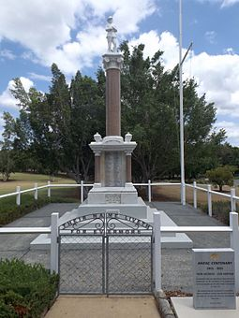
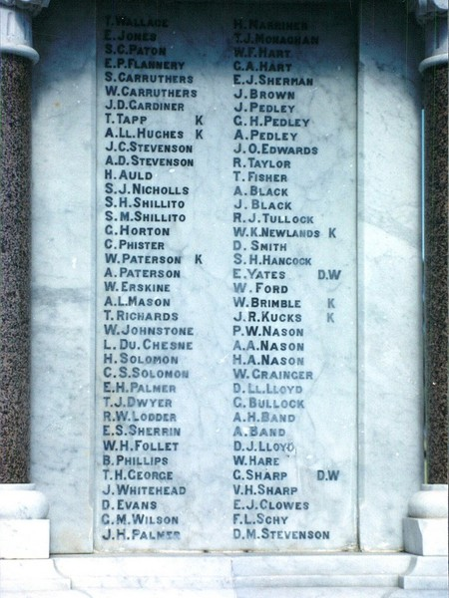
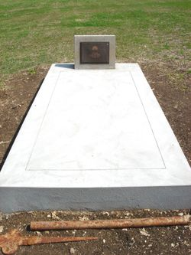
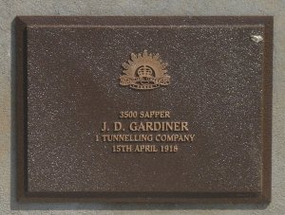
Booval War Memorial Qld
Photos sourced from Heritage Memorials Register website
His Commonwealth War Grave in Ipswich General Cemetery, Q
Photo sourced from Find-a-Grave website contributed by Anne – lies here

