FRANCIS BROTHERS

2nd CORPORAL REGINALD GEORGE FRANCIS
109 – 1st Tunnelling Company

The birthplace of Reginald George Francis was Frome, Somerset, England about 1881, the son of James Richard and Fanny (nee Witcomb/Whitcomb) Francis.

In the 1891 Census, James, a 47 year-old Farmer/Postmaster, is living at Spring Gardens, Frome, with wife Fanny, 46, and children Albert Henry, 21, farmers son; Charles Ernest, 17, carpenters apprentice; Joseph Gerald, 14, telegraph messenger; Mable Fanny, 11, scholar; George Reginald, 9, scholar; Myra Lydia, 7, scholar and William Frank, 4, scholar.

In 1911, James, now 67, Postmaster, and Fanny, 66, are still living at Spring Gardens with Reginald, 29, dairyman, and William, 24, who is assisting his brother on his farm. He came to Australia, possibly arriving at Brisbane on 4 June 1911 on board Norseman.

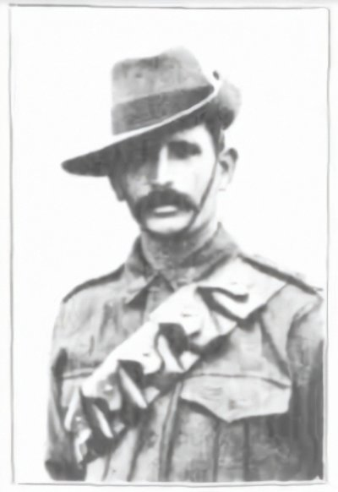
On November 6, 1915 the single thirty-four-year-old miner enlisted at Townsville, Queensland and passed the medical examination being sworn in the same day. Attestation Forms show he stood 175cms (5ft 9ins) tall, weighed 66kgs (145lbs) with a chest expansion of 85-92cms (34-36ins). His dark complexion complimented his grey eyes and brown hair and four vaccination scars on his left arm were distinguishing marks. Church of England was his religion. Next-of-kin nominated was his father James Richard Francis of Spring Gardens, Frome, Somerset, England.

Basic training commenced at Enoggera Camp, Brisbane, Qld on November 28, 1915 then was transferred to the Mining Corps camp at Casula near Liverpool, NSW for further instruction. Was assigned the regimental number 109 and placed with No 1 Company Mining Corps in the rank of Sapper for departure.

At a civic parade in the Domain, Sydney on Saturday February 19, 1916, a large crowd of relations and friends of the departing Miners lined the four sides of the parade ground.

Sixty police and 100 Garrison Military Police were on hand to keep the crowds within bounds. The scene was an inspiriting one. On the extreme right flank, facing the saluting base, were companies of the Rifle Club School; next came a detachment of the 4th King’s Shropshire Light Infantry, then the bands of the Light Horse, Liverpool Depot, and the Miners’ on the left, rank upon rank, the Miners’ Battalion.

The Corps boarded HMAT A38 Ulysses in Sydney, NSW on February 20 and sailed for the European theatre. Arriving in Melbourne, Victoria on February 22 the Miners camped at Broadmeadows for a stay of 7 days while further cargo was loaded.

Another parade was held at the Broadmeadows camp on March 1, the Miners’ Corps being inspected by the Governor-General, as Commander-in-Chief of the Commonwealth military forces. Leaving Melbourne on March 1, Ulysses arrived at Fremantle, Western Australia on March 7 where a further 53 members were taken on board.

On Wednesday March 8, 1916 the whole force, with their band and equipment, paraded at Fremantle prior to leaving Victoria Quay at 9.30 o’clock. The ship hit a reef when leaving Fremantle harbour, stripping the plates for 40 feet and, although there was a gap in the outside plate, the inner bilge plates were not punctured.
The men on board nicknamed her ‘Useless’. The Miners were off-loaded and sent to the Blackboy Hill Camp where further training was conducted.

The Mining Corps comprised 1303 members at the time they embarked with a Headquarters of 40; No.1 Company – 390; No.2 Company – 380; No.3 Company – 392, and 101 members of the 1st Reinforcements.

Finally departing Fremantle on April 1, Ulysses voyaged via Suez, Port Said and Alexandria in Egypt. The Captain of the ship was reluctant to take Ulysses out of the Suez Canal because he felt the weight of the ship made it impossible to manoeuvre in the situation of a submarine attack. The troops were transhipped to HM Transport B.1 Ansonia, then on to Valetta, Malta before disembarking at Marseilles, France on May 5, 1916. As a unit they entrained at Marseilles on May 7 and detrained on May 11 at Hazebrouck.

A ‘Mining Corps’ did not fit in the British Expeditionary Force, and the Corps was disbanded and three Australian Tunnelling Companies were formed. The Technical Staff of the Corps Headquarters, plus some technically qualified men from the individual companies, was formed into the entirely new Australian Electrical and Mechanical Mining and Boring Company (AEMMBC), better known as the ‘Alphabetical Company’.

A promotion to 2/Corporal was given on December 1, 1916 and on Christmas Eve, 1916 was assigned to the 1st Tunnelling Company.

Went to hospital sick on January 7, 1917 and admitted to the NS Casualty Clearing Station the next day suffering from Synovitis (Tissue lining certain joints becomes injured or inflamed). Ten days later was admitted to the 47 D.R.S. diagnosed with Myalgia (Muscular Pain) and discharged to duty on January 26, 1917 rejoining his unit the following day.

On February 7, 1917 was taken to 47 D.R.S. then brought to 17 C.C.S. before a transfer to Wimereux and admission to 14 General Hospital suffering a recurrence of Synovitis on February 15, 1917. The hospital ship Princess Elizabeth evacuated him from Boulogne to England on February 16, 1917 and the next day admitted with Synovitis right knee to 3 London General Hospital at Brighton.

A transfer to 3 Auxiliary Hospital on March 5, 1917 to convalesce for several days then discharged on furlough from March 9 to report to Perham Downs on March 24, 1917. Two days later marched into No 1 Command Depot with his injury classified as B1a. He marched out from the H & D Depot on May 9, 1917 for camp Headquarters the following day.

On June 4, 1917 proceeded to France and after two days reported to the Aust. General Base Depot at Rouelles. 2/Corporal went to rejoin his unit on June 12 arriving the next day.

He was promoted to Temporary Corporal on October 27, 1917 which reverted to 2/Corporal the following year on June 20, 1918.

He was taken to 9 Aust. Field Ambulance sick with N.Y.D. (not yet diagnosed) Pyrexia (Fever). Three days later was discharged to duty and rejoined the Unit.

Proceeded on leave on October 23, 1918 and returned on the day Armistice was declared.

The unit remained on duty to assist with rehabilitation of the country restoring roads and bridges until recalled on February 12, 1919 to Base Depot. Marched out for England on February 24, 1919 and arrived at No 3 Command Depot, Parkhouse, England a day later.

Reginald Francis was a member of 1ATC from May 1916 until his return to Australia in October 1919. In that period he would have worked at Hill 60 in the preparations for the Battle of Messines Ridge. He also most likely worked on the digging of the Catacombs at Hill 63 and may have been involved with the Easter Raid of April 1917 and the accidental explosion of 25 April 1917 which killed 10 members of his unit.
He may have also been involved with operations on the Hindenberg Line in September 1918 when 20 members of 1 & 2ATCs where decorated. He may also have worked on the construction of the Hooge Crater dugouts.
The Australian war photographer Captain Frank Hurley visited the Hooge Crater dugouts three days before the Battle of Menin Road and described the conditions he found:

It is a wretched job as they are working 25 feet below the surface level and most of the time knee deep in mud, which they jocularly term ‘hero juice’ on account of it percolating through tiers and tiers of buried corpses. Most of the men are miners and they are applying their knowledge to supreme advantage whilst the Boche shells whiz and burst around them.
Damien Finlayson ‘Crumps and Camouflets’, page 241

On March 17, 1919 R.B.A.A. reported him AWL but no disciplinary action was taken and he returned from leave of absence to Heytesbury on March 31, 1919.

2/Corporal reported to No 2 Group at Sutton Veny on April 10, 1919. An extension of leave was granted from June 10 - 13, 1919. Marched out for the Demobilisation Depot, Sutton Veny on June 10 and arrived at A.I.F. Headquarters soon after.

Departed for Australia aboard HT Anchises on August 22, 1919 and arrived in 2nd Military District (NSW) on October 13, 1919 returning to the 1st Military District (Qld) on December 6, 1919 for discharge from the A.I.F.

For active service overseas 2/Corporal 109 Reginald George Francis, 1st Tunnelling Company was decorated with the British War Medal (12146) and the Victory Medal (11987).
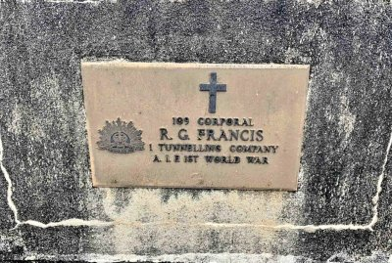
Photos of Reginald Francis in uniform and his plaque sourced from
FindaGrave : www.findagrave.com
added by Lyn Turner
The Telegraph, Brisbane – Monday 4 April 1938:
GOVERNMENT NOTICES
Name of Deceased Proprietor— Annie Elizabeth Tamblyn late of Charters Towers, widow.
Date of Death— 18 September, 1937.
Name of Claimant— Reginald George Francis
Tamblyn, of Ingham.
Description and Situation of Land – Allotment 16 of section 53, town of Ayr.
Estate Claimed to be Transmitted - Fee-simple.
Particulars of Will or Otherwise - Will dated 31 March, 1936.
Date within which Caveat may be Lodged - 16 May, 1938.
Reginald George Francis died of natural causes at Herberton on 16 January 1969 and was buried in the Herberton General Cemetery at Anglican Row 24, grave number 5, next to his brother Bert.
© Donna Baldey 2009 / 2023
www.tunnellers.net
His brother also served in WW1:
On October 1, 1941 his Statement of Service was sent to the Repatriation Department in Brisbane, Qld.
SAPPER ALBERT HENRY FRANCIS
7210 – TUNNELLERS REINFORCEMENTS
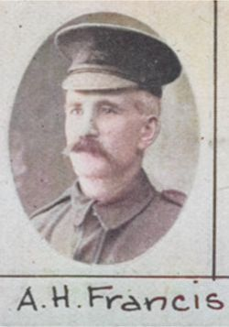
Between 1903 and 1916 Albert Henry Francis is recorded on the Electoral Roll as a Miner living at Home Rule Pocket, Rossville, Queensland.

Albert enlisted in Normanton, Queensland on 26 January 1917. Stating he was born at Hereford City, England and recording his age as 46 years 11 month, Albert referred to himself as an Engineer and Miner. A medical examination at Normanton the same day recorded that he was 5 feet 7½ inches tall and weighed 140 pounds. He had a fresh complexion, blue eyes and fair hair and was of the Church of England faith.

He named as his next-of-Kin his brother, Frederick James Francis of Lorna Doone Mine, Rossville, Queensland. He signed the Oath to ‘well and truly serve’ on the same day at Cairns and training began at 11th Depot Battalion on 3 February 1917.
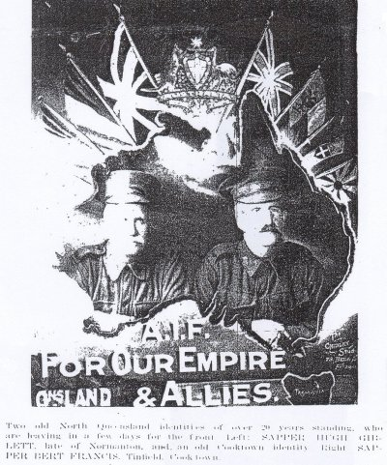
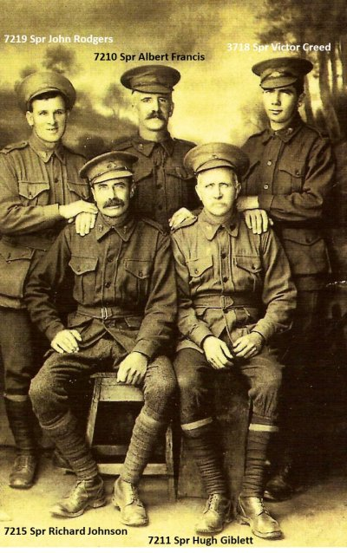
‘Says he is in good health. Training Officer reports normally. Never on sick parade.’

After 270 days service. Albert was discharged from the A.I.F. at Bendigo on 15 October 1917 as medically unfit, not due to misconduct. He was stated to be of ‘Good’ character.

He was not entitled to any War Medals.

He returned to his mining at Home Rule until about 1925 when the Electoral Roll records him as a dairyman at Daintree River where he remained until 1937.
Two old North Queensland identities of over 20 years standing who are leaving in a few days for the front. Left: Sapper Hugh Giblett, late of Normanton, and, an old Cooktown identity, Right: Sapper Bert Francis. Tinfield, Cooktown.
On 27 February 1917 he was appointed to the Mining Corps, Engineers Camp in Queensland. He was transferred to the Miners Reinforcements at the training camp at Seymour, Victoria on 14 March 1917.

His photo appeared in the North Queensland Register newspaper on 28th May 1917 in a patriotic setting with his friend and fellow sapper, Bert Francis. The caption states that both had been North Queensland identities for 20 years.

At the Seymour camp he formed a friendship with other Queensland recruits and group was photographed, possibly on leave together, and in training.
Photo courtesy Val McKenzie
Granddaughter of John Rodgers

A Medical Board at Seymour on 1 August recorded that there was no disease or debility evident and that his present condition was:

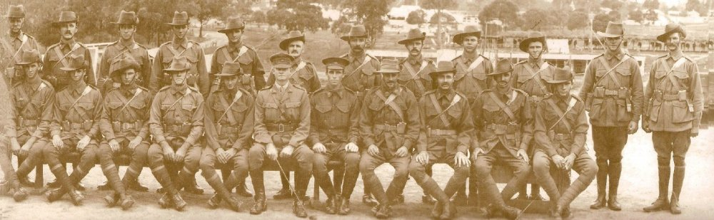
The Electoral Rolls for 1937 thru 1943 record him at Shipton’s Flat, Cooktown.
Photo courtesy of Val McKenzie. Details of those named in the two photos indicate they were probably taken in early May 1917.
Richard Johnson Victor Creed
Hugh Giblett Bert Francis John Rodgers
Cairns Post, Queensland – Saturday 23 February 1946:
HERBERTON PERSONAL
A small party of Millaa Millaa folk who intend to spend, the wet season in Herberton, arrived and took up their residence yesterday. They were Messsr r. G. and A. H. Francis and Mr. N. Witham. They were accompanied by Mr Geo. McKenzie, who returned to Millaa Millaa to-day.
Cairns Post, Queensland – Saturday 24 March 1947:
HERBERTON PERSONAL
Messrs. A. H. and R. O. Francis have returned to the Tableland from Cairns where Mr. A. H. Francis has been receiving medical attention.

Albert Henry Francis died on 6 January 1950 and was buried in the Herberton General Cemetery at Anglican Row 24, grave number 6.
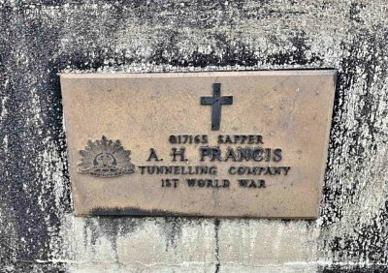
Cairns Post, Queensland – Tuesday 9 January 1950:
DEATH
FRANCIS.—At the Herberton District Hospital on January 6, 1950, Albert Henry Francis, aged 72 years 11 months, brother of R. G. Francis and the late F. J. Francis.
"Deeply mourned."
Photo sourced from FindaGrave : www.findagrave.com - added by Lyn Turner
Cairns Post, Queensland – Tuesday 17 January 1950:
THANKS
Mr. R. G Francis, Mrs. F. J. Francis and family wish to thank the Doctor, Matron and Nursing Staff of the Herberton District Hospital for their unremitting care and attention to the late Albert Henry Francis, while an inmate there; also all kind friends who sent messages of sympathy and floral tributes in their recent sad bereavement. Please accept this as their personal thanks.
Cairns Post, Queensland – Wednesday 18 January 1950:
OBITUARY
ALBERT HENRY FRANCIS
HERBERTON, Jan. 15 - With the passing of Albert Henry Francis January 6, 1950, at the age of 79 years 11 months, Queensland lost another of those many Englishmen who helped to pioneer the North.
The late Mr. A. H. Francis was born in Fownhope, Hereford, England, in 1870 and at an early age he went with his father and mother and small brother and sister (the brother was F.J. Francis who died some years ago) to Spring Gardens, Frome, Somerset, where his father had a farming property.
The young Albert showed an attachment for the land and when his education was completed he returned home to learn farming which in those days included dairying, cheese-making and bacon curing as well as the proper care of cattle. When he reached 21 he decided to go to Australia and put his knowledge of farming into Empire building. He landed in Cooktown in November, 1891, made inquiries about dairying in Australia and started work at Keating's dairy.
It was while he was there that he had his famous adventure with the yacht Merrie England. In those days the milk was packed into Cooktown in milk cans on a packhorse and then delivered from door to door by hand, but the local youth had decided that already the new chum was too cocky and must be taken down a peg. They gave him the friskiest horse on the place and a big can of milk and told to deliver the milk to the Merrie England lying at the Cooktown wharf.
They then waited for him at the butcher's shop half way up the long straight Charlotte-street with a number of empty kerosene cans and loaded revolvers. As he rode into Charlotte-street they threw the cans in front of the horse and fired shots into the air - and of course, the horse bolted. The jokers reckoned without one factor - that like most young English gentlemen of his time their victim was a superb rider - he guided his mount straight down Charlotte street to the wharf and putting it at the jump landed on the deck of the yacht and pulled up to hand the milk to the astonished steward. "Do you always deliver milk like that in Australia?" said the steward. "Always," said the young red head. "That is the Australian way." He then turned his terrified horse and jumping back on to the wharf proceeded to ride up the street and into the butcher's shop, where he rode his horse round the butcher's block.
From Keating's dairy he went to work at McCarey's, then the late James Neill, of Killarney, but dairying could not hold him at a time when gold was the word on everybody's lips. He went down to the Burdekin first and was for a time drafting bullocks for the Ross River meatworks.
He was back in Cooktown and working for a mining company at Rossville when the Batavia gold rush broke out. He went to the Batavia rush with Bill Standen but did not get on to anything worthwhile. The aborigines were trouble-some and they returned just before the tragedy of the spearing of William Baird by the wild blacks at Batavia.
The Bloomfield River was then a busy centre and with the late Peter Doolan and Dan Bolen he got together a bullock team, and the three men put in a considerable time pulling cedar and kauri pine for a sawmill there.
They next got a contract to bring 100 tons of mining machinery from Cooktown to Rossville for a Charters Towers firm. The machinery was delivered at the Cooktown wharf at the beginning of the wet season and the haulers made the mistake of starting work straight away, as the company wished to have their dredge working before the next wet. Flooded rivers and roads deep in mud defied even the efforts of their best bullocks and the 38 miles of road proved an almost impassable bog - on one occasion it took them 13 weeks to deliver a load from Cooktown to Rossville. The contract was not a success.
The year 1897 saw him preparing to go back into timber again, and on Queen Victoria's jubilee day Bert Francis was coupling steers which were also christened on that day, receiving Royal names like Victoria, Albert, Jubilee and so on.
The Starkey rush broke out in 1899 and Bert Francis went to the Starkey with Billy Nunn, Dan Bolen and others from Cooktown. On arrival at the field he took over the management of the Last Hit and later opened up on a reef of his own, the Rio Tinto, which proved to be a remarkably good mine. One clean-up was worth £418 at a time when gold was only £4 an ounce. He employed one wages man and did very well, staying on at the field for about four years.
While there he visited Brisbane for the visit of the late King George, then Duke of York.
Contd.
continues
Back in Cooktown again he went into partnership with Jack Elliott, and in 1904 they opened up the Home Rule tin mine near Rossville, struck rich alluvial tin and sold out to the North Queensland Sluicing Co. The late Alec Hedley went into as manager. The sale took place in 1906. The two parted then and Jack Elliott later put the water on to Lode Hill. Bert Francis worked on different mines for several years, always being fairly lucky, and life went on uneventfully until his brother, F. J. Francis arrived from England with his family and a partnership began, which was to last for many years. They first took up a mine in the Bloomfield scrub near China camp and gained a lot of tin and more experience. Later on again they moved to Rossville and opened up the Lorna Doone mine and established a home. Just before the 1914-18 war another brother, Reg Francis, arrived from Canada. On the outbreak of hostilities Reg and Bert joined the AIF, and F. J. Francis, who was unfit for military service, remained to look after the mine. In 1920 F. J. Francis re-purchased from the North Queensland Tin Sluicing Co. the Home Rule mine and the three brothers worked it together for a time. In 1933 Bert Francis with his brother Reg went up to Daintree, where they went into dairying. Once established they sold out to another brother, Will Francis, and returned to mining at Shipton's Flat, near Cooktown, where they stayed until after the 1939-45 war. After a short period at Millaa Millaa Bert and Reg Francis retired to a small property at Wondecla, where Bert lived until the time of his death.
Deceased was a bachelor and was predeceased by his brother, F. J. Francis, in 1942. Surviving relatives are three sisters - Rose. (Mrs. Crocker, Putney), Mabel (Mrs. E. Crocker. Minehead, Somerset), Myra (Ramsgate) - and four brothers Charles (Berkshire), Joseph (Africa), Will (Southport) and Reg (Wondecla), a sister-in-law, Mrs. Nancy Francis (Herberton); also a number of nephews and nieces, including Mrs. Jack Carkeet (Ayr), Mr. P. Ranpolt (Mackay), Mrs. C. Burrell (Herberton), Mr. David Francis (Herberton), Mrs. Bert Johnson (Cooroy).
The funeral took place on January 7 from the Holy Trinity Church of England at Herberton. Rev. Brother Warren presiding at the church and the graveside. The Herberton sub-branch of the R.S.S.A.I.L.A. accorded military honours. A military guard fell in at the main street. At the grave-side the citation was read and poppies handed round by the president of the sub-branch (Mr. O. J. Burrell).
The pall-bearers were Messrs. W. Buddy, A. C. Camp, D. H. M. Francis, T. Kästner. J. Still and N. Bowditch. K. Camp and M. Mulholland attended to the draping of the flag. There was a large attendance of ex-servicemen and townspeople and many beautiful floral tributes were received.
The deceased, was a keen sportsman and a great hunter, being an exceptional rifle shot. Until later years he always kept a good horse and hunting dogs, while another hobby in which he was interested was music. He will be missed by a wide circle of friends in the Far North.

© Donna Baldey 2023
www.tunnellers.net

