SAPPER EDWARD JOHN FLOWERS
560 – 2nd Tunnelling Company

Wallaroo, South Australia is given as the birthplace of Edward John Flowers who was born on October 5, 1890. Tickera was registered as his birthplace at Daly, South Australia and his parents were Joseph and Mary Jane (nee Jones) Flowers. His education was at the Public School and he had some experience as a clerk.

He was a labourer at Broken Hill, NSW when he volunteered to enlist, along with forty-five other recruits they were farewelled by a large crowd from the Railway Station. This was reported in the:
Barrier Miner Friday September 10, 1915:
DEPARTURE OF RECRUITS
LAST NIGHT’S SEND-OFF
Another batch of Broken Hill recruits numbering 46, left by the last night’s train for camp in Adelaide. The men were formed up at the Barrier Boys’ Brigade Hall in the usual way, and marched to the station via Oxide, Argent and Bromide streets. A large crowd of members and sympathisers of the Barrier Empire League, and the City Band, met the volunteers at the New Masonic Hall, and escorted them for the remainder of the journey to the station. The crowd at the platform was exceptionally large, and the men were loudly cheered. The enthusiasm en route was also especially marked. Following are the names of the recruits:
Alfred Norman Dawson, Charles Montague Keats, D.S. Noble, Patrick Sharkey (Morden), D.F. Flanagan, Thomas James Stevens, J. Constantine, Harry Plane, George Arnold Moody, Walter Simeon Flanagan, William Groves, James Williams, Frank Oliver Loader, John Clare Murphy, Albert Edward Douglas, Leslie John Noonan, Horace John Gardner, Roy Nathaniel Heitman, Alfred Thomas Sully, Henry Lawry, Augustus William Edwards, George Henry Lynch, George Henry Oswald Thomas, Charles Imhoff, Albert Harridge, Charles James Crawford, George James Lynas, Edward John Flowers, Michael Henry George Carroll, William Allen Brownley, Alexander Henderson Arthur, William Leonard Jenkin, John Wheatley, Albert Hare, Herbert Sheryn Griffiths, Frank Andrew Campbell, Harold George Pearce, James Henry Knevitt, James Bertrand Hammond, L.O. Erskine, S.C. Ford, T.D. Larkin, J. Lawler, E. Plane.

In Adelaide, S.A. on September 10, 1915 the twenty-one year old applied to enlist at the Recruiting Depot where he passed the medical examination. His description on enlistment from the Attestation Forms reveal he was 169cms (5ft 6½ins) tall, weighed 59kgs (130lbs) with a chest expansion of 83-88cms (32½-34½ins). Fair was his complexion with blue eyes that tested to good vision and had brown hair. Distinctive marks were three vaccination scars on his left arm. Religious faith was Church of England. Next-of-kin nominated was his mother Mrs Mary Jane Flowers of Hebbard Street, South Broken Hill, NSW.

He was immediately assigned to ‘E Coy’ for basic training until September 30, 1915 at the Adelaide Exhibition Ground then moved to the 1st Depot Battalion at Morphetville on October 1 concluding a month later on November 1, 1915 then transferred to No. 2 Company, Mining Corps at the 2nd Depot Battalion. Final Home Leave was granted from December 1. His rank was Sapper with the regimental number 560 and the recruits were sent to Casula camp near Liverpool, NSW for final assembly of the Corps.

At a civic parade in the Domain, Sydney on Saturday February 19, 1916, a large crowd of relations and friends of the departing Miners lined the four sides of the parade ground. Sixty police and 100 Garrison Military Police were on hand to keep the crowds within bounds. The scene was an inspiriting one. On the extreme right flank, facing the saluting base, were companies of the Rifle Club School; next came a detachment of the 4th King’s Shropshire Light Infantry, then the bands of the Light Horse, Liverpool Depot, and the Miners’ on the left, rank upon rank, the Miners’ Battalion.

The Corps boarded HMAT A38 Ulysses in Sydney, NSW on February 20 and sailed for the European theatre. Arriving in Melbourne, Victoria on February 22 the Miners camped at Broadmeadows for a stay of 7 days while further cargo was loaded.

Another parade was held at the Broadmeadows camp on March 1, the Miners’ Corps being inspected by the Governor-General, as Commander-in-Chief of the Commonwealth military forces.
Leaving Melbourne on March 1, Ulysses arrived at Fremantle, Western Australia on March 7 where a further 53 members were taken on board.

On Wednesday March 8, 1916 the whole force, with their band and equipment, paraded at Fremantle prior to leaving Victoria Quay at 9.30 o’clock.

The ship hit a reef when leaving Fremantle harbour, stripping the plates for 40 feet and, although there was a gap in the outside plate, the inner bilge plates were not punctured. The men on board nicknamed her ‘Useless’. The Miners were off-loaded and sent to the Blackboy Hill Camp where further training was conducted.

The Mining Corps comprised 1303 members at the time they embarked with a Headquarters of 40; No.1 Company – 390; No.2 Company – 380; No.3 Company – 392, and 101 members of the 1st Reinforcements.

Finally departing Fremantle on April 1, Ulysses voyaged via Suez, Port Said and Alexandria in Egypt. The Captain of the ship was reluctant to take Ulysses out of the Suez Canal because he felt the weight of the ship made it impossible to manoeuvre in the situation of a submarine attack. The troops were transhipped to HM Transport B.1 Ansonia, then on to Valetta, Malta before disembarking at Marseilles, France on May 5, 1916. As a unit they entrained at Marseilles on May 7 and detrained on May 11 at Hazebrouck.

A ‘Mining Corps’ did not fit in the British Expeditionary Force, and the Corps was disbanded and three Australian Tunnelling Companies were formed. The Technical Staff of the Corps Headquarters, plus some technically qualified men from the individual companies, was formed into the entirely new Australian Electrical and Mechanical Mining and Boring Company (AEMMBC), better known as the ‘Alphabetical Company’.

On May 15, 1916 Sapper Flowers was taken to the 8th Field Ambulance with Influenza where two days later was transferred to the 7th Field Ambulance suffering from Bronchitis.

Sapper Flowers was killed in action on June 29, 1916 along with Sapper 1384 Charles Pumfrey. There are no Unit Diaries for May and June therefore it is not recorded where they were working at the time.

Both soldiers were buried in graves beside each other at Kemmel Chateau Military Cemetery, 2½ miles North East of Dranoutre, France by Rev. R.T. Dodd who was attached to the 9th Royal Sussex Regiment.

On July 11, 1916 the Medical Officer’s Report advised of his death to A.I.F. Headquarters after a cable had been sent and confirmed two days later. His next-of-kin were advised and the following notice was published in the:
Barrier Miner Saturday July 15, 1916:
DEATHS
FOR KING AND COUNTRY
SAPPER EDWARD JOHN FLOWERS, beloved son of J. and M.J. Flowers, of South Broken Hill, who was killed in action at Belgium on June 29th, 1916. Aged 25 years and 9 months.

A copy of his Service was made for the War Pension Department on July 22, 1916 and a month later on August 22, 1916 the Field Service Report was completed in Rouen by the Records Section, 3rd Echelon, A.I.F.

On October 24, 1916 Base Records wrote to his mother expressing sympathy on the regrettable loss of her son and to advise the place of burial and by whom. These details had now come to hand and being the policy of the Department to inform next-of-kin of details in connection with the death of a member of the A.I.F.

Personal effects of the soldier were sent to Base Records on the transport Wiltshire and a registered package no. 3835 was sent to his mother on January 31, 1917. It contained the following items:
Disc, Sovereign purse, Wristlet watch and strap (damaged), Testament and Razor.

Mrs Flowers receipted delivery of these items on April 17, 1917.

On June 6, 1917 the Paymaster sent a Telegram to Base Records in Melbourne after being advised of his death but had no record of him and requested information. A telegram of reply was sent the next day advising “E.J. Flowers 2nd Company Mining Corps enlisted Adelaide on tenth September, 1915. Commandant 4th District notified of casualty on 4th July last.”

The British War Medal (32069) and the Victory Medal (31846) were issued to Sapper 560 Edward John Flowers, 2nd Tunnelling Company for his Supreme Sacrifice in serving his country.

On November 9, 1921 the Medals Section of Base Records wrote to Mrs Flowers inquiring if her husband was still alive. In accordance with the Deceased Soldiers’ Estates Act of 1918 disposal of medals followed the procedure set as medals went to the father of the soldier first. Mrs Flowers replied from 109 Hebbard Street, South Broken Hill on November 21, 1921 that her husband was still alive and his full name was Joseph Flowers.

The War Medal was forwarded to the Commandant 4th Military District on December 2, 1921 for distribution to his father.

The Booklet ‘Where the Australian’s Rest’ was mailed out on December 12, 1921 along with the Memorial Scroll (320472) and signed for on November 28, 1921.

Photographs of his grave in triplicate were sent to his mother on December 16, 1921. J. Flowers acknowledged receipt of these on January 2, 1922.

The Memorial Plaque (320472) went directly to his father on August 4, 1922.

The Victory Medal was posted to his father on February 19, 1923 and signed for on February 23, 1923.

At the request of the Commonwealth War Graves Office a printed order form relating to the purchase of the Register of Kemmel Chateau Military Cemetery where the remains of Sapper Flowers were interred was sent on March 21, 1924. Also details finalised of the location of his gravesite as Plot 1, Row X grave No. 9.

The Public Trust Office, 14 Castlereagh Street, Sydney wrote to Base Records on March 16, 1938 regarding the Estate of his father Joseph Flowers and Sapper E.J. Flowers inquiring if they held the Military Will and whether their records disclosed that he was married or single and if married particulars of his children.

Base Records replied on March 23 that they had no record of Sapper E.J. Flowers having made a Will whilst a member of the A.I.F. and that his status was unmarried.

On April 8, 1938 the Public Trust wrote requesting the Certificate of Death for the ex-soldier. This was issued on April 12, 1938 by Base Records.

During the Memorial Service for the 1947 Remembrance Day Sapper Flowers was remembered with a wreath. The service was covered in the:

Barrier Miner Tuesday November 11, 1947:
REMEMBRANCE DAY SERVICE AT MEMORIAL
As the Town Hall clock commenced to strike the eleventh hour, and as the strident Stan To was sounded by the bugler, Argent Street today became silent while returned servicemen and citizens paid tribute to the fallen of both wars. Thus Remembrance Day was celebrated at the Fallen Soldiers’ Memorial.
Simple, but impressive was the service. Prior to the commencement returned servicemen marched from the hostel to the Memorial.
Following the two minutes’ silence, the president of the R.S.S. and A.I.L.A (Mr M. Austen Brown) paid the Tribute and the members joined with him in the last line, “We will remember them.”
Bugler J. Keenan sounded the Last Post followed by the stirring Reveille, and the service was brought to a close.
Mr Brown also laid on the Memorial the traditional laurel wreath on behalf of the League.
Other wreaths placed on the memorial by relatives and associations were—L/Cpl Chas. Holman, from his wife and children; Broken Hill Red Cross Association; three for Pte K.H. Files, from his father, mother and brother, and also Mr and Mrs Fillery and girls; Pte Pat Hoare, from his mother, sister, sister-in-law, brothers and brothers in law; Pte Alf Brown, from his sister and brother-in-law (Edith and Burnie); Sapper Edward John Flowers; Pte J. Gebert, from his sons Robert and Davy; Pte J.A. Pointer, from his wife and son; Pte W. Green, from Mr and Mrs Corner and family; and Sapper Red (Eddie) Radford from his father, mother, sisters and brothers.

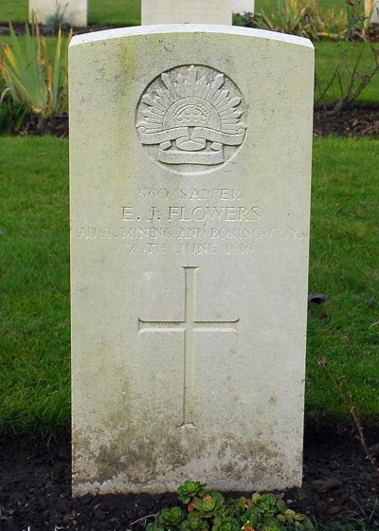
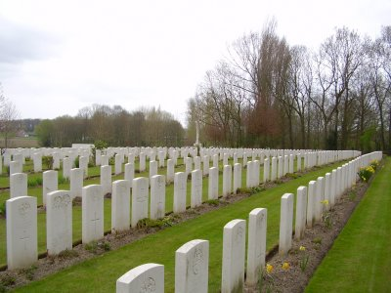
His grave is located in the Kemmel Chateau Military Cemetery in Row X, grave no. 9.
Photos of headstone and cemetery by kind permission of The War Graves Photographic Project www.twgpp.org

In the Commemorative Area of the Australian War Memorial on Panel 26 the name of E.J. Flowers is commemorated.
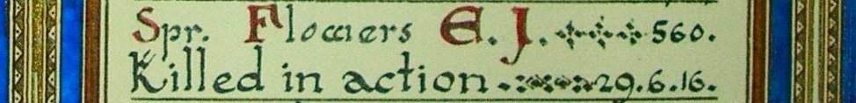
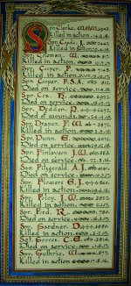
The Sydney Morning Herald - Saturday 23 July 1921:

ENGINEERS' ROLL OF HONOUR
The Royal Engineer War Memorial Committee are arranging to deposit a roll of honour of all ranks of the Royal Engineers whose names were officially published as killed in action or died of wounds or disease in the war in the chapel of St. Paul's Cathedral, and the Engineer corps of the dominions, colonial, and Indian armies have been invited to deposit similar rolls of honour in St. Paul's, to be attached to that of tho Royal Engineers. This invitation has been accepted in Australia. The roll will be inscribed on vellum and enclosed in a casket of Australian timbers to rest on a slab of Australian marble.

This extract from the Tunnellers Roll of Honour with the kind permission of the
Dean and Chapter of St Paul’s Cathedral, London
Photos courtesy of Robin Sanderson, Paris

LEST WE FORGET

© Donna Baldey 2013
www.tunnellers.net

