SAPPER / PRIVATE WILLIAM ERSKINE
102 1st Tunnelling Company / 52nd Battalion

William Erskine was born on 23 May, 1888 in Ipswich, Queensland the son of William and Christina Dalziel (nee Archibald) Erskine. He was a miner by trade.

At the Darling Downs Central Recruiting Depot in Toowoomba on 1 October, 1915 the single twenty-seven-year-old miner applied to enlist for active service abroad and passed the medical examination. Attestation forms describe him as 170cms (5ft 7ins) tall, weighing 75kgs (165lbs) with a chest measurement of 97cms (38ins) and had a fair complexion with blue eyes and brown hair. Presbyterian was his faith. Next-of-kin nominated was his father William Erskine of Booval via Ipswich, Qld. The Oath of Enlistment was signed and taken the same day.

Acknowledgment to the new recruits was published in the:

Basic training commenced at Enoggera Barrack, Brisbane (1st Military District) and was allotted to the Mining Corps until 28 October then transferred to join other volunteers from across the country at Casula camp, near Liverpool, New South Wales to train as a Corps. His rank was Sapper with the regimental number 102.
Brisbane Courier Saturday October 2, 1915:
COUNTRY VOLUNTEERS
For the 24 hours ended at 1 p.m. today 29 men presented themselves to the Recruiting Office. Of this number 25 were passed as fit, while four were rejected as unfit. Those passed were: William Erskine (Killarney) Article abridged

At a civic parade in the Domain, Sydney on Saturday February 19, 1916, a large crowd of relations and friends of the departing Miners lined the four sides of the parade ground. Sixty police and 100 Garrison Military Police were on hand to keep the crowds within bounds. The scene was an inspiriting one. On the extreme right flank, facing the saluting base, were companies of the Rifle Club School; next came a detachment of the 4th King’s Shropshire Light Infantry, then the bands of the Light Horse, Liverpool Depot, and the Miners’ on the left, rank upon rank, the Miners’ Battalion.

The Corps boarded HMAT A38 Ulysses in Sydney, NSW on February 20 and sailed for the European theatre. Arriving in Melbourne, Victoria on February 22 the Miners camped at Broadmeadows for a stay of 7 days while further cargo was loaded.

Another parade was held at the Broadmeadows camp on March 1, the Miners’ Corps being inspected by the Governor-General, as Commander-in-Chief of the Commonwealth military forces.

Leaving Melbourne on March 1, Ulysses arrived at Fremantle, Western Australia on March 7 where a further 53 members were taken on board.

On Wednesday March 8, 1916 the whole force, with their band and equipment, paraded at Fremantle prior to leaving Victoria Quay at 9.30 o’clock.

The ship hit a reef when leaving Fremantle harbour, stripping the plates for 40 feet and, although there was a gap in the outside plate, the inner bilge plates were not punctured. The men on board nicknamed her ‘Useless’. The Miners were off-loaded and sent to the Blackboy Hill Camp where further training was conducted.

The Mining Corps comprised 1303 members at the time they embarked with a Headquarters of 40; No.1 Company – 390; No.2 Company – 380; No.3 Company – 392, and 101 members of the 1st Reinforcements.
Finally departing Fremantle on April 1, Ulysses voyaged via Suez, Port Said and Alexandria in Egypt. The captain of the ship was reluctant to take Ulysses out of the Suez Canal because he felt the weight of the ship made it impossible to manoeuvre in the situation of a submarine attack. The troops were transhipped to HM Transport B.1 Ansonia, then on to Valetta, Malta before disembarking at Marseilles, France on May 5, 1916. As a unit they entrained at Marseilles on May 7 and detrained on May 11 at Hazebrouck.

A ‘Mining Corps’ did not fit in the British Expeditionary Force, and the Corps was disbanded and three Australian Tunnelling Companies were formed. The Technical Staff of the Corps Headquarters, plus some technically qualified men from the individual companies, was formed into the entirely new Australian Electrical and Mechanical Mining and Boring Company (AEMMBC), better known as the ‘Alphabetical Company.’

He went sick to hospital on 1 June, 1916 to the 2nd New Zealand Field Ambulance N.Y.D. (not diagnosed yet) and returned to duty five days later.

Military discipline was issued for the following:
Crime: While on Active Service AWL from advanced billets from 10 a.m. till 4.30 p.m. 26/7/16
Crime: W.O.A.S. AWL from advanced billet from 11 a.m. till 5 p.m. 27/7/16
Award: 7days Field Punishment No. 1 by O.C. Coy 29/7/16
Crime: Insolence to an Officer
Award: 14 days F.P. No. 1 both charges included by C.O. Coy
Total forfeiture: 16 day’s pay
Crime: W.O.A.S. Absent without leave from 2.15 p.m. to 10.30 p.m. 13/9/16
Award: 14 days F.P. No. 1 by C.O. Coy 14/8/16

He appeared before the Field General Court Martial in the field on 9 September, 1916 at the 107th Infantry Brigade.
Charge: Section 9 (2) (1) When on active Service, disobeying a lawful command given by
his superior officer. (2) When on active service, using insubordinate language to his superior Officer.
Pleaded: Not guilty
Found: Guilty on all charges.
Sentence: Five years penal servitude
Confirmed: By Brigadier-Gen. W.M. Withycombe, 107th Infy Brigade.
President: Major W.B. Ewart, 15 M.R.S.R.
In confinement awaiting trial from 28/8/16 to 9/9/16

Marched out to undergo sentence 2 years H.L. 23/9/16 at the military prison at Havre.

Sentence of 5 years penal servitude commuted to 2 years including hard labour on 15 September, 1916.

Authorities wrote for part of suspension of sentence from 5 years to 2 years on 14/5/17

On 26 January, 1918 at Conder City No. 3 Military Prison, Havre was classified “A” under the powers. Conferred by Sect 83 (7) (b) A Act, the C in C remits 6 months of the sentence of 2 years H.L. awarded, and directs that he be held to General Service and transferred to an Infantry Battalion, raised in the Australian State in which he enlisted.

Sapper was transferred on 20 February, 1918 to the 52nd Infantry Battalion 4th Aust Division on release from the Military Prison sentence to the Aust Infantry Base Depot. Proceeded on 9 March, 1918 to join this unit and was taken on strength on 12 March, 1918. His rank became Private.

Was wounded in action on 5 April, 1918 suffering a gunshot wound to his back and taken to the 20th Canadian Casualty Clearing Station then to the 56th C.C.S. the following day. Ambulance train no.24 conveyed him to the 56th General Hospital then was invalided to England on the hospital ship Princess Elizabeth on 24 April and admitted to the Barnet War Hospital at High Barnet.

Base Records advised his father on 19 April, 1918 that his son had been wounded in action. This news was shared in the:
Queensland Times (Ipswich) Tuesday April 23, 1918:
MILITARY ITEMS
Yesterday, Mr W. Erskine, of Station-road, Booval received a message from the military authorities indicating that his son, Pte W. Erskine, has been wounded.

His name appeared in the Casualty List published in the:

On 9 August was transferred to the 1st Aust Auxiliary Hospital in Harefield then to the No. 2 Command Depot on August 13.
Queenslander (Brisbane) Saturday May 11, 1918:
ROLL OF HONOUR – LISTS NOS 395 – 396
Casualty Lists Nos 395 and 396 were released from the Censor’s office on Saturday. They contain the names of the following Queenslanders.
WOUNDED
William Erskine, Booval Article abridged

Private Erskine was invalided to Australia on 19 October, 1918 due to his wounding on the H.T. Sardinia. Base Records advised his father on 15 November that he was returning home.

His name was among those listed as returning in the:

The troopship docked in Melbourne (3rd M.D.) with news of their arrival published in the:
Brisbane Courier Saturday November 23, 1918:
COMING HOME – TWO BATCHES OF SOLDIERS – LIST “C”
The military authorities advise that the following soldiers Lists “C” and “T” have been listed for return to Australia and are actually en route from abroad.
102. Pte W. Erskine, 52ND Bn, Toowoomba
Article abridged

The voyage continued to Sydney (2nd M.D.) with their impending arrival announced in the:
Herald (Melbourne) Friday December 27, 1918:
U BOAT MEETS LINER – R.M.S. SARDINIA ARRIVES – P. & O. SAILINGS TO RESUME
After a prolonged and uneventful voyage of seventy-two days from London the P. & O. liner Sardinia berthed at the new pier Port Melbourne, this morning with troops. Leaving London on October 15, the Sardinia proceeded to Plymouth and left that port on October 19 with a large fleet of transports in convoy. Escorted as far a Sierra Leone, the vessel continued the journey to Australia unattended.
Sydney Morning Herald Tuesday December 31, 1918
AT NORTH HEADS – TROOPS BY SARDINIA
The P. & O. Liner Sardinia with 196 troops on board will arrive this morning and is expected to berthed at Woolloomooloo at 9.40 o’clock following upon with the normal medical inspection. She is expected to be a clean ship.
The Queensland soldiers boarded the mail train in Sydney on the final part of their journey to Brisbane with their arrival reported in the:
Daily Mail Thursday January 2, 1919:
MEN ARRIVE IN BRISBANE
Between 100 and 150 of the 200 Queenslander soldiers who were on board the transport Sardinia, arrived in Brisbane last night by the mail train from Sydney. The others had remained in Sydney.
The Sardinia is the troopship on which serious trouble owing to [blurred] developed during the vessels journey from England. Discipline was very bad, the men openly defying the officers. An attempt to prevent “two-up” being played failed and there was a great deal of gambling during the voyage.
The men also reached Brisbane yesterday evening were loud in their complaints regarding the conditions that prevailed on the transport and declared that an inquiry should be held.
After arriving at the railway station, the men were taken to the Australian General Hospital, where they were welcomed by Mr Durham, the Hon. Secretary and the Mayor of Brisbane (Alderman M’Master).

Military Discharge was issued in Brisbane (1st M.D.) on 16 February, 1919 as wounded.

He returned to Station Road, Booval with the occupation of miner and married on 29 December, 1919 to Elsie May Pedley.

In 1931 they were at 5 Macquarie Street, Booval with the same occupation where they remained.

William Erskine passed away on 28 September, 1961 aged 73years. Cremation took place at Mt Thompson Crematorium, Brisbane.

His commemorative plaque is located on columbarium wall 12 on panel 9 in the crematorium grounds.

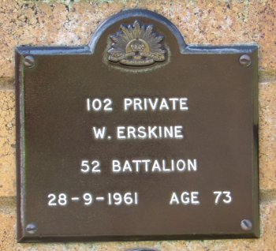
Plaque Mt Thompson Crematorium, Brisbane
Photo supplied by Dept. of Veterans’ Affairs and used with permission

His service is also commemorated on the Booval War Memorial.
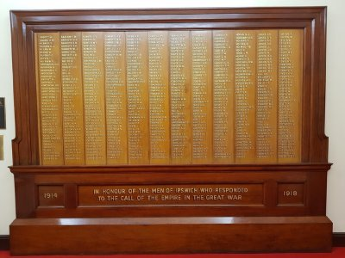
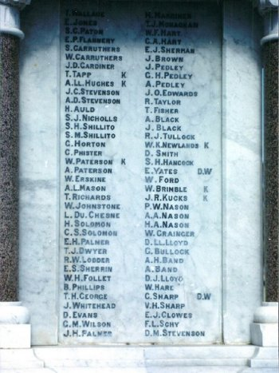
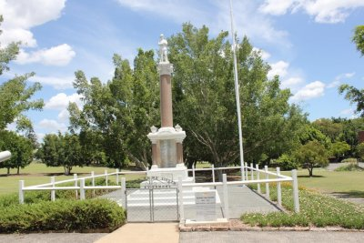
Ipswich Soldiers’ Great War Roll of Honour panel 2
Photo contributed by Ipswich RSL Sub-branch to Virtual Anzacs website
War Memorial, Booval, Qld
Photos sourced from Qld Memorial Register
And the Ipswich Soldiers’ Great War Roll of Honour

© Donna Baldey 2023
www.tunnellers.net

