SAPPER NATHANIEL DEDDEN
6672 – 2nd Tunnelling Company

Nathaniel E. Dedden was born at Pyrmont, Sydney, New South Wales in 1890 the son of William and Mary Lucy (nee Lee) Dedden. His education was received at Mosman School and as a twelve-year-old was a performer with the local Dramatic Club with their production in 1902 reviewed in the:
Sydney Morning Herald Friday May 16, 1902:
ENTERTAINMENT AT MOSMAN
On Wednesday evening in the Mosman Council-chambers’ Hall the local Dramatic Club produced the drama “The Enchanted Princess,” to a large audience. The performance was under the patronage of Mr E.W. Quirk, M.L.A. (Mayor of Manly) and characters were sustained by the: Messrs N. Dedden Article abridged

At the end of 1907 he was arrested and charged with assault in company with details reported in the:
New South Wales Police Gazette Wednesday December, 18, 1907:
Mosman—Walter Stevens (18), William John Lang (19), Wilfred Ernest Farran (19), Robert John McKay (18) and Nathaniel Dedden (17), charged in company with assaulting Johanna Camp with the intent to commit rape at Mosman on the 3rd instant, with the arrests by Senior-sergeant Grunley and Constable Martin, Sydney Police. Committed for trial at Quarter Sessions. Bail allowed.

The charges against him were acquitted with proceedings published in the:
Daily Telegraph (Sydney) Saturday April 25, 1908:
QUARTER SESSIONS – FIVE YOUNG MEN CHARGED
Walter Stevens, Thomas Lang, Wilfred Ernest Farran, Robert John McKay and Nathaniel Dedden, all young men, were charged with committing an assault on an elderly woman at Mosman on December 3 last. The accused, who pleaded not guilty, were defended by Mr H.H. Levian.
The five accused were charged at the February sessions, before Judge Docker, on a more serious charge, as well as with assault. The jury found the accused not guilty on the first count, and on the second they dis-agreed.
The jury, at 8.30 p.m., brought in a verdict as follows: “we agree to acquit Farran, McKay and Dedden, and convict Stevens and Lang, with a strong recommendation to mercy, on the grounds of their youth and the drunken state of the woman.”
Stevens and Lang were remanded for sentence, and the other three accused were discharged.

He was a grocer’s collector according to his father. This possibly was around 1911.

At the recruiting depot at Victoria Barracks, Sydney on 14 October, 1916 the single twenty-six-year-old carpenter applied to enlist for active service abroad and passed the preliminary medical examination. Personal particulars taken show he was 163cms (5ft 4ins) tall with a chest expansion of 82-93cms (32-36½ins) and lived at Cardinal Street, Mosman, had a good physique and a pulse rate of 75. Declared fit his application was accepted by the recruiting officer.

Attestation forms describe him further weighing 54.5kgs (120lbs) and had a dark complexion with good vision in his blue eyes and brown hair. Distinctive marks were two small moles at the back of his left shoulder blade. Religious faith was Church of England. Next-of-kin nominated was his father William Dedden of Cardinal Street, Mosman. The Oath of Allegiance was signed and taken on 16 October, 1916 at the Royal Agricultural Showground, Sydney. His brother Harold Dedden was also there for a short period of time.

Basic training commenced there until October 21 when sent to the Engineer Reinforcements at Moore Park to 14 November and allotted to the Miners Reinforcements and passed the dental examination.
He was placed with the January, 1917 Reinforcements to the Tunnelling Companies on 8 January, 1917 training at Seymour, Victoria. His rank was Sapper with the regimental number 6672.

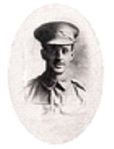
The Reinforcements consisting of 168 members departed Melbourne, Vic at 3 p.m. on January 17, 1917 on board the HMAT A5 RMS Omrah. The mail ship arrived at 8 a.m. two days later at Adelaide, S.A. and headed off at 4 p.m. that afternoon. It sailed into the West Australian port of Fremantle on January 21 where the Reinforcements were granted Day Leave ashore the next day before leaving on January 24, 1917.
Sapper Nathaniel Dedden
With the Colours

The ship returned to Fremantle at 7 a.m. on February 1 and put out to sea again at 5 p.m. the next afternoon February 2. Durban, South Africa was reached at 7 a.m. on February 16 and sailed at 6 p.m. the following evening. The next port of call was Cape Town on February 20 arriving at 8 a.m. where two days later the men were granted Day Leave ashore until 11 p.m. on the 22nd before departing at 5 p.m. on February 24.

The sights of Sierra Leone were seen closely on March 9, 1917 as the vessel docked at 8 a.m. and after refuelling left at 7 a.m. on March 12, 1917.

The voyage concluded at Devonport on March 27, 1917 and the troops disembarked at Plymouth after 74 days at sea.

The three officers and 165 other ranks were detrained to Tidworth then marched into the Drafting Depot at Perham Downs camp.

The Reinforcements proceeded to France from Folkstone on 14 April, 1917 arriving at the Aust General Base Depot the next day.

On April 21 sent to the 1st Anzac Entrenching Battalion which was an advanced section of the Base Depot that organised works near the lines and through duties, usually of ten days duration, would accustom the reinforcements to war conditions before being assigned to a company in the field.

Was attached to the 2nd Tunnelling Company on 17 May, 1917 and taken on strength on June 6.

Sapper went sick on 12 June to the 6th London Field Ambulance with incontinence of urine and sent to the 2nd Canadian Casualty Clearing Station progressing to the 17th Casualty Clearing Station. Two days later was conveyed on Ambulance Train no.28 to Wimereux entering the 2nd Aust General Hospital.

On 12 July, 1917 was invalided to England on the hospital ship Jan Breydal and admitted to the East Suffolk and Ipswich Hospital, Ipswich. Medical notation while there stated:

Frequency of incontinence and headaches. Has had these symptoms on & off for six years at which time (six years ago) he was thrown out of a cart & was in hospital a month. Says that this disaster started of this frequency of incontinence. He also says has to get up two or three times every night & the condition is worse during the daytime. He had never to his knowledge passed blood. Nothing abnormal was found in his urine in France. On 4 June headaches came on severely & frequency of incontinence became worse. Had pain in back, not in legs, felt v. weak. After he was his hospital had a 2nd feverish attack which came on suddenly with chills, malain & incontinence, pain in arms, legs etc & headaches.
18/7/17 No frequency of incontinence since admission. No stone passed.

Was transferred to the 3rd Aust Auxiliary Hospital at Dartford on July 27 remaining until 10 August when discharged to the No. 2 Command Depot at Weymouth.
Marched out on 12 September to the No. 4 Command Depot at Codford until sent to the Overseas Training Brigade at Perham Downs on 5 October. Medical note states dentally fit – partial denture in situ.

From Southampton proceeded to France on 17 October, 1917 arriving at the Aust General Base Depot in Rouelles the following day then left to re-join his unit on October 22 arriving three days later.

Blue Chevrons were issued to wear on his uniform for serving twelve months abroad.

On 24 April, 1918 was wounded in action suffering shrapnel wounds to his shoulder and head and taken to the 14th Aust Field Ambulance then sent to the 4th Casualty Clearing Station where died the same day recorded as gunshot wounds to his head and gas poisoning. He was 27 years of age.

Burial took place in Pernois British Cemetery, Halloy-Les-Pernois in section XI, row C grave no. 6 officiated by Rev. J.I Friend who was attached to the 4th Casualty Clearing Station. The cemetery was situated 12½ miles North-north-west from Amiens.

2nd Military District was advised and next-of-kin told the news of his wounding on 5 May, 1918 and later his death. A copy of his Service Records was made for the Pension Department on May 10.

News of his death was reported in the:
Mosman, Neutral and Middle Harbour Resident Saturday May 11, 1918:
ROLL OF HONOUR
Alderman and Mrs W. Dedden of Cardinal Street, received word last Wednesday that their son, Priv. N. Dedden, had been killed in France.
During the week word has been received of the following deaths, etc, of our soldiers at the front.
KILLED
Sapr. S.H. McKern (previously reported missing).
Priv. N. Dedden Article abridged

The following tribute was placed by his grieving family in the:

Sydney Morning Herald Saturday May 11, 1918:
ROLL OF HONOUR
DEDDEN—Died of wounds in France, April 24, 1918, Sapper Nat. Dedden, aged 27 years, loved brother of Harold Dedden (on active service). Inserted by his loving parents and brothers and sisters, Cardinal-street, Mosman.
In the Casualty List his name was among those soldiers listed in the:

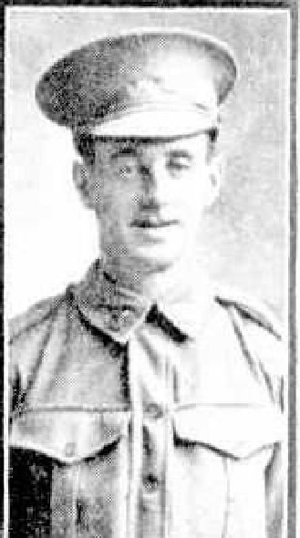
Sydney Morning Herald Thursday May 23, 1918:
402nd CASUALTY LIST – NEW SOUTH WALES
DIED OF WOUNDS
Spr. NATHANIEL DEDDEN, Mosman Article abridged
The Australian Kit Store, London packaged his personal effects on 11 June, 1918 for return to his next-of-kin on the transport Australcrag and their Inventory noted:
Gold ring, YMCA Wallet, letters, photos & cards.

His photograph appeared in the Sydney Mail on 24 July, 1918 p 8:
Sapper N. Dedden – died of wounds
On 19 December, 1918 Base Records forwarded by separate post one package of personal effects to his father in Mosman, Sydney. Delivery was receipted on 23 December by his father who thanked them.
Three Sappers from the company died of wounds (gas poisoning) received on 24th April, 1918 and all interred in Pernois British Cemetery, France.

Vera Deakin, he Secretary of the Australian Red Cross Society, 36 Grosvenor Place, London S.W.1, wrote to the Officer Commanding 4th Casualty Clearing Station B.E.F., France on July 24th in regards to Pte E.J. Williams of the same company who had succumbed to lethal gas poisoning on April 26, 1918 stating that they had been asked by the relatives in Australia to obtain the fullest details possible of the wounds, death and burial of the above, who died in your hospital on 26-4-18 and would greatly appreciate any information that you may send us.

Lt-Colonel R.A.M.C. Officer Commanding No. 4 Casualty Clearing Station replied on 30 July, 1918 that No. 800 Pte Williams, E.J. was admitted to the C.C.S. under his command on April 24th, 1918 suffering from Gas Shell Lethal. Died 26/4/18 at 2-30 a.m.
Buried 26/4/18 in British Cemetery, Grave No. Plot 1.A.20.
Map Reference Sheet Lens 11.C.6.

Informants were sought to give further information on the circumstances surrounding Williams’ death and the following come from their files:

Tunnelling Co. WILLIAMS
A.I.F. E.I. 800
Died 26-4-18
He was billeted at Corbie, where the tunnellers were working. The Huns were trying to break through at Villers Bretonneux, and were shelling heavily all round, and dropped a gas shell on the billets and Williams was badly gassed. I saw him on his way to dressing station. This was April 23rd about 7 a.m. and he died April, 26th. He was in my Section.
Informant: Selby A.A. 6683
2 Tunnellers, A.I.F. Southall
London 16-10-18

1st Aust Mining & Tunn. Coy WILLIAMS E.J. 800
Died April 26/1918
Sapper M. Allen (1st Coy) told me he saw him killed by a shell near Villers Brettoneux on the Somme on about the 26th April, 1918. He was buried outside Hamlet about two kilometres from where he was killed. I knew him; he was about 5ft 9, well built, about 30 years.
Informant: Sapper G.R.V. Boundy 8142
1st Aust Mining & Tunn. Coy
No. 72 General Hospital
Havre
7-11-18

1st Aust Tun. Coy. WILLIAMS
A.I.F. E.J., 800
Died April 26th 1918
“Was in 2nd Aust Tunnelling Coy. About this date in village of Corbie in bullets. Enemy gas shell fell on building in which he was sleeping, he was gassed. He was taken on G.S. wagon to Corps Headquarters at Query, but only lived 3 or 4 hours. I was in next cottage to him when shell burst. 2 cooks were killed outright by same shell. Was buried in Military Cemetery at Query (outside Amiens). I have not seen his grave, but men in Coy were at the burial, cross erected. Knew him as “Billy of the 800^{th.}”.
Informant: Pte F. Bristow 7824
2nd Aust. Tunnelling Company, A.I.F.
Aldwych Theatre
A.D.C.
London 29-11-18
The Circular re Graves of the Fallen was posted to his father on 12 December, 1919 and was acknowledged by printed card on 4 May, 1920.

Photographs of his grave in triplicate were sent to his father on 6 March, 1920.

The British War Medal (57089) and the Victory Medal (56129) were issued for his supreme sacrifice to Sapper 6672 Nathaniel Dedden, 2nd Tunnelling Company in serving his country.

The Roll of Honour of the Royal Engineers was to be placed in the chapel of St Paul’s Cathedral and arrangements described in the:
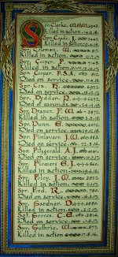

The Sydney Morning Herald - Saturday 23 July 1921:
ENGINEERS' ROLL OF HONOUR
The Royal Engineer War Memorial Committee are arranging to deposit a roll of honour of all ranks of the Royal Engineers whose names were officially published as killed in action or died of wounds or disease in the war in the chapel of St. Paul's Cathedral, and the Engineer corps of the dominions, colonial, and Indian armies have been invited to deposit similar rolls of honour in St. Paul's, to be attached to that of the Royal Engineers. This invitation has been accepted in Australia. The roll will be inscribed on vellum and enclosed in a casket of Australian timbers to rest on a slab of Australian marble.

This extract from Tunnellers Roll of Honour included in profile with the kind permission of the
Dean and Chapter of St Paul’s Cathedral, London.
Photos courtesy of Robin Sanderson, Paris

The British War Medal was sent on 27 May, 1921 to the Commandant 2nd Military District for distribution to his next-of-kin.

The Pamphlet Where the Australians’ Rest went out to Mr W. Dedden on 2 June, 1921.

The Memorial Plaque (34067) left by registered post on 31 October, 1922 and the King’s Message and Scroll posted on 6 November, 1922. The scroll was signed for on November 14, 1922 and the Memorial Plaque receipted on 13 November, 1922.

The Victory Medal left Base Records on 8 May, 1923 for his father and receipted for delivery on May 10, 1923.

Base Records advised his father on 30 January, 1923 that the site of his son’s grave is now registered as Plot 1, Row A in grave no. 4.

A letter from Base Records dated 9 January, 1925 to the Imperial War Grave Commission, 82 Baker Street, London, W.1. in forwarding information and favour of any necessary action, please, communication from next-of-kin respecting the engraving of the late soldier’s name on the headstone in Pernois British Cemetery, Amiens.

The same day they replied to Mr Dedden’s communication dated 21 December in connection with the engraving of the name of his son on the memorial erected in Pernois British Cemetery, has now been referred to their office and directly to the secretary, Imperial War Graves Commission, London for attention. According to records held at this office the late soldier attested under the name of Nathanial Dedden and the permanent headstone should, of course, be inscribed accordingly.
Mr W. Dedden wrote to Base Records from Cardinal Street, Mosman on 15 January, 1925 advising that their letter contained correct information of his son which they said would have been inscribed on the permanent headstone. He thanked them for their promptness in dealing with this matter.

His name is located at the Australian War Memorial, Canberra, ACT on panel 26 in the Commemorative area.

The Roll of Honour With the Colours for the Mosman district bears his name and image as follows:

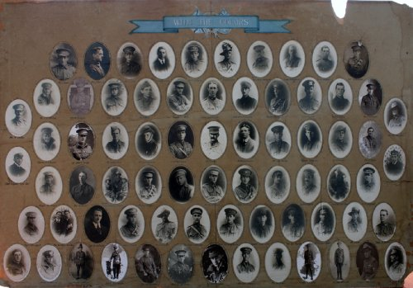
Mosman and District Pictorial Roll of Honour With the Colours
Photo Mosman Library, NSW
A further tribute from his family was placed in the:

Sydney Morning Herald Friday April 24, 1936:

IN MEMORIAM – ON ACTIVE SERVICE
DEDDEN—In ever loving memory of Sapper Nat. Dedden, died of wounds in France, April 24, 1918, aged 27 years.
Never forgotten

Inserted by his loving mother, father, sisters and brothers.
His grave is in plot 1 of Pernois British Military Cemetery, Halloy-Les-Pernois, France within Row A in grave no. 4.

LEST WE FORGET

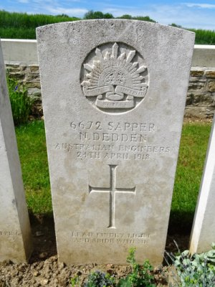
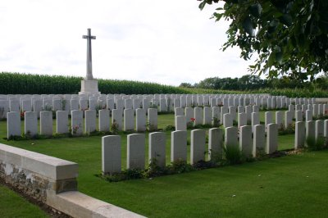
Photo of Pernois British Cemetery by kind permission of
The War Graves Photographic Project - www.twgpp.org

Photo sourced from www.findagrave.com - added by Len

His brother also served.

SAPPER HAROLD DEDDEN M.M.
16191 – 16th Field Company Engineers

Pyrmont, Sydney, New South Wales was the birthplace of Arthur Harold Dedden in June, 1888 the son of William and Mary Lucy (nee Lee) Dedden. He was apprenticed to his father for five years and was a builder.

At the recruiting depot at Victoria Barracks, Sydney the single twenty-eight-year-old builder applied to enlist for active service abroad and passed the preliminary medical examination. His personal details taken on 11 September, 1916 show he was 167cms (5ft 6½ins) tall with a chest expansion of 92cms (36ins). His postal address was Rockleigh, Cardinal Street, Mosman, NSW. Declared fit his application was accepted by the recruiting officer.

Attestation forms describe him further weighing 70.9kgs (156lbs) with a fair complexion good sight in his blue eyes and fair hair. Distinctive mark was an operation scar on his right side (kidney). Religion was Wesleyan.

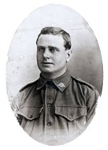
Next-of-kin nominated was his father William Dedden of Cardinal Street, Mosman, NSW. He was sworn in on 9 October, 1916 at the Royal Agricultural Showgrounds, Sydney where both brothers were situated for basic training.
Spr. Harold Dedden
With the Colours

A day later was sent to the Engineers Depot at Moore Park, Sydney and allotted to the Engineer Reinforcements. His rank was Sapper with the regimental number 16191.

The recruits embarked on 11 November, 1916 from Sydney on HMAT A29 Suevic and arrived at Devonport, England on 30 January, 1917 and transferred to Nos 6 & 7 Camps but he was admitted to the Devonport Military hospital suffering rheumatism.
Was transferred to the 1st Aust Auxiliary Hospital at Harefield on 27 February, 1917 and re-joined his unit on 2 April. Was taken on strength on April 9 with the 16th Field Company, Engineers at Parkhouse from Reinforcements. On 11 October was transferred to Codford with the First Army Company, Engineers.

Proceeded to France from Southampton on 17 November, 1917 and his service continued with the 16th F.C. Engineers.

He was recommended for the Military Cross on 30 September, 1918 which was awarded on 9 November, 1918. The recommendation was as follows:

69th Brigade R.G.A. Aust Corps 30/9/18
Action for which commended
1st Aust Troops Coy, Aust Engineers
(attached to 291st Siege Bty, R.G.A.)

16191 Spr. H. DEDDEN
For continuous and conspicuous gallantry and devotion to duty during the period 23rd Aug.to 21 Sept 1918 whilst employed with 69th Brigade R.G.A.
Particularly on August 28th near ESTRES, when the party, commanded by Sgt Beasley was employed in repairing the Mind Road which was mined and was rendered fit for traffic whilst under harassing shell fire.
Again during the 16th Sept, he prepared positions near VENDELLES within 2000 yards of the front line, the ground being shelled all day. On the night 16-17th Sept when the guns pulled in, he repaired roads under shell fire and when the guns were in, he worked on B.C. and Wireless Posts.
During the night 150 to 200 shells fell in and around the Bty position.
Spr. Dennen [Dedden] was working all the time under Sgt Beasley, and where all did
well, was conspicuous in working in a courageous manner.
Honour or Reward MILITARY MEDAL
Immediate Reward
Recommended by: A/Major W.B. PARTON M.C. RGA O.C. 281ST Siege Bty RGA
Lt-Col. W.F.T. CORRIE RGA Commanding 69th Bde RGA
Signed Brig-Gen. Commanding Aust Corps H. Arty.

After demobilisation he returned to Australia on 10 April, 1919 on board H.T. Medic. Base Records advised his father on 12 May, 1919 that he was returning home.

Military Discharge was issued in Sydney (2nd M.D.) on 28 December, 1919 on termination of his period of enlistment.

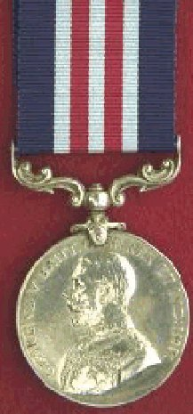
The Military Medal was forwarded to the Commandant 2nd Military District on 8 January, 1920 for distribution to the soldier.

To wear with this Military Medal Sapper 16191 Harold Dedden, 16th Field Company Engineers was issued with the British War Medal (63990) and the Victory Medal (61785) for serving his country.

He married in 1923 to Margaret Alice Leach in Paddington, Sydney. In 1933 they were living at Balgowlah and in 1949 were at 16 Peacock Street, Seaforth with the occupation of carpenter where they remained.

Harold Dedden passed away on 10 October, 1958 aged 70 years. Family arrangements were published in the:
Sydney Morning Herald Monday October 13, 1958:
FUNERALS
DEDDEN—The relatives and friends of the late HAROLD DEDDEN of Peacock Street, Seaforth are invited to attend his Funeral to leave Ernest Andrews Chapels corner of Pacific Way and Thomas Street, Chatswood; this day after service commencing at 12.30 p.m. for the Northern Suburbs Crematorium.
Cremation took place at Northern Suburbs Crematorium.

His name is also commemorated on the Mosman District Pictorial Roll of Honour With the Colours as per personal photograph above.

© Donna Baldey 2023
www.tunnellers.net

