SAPPER SYDNEY JAMES DARE
5517 – 1st Tunnelling Company

Sydney James Dare was born on 1 August, 1893 at Woodsdale, Tasmania and registered at Spring Bay the son of James and Eliza (nee Palmer) Dare. He was working at Oatlands in 1915.

At the recruiting depot at Turnack, Tas on 1 March, 1916 the twenty-two-year-old single farmer applied to enlist for active service abroad and passed the medical examination. Attestation forms describe him as 170cms (5ft 7ins) tall, weighing 71.7kgs (158lbs) with a chest expansion of 88-97cms (34½-38ins) and had a fair complexion with blue eyes and light brown hair. Church of England was his religious faith. Next-of-kin nominated was initially his father James Dare of Woodsdale, Oatlands, Tas and later changed to his mother Eliza Dare of the same address. He took and signed the Oath of Allegiance on 4 April, 1916 at Claremont camp.

Acknowledgment to the new recruits was published in the:
Mercury (Hobart) Thursday April 6, 1916:
THE TASMANIAN BATTALION – ENTERED CAMP
The undermentioned men (62) joined the Claremont Camp on Tuesday: S.J. Dare Article abridged

Basic training commenced with the No. 3 Company, Miners’ Corps (6th Military District) until 31 May then transferred to their training camp at Seymour, Victoria (3rd Military District) for further instruction and later allotted to the October, 1916 Reinforcements to the Tunnelling Companies. His rank was Sapper with the regimental number 5517.

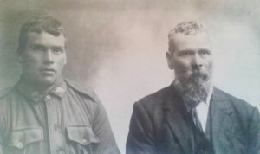
The 516 Reinforcements departed Melbourne, Victoria on October 25, 1916 at 1.30pm aboard the transport HMAT A38 Ulysses. The Australian coastline disappeared from view on October 30, 1916 with the port of Durban reached at 11.30am on November 13, 1916. Windy weather was experienced going around the Cape and arrived at Cape Town at 7am on November 19. Sierra Leone was the next port of call but their departure was delayed until December 14, 1916 as it was not safe to proceed further. Arrived at Plymouth, England on December 28, 1916 after 65 days at sea, with the troops disembarking at 1.30pm and detrained to the station at Tidworth and marched in to Perham Downs the following day for further training for the front at the Aust. Details Camp, Perham Downs.
Spr Sydney James Dare with his father James Dare circa 1916
Photo submitted to Virtual Anzacs Memorial
By David McMahon, Tas.

The Reinforcements proceeded to France from Folkstone on the transport S.S. Onward on 28 January, 1917 arriving at the Aust General Base Depot the next day. On 6 February was attached supernumerary to the 1st Tunnelling Company who were working on the underground mining system at Hill 60 and Caterpillar (Hill 59). Sapper was taken on strength with the company on February 17.

Blue Chevrons were issued to wear on his uniform for serving twelve months abroad.

Service continued without illness of injury and was counted in an audit of the company as still with his unit on 17 July, 1918. Leave was granted and taken from 22 July and re-joined his unit on August 7, 1918.

He was with his unit when Peace was declared.

The Tunnelling Companies remained on the front as part of the Army of Occupation assisting with rehabilitation of their districts by clearing roads and bridges of booby traps and delayed action mines left by the enemy.
He went sick to the 48th Casualty Clearing Station with Influenza on 19 January, 1919 and discharged to his unit on 26 January.

Orders were received on 3 April, 1919 to report to the Aust General Base Depot and left there on April 10 crossing to England and marching into the No. 1 Group camp at Deverill the next day.

After demobilisation Sapper Dare embarked for Australia on 31 May, 1919 on board H.T. Aeneas. Base Records advised his parents on 26 June that he was returning home. The troopship docked in Melbourne (3rd M.D.) on 12 July, 1919 with news of their arrival reported in the:
Age Monday July 14, 1919:
TROOPS PER AENEAS LANDED
Though timed to land at Port Melbourne at 2 p.m. on Saturday, troops arriving by the transport Aeneas, to the number of 300, reached the pier a little earlier, and by 2.20 p.m. the first of the men were at Sturt-street undergoing medical examination. The usual welcome by Brigadier-General Brand, State Commandant, and advice on how to proceed, by Captain E.M. Wright, were tendered to the soldiers on landing, and they were given a hearty welcome in the streets of the metropolis and by relatives and friends at the “finalisations” depot. The Aeneas carried troops for New South Wales and Queensland, who were sent on special trains to their respective States immediately upon quitting the transport.

His name was among those listed as returning published in the:
Advocate (Burnie) Saturday July 19, 1919:
PER H.T. AENEAS
Spr. S.J. Dare, Oatlands. Article abridged

Examiner (Launceston) Tuesday July 22, 1919:
MEN ON ROUTE
The attached list of troops are shortly returning from abroad per Aeneas:
Spr. S.J. Dare, 1st Tunn. Co., Oatlands Article abridged

News of their arrival at Barnes Bay was published in the:
World (Hobart) Tuesday July 22, 1919:
HOME FROM THE WARS – DUTY DONE AND HONORS WON – BARNES BAY ARRIVALS
Troops disembarked at Barnes Bay yesterday from tug Rio Pardo, which in addition to the troops brought from overseas, carried from Adelaide a number of troops sent overland from Melbourne after having been stranded in that city.

Military Discharge was issued in Hobart (6th M.D.) on 6 September, 1919 on termination of his period of enlistment.

Anglesea Barracks, Hobart (6th M.D.) forwarded to Base Records on 27 September, 1919 medical proceedings and dates of his arrival and discharge.

Sapper 5517 Sydney James Dare, 1st Tunnelling Company received the British War Medal (6530) and the Victory Medal (6369) in service for his country.

The War Medal was signed for in Hobart on 11 January, 1922 at Headquarters 6th Military District. The Victory Medal was not collected from Anglesea Barracks and returned to Base Records on 29 March, 1924.
A letter was sent to him care of the last known address of his next-of-kin and he returned their order form dated 28 May, 1924 for his medal requesting it to be sent by registered post to his address – Granton, Tas. He signed their delivery receipt on 28 June, 1924.

At St Mark’s Church, Bellerive on 20 December, 1922 he married Gertrude Mable Webb and resided at Granton.

Snippets appear about him in the:
Mercury (Hobart) Saturday February 11, 1928:
LAW COURTS – A BUSY WEEK
The Civil sittings of the Supreme Court will be commenced at Campbell Street on Tuesday, before Mr Justice Crisp, the following fifteen cases being listed for hearing:
S.J. Dare v. Bridgwater Lime Co. Pty Ltd, money payable: Article abridged

In 1928 the couple were listed in Electoral Rolls at Woodsdale with his occupation as a labourer. In 1930 they were at Granton with the same occupation. In 1936 and 1937 their address was the same.

The Hobart branch of the Repatriation Department requested a copy of his service records from Base Records which were sent on 12 April, 1939.

Sydney James Dare, late of Bridgewater, passed away in the Royal Hobart Hospital on 31 May, 1939 aged 45 years. Announcement was placed in the:
Mercury (Hobart) Friday June 2, 1939:
DEATHS
DARE—On May 31, 1939, at Royal Hobart Hospital, Sydney James, dearly loved and loving husband of Gertrude Margaret Dare, of Bridgewater, late Sapper, 40th Batt., A.I.F., aged 45 years. At rest.
FUNERAL NOTICES
DARE—Funeral of the late Mr Sydney James Dare, of Bridgewater, late Sapper 40th Battalion A.I.F., will move from the residence of his cousin (Mr E. Dalgleish), 36 Melville Street, on Friday (This Day), at 3.30 p.m. arriving Cornelian Bay Cemetery 3.50 p.m. when friends are respectfully invited to attend.
HOOPER AND BURGESS
Funeral Directors
R.S.S.I.L.A.
Members of the above League and 40th Battalion A.I.F. are requested to assemble at Cornelian Bay Cemetery Gates on Friday (This day), at 2.45 p.m. to attend the funeral of their late comrade, Sapper Sydney James Dare.
E.W. LACY
195 Elizabeth Street.
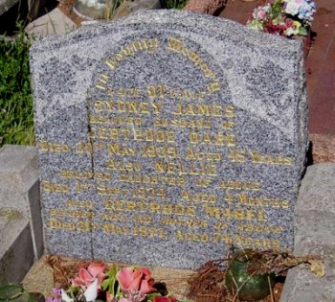
Dare Family Plot in Cornelian Bay Cemetery, Hobart
Photo sourced from Graves of Tasmania website
Interment took place in the Church of England portion of Cornelian Bay Cemetery withing section O in grave no. 172.

Gertrude Dare died on 21 May 1977 and was interred with her husband.

Business arising from his Estate was advertised in the:

Voice (Hobart) Saturday July 29, 1939:

ALL persons having claims against the undermentioned estates are required to lodge the same with the Public Trustee, Hobart, on or before the 22nd day of August next: SYDNEY JAMES DARE, late of Bridgewater, labourer
E.D. KEMP, Public Trustee.
His name is commemorated on the Oatlands Soldiers’ Memorial.
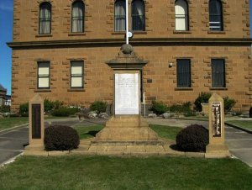
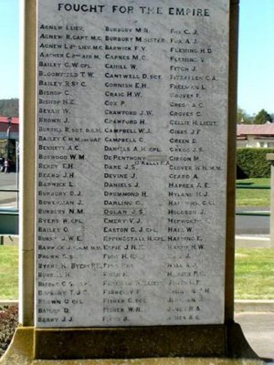
Oatlands Soldiers’ Memorial, Tasmania
Photo sourced from Monument Australia
submitted by Diane Watson 2009

© Donna Baldey 2024
www.tunnellers.net

