SAPPER RICHARD DANIELS
5253 – 3rd Tunnelling Company

Peckham, London, England was the birthplace of Arthur Richard Daniels in the second quarter of 1895 the son of Edward William and Susannah (nee Payne) Daniels and registered at Camberwell. He was baptised in the Church of England Church of St Luke, Camberwell, London on 31 May, 1895. He received his education at the Gloucester Road, Council School in Peckham.

In 1901 the family were living in Grenard Road, Camberwell and consisted of Edward W. (38) carpenter, wife Susannah (45) and children George V. (17) birdcage manufacturer, Rosaline (15), Edward W. (12), Henry Albert (10), Arthur (5) and John S. (3).

A decade later in 1911 they were at 32 Grenard Road, Camberwell and citizens in the six-roomed house were Edward William (48) broom handle manufacturer, Susannah (54), Edward William (22) tinman, Henry Albert (20) pressed tin worker, Arthur Richard (15) printer’s labourer, John Stanley (13) and Charles Horace (9) scholars.

Arthur Richard Daniels came to Australia when he was about eighteen years old and was working as a miner at the copper mine at Linda Valley, Tasmania in 1914.

At the recruiting depot in Claremont (6th Military District) on 14 February, 1916 the single miner applied to enlist for active service abroad and passed the medical examination giving his age as twenty-two-years. Attestation papers describe him as 179cms (5ft 8ins) tall, weighing 61.3kgs (135lbs) with a chest measurement of 89-97cms (35-38ins) and had a fair complexion with good vision in his blue eyes and fair hair. A distinctive mark was a tattoo of the Southern Cross on his left forearm. Religious faith was Church of England.

Next-of-kin nominated was his father Edward William Daniels of 32 Grenard Road, Peckham, London, England. He took and signed the Oath of Allegiance the same day.

Acknowledgment to the new recruits was published in the:
North Western Advocate and the Emu Bay Times Friday February 18, 1916:
THE TASMANIAN BATTALION – NEW ARRIVALS AT CLAREMONT
The under-mentioned men joined the Claremont camp on Monday: R. Daniels Article abridged

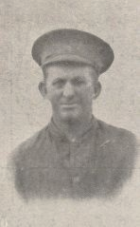
Basic training commenced with the No. 3 Company, Mining Corps until 24 May then transferred to their training camp at Seymour, Victoria (3rd Military District) until 18 July. His rank was Sapper with the regimental number 5253.
Sapper Richard Daniels
Photo www1anzacs.com

The following day Sapper Daniels was one of 79 Reinforcements departing on HMAT A26 Armadale from Port Melbourne, Victoria on July 19, 1916. Durban, South Africa was reached on August 15, 1916 and leave was granted from 11 a.m. to 11 p.m. and they departed the next day. Arrived at Cape Town a few days later on August 20, 1916 and a Route March lasting three hours kept them fit before enjoying leave until 11 p.m. The ship was scheduled to leave at 2 p.m. but cancelled and left the following day at 5 p.m. The quality of liquor in town was considered bad. A one-day stopover to refuel at Port le Grand, St Vincent was the last harbour visited on September 8, 1916. After a 64 day voyage the ship arrived at Devonport, England on September 20, 1916. The troops were detrained to Tidworth Station marching into the No. 3 Details Camp at Parkhouse for further training for the front.

The Reinforcements proceeded to France on 15 October, 1916 marching into the Aust General Base Depot at Etaples on October, 19.

At the beginning of November 1916, the 3rd Tunnelling Company received orders from the C.E. to relieve the 258th Coy Royal Engineers in the Hill 70 Sector at Loos in the 1st Corps 1st Army Area. The mining work at Hill 70 was all in hard chalk and much deeper than that carried out at Laventie.

A complete survey of the mine galleries and the adjustment of levels was immediately undertaken by Capt. A. Sanderson.

Sapper was taken on strength with the 3rd Tunnelling Company on 23 November, 1916.

Sapper was deemed missing on November 28, 1916.

On 27 November, 1916 an explosion occurred in the Black Watch Shaft at Hill 70, Loos and Sapper Daniels, as a result, was reported killed in action aged 21 years. He had been a just over a month in France and about three days working in the field. In the After War Report of the 3rd Tunnelling Company the following was recorded:

“On 27/11/17 while preparing to tamp gallery 21.DD at (36.c.S.W.1. M.b.87.60) the charging of 17,500 lbs of ammonal having been completed, the enemy exploded a camouflet, which exploded our charge. Casualties were 1 officer (Lt H. Russell) and the following 8 O.Rs were “mine gassed” and the following 20 O.Rs were killed:
Gassed 4340 Spr J. Gould 991 Spr J.J. Eddison
4521 “ G.J. Woods 1251 “ S. Barsby
1304 “ S.P. Wagner 4418 “ W. McKnoe
1270 “ B.J. Lear 4993 Cpl L.G. Brown
Killed:
1030 Spr W.F. Horton 4468 “ O.J.S. Russell 1414 Spr L.B. Edwards
2370 “ J.R. Brockley 4309 “ R.E. Daniels [5253] 4431 “ W. Nightingale
4304 “ D. Coulton 2893 “ H.F. Francis 5258 “ C.V. Barker
1364 Sgt M.J.M. Kerby 1122 Cpl J. Pember 4451 Spr J. Praed
4456 “ J. Reid 5014 Spr T.E. Prosser 4402 “ W.J. Moore
4421 “ H. McLean 943 “ W.H. Batson 1273 “ M. Lyons
1071 “ A.E. Ladd 1313 “ P.M. Christiansen

On this occasion after the enemy “Blow” Lt O.R. Howie organised the rescue parties & wearing Proto apparatus, led them into the mine, thereby saving lives & performing valuable exploratory work underground. He carried out this arduous & dangerous work for 24 hours until relieved.

On 28/11/16 the enemy exploded another camouflet (at 36.c.S.W.1. N.1.a.45.95). Slight damage done to our workings in the vicinity of the blow. The casualties were 3 O.Rs mine gassed, 1 O.R. wounded & 2 O.Rs. killed.”

Burial took place in Hersin Communal Cemetery Extension, France situated 2¼miles from Noeux-les-mines.

On 12 December, 1916 Base Records was advised of his demise and confirmation of the cable from London Headquarters was returned the next day. A copy of his service records was made for the Pension Department on December 16.

The 6th Military District, Hobart requested the next-of-kin from Base Records which were sent in a Telegram dated 16 December, 1916 giving his details as Mr E.W. Daniels, 32 Grenard Road, Peckham, England.

His name was listed in the Casualty List published in the:
Daily Post (Hobart) Tuesday December 26, 1916:
TASMANIA – KILLED IN ACTION
Spr. Daniels, R., England 28/11/16 Article abridged
On 17 January, 1917 the Anzac Section, 3rd Echelon G.H.Q. B.E.F. prepared the Field Service Report on the death of Sapper Daniels.

His Will revealed he left his Estate to his father in Peckham, England.

The Kit Store at Fulham Road, Hammersmith prepared his personal items for return to his father in Peckham, London and the inventory stated:
2 Identity discs, handkerchief, keys on ring, photos, letters, sleeve link.

The delivery receipt of personal effects was signed and returned on 5 May, 1917 by his father.

The District Pay Office, 6th Military District, Hobart requested two copies of his Certificate of Report of Death in connection with this soldier from Base Records, Melbourne on 18 January, 1918. These were returned on January 24.

Photographs of his grave were forwarded from the Commanding Officer, 3rd Tunnelling Company in France on 20 October, 1918 to Mr E.W. Daniels at 32 Grenard Street, Peckham.

The Commanding Officer, Major Alex. Sanderson, 3rd Tunnelling Company from Headquarters at Tournai, Belgium forwarded on 19 May, 1919 photographs to his father at Peckham of the resting place of his son who gave his life so faithfully in the service of his country. He advised that a permanent stone memorial would later be erected over the grave and trusted that some comfort would come from the photographs.

The Circular and Booklet re Graves was sent to his father on 24 December, 1919 and a reminder on 2 August, 1920.

In the After War Report of the 3rd Tunnelling Company is their Roll of Honour and his details were recorded in the as:
“4309 Spr Daniels, R.E. Killed by enemy blow at Hill 70 on 27/11/16 Buried at Hersin.”

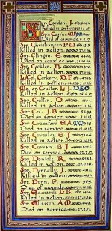

Sydney Morning Herald - Saturday 23 July 1921:
ENGINEERS' ROLL OF HONOUR
The Royal Engineer War Memorial Committee are arranging to deposit a roll of honour of all ranks of the Royal Engineers whose names were officially published as killed in action or died of wounds or disease in the war in the chapel of St. Paul's Cathedral, and the Engineer corps of the dominions, colonial, and Indian armies have been invited to deposit similar rolls of honour in St. Paul's, to be attached to that of the Royal Engineers. This invitation has been accepted in Australia. The roll will be inscribed on vellum and enclosed in a casket of Australian timbers to rest on a slab of Australian marble.

This extract from Tunnellers Roll of Honour included in profile with the kind permission of the
Dean and Chapter of St Paul’s Cathedral, London

Photos courtesy of Robin Sanderson, Paris
For his supreme sacrifice Sapper 5253 Richard Daniels, 3rd Tunnelling Company was issued with the British War Medal (44286) and the Victory Medal (43793) in service for his country.

The War Medal and a pamphlet Where the Australians Rest were sent from Australia House, London to his father. The Victory Medal was inscribed at Australia House and also went out to Mr E.W. Daniels.

The Memorial Scroll and King’s Message together with the Memorial Bronze Plaque (321349) were issued in England and sent on 8 August, 1922 to his father.

In the commemorative area of the Australian War Memorial, Canberra, ACT his name appears on panel 26.

His grave can be located in plot 1 of Hersin Communal Cemetery Extension, France within row C in grave no. 17.
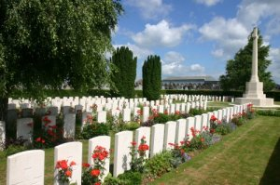
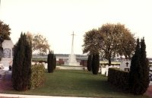
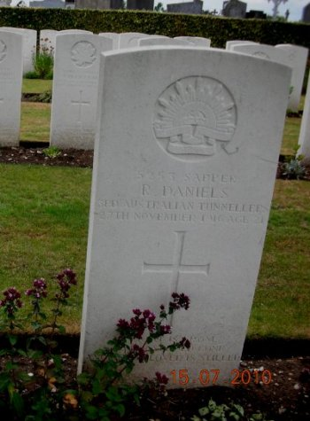
Photos of Hersin Cemetery by kind permission of
The War Graves Photographic Project - www.twgpp.org

Photo of headstone courtesy John Battersby, England

LEST WE FORGET

©Donna Baldey 2024
www.tunnellers.net

