SAPPER WILLIAM DABB
5315 –2nd Tunnelling Company

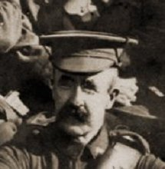
Born in 1869 at Malden, Victoria, the son of James and Catherine Frances (nee Egen) Dabb, William Henry Dabb gave his address as Brown Hill Post Office, Western Australia (WA) when he completed the application to enlist in the A.I.F. at Kalgoorlie WA on 15 March 1916.
William Dabb – 1916
see Photo Albums / Carman 5304 William

A medical examination on the same day found him to be fit for active service and he signed the Attestation Paper of Persons Enlisted for Service Abroad and took the Oath to ‘well and truly serve’ at Blackboy Hill, near Perth WA on 20 March 1916.

William stated that he was a widower, a miner by trade and stated his age as 44 years (in fact he was 47). William was 5ft 4in tall and weighed 152lbs. He had a fair complexion, blue eyes and brown reddish hair.

He named as his Next of Kin his son James Wilson, c/o Mrs. Wilson, Brown Hill Post Office, Kalgoorlie, WA and allotted two fifths of his pay for the support of his son.

Initially a Private at 54 Depot, he was transferred to Miners Reinforcements at their Seymour Camp in Victoria on 10 May 1916 and, after training, embarked with 172 reinforcements for the Tunnelling Companies for the Western front from Melbourne, Victoria on 30 September 1916 on board HMAT A23 Suffolk.

The ship arrived at Fremantle on October 10 and departed the same day. The South African port of Capetown was reached on October 30 and after an overnight stay left the following day. The vessel arrived at Dakar, West Africa on November 15, 1916 staying in the harbour until November 20, 1916.

After 64 days at sea the voyage terminated and they disembarked at Plymouth, England on 2 December 1916, William was marched in to No.3 Camp, Parkhouse the next day for further training for the front.

The reinforcements proceeded overseas to France on 1 January 1917 onboard SS Arundel and marched into to the Australian General Base Depot (AGBD) on 2 January.

On 13 January 1917 he was attached to the 1st Anzac Entrenching Battalion as a member of the Australian Tunnelling Company Details. The 1st Anzac Entrenching Battalion was an advanced section of the Base Depot that organised works near the lines and through duties, usually of ten days duration, would accustom the reinforcements to war conditions before being assigned to a company in the field.

He was attached to the 2nd Australian Tunnelling Company on 15 March 1917 and was taken on strength of that unit on the same day.

William enjoyed some leave from the front from 26 June 1918, rejoining his unit on 12 July.

The following photograph was dated as taken on 30 November, 1918 of the C.Q.M.S. and his staff in the Corbie-Amiens area, Querrieu, France but some of the men in the photograph were invalided in England or on leave there during October and November, 1918.

At the end of March, 1918 the Company’s Headquarters was at Querrieu and was possibly taken after that time.
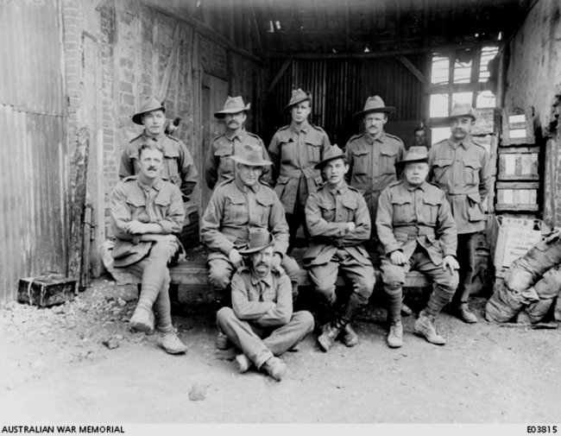
Sapper was with his unit when Peace was declared and the Tunnelling Companies remained on the front as part of the Army of Occupation assisting with rehabilitation of their area by clearing roads and bridges of booby traps and delayed action mines left by the enemy.
Standing back: Spr. Whitmarsh, Spr. J. Byrne, Spr. R. Coleman, Spr. G. Parry, Spr W. Eva
Middle seated: Cpl W. Hill, RQMS G.A. Drummond MSM, Cpl R.G. Down, Spr. J. Jones,
Front: 5315 William Dabb

He returned to the AGBD for repatriation on 3 February 1919 and proceeded back to the United Kingdom on 12 February, marching in to the 2nd Training Brigade.

William returned to Australia on board H.T. Castalia, leaving London on 13 April 1919 and disembarking in Fremantle on 24 May. News of their arrival was reported in the:
Albany Advertiser Saturday May 24, 1919:
RETURNING SHIPS - PER CASTALIA AND WYREEMA
The transports Castalia and Wyreema, with returning West Australian troops on board, arrived from the United Kingdom on Thursday afternoon. Both were pronounced clean ships, and not only were the local soldiers landed yesterday morning, but the others passing through were given shore leave. From the Castalia there were disembarked eight officers and 60 other ranks. Both batches were entertained at luncheon by the Red Cross ladies at the Town Hall and then proceeded to the railway station to catch a special train which left for Perth at 2 o’clock.

He had been hospitalised for 8 days on the voyage home with rheumatism, although a Medical examination at No.8 Australian General Hospital on the same day found no wounds or injury, but noted that he had suffered rheumatism on the boat returning home resulting in slight disability. The soldier’s comment on his condition was ‘fit’.
William was discharged from the A.I.F in the 5th Military District on 8 July 1919, entitled to wear the British War Medal (13885) and the Victory Medal (13630) for his service.

The following was reported in the:
Western Argus - Kalgoorlie, WA - Tuesday 13 April 1920:

Sydney Cup Sweep.- Mr. Don. Leslie reports that the first prize in the Sydney Cup sweep, of £242 6/9, was drawn by Mr.. Malcolm Gaston, Soldiers' Institute; second prize, £60 11/8, by W. H. Dabb, Brown Hill; and the third prize, £36 7/, by Cyril Slee, Hampton Plains. The three principal prize winners are returned soldiers. The first and third prize tickets were sold by Messrs. H. Kingsbury and R. Cawrse, on McKenzie's corner.

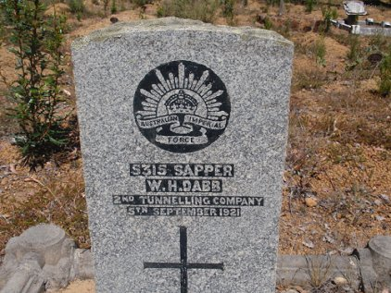
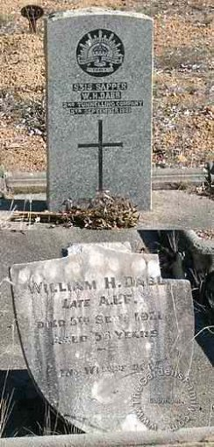
William Henry Dabb died on 5 September 1921 and was buried in the Anglican portion of Wooroloo Cemetery in grave no. 233, adjacent to the Wooroloo Sanatorium, Western Australia.
Photo above courtesy Henry Slyns, WA

Photo right courtesy www.thegardensfamily.com

The West Australian - Perth, WA - Monday 10 May 1948:
Amount
owing
Name of Registered Proprietor as rates Description of Land
£ s. d.
William Henry Dabb, Brown Hill, P.O., Miner, 5 14 7 Portion of Canning Location 25 and being lot 410 on
as Registered Proprietor and Owner. 1/7/33. Plan 4393, Melrose-street, being the whole of the land comprised in certificate of Title Volume 754 Folio 17.

As the ex-soldier died within the nominated period after discharge his name is on the State War Memorial Honour Boards situated at Kings Park, Perth. The following was advertised in the:

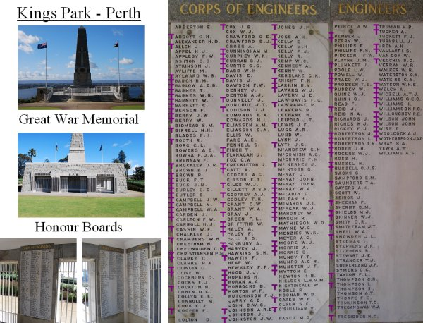
Purple ‘T’ added by www.tunellers.net
The West Australian Thursday August 1930:
STATE WAR MEMORIAL - NAMES FOR TABLETS

The names of all West Australian soldiers who gave their lives during the Great War are to be handed down to posterity by means of a series of tablets bearing their names on the walls of a section of the State War Memorial on Mount Eliza.

© Donna Baldey 2009 / 2018 / 2020
www.tunnellers.net

Footnote:
WOOROLOO SANATORIUM
In the Darling Ranges of Western Australia the State Government set up in response to curbing infectious diseases such as diphtheria, typhoid and tuberculosis a Sanatorium at Wooroloo which opened in May, 1915. All 74 patients from the Coolgardie Sanatorium were transferred by train to the new facility and it was then closed.
The site, on Linley Valley Road, Wooroloo was chosen because of the beauty of the countryside and an elevated position which enhanced the emphasis placed on the use of sunlight and fresh eucalypti-laden air required for curative care. Three successive tiers one above the other formed a half circle on the western slope of a forest clad hill containing thirty-six buildings built between 1914 and 1917. First row was near the valley and housed reception and for primary patients. Second tier held wards for those in whom the disease held greater activity and the third tier was for advanced and terminally ill patients. A magnificent panorama was obtained from all wards.
Electricity was provided on the grounds by an 11 horsepower generator for lighting and refrigeration and a large disinfector controlled the spread of infection at the hospital laundry. The facility had to be self-sufficient with its own kitchen, bakery and dining room and an operating theatre and laboratory. It also had a billiard room, small library and school for young children.
The cemetery is the only one in Western Australia established to serve a hospital and contains many nationalities and includes many soldiers from World War I who were sent to the Sanatorium for treatment. The cemetery is located midway between the Sanatorium and the Wooroloo township.

