SAPPER CHARLES CUTHBERTSON
3466A – 1st Tunnelling Company

Charles Cuthbertson was born in Ipswich, Queensland on 16 August, 1890 the son of Matthew and Jane (nee Sinclair) Cuthbertson. He was educated at the Tivoli State School. From 1912 he is listed working as a miner from Tivoli, Ipswich.

At the recruiting depot in Brisbane (1st Military District) on 10 February, 1916 the twenty-five-year-old single miner applied to enlist for active service abroad and passed the medical examination. Attestation forms describe him as 176cms (5ft 9ins) tall, weighing 61.3kgs (135lbs) with a chest expansion of 86-94cms (34-37ins) and a medium complexion with good vision in his grey eyes and light brown hair. Distinctive marks were scars on both legs and on his head and required dental treatment. Presbyterian was his religious faith. Next-of-kin nominated was his mother Jane Cuthbertson of Lower Tivoli, Ipswich, Qld. The Oath of Allegiance was signed and taken the same day.

Basic training commenced with the 11th Depot Battalion, Enoggera Barracks, Brisbane from February 11, 1916.

Acknowledgement to the new recruits was published in the:
Brisbane Courier Friday February 25, 1916:
COUNTRY VOLUNTEERS – IPSWICH
Since the appointment on February 2 of Sergeants Reid and Adams at local recruiting offices, there has been a steady flow of recruits, and 64 were accepted up to 22nd instant. They were: Charles Cuthbertson Article abridged

He returned on leave where the following presentation and farewell was made and reported in the:
Brisbane Courier Tuesday February 29, 1916:
PRESENTATIONS
The soldiers were farewelled in the Tivoli State School, Ipswich on Saturday night. The men were Tivoli residents and were Privates C. Cuthbertson
Mrs A.J. Barfer, on behalf of the residents of Tivoli, presented each man with a parcel containing suitable gifts, such as razors, strops, wallets, service knives, match boxes &c. A liberal supply of cigars and cigarettes was also given to each one. A musical programme was carried out. Article abridged

On behalf of the colliery he worked for, a presentation evening was held which he was unable to attend but was mentioned in the article in the:
Queensland Times (Ipswich) Monday March 20, 1916:
PRESENTATIONS TO VOLINTEERS – BY ABERMAIN COLLIERY PROPRIETORY AND EMPLOYEES
Recently the employees of the Abermain Colliery, Tivoli, decided to mark their appreciation of the action of some of their late workers who have volunteered for service at the front. A presentation to each who decided upon, and the proprietor (Mr W.R. Black) lent his sympathy and practical aid to the arrangements. The result was a large gathering at the social which was held at the Olympic Hall last Saturday night, at which several volunteers from Abermain were each made the recipient of an illuminated wristlet watch, supplied and engraved by Mr W. Pratt. Dancing was the chief pastime at the social, and Ferguson’s orchestra supplied splendid music. Mrs Lee and Mr F. Holt playing extras. Mr F. Harrold made a capable M.C.
The arrangements for the evening were in the capable hand of a committee consisting of Messrs J. Crick (chairman) T. Gibson, T. Armstrong, G. Duncan, P. Thompson, senr. H. Johnson and T. Ferrier (secretary)
In the course of an interval the volunteers present were asked to come up on the platform.
Mr Ferrier mentioned that similar present would, when opportunity offered, be given to Ptes W. Harrold and C. Cuthbertson, who were unable to be present that night, and one would be forwarded to Scotland to the mother of Pte G. Mitchell, who is now in Egypt.
Article abridged
On March 21, 1916 he was allotted to the No. 4 Tunnelling Company and continued training until early in May, 1916 when they embarked from Brisbane on board HMAT A69 Warilda for Sydney, NSW.

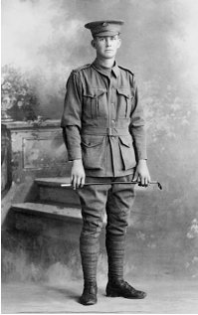
Six officers and 152 other ranks together with the 1st Reinforcements of fifteen other ranks made up the two sections. At Rosebery Park, Sydney, NSW on 10 May they joined their Headquarters and two sections (8 officers & 153 O.Rs.) plus 1st Reinforcements consisting of one officer and seventeen other ranks for final training. The rank of Sapper and the Regimental number 3466 in No. 4 Company was assigned to him.
Sapper Charles Cuthbertson
Photo sourced from Aust War Memorial – public domain photo

He did not embark on the troopship Warilda and continued training in Sydney with the Reinforcements until 5 July when transferred to their training camp at Seymour, Victoria and allotted to the 4th Reinforcements to the Tunnelling Companies.

The 81 Reinforcements embarked on the transport RMS Orontes on August 16, 1916 from Melbourne, Vic. The mail ship sailed to Adelaide, S.A. then Fremantle, W.A departing on August 23, 1916. After leaving the stormy Australian coast the vessel docked at the African ports of Durban, Capetown and St Vincent and after fifty-two days at sea of generally fine and mild weather arrived at Plymouth, England on October 2, 1916. They were detrained to Tidworth and marched in to No. 3 Details Camp at Parkhouse for further training at the front.

The Reinforcements proceeded to France on 19 November, 1916 arriving at the Aust General Base Depot at Etaples then sent to the Segregation camp. On 4 December was attached to the 1st Anzac Entrenching Battalion which was an advanced section of the Base Depot that organised works near the lines and through duties, usually of ten days duration, would accustom the reinforcements to war conditions before being assigned to a company in the field.

On 11 January, 1917 London Headquarters advised his regimental number would be 3466A.

Military discipline was issued for the following:

Offence: (1) while on active service – drunk (2) being in town of Amiens
without a pass
Award: Forfeits 7 day’s pay

Proceeded on 7 March, 1917 to the 1st Tunnelling Company and attached on March 12 who were situated at Poperinghe, Belgium maintaining the mining system under Hill 60 and Caterpillar (Hill 59).

He was sent to the 98th Field Ambulance on 10 November, 1917 with dental caries and transferred to the 2nd Casualty Clearing Station with further treatment at the New Zealand Stationary Hospital and returned to duty on 7 December, 1917.

On 1 February, 1918 was taken on strength with the 1st Tunnelling Company.

A conference was held at Company Headquarters, West Cartigny on 24 September, 1918 to discuss and adopt a policy in connection with the reconnaissance, repair and maintenance of forward roads, prior to, and during the forthcoming offensive operations. On 29 September the offensive began and sections of the 1st and 2nd Tunnelling Companies carried on in accordance with instructions.

The Unit Diary of the 1st Tunnelling Company gives little information and the following extract is taken from the unpublished book My War Story of the Great War by Captain O.H. Woodward, also of the 1st Tunnelling Company:

“THE SOMME AND HINDENBURG LINE

At 5 a.m. on the 29th September, I arrived at Benjamin Post with 82 men of No. 4 Section and 65 men of the 102nd “B” Company U.S. Engineers. The attack was launched at 5.50 a.m. and shortly after we commenced work on repairs to the road. When we approached Quennet Copse and Guennemont Farm we were held up by machine gun fire, owing to the failure of the Americans to “mop up” these positions. Before we realised what had happened, we lost one officer and one sapper killed and twenty others wounded. At 9 a.m. I received an order from the C.R.E. Australian Corps to report immediately on the condition of the road leading to Hargicourt, and then as far as possible toward Bellicourt.

At 6 a.m. next morning, we were again on the road work and got up to the outskirts of Bony, and from the crest of the hill witnessed Australians “mopping up” the village; next morning the position had been cleared up and by noon we had the forward road repaired to a point just beyond Bony. When we ceased work that night, we had carried the road forward to a point about a quarter of a mile beyond the town.

By October 2nd the attack had advanced sufficiently well to allow moving the Section up to new Bivouac in the original Hindenburg Line at Bellicourt. Shortly after Zero on the morning of the 3rd October, with Sergeant Stevenson and Sapper Mooney I inspected the forward roads from Grandicourt to Lornisset Farm, but beyond this it was impossible to proceed on account of machine gun fire sweeping the wood. We then inspected the Grandicourt-Estrees Road as far as Folemprise Farm, and from there the Estree-Beaurevior Road until we reached the line of supporting Infantry. On the 4th October, we started work on the repairs of the Estree-Beaurevoir Road, but when opposite La Motte Farm we came under heavy machine gun fire from the position somewhere around Beaurevoir. On the 5th October, No. 4 Section was relieved by No. 3 Section and we had a couple of days rest in our bivvies in the Hindenburg Line just outside Bellicourt.

No. 4 Section resumed duty on October 8th and by that date the forward road had been carried to a point outside Premont, and by 4.30 p.m. on October 10th we had carried it forward to a point in the wood of La Sabliere, about midway between Premont and Becquigny.”

Sapper Cuthbertson was wounded in action on 8 October, 1918 and taken to the 12th Casualty Clearing Station where he died from his wounds the same day. He was twenty-eight years of age. Burial took place in Tincourt New British Cemetery 4¼ miles East of Peronne.

A cable was sent on 21 October, 1918 to the 1st Military District advising of the demise of the soldier and confirmation of the cabled news replied to the same day. News was then conveyed to the Moreton Shire Council to advise his next-of-kin and his death was shared in the:
Queensland Times (Ipswich) Thursday October 24, 1918:
MILITARY ITEMS
The Rev. G. Cameron-Wood, and Mr T Finimore (Clerk of the Moreton Shire Council), conveyed the sad news to Mrs Cuthbertson, of Tivoli, that her son, Pte A. Charles Cuthbertson died of wounds on the 8th of October.

A copy of his service records was made for the Pension Department on 4 November, 1918.

The Secretary, Henry W. Leigh of the Rising Star Lodge No. 2028 North Ipswich wrote to Base Records on 13 November, 1918 asking to be supplied with the necessary information concerning the death of this soldier and the name of the legally authorised person to pay to any funeral donation from the above Lodge. Base Records replied by their formal statement on 22 November, 1918 that no documentation had been received from abroad and would respond with the information when to hand.

His name appeared in the 447th Casualty List published in the:
Telegraph (Brisbane) Thursday November 28, 1918:
ROLL OF HONOUR – 174 QUEENSLANDERS INCLUDED
DIED OF WOUNDS
Spr. Charles Cuthbertson, Ipswich, 8/10/18 Article abridged

The Red Cross Society in London received an inquiry from relatives of the former soldier, for the fullest details possible of the cause of death and the Red Cross wrote on 4 January, 1919 to the 12th Casualty Clearing Station.

The Officer Commanding replied on 12 January, 1919 that the soldier was admitted to the C.C.S. on 8-10-18 suffering from shell wounds, leg and hand, right severe from which he died at 12.30 p.m. the same day. He was buried in Military Cemetery, Tincourt, France on 9-10-18.

His mother and family placed the following notice in the:
Queensland Times (Ipswich) Saturday January 11, 1919:
BEREAVEMENT NOTICES
Mrs CUTHBERTSON and FAMILY, of Tivoli, North Ipswich, desire to THANK their many kind friends for letters and cards of sympathy in the loss of their son and brother, Sapper Charles Cuthbertson, who died of wounds in France, 8th October, 1918.

On 16 January, 1919 Base Records replied to the Rising Star Lodge, East Ipswich enclosing the Report of Death Certificate of the late soldier. With regards to the Funeral donation their branch had no knowledge of a Will executed by the late soldier and should have prepared such a document overseas. If discovered it would be forwarded to the Paymaster, Victoria Barracks, Brisbane for necessary action. The writer stated that he nominated his mother Mrs J. Cuthbertson, Lower Tivoli, Ipswich, Qld as next-of-kin.

The Red Cross Society received replies from informants who witnessed the wounding of Sapper Cuthbertson and the following statements are from their information cards:

Havre 27 February, 1919
No. 1 Mining & Tunn. Coy A.I.F. Cuthbertson, C. 3466

Died of Wounds 8-10-18
He came from Queensland and was single. I was alongside of him when he was hit by a shell with 2 other men, about 4 kilos outside Bellicourt. He was hit in the leg, arm and thigh. He was taken to a C.C.S. and died the same day and was buried in the cemetery at Tincourt.
Informant: Sapper T. Murphy 2429
No. 1 Mining & Tunn. Coy - Aust Demob. Base.

1st Tunnelling Coy, A.I.F. Cuthbertson, C. 3466A
Died of Wounds 8-10-18
Was a Sapper in 1st Tunnelling Company, tall, slim fair, boyish looking. We were at Neurcy, between Bellicourt and Estrees on 8th October, 1918 in a sunken road. We were moving up to the forward roads and Fritz was shelling a battery nearby. About 9.30a.m. a shell got 5 of us, 1 was killed straight out, 2 wounded and died later, 2 recovered. Cuthbertson was hit badly in the buttocks and right hand was blown off. He was conscious and was very game, said he would be alright. Stretcher bearers carried him to a Hospital near Bellicourt., and we were very surprised to hear that he died. A despatch rider took a cross back to Tincourt where he was buried.
Informants: Cpl W. McIntosh 3473A
2/Cpl A.J. Wilkinson 3468
London 12-3-19 1st Tunnelling Company
Note: several other men of 1st Tun. Coy confirmed this story.

Havre 7 March, 1919 Cuthbertson, C. 3466A
1st Tunnelling Coy
Died of Wounds 8-10-18
I saw him killed by a shell at Bellicourt. I was alongside of him and assisted to carry him down on a stretcher to an American Dressing station. He was taken from there to a C.C.S. at Tincoourt. He was buried in the Military Cemetery there and I have seen his grave. There is a cross over it. He came from Queensland, and was a miner.
Informant: Sapper T. Murphy 2429
4th Section 1st Mining & Tunnelling Coy - Aust Demob. Base.
Base Records received a letter dated 27 May, 1919 from Mrs J. Cuthbertson in which she advised the following:

“I hope you will pardon me taking the liberty in writing you but would like to explain matters concerning 2 parcels I sent on to France, one at the end of September last & the other first week in October last to be at France in time for Christmas & cold weather both parcels containing all knitted goods for comfort. However my son got badly wounded on the 8th October last. The Base sent word that he died of his wounds & I of course got word that all parcels that is unclaimed are sent to the Comforts Fund.

Now Dear Sir when my son died of his wounds, he could not claim them. My son was my only support at home & myself a widow & knitted the goods of wool at pre-war prices; is there no way that the defence at home could be acquainted in regard of the parcels. They were well sewed up in grey calico & well addressed thus to Charles Cuthbertson No. 3466, 1st Tunnelling Company, the rest of the address following then on the side was my own address, also printed from Mrs J. Cuthbertson, Lower Tivoli, North Ipswich, Queensland, Australia. Of course, they may come yet but would like you to send me word if I may expect them as I got one married son very ill & would like to give him socks etc for comfort in this trying time of sickness. Trusting I have not intruded to far on your valuable time. Trusting to hear from you soon & oblige. Yours respectfully,
Jane Cuthbertson”

A reply to her letter from Base Records dated 3 June, 1919 stated that parcels forwarded to a soldier and arriving at his unit after his decease are opened and the contents divided amongst his immediate comrades, with the exception of any articles of sentimental or intrinsic value which are extracted and returned. It was regretted that as the parcels to which you refer were dispatched in September and October any instructions from this branch would arrive too late to affect their disposal.

The AIF Kit Store at Hammersmith, London completed an Inventory of his personal effects from the field and sent sealed in a parcel which contained:
Safety razor, strop, Wrist watch (damaged), Notebook, Cards, Letters, Handkerchief.

This left on the transport Bulla for Base Records to be transmitted to his mother. The parcel was posted to her on 9 July, 1919.

Another sealed parcel containing articles from the field was packed for his mother by the AIF Kit Store and also consigned on the transport Bulla and the Inventory reads:
Combined knife, fork & spoon, coin, fountain pen (damaged), metal cigarette case, religious
Charm, YMCA wallet, photos, cards, letter.

Base Records posted the parcel to his mother on 11 July, 1919 under separate cover.

One of these packages did not arrive and Base Records replied on 1 August, 1919 with reference to undelivered parcel containing valuables, addressed to her son has been referred to the Officer-in-Charge, Base Post Office, Coventry Street, South Melbourne for attention and would reply direct.

On 22 August, 1919 Base Records wrote with reference to the regrettable loss of her son and was now in receipt of advice which shows that he was wounded in action on 8 October, 1918 and admitted to the 12th Casualty Clearing Station, where he died the same day as the result of his wounds. He was buried in Tincourt New British Cemetery 4½ miles East of Peronne, France. The utmost care and attention was being devoted to the graves of our fallen soldiers, and photographs were being taken as soon as possible for transmission to next-of-kin.

These details were furnished by direction, it being the policy of the Department to forward all information received in connection with deaths of members of the Australian Imperial Force.

A reply dated 27 August, 1919 to Mrs Cuthbertson’s request of a photograph of the grave of her late son, the Officer-in-Charge, London advised the writer that action was being taken to have the grave photographed and when available a copy would be forwarded to their office for transmission to her.
On the first anniversary of his demise his family placed the following in the:
Queensland Times (Ipswich) Wednesday October 8, 1919:
ROLL OF HONOUR
CUTHBERTSON—In sad but loving memory of our dear son and brother, Sapper Charles Cuthbertson, who died of severe wounds in France, October 8, 1918.
Dear Charlie, we pictured your safe returning,
And longed to clasp your hand
But God postponed our meeting,
He was one of the best that God could find.
A loving son and faithful friend.
Too far away for your grave to see,
But not too far to think of thee,
In a grave in France you are laid to rest,
It was hard to hear, but God’s will is best.
He sleeps beside his comrades,
In hallowed graves unknown,
But his name is written in letters of love,
In the hearts he left at home.
(Inserted by his sorrowing mother, brothers and sisters.)

A Circular and Booklet re Graves were dispatched to Mrs Cuthbertson on 29 November, 1919.

On 18 March, 1921 the pamphlet Where the Australians’ Rest went out to his mother.

Photographs of his grave in triplicate were transmitted to Mrs Cuthbertson on 25 May, 1920.

For his supreme sacrifice Sapper 3466A Charles Cuthbertson, 1st Tunnelling Company was issued the British War Medal (45566) and the Victory Medal (45044) in service for his country.

The War Medal was sent to the Commandant 1st Military District for distribution as a suitable time for his mother.

A Roll of Honour was being arranged for the Engineers who died with details appearing in the:

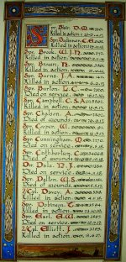

The Sydney Morning Herald - Saturday 23 July 1921:
ENGINEERS' ROLL OF HONOUR
The Royal Engineer War Memorial Committee are arranging to deposit a roll of honour of all ranks of the Royal Engineers whose names were officially published as killed in action or died of wounds or disease in the war in the chapel of St. Paul's Cathedral, and the Engineer corps of the dominions, colonial, and Indian armies have been invited to deposit similar rolls of honour in St. Paul's, to be attached to that of the Royal Engineers. This invitation has been accepted in Australia. The roll will be inscribed on vellum and enclosed in a casket of Australian timbers to rest on a slab of Australian marble.

This extract from Tunnellers Roll of Honour included in profile with the kind permission of the
Dean and Chapter of St Paul’s Cathedral, London
Photos courtesy of Robin Sanderson, Paris

The Memorial Scroll (354575) went out to her on 15 July, 1921 and delivery slip was signed on 23 July and returned. The Victory Medal was posted on 23 March, 1923 and the receipt signed on March 29.
The Memorial Plaque (354575) was also issued to her on 21 November, 1923.

Mrs J. Cuthbertson wrote to Base Records on 29 March, 1923 asking if they would kindly forward to her a copy of the graves of the soldiers for which she enclosed stamps in payment. The booklet was dispatched on 4 April, 1923. She also signed and enclosed their receipt for the Victory Medal.

Base Records wrote to Mrs Cuthbertson on 18 July, 1925 advising that the official site of her late son’s final resting place was in Tincourt New British Cemetery in Plot 8, Row B, grave 14.

His name can be located in the Commemorative Area of the Australian War Memorial on panel 26.

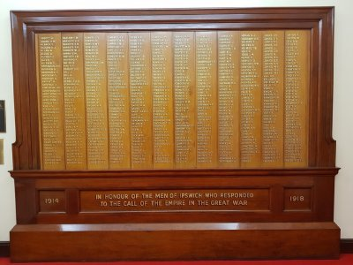
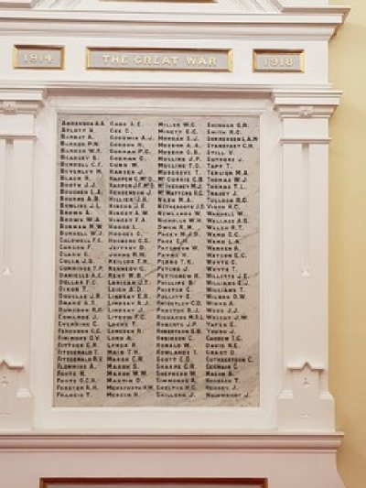
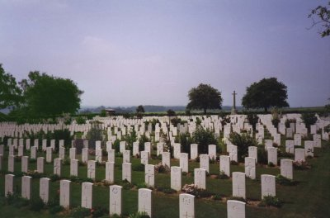
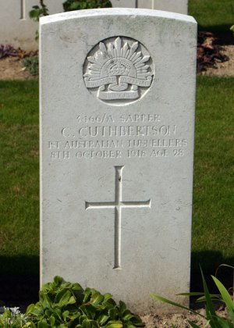
The Ipswich Memorial Hall Roll of Honour also bears his name in remembrance as does the R.S.L. Ipswich
Ipswich Memorial Hall Roll of Honour

Photos sourced from Virtual Anzacs website
R.S.L. Roll of Honour, Ipswich, Q
His grave is in plot 8, row B in grave no. 14 of Tincourt New British Cemetery, France.
Photo of headstone & Tincourt Cemetery by kind permission of
The War Graves Photographic Project - www.twgp.org
LEST WE FORGET
© Donna Baldey 2023
www.tunnellers.net

