SAPPER RICHMOND NORMAN COGGAN
7811 – 2nd Tunnelling Company

Richmond Norman Coggan was born in 1888 in Inverell, New South Wales the son of Frank Herbert and Annie Hyde (nee Nias) Coggan. In 1911 he registered his cattle brands in accordance with the Stock Act and was living at Wallangra. From 1913 to 1915 he was working at Richmond, Central Queensland as a stockman. Later he became a selector at Kurrumbul, Goondiwindi, Qld.

At the Darling Downs Central Recruiting Depot in Toowoomba on 31 May, 1917 the twenty-eight-year-old farmer from Kurrumbul, near Goondiwindi applied to enlist for active service abroad and passed the preliminary medical examination. Personal particulars taken show he was 181cms (5ft 11¼ins) with a chest expansion of 80-88cms (31½-34½.) Declared fit his application was accepted by the recruiting officer.

Attestation forms were completed on 2 June, 1917 and describe him further as weighing 68kgs (150lbs) with a medium complexion with good vision in his blue eyes and dark brown hair. Church of England was his religious faith. Next-of-kin nominated was his father Frank Coggan of Henderson Street, Belgravia, Inverell, NSW. He took and signed the Oath of Allegiance the same day.

Acknowledgment to the volunteers was reported in the:
Brisbane Courier Monday June 4, 1917:
COUNTRY VOLUNTEERS
TOOWOOMBA, June 3.
The following recruits were accepted for active service yesterday—Messrs John Thomas Scandrett, (Goondiwindi), Richmond Norman Coggan (Goondiwindi) Walter Roy Clifford (Warwick), Thomas Joseph Coombe (Toowoomba).

Further acknowledgment appeared in the:
Warwick Examiner and Times Saturday June 16, 1917:
PERSONAL
Mr H.N. Coggan of Kurrumbul has evidenced his practical patriotism to enlisting in the A.I.F.

Basic training commenced at Enoggera Barracks, Brisbane with the No. 1 Depot Battalion for two days then allotted to the Miners’ Depot from 1 August to 13 September with final home leave granted from 23rd to 28 July. From there was transferred to their training camp at Bendigo, Victoria for further instruction until 2 November and returned to Seymour camp where they remained in final training.

Military authorities noted his Will was lodged with the Public Curator, Government Savings Bank, Brisbane. His rank was Sapper with the regimental number 7811 with the May Reinforcements to the Tunnelling Companies. An overnight stay at Broadmeadows camp, near Melbourne completed their training.

The troopship HMAT A71 Nestor departed Port Melbourne, Vic on November 21, 1917 with 168 Reinforcements on board. The voyage of twenty-five days duration terminated at the Suez on December 15, 1917 and the men disembarked going to the Australian Infantry Camp, Suez the same day. They entrained for Alexandria on January 4, 1918 and marched into the Australian Camp, Gabbary, in Alexandria on January 5. They boarded on January 8, 1918 the Transport E620 Abbasiah, disembarking at Taranto, Italy on 12 January. It was an unusual journey for the troops to undertake the weeklong train travel from Taranto to Cherbourg, France, and to then cross the English Channel to Southampton, England disembarking on January 24, 1918. A further entrainment completed their journey to Tidworth and they marched into No. 3 Details Camp at Parkhouse for further training for the front.

The following day was appointed to be Acting Lance Corporal and reverted to Sapper on 2 February, 1918.

The Reinforcements proceeded overseas to France from Southampton on 2 March, 1918 arriving at the Aust General Base Depot in Rouelles a day later.

Miss Annie Baird of “Ailsa,” Malcolm Street, Enoggera wrote on 7 March, 1918 to Base Records asking at their earliest convenience the correct address of this soldier who left Brisbane on the 12 September, 1917 for Victoria to undergo further training before embarkation. By doing so they would greatly oblige.

Base Records replied on 12 March, 1918 to her letter advising the postal address of the soldier.

Sapper left the Aust Corps Depot on 8 March for the 2nd Tunnelling Company and attached on 14 March.

The Unit Diary of the 2nd Tunnelling Company recorded the following on their arrival:

“14/3/18
45 Reinforcements marched in from Aust Corps Depot.”

Sections of the company were working in chalk on dugouts for Brigade Headquarters.

On 29 March, 1918 went sick to the 11th Aust Field Ambulance with debility then the following day sent to the 56th General Hospital with P.U.O. (Pyrexia (fever) uncertain origin) later diagnosed as trench fever. On 5 April was invalided from Havre to England with Tubercule in lungs on the hospital ship Ville de Liege being admitted to the Fort Pitt Military Hospital at Chatham the same day.

Was transferred to the 1st Aust Auxiliary Hospital at Harefield on 18 April. On arrival from hospital his Kit was inspected and contained:
Hat badge, ankle boots & laces, braces, hair, shaving & tooth brushes, comb, drawers, greatcoat
Khaki hat, cardigan jacket, razor & case, flannel shirt, singlet, socks, chin strap, breeches,
Putties, identity disc with cord.

Item replaced was:
Towel.

He remained in hospital until 31 May then moved to the No. 2 Command Depot at Weymouth. His Kit was inspected at Monte Video camp and found in order.

Advice was issued from Base Records on 8 May, 1918 regretfully advising that his son was admitted to Fort Pitt, Military Hospital, Chatham, England on 5/4/18 suffering from tuberculosis lung.

His name was among those listed in the Casualty List published in the:

On 4 June, 1918 a Kit inspection after discharge from hospital added the following:
Queenslander Saturday June 1, 1918:
LIST No. 405 – 144 QUEENSLANDERS INCLUDED
Casualty List No. 402 was issued from the Censor’s office on Saturday and contained the following information.
ILL
Spr. Richmond Norman Coggan, Inverell, NSW Article abridged
Universal Kit bag, drawers, fork, knife & spoon, holdall, housewife, flannel shirt, 2 prs socks,
Towel, 2 collar badges, sea kit badge, comforter cap, identity disc with cord.

Unserviceable item withdrawn was the identity disc with cord.
He was readmitted to the 1st Aust Auxiliary Hospital on 15 July, 1918.

Mrs A.H. Coggan wrote to Base Records from Henderson Street, Belgravia, Inverell on 6 July, 1918 stating that she would be very thankful if they could let her know anything further about her son as she was naturally most anxious and would be glad of any information as to his state of health and if returning, by what boat and when expected to arrive. She hoped it was not too much trouble.

Base Records replied on 13 July, 1918 to her communication and stated that no information had been received that your son is returning to Australia. Should such information be received, it will be duly communicated to next-of-kin, shown as his father.

Sapper Coggan embarked for return to Australia on 20 July, 1918 on board H.T. Karoola due to infective T.B. in sputum. Base Records advised his father on 16 August that he was returning home.

On 2 August, 1918 Base Records advised his father that he was admitted to the 1st Aust Auxiliary Hospital, Harefield, England on 15 July, 1918 from the No. 2 Command Depot at Weymouth with tubercule lung.

He was listed as a soldier returning home in the list published in the:
Townsville Daily Bulletin Friday August 30. 1918:
SOLDIERS RETURNING HOME
A. L-Cpl H.N. Coggan, Tnlg Dtls, Toowoomba Article abridged

The troopship docked in Melbourne (3rd M.D.) on 4 September, 1918 and New South Wales and Queensland soldiers returned to their states within days.

Military discharge was issued in Brisbane (1st M.D.) on 24 September, 1918 as medically unfit.

He returned to his property at Kurrambul via Goondiwindi.

He married on 21 December, 1921 to Alice Maud Frances Austin and they continued to reside on the property.

For serving his country Sapper 7811 Richmond Norman Coggan, 2nd Tunnelling Company was issued with the British War Medal (32371) and the Victory Medal (30410).

Applications for leases were granted in 1925 as reported in the:
Queenslander (Brisbane) Saturday October 10, 1925:
PRICKLY PEAR WARDEN’S COURT
At the Prickly Pear Warden’s Court, Goondiwindi, on Friday, October 2, the following matters were dealt with by the warden, Mr S. Dunn:
Application for certificates for lease—P.L.S. 2722, R.N. Coggan, granted. P.L.S. 2821, R.N. Coggan, granted.

The couple were listed in Electoral Rolls for 1936 to 1943 at Kormine, Warrum as a farmer. From 1943 to 1949 were a Warind, Injune with the occupation of grazier. In 1949 they moved to 48 Curzon Street, East Toowoomba with the same occupation and in 1954 home was 31 Gostwyck Street, Toowoomba.

Mrs Maud Coggan died on 12 June, 1957 with burial in the Drayton and Toowoomba Cemetery.

Richmond Norman Coggan passed away on 16 May, 1969 aged 80 years. Interment took place two days later in the Presbyterian portion 5 of Drayton and Toowoomba Cemetery within row 1 in grave no. 17 with his wife.
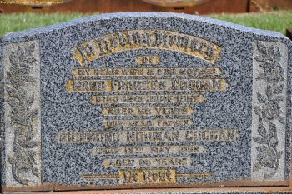
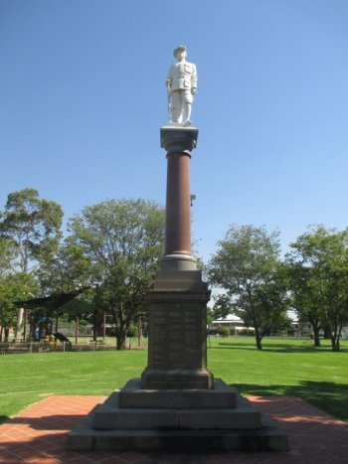
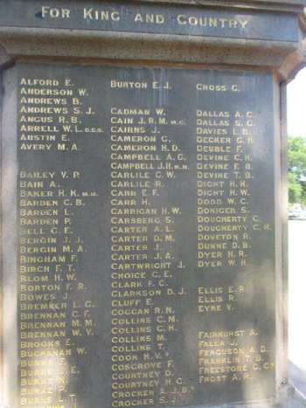
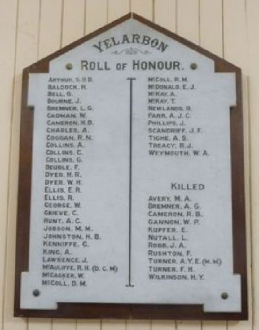
and Yelarbon district’s Roll of Honour held in the Memorial Hall, Yelarbon
Their grave in Drayton & Toowoomba Cemetery
Photo sourced from Cemetery’s website
Goondiwindi War Memorial and tablet bearing his name
Photo taken from Virtual Anzacs website
His name is commemorated on the Goondiwindi War Memorial,
© Donna Baldey 2023
www.tunnellers.net

