SAPPER GARNET ROBINSON CLOUGH
3839 – 2nd Tunnelling Company

Eaglehawk, Bendigo, Victoria was the birthplace of Garnet Robinson Clough in 1887 the son of John and Mary Ann (nee Berkery) Clough. At sixteen years of age in 1903 the following occurred and reported in the:
The Age (Melbourne) Saturday March 7, 1903:
COUNTRY NEWS – BENDIGO
Four lads, Arthur M’Donald, James Muldery, Garnet Clough and Albert Wilson, who had been arrested on charges of housebreaking, have been sent to the reformatory, and Alfred Larsen and Richard Fletcher, were each sentenced to a month’s imprisonment, the sentence to be suspended during their good behaviour.

Police Gazette 15th July, 1903:
GARNET CLOUGH, absconded from the Pakenham Reformatory on the 9th inst. Description—16 years of age, 4 feet 6 inches high, fair complexion, fair hair, brown eyes, right hand very blue, apparently the result of a sore, medium build; wore a black slouch hat, navy blue serge coat, moleskin trousers and good blucher boots. A native of Eaglehawk. May go to Bendigo. —O.6181. 11th July, 1903.

He married on 18 August, 1911 in Bendigo to Sophia May Whitten.

In 1912 he was in the Eaglehawk police court as reported in the:
The Age Wednesday September 11, 1912:
BENDIGO
A case presenting unusual features was heard in the Eaglehawk police court on Tuesday, when John Veale sued Garnet Clough for the recovery of £1/13/6. Mr Smalley, who appeared for the plaintiff, stated that defendant was a miner in the employment of the Johnson’s Reef Gold Mines Co. Mr Veale was served with a garnishee order at the insistence of Mr W. Fox, grocer for the amount owing by defendant and in the hands of the company. On pay day the money was inadvertently handed over to the defendant, but immediately on discovering the mistake Mr Veale called out to the defendant to hand the money back. He refused to do so, and Mr Veale had to pay the money out of his own pocket, in compliance with the order of the court. A verdict was given the amount claimed, with costs.

At the recruiting depot in Bendigo on 21 February, 1916 the married twenty-eight-year-old miner applied to enlist for active service abroad and passed the medical examination but required dental attention. Attestation forms describe him as 163cms (5ft 4ins) tall, weighing 54kgs (122lbs) with a chest expansion of 87-94cms (34-37ins) and a fair complexion, good vision in his blue eyes and dark brown hair. Distinctive mark was a vaccination scar on his right arm and a small brown mark point left shoulder. Religion was Roman Catholic. Next-of-kin nominated was his wife Mrs Sofie May Clough of care of Mrs E.H. M’Kippar, Hargreaves Street, Bendigo and later changed to 15 Palmerston Street, Quarry Hill, Bendigo, Vic and allotted three-fifths of his pay in support of her and their children. The Oath of Enlistment was taken the same day.

Acknowledgement to the new recruits was published in the:
Bendigo Independent Tuesday February 22, 1916:
RECRUITING IN BENDIGO – 22 PRESENTED; 22 PASSED
Yesterday was an exceptionally good day at the Town Hall Recruiting Depot. Twenty-two men presented themselves for enlistment, and the twenty-two passed. This is the first time that 100 per cent pass has been obtained. Three other men who applied for enlistment on Saturday were examined yesterday and failed.
The names of the accepted men are: Garnet Robinson Clough, miner, Hargreaves Street, Bendigo;
Article abridged

Basic training commenced with the No. 5 Tunnelling Company at Broadmeadows camp, near Melbourne on 1 March, 1916.
The recruits forming part of the No. 4 Tunnelling Company embarked from Brisbane, Qld early in May, 1916 aboard HMAT A69 Warilda for Sydney, NSW. Six officers and 152 other ranks together with the 1st Reinforcements of fifteen other ranks made up the two sections.

At Rosebery Park, Sydney, NSW they joined their Headquarters and two sections (8 officers & 153 O.Rs.) plus 1st Reinforcements consisting of one officer and seventeen other ranks for final training.

The 7713-ton transport departed Sydney, NSW on May 22, 1916 and collected in Melbourne, Victoria the No. 5 Company recruited from Victoria, South Aust. & Tasmania made up of Headquarters and 2 Sections (8 officers & 173 men) (3 M.D.). 1 Section from Tasmania (3 officers & 76 O.Rs.); also 1st Reinforcements for No. 5 Company (17 men from Vic. & 8 men Tas.)

The rank of Sapper and the Regimental number 3839 in No. 5 Company was assigned to him.

He was photographed with other members of the No. 5 Tunnelling Company from Bendigo and appeared in the Bendigo Advertiser on Saturday 27 May, 1916 and The Bendigonian issue on 1 June, 1916.

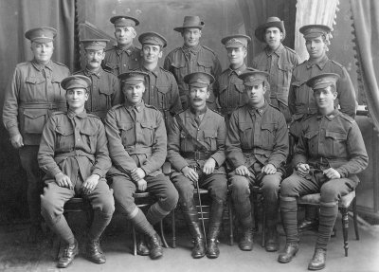
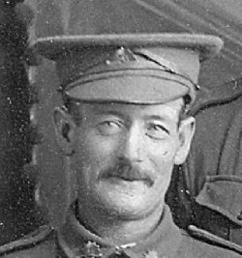
Bendigo Advertiser – Vic – Saturday 27 May 1916:
BENDIGO MEMBERS OF No.5 TUNNELLING CORPS (Broadmeadows), with their O.C.,
CAPTAIN WAGSTAFF, of Bendigo.
Top Row : J. Cain (5293), J. Helsdon (3823), D. Dowsey (5566)
Second Row: T.P.L. Huray (3933), G.R. Clough (3839), F.S. Thornton (3725), R. Brown (3816), (Unnamed)
Third Row: T. Simmons (3922), L.H. Hancock (3950), Capt. P.W. Wagstaff, P. Prince (T.M. 3828), G.T. James (3917)
[Numbers added by tunnellers.net] Photo courtesy Peter Wagstaff
The Warilda departed on May 25, 1916 for Adelaide, S.A. to collect one Section of 3 officers & 76 O.Rs. with 1st Reinforcements of 8 O.Rs.

In Perth the No. 6 Tunnelling Company was in their final stages of preparation for departure giving a regimental show of their strength in parades.

Docking at Fremantle, W.A. on June 1, 1916 added No. 6 Company recruited from W.A. of 14 officers and 325 O.Rs. along with 1st Reinforcements of 1 Officer & 32 O.Rs. departing the same day.
Durban, South Africa was reached on June 16, 1916 and Cape Town on June 21, 1916 while St Vincent completed the African ports of call on July 7, 1916. Discipline was fairly good except at intermediate ports where Away without Leave caused concern. The fifty-eight-day voyage experienced remarkable pleasant weather terminating at Plymouth, England on July 18, 1916.

Four, Five and Six Companies comprising of 1064 officers and other ranks were detrained to Amesbury and Tidworth to begin training for the front at Perham Downs camp.

The Reinforcements proceeded to France on 28 August, 1916 arriving at the 2nd Aust Divisional Base Depot two days later. Sapper marched out on 25 September to join the 2nd Tunnelling Company and taken on strength on September 29.

He was mentioned in a letter about the Catholic Soldiers’ Guild in France which was published in the:
W.A. Record (Perth) Saturday November 4, 1916:
CATHOLIC SOLDIERS’ GUILD
Writing from France, Corporal J.J. Purtell says the Soldiers’ Guild has so far given excellent results, and has been the means of restoring the Faith to the careless ones, and bringing back to God those who have forgotten Him for years.
He sends the following budget of names to be added to the membership of the Guild, and begs the prayers of our devout readers for their spiritual and temporal welfare:
Sapper J. Hickey, F.M. Petney, E.J. Shields, W. Moss, M.J. Cullen, J. Hogan, G.R. Clough.
Article abridged

On 7 May, 1917 Sapper suffered shell shock being admitted to the 4th London Field Ambulance and transferred to the 6th London Field Ambulance diagnosed with neurasthenia (nervous condition, constantly worried to point of exhaustion). On May 8 was transferred to the 10th Casualty Clearing Station and the following day went to the 4th Stationary Hospital at Arques with shell shock.

He appeared before the Medical Board and given “C” class debility – neurasthenia on May 11.

Base Records advised his wife on 19 May, 1917 that he was wounded but this was amended on June 5 he was suffering from neurasthenia and not wounded.

His name appeared in the Casualty Lists published in the:
Mildura Cultivator Saturday June 2, 1917:
THE 304TH CASUALTY LIST
The 304th Casualty List contains [word cut off] names. Appended are the Victorians:
Sapper G.R. Clough, Bendigo
Article abridged

Bendigo Advertiser Saturday June 23, 1917:
Spr G.R. CLOUGH, Quarry Hill (not wounded)
Article abridged

A month later on 11 June was admitted to the 10th Stationary Hospital in St Omer. On 10 July was invalided to England on the hospital ship St David entering the Kent and Canterbury Hospital a day later remaining a patient there until the 11th July.

Base Records further advised his wife on 26 July, 1917 of his admittance to hospital in England on 11 July with shell shock.

Was transferred on 27 August from Shorncliffe Military Hospital to the 3rd Aust Auxiliary Hospital in Dartford with nasal polypus and two days later was discharged to furlough and report to the No. 2 Command Depot at Weymouth.
Marched out on 19 September for the No. 4 Command Depot at Codford and then moved to the Overseas Training Brigade at Deverill on 9 February, 1918. Proceeded overseas from Southampton to France on 15 February arriving at the Aust General Base Depot at Havre.

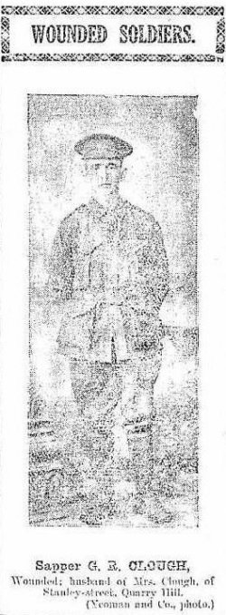
Left there sick on 5 March, 1918 with gastritis (inflammation of the stomach lining) and admitted to the 2nd General Hospital then invalided to England on the hospital ship Panama entering a day later the Northamptonshire War Hospital with gastritis (slight). On 21 March marched out for the 3rd Aust Auxiliary Hospital at Dartford then discharged from Administration Headquarters for a change to Australia.
Bendigo Advertiser
Wednesday June 20, 1917

His wife received notification from Base Records on 5 April he was again admitted to hospital in England on 10 March.

Sapper Clough embarked for home on the Hospital Ship Dunluce Castle on 8 April, 1918. The returning soldiers were transferred at the Suez on 27 April, 1918 to the transport Karoola. Base Records advised his wife on 11 May by printed card he was on his way home. The troopship docked in Melbourne (3rd Military District) on 26 May, 1918.

Military Discharge was issued in Melbourne (3rd M.D.) on 13 July, 1918 as medically unfit due to chronic gastritis.

In 1919 he was a hawker at Goornong and later residing with his wife at 14 Stanley Street, Quarry Hills with his occupation changed to miner. In the City Directories for Bendigo in 1920 he is listed at Panton Street, Bendigo.

The British War Medal (45391) and the Victory Medal (44620) were issued for serving his country to Sapper 3839 Garnet Robinson Clough, 2nd Tunnelling Company.

The War Medal was collected at Victoria Barracks, Melbourne on 16 August, 1921 with While Hills noted in pencil on the receipt. The Victory Medal was not collected from the designated barracks and returned to Base Records on 10 May, 1923. A letter addressed to the last known address of his wife at Quarry Hill dated 3 August, 1923 was returned unclaimed and re-addressed on 16 November to White Hills, Bendigo.

In 1924 they were at Warrenheip and a railway repairer up to the 1927 listing.

The Melbourne Branch of the Repatriation Commission requested a copy of his service records from Base Records which were forwarded on 16 May, 1927.
They were listed at Railway Gates, Thunder Street, Bendigo with his occupation as railway employee.

His wife Sophia Clough died and was buried on 17 September, 1928 in the monumental portion of Bendigo General Cemetery within section P3X in grave no. 23737.

Garnet Robinson Clough passed away aged 43 years on 18 May, 1930. Interment took place in Roman Catholic portion of Eaglehawk Cemetery within section C2 in grave no. 236.

M.E. Crossley, Simpson Road, Eaglehawk replied to a letter from Base Records on 21 April, 1922 with reference to the Mother’s Badge. Her name was Mrs Mary Ann Clough and her son’s name is Garnet Robinson Clough, 38th Battalion.
If they could kindly send her the number of her mother’s badge, she will advertise it in the Bendigo Advertiser paper. The other Mother’s badge belongs to Mrs Houston, a schoolmaster’s wife. Hoping to hear from you soon and hope Mrs Clough will be able to trace it as she would very much like to get it again.

Base Records replied on 4 May, 1932 advising that no record was held of a badge being issued to the mother of the abovenamed ex-member of the A.I.F., a nearest female relative badge was however, issued to his wife – Mrs Sophie May Clough of Quarry Hills. The writer went on to mention that this Soldier’s Victory Medal was held at their Office and would be issued to him on making his application.

His grave is a marked Commonwealth War Grave.
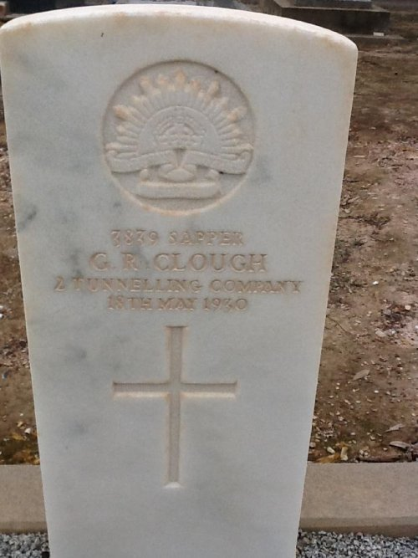
His war grave in Eaglehawk Cemetery, Vic
Photo sourced from Dept of Veteran’s Affairs and used with permission

© Donna Baldey 2022
www.tunnellers.net

