SAPPER JAMES BRADBURY
6872 – Tunnelling Reinforcements – 1st Anzac Entrenching Battalion

Hobart, Tasmania was stated to be the birthplace of James George Bradbury in 1883.

He went to work at the Cornwall Coal mine on Tasmania’s East Coast and in 1903 the following notice was published in the:
Examiner (Launceston) Saturday November 14, 1903:
MISSING FRIENDS
Wanted, known, whereabouts of George James Bradbury, 21 years of age, born at Hobart, last heard of as working at Cornwall Coal Mine, Tasmania. Any information sent care of Proprietor, “Examiner,” would be appreciated.

Several years later he placed the following notices to contact his mother in the:
Mercury (Hobart) Thursday October 18, 1906:
PUBLIC NOTICES
WILL MRS ELLEN BRADBURY SEND HER PRESENT ADDRESS to J.G. BRADBURY, Oyster Cove, Tas.

Mercury (Hobart) Wednesday April 10, 1907:
MISCELLANEOUS WANTS
WILL MRS ELLEN BRADBURY SEND HER ADDRESS TO J.G. BRADBURY, Oyster Cove.

Later that year a contest was proposed for a 20-mile walk with the challenge advertised in the:
Daily Telegraph Wednesday November 6, 1907:
NOTICES
I, the undersigned, am willing to walk J.G. Bradbury, of Cornwall Mines, East Coast, 20 miles for £25 a side.
C. MATTLIN, Gisborne, Victoria.

Four months later the private match took place with the results reported in the:
Mercury (Hobart) Wednesday March 25, 1908:
ATHLETICS – WALKING MATCH
A correspondent sends us the following—The private walking match for 20 miles for £25 a side between J.G. Bradbury, of Tasmania and C. Mattlin, of Gisborne, Victoria, took place last week.
The Tasmanian proved himself too good for the Victorian in a good race. Winner’s time 2h 58mins, 10 secs; Mattlin’s time 3h 4 mins 3sec.

At the recruiting depot at St Marys on 13 October, 1916 the thirty-three-year-old coal miner applied to enlist for active service abroad and passed the medical examination after previously being rejected due to defective teeth. Attestation forms describe him as 168cms (5ft 6ins) tall, weighing 61.8kgs (136lbs) with a chest expansion of 79-86cms (31-34ins) and a sallow complexion with his brown eyes testing to fair eyesight and dark hair. Religious faith was Church of England. Next-of-kin nominated was his mother Mrs Ellen Bradbury of 118 Wellington Street, Launceston, Tas and later changed to 81 Wellington Street. The Oath of Allegiance was signed and taken the same day.

Basic training commenced at Claremont camp until 8 December, 1916 then transferred to Seymour camp, Victoria joining the Miners’ Reinforcements for further instruction then allotted to the January, 1917 Reinforcements to the Tunnelling Companies on January 11.

His rank was Sapper with the regimental number 6872.
The Reinforcements consisting of 168 members departed Melbourne, Vic at 3 p.m. on January 17, 1917 on board the HMAT A5 RMS Omrah. The mail ship arrived at 8 a.m. two days later at Adelaide, S.A. and headed off at 4 p.m. that afternoon. It sailed into the West Australian port of Fremantle on January 21 where the Reinforcements were granted Day Leave ashore the next day before leaving on January 24, 1917.

The ship returned to Fremantle at 7 a.m. on February 1 and put out to sea again at 5 p.m. the next afternoon February 2. Durban, South Africa was reached at 7 a.m. on February 16 and sailed at 6 p.m. the following evening. The next port of call was Cape Town on February 20 arriving at 8 a.m. where two days later the men were granted Day Leave ashore until 11 p.m. on the 22nd before departing at 5 p.m. on February 24. The sights of Sierra Leone were seen closely on March 9, 1917 as the vessel docked at 8 a.m. and after refuelling left at 7 a.m. on March 12, 1917. The voyage concluded at Devonport on March 27, 1917 and the troops disembarked at Plymouth after 74 days at sea. The three officers and 165 other ranks were detrained to Tidworth and the remainder marched into the Drafting Depot at Perham Downs camp.

The Reinforcements proceeded to France from Folkstone on 14 April, 1917 arriving at the Aust General Base Depot the following day.

On 21 April marched in to the 1st Anzac Entrenching Battalion which was an advanced section of the Base Depot that organised works near the lines and through duties, usually of ten days duration, would accustom the reinforcements to war conditions before being assigned to a company in the field.

Sapper went sick on April 28 to the 38th Field Ambulance then moved to the 6th Casualty Clearing Station progressing to the 5th Divisional Rest Station at the 8th Field Ambulance with debility. He left the 9th Casualty Clearing Station on April 30 and discharged to duty on 18 May, 1917 to the 1st Anzac Entrenching Battalion.

Went sick on 3 July, 1917 was admitted to the 7th Aust Field Ambulance with Asthenia (weakness due to underlying medical condition) and sent to the 5th Aust Field Ambulance and moved to the 7th Aust Field Ambulance. On 12 July went to the 56th Casualty Clearing Station until admitted to the 5th General Hospital at Rouen with inflammation of stomach. On July 24 was invalided to England on the hospital ship Abergonian entering the 2nd Southern General Hospital, Bristol with gastritis (inflammation of stomach lining, severe) on July 25.

Base Records advised his mother on 7 August, 1917 that it was reported her son was admitted to hospital suffering from gastritis. The letter was returned and Base Records notified the 6th Military District who placed the following advertisement in the:
North-Eastern Advertiser (Scottsdale) Tuesday August 21, 1917:
TASMANIA’S ROLL OF HONOUR
The addresses given are those of next-of-kin:
HOSPITAL CASES (ILL)
Spr. Jas Bradbury (Launceston) seriously. Article abridged

His mother was advised on 5 October, 1917 that he was progressing favourably.

On 15 October, 1917 Sapper was transferred to the 3rd Auxiliary Hospital in Dartford then discharged to furlough on October 22 and report to the No. 2 Command Depot at Weymouth on 5 November. Arrived as ordered from Administration Headquarters.

Mrs Bradbury was again contacted on 9 November by Records that it was reported he was now convalescent.

On 21 December, 1917 Sapper Bradbury embarked from Plymouth, England for return to Australia due to chronic gastritis on the H.T. Persic. Base Records advised his mother on 7 January, 1918 that he was on his way home.

The troopship docked in Melbourne (3rd Military District) on 12 February, 1918.

News of their impending arrival was reported in the
Age (Melbourne) Tuesday February 12, 1918:
GENERAL NEWS – WOUNDED ARRIVE TO-DAY
A vessel bringing a large contingent of returning soldiers to Australia will arrive at Port Melbourne at 7.30 a.m. to-day. Disembarkation will commence at 10 a.m. The following are the quotas for the various States—Victoria 11 officers and 345 other ranks; South Australia, 1 officer, 1 nurse and 147 others; Tasmania, 53; New South Wales, 13 officers and 430 others; Queensland, 4 officers and 172 others. Those for New South Wales and Queensland will not disembark here.

The Tasmanians left by the Loongana crossing Bass Strait arriving at Launceston on February 14, 1918. News of their arrival was reported in the:
Mercury (Hobart, Tas.) Friday 15 February 1918:
BACK FROM THE WAR. – OVER 100 TASMANIANS ARRIVE.
LAUNCESTON, February 14.
A record number of returned soldiers arrived by the Loongana to-day, there being 103 in all, including Nurses McAuley, Falkland, and Iles. The Reception Band was on the wharf, and rendered appropriate music. The returned men and women were heartily welcomed, and then motored in 26 cars supplied by the Automobile Club to the Base Hospital. The Southern men subsequently joined the express. The names of the men are as follows. Where the cause of a soldier's return is not given, the omission is due to the information not appearing on the official list.
NORTHERN MEN.
Sapper T S. Brampton, 1st Tunnelling Co., trench fever.
Sapper O.T. Mosley, 3rd Tunnelling Co., deafness.
Sapper A.J. Neasy, 3rd Tunnelling Co., over age.
Sapper J. Bradbury, Tunnelling Co., sick, Abridged to Tunnellers

On 9 April, 1918 the 6th Military District, Anglesea Barracks sent to Base Records his medical and service records advising that he returned to Australia on 12 February and discharge to take place on 19 April, 1918.

Military Discharge was issued in Hobart (6th M.D.) on 19 April, 1918. Intended place of residence was Cornwall Coal Mines, Fingal.

He married in Christ Church, Cullenswood, Tas to Hilda Frances Hill on 3 February, 1919 and resided at Cornwall, Fingal.

He discovered human remains near Cornwall on 10 April, 1920 with an inquest taking place at Fingal on 7 May and reported in the:
World (Hobart) Monday May 10, 1920:
FIND OF HUMAN REMAINS – INQUEST AT FINGAL
An inquest was held at Fingal on Friday on the human remains found near Cornwall on April 10 last.
James Bradbury, a miner, stated that whilst in the bush near Cornwall he noticed a crevice blocked by a stone in the sand cliff. He removed the stone and found a leather bag with some human bones beside it. He established the bones and found them to be a human right hand. He went to St Mary’s and reported the matter to the police.
Contd.
continues
Trooper Marshall searched the locality, but only found an old rusted shackle, evidently those used to tether convicts.
Trooper Marshall stated that there were five bones in the parcel and two hands. Several marks were on the bones as if cut by a knife. Also a number of pieces of dried-up skin and bones were in a mummified condition.
Dr Charles Dean, of Fingal, stated that he examined the remains and found there were two hands, two long arm bones, two small bones, and a right radius left was missing. Two hands were attached to dried skin, and part of one finger broken off. He would say that the bones were that of a female or young man, which may have been there for 20 or 30 or 50 years. Examination tended to the impression that the remains were those of a white woman, with the presumption that there had either been a murder or the improper removal of remains.
The inquest was adjourned sine di.
For serving his country Sapper 6872 James Bradbury, 1st Anzac Entrenching Battalion was issued to wear the British War Medal (6969) and the Victory Medal (6786).

He receipted delivery of the War Medal at St Marys on 15 February, 1922 and the Victory Medal on 2 February, 1923.

Further discovery of an aboriginal tomahawk in 1926 gave further clues to his discovery and reported in the:
Mercury (Hobart) Wednesday August 11, 1926:
ABORIGINAL TOMAHAWK FOUND
During the week, while excavation work was being carried out at the Cornwall bank top at St Marys, a fine specimen of a blackfellow’s tomahawk was unearthed. Mr James Bradbury discovered human remains, which were identified as those of an aboriginal, and which were subsequently forwarded to the Hobart Museum. From the spot where the tomahawk was unearthed to where the remains were discovered is approximately 400 yards. The tomahawk is in charge of the colliery manager (Mr C.S.F. Hood.)

He met with an accident while at work with details appearing in the:
Mercury Tuesday August 7, 1934:
ACCIDENTS – FALL ACROSS TRAVELLING ROPE
Mr James Bradbury employed at the Cornwall colliery as a flat man, met with a serious accident yesterday. He was clipping some full skips of coal to the haulage ropeway when a quantity of the full skips from another portion of the pit collided with the ones at which he was working. The impact knocked him down, causing him to fall across the travelling rope. Fortunately the front skips were spragged, which prevented the wheels from revolving and passing over his body. He was dragged along head downwards for some distance, and was rescued by a fellow-worker.
Mr Bradbury was attended to by Dr. Stephens, who fund that he was extensively bruised and lacerated about both legs, shoulders and neck.
His condition last night was satisfactory.

In 1936 the couple were residents at St Marys with miner as his occupation.

The Hobart branch of the Repatriation Commission requested from Base Records a copy of his service records and forwarded on 22 May, 1939.

From 1949 to 1954 they were listed at Rosegarland Road, St Marys with the same occupation and last residence was Gardeners Creek Road, St Marys and retired.

James George Bradbury passed away on 30 April, 1960 aged 77 years. There are no public records for St Marys Cemetery but most likely burial took place there.

Mrs Hilda Bradbury died on 10 August, 1970 at Fingal, Tas.
His name is commemorated on the Cornwall State School Honour Board.

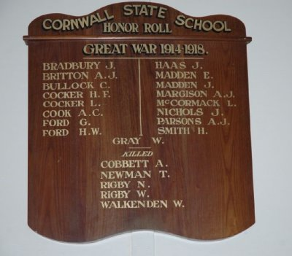
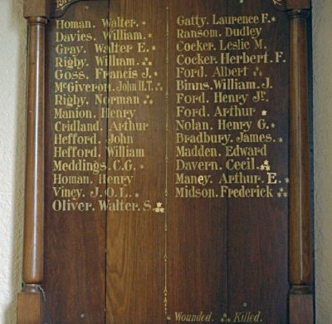
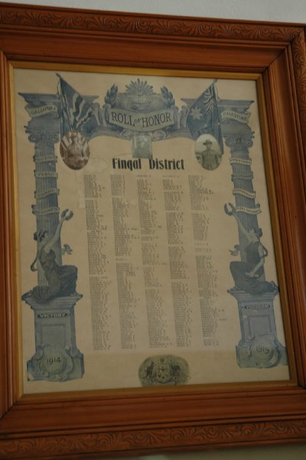
Cornwall State School Honor Roll
Photo sourced from Places of Pride website
St Nicholas Honour Roll marked as wounded
Places of Pride website
Fingal District Honor Roll
Places of Pride website

© Donna Baldey 2023
www.tunnellers.net

