SAPPER ALBERT ROY BOLCH
2892 – 3rd Tunnelling Company

Albert Roy Bolch was born at Kangaroo Flat, Bendigo, Victoria on 2 September, 1893 the son of James William and Kate Ann Bolch. The family moved to Bradshaw’s Creek, Tasmania where he worked as a farmer.

At the recruiting depot at Wirraleah on 24 September, 1915 the single twenty-two-year-old farmer applied to enlist for active service abroad and passed the medical examination. Attestation forms describe him as 179cms (5ft 10½ins) tall, weighing 76kgs (168lbs) with a chest expansion of 92-97cms (36-38½ins) and had a fair complexion with good vision in his blue eyes and fair but inclined to be ruddy hair. Religion was Church of England. Next-of-kin nominated was his father Albert Roy Bolch of Bradshaw’s Creek, Tas. The Oath of Enlistment was signed and taken at Claremont camp on 12 October, 1915.

Acknowledgment to the new recruits was published in the:
Mercury (Hobart) Saturday October 16, 1915:
RECRUITING – TASMANIA
The following are the names of the men (86) who have entered the camp since Sunday:
A.R. Bolch
Article abridged

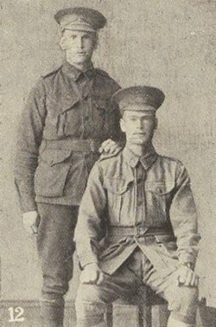
After basic training he was allotted to the No. 3 Company of the Mining Corps on 27 March, 1916 at Claremont camp and were transferred to Broadmeadows camp, near Melbourne three days later. His rank was Sapper with the regimental number 2892.
Spr Albert Roy Bolch (l)
Pte Wm James (r)
Photo from WWIAnzacs.com

Eighty members of the Reinforcements departed on transport HMAT A14 Euripides from Melbourne, Vic on April 4, 1916. During their voyage a port of call for refuelling was Colombo, Ceylon and terminated at the Suez about May 5 where the men were transhipped at Alexandria to the City of Edinburgh. They disembarked at Marseilles, France on May 17, 1916 and on June 1, 1916 marched into Etaples and attached to the 3rd Tunnelling Company on June 25. News of their arrival was recorded in the Unit Diary of the 3rd Tunnelling Company:

“Lieut. J. Thompson joined the 3rd Aust. Tunnelling Company at Laventie on 25/6/16 when he marched into billets with 60 O.Rs. Reinforcements.
The Mine systems of the Red Lamp, Winchester, Colvin, Ducksbill & Sign Post Lane were composed of workings in blue clay at depths from 20 – 35 feet.”

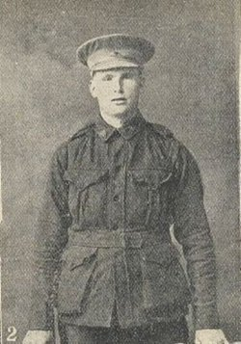
On 5 July, 1916 Sapper was wounded in action but remained on duty. Base Records advised his father on 21 July, 1916.

His photograph was published in the Tasmanian Weekly Courier on 27 July, 1916 in tribute to wounded soldiers.

He was taken on strength with the 3rd Tunnelling Company on 30 September, 1916.

In the list of casualties published his name was among those appearing in the:
Examiner (Launceston) Friday August 4, 1916:
ROLL OF HONOUR
Wounded—Sapper A.R. Bolch, Bradshaw’s Creek Article abridged
Blue Chevrons were issued to wear on his uniform for serving twelve months abroad.

In an audit of the company on 26 April, 1918 was noted to be serving with his unit. He was paid in France on 6 May, 1918.

Leave was granted and taken from 11th to 27th August, 1918.

On 30 October, 1918 Sapper was accidentally injured suffering a gunshot wound to his chest and taken to the 15th Casualty Clearing Station moving to the 2nd Aust General Hospital in Boulogne on November 4. A report from the commanding officer was sent to the Vth Army that the injury occurred accidentally.

On the day Peace was declared Sapper was invalided to England on the hospital ship Pieter de Connick entering the Northampton War Hospital with a non-penetrating shrapnel wound to his chest.

His name appeared in the Casualty List published in the:
Examiner (Launceston) Tuesday December 3, 1918:
INJURED
Spr. A.R. BOLCH, Bradshaw’s Creek, (previously reported wounded) Article abridged

His father was notified by Base Records of his accidental wounding on November 10 and again on November 28 of admittance to hospital in England and was shared in the:
Examiner (Launceston) Saturday December 7, 1918:
WOUNDED
Mr and Mrs Bolch, of Bradshaw’s Creek, have received word from the Base Records that their son, Sapper Albert Roy Bolch, has been admitted to the Northampton War Hospital, England, on November 11, suffering from gunshot wounds in the chest.

Was transferred on 9 December, 1918 to the 1st Aust Auxiliary Hospital in Harefield the discharged to A.I.F. Headquarters on December 12 who granted him furlough. Reported back to London Headquarters on 30 December and then sent to Sutton Veny Depot to await his voyage home.

Sapper Bolch embarked from Devonport, England on 25 January, 1919 for discharge in Australia on board H.T. Delta. Was admitted to the ship’s hospital with Influenza on 2 February and discharged to duty on February 9.

Base Records advised his father on 12 February that he was returning home.

He was among those soldiers listed as returning as reported in the:
North-Eastern Advertiseer (Scottsdale) Friday February 28, 1919:
LOCAL AND GENERAL
NEARING HOME
The troops who returned by the transport Orsova to Hobart have disembarked at the quarantine station.
Invalided per Delta—A.R. Bolch, Bradshaw’s Creek; W. M. Healey, Pyengana.

The troopship docked in Melbourne (3rd M.D.) on 7 March, 1919 with news of their arrival published in the:
Age Tuesday March 11, 1919:
RETURNING SOLDIERS – A BIG DISEMBARKATION
Another large complement of returned Victoria soldiers arrived by the Bay steamer Courier from the quarantine station yesterday. The Ulysses and Delta, which brought the men from England, had on board 450 men and 410 soldiers respectively. Yesterday was the eighth day of the Ulysses in quarantine, but the Delta only reached the station on Friday last. A number of the men on this vessel protested against the quarantining of the Delta, and the protest took formal shape. When the objection was made known to authorities, the order was given the troops should disembark with those on the Ulysses. The decision greatly pleased the men, who longed for home.
It took a large fleet of motor cars to convey them to the “finalisation” depot, where were 3000 of friends and relatives congregated. The soldiers were accorded a rousing reception on passing through the streets and at the depot they were cheered by all. It is a pleasing commentary on the work of the officials at the depot that their duties were discharged at 7 p.m., about 3 ½ hours after the arrival of the Courier. The system at the “finalisation” depot is now so completed that it may be taken as a pattern in the proposed standardisation of similar depots throughout the Commonwealth.
Further news of his arrival in Tasmania on March 13 was reported in the:
Examiner (Launceston) Friday March 14, 1919 and World (Hobart) Friday March 14, 1919:
A.R. Bolch, 3rd Tun. Co. Article abridged

Anglesea Barracks, Hobart (6th M.D.) informed Base Records on 15 April, 1919 with the dates of arrival and discharge and also enclosed his medical records.

Military Discharge was issued in Hobart (6th M.D.) on 28 April, 1919 on termination of his period of enlistment.

In service for his country Sapper 2892 Albert Roy Bolch, 3rd Tunnelling Company was issued with the British War Medal (4040) and the Victory Medal (4029).

He receipted delivery of the Victory Medal on 21 October, 1923 at Bradshaw Creek.

He married in the Church of England at Pioneer on 4 February, 1923 to Dorothy May McLaughlin.
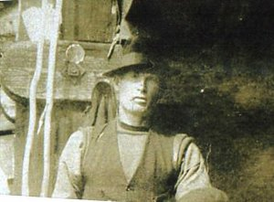
Albert Roy Bolch taken Christmas 1925 Boobyalla bridge
Photo sourced from Ancestry Public Member Tree
Submitted by B. Crockett 22/2/2014
From 1928 to 1936 the couple were listed in Electoral Rolls at Bradshaw’s Creek with his occupation as a labourer.

On 7 April, 1942 he re-enlisted with the Australian Army at Launceston, Tas leaving his occupation as a builder’s labourer and passed the medical examination with a notation of a gunshot wound left side of chest received in 1918 but caused no disability.

He took the Oath of Enlistment on 6 January, 1943 in Launceston.

Next-of-kin nominated was his wife Mrs Dorothy May Bolch of 25s Trevallyn Crescent, Launceston.

His service number was T155525 but no service is recorded for him.

By 1949 they were still living at 25a Trevallyn Crescent, Launceston with the same occupation. In 1954 were listed at 87a Bain Terrace in Launceston West and in 1968 was a timber worker at the same address.

The Hobart Branch of the Repatriation Commission requested copies of his service records from Base Records which were forwarded on 18 March, 1954.

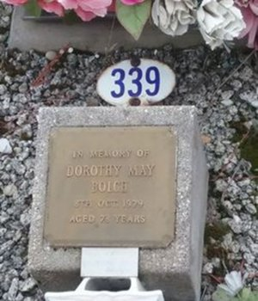
1 Newland Crescent, Launceston West was their address in 1972 and he was a timber worker.
Photo sourced from
Find-a-Grave website

Mrs Dorothy Bolch died on 8 October, 1979 at 78 years of age and her ashes were scattered at Carr Villa Cemetery, Launceston and has a memorial plaque at A3 position 339 in the memorial section.

Albert Roy Bolch passed away aged 92 years on 30 October, 1985 in Launceston with cremation taking place at Carr Villa Crematorium, Launceston and his ashes were collected. There is a family notation that they were taken to St Alban’s Church of England Cemetery at Ringarooma, Tas but no records can prove this at this time.

His service is commemorated on the Pioneer Anglican Church Honour Roll held at the Pioneer Memorial Hall.
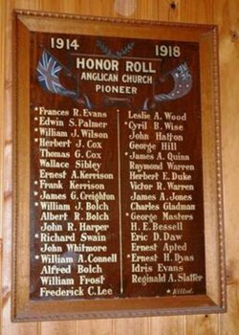
Honour Roll of Anglican Church at Pioneer, Tas
Photo sourced from Virtual Anzacs Memorial website

© Donna Baldey 2024
www.tunnellers.net

