SAPPER NORMAN BERRIGAN
3492A – 1st Tunnelling Company

Norman Thomas Berrigan was born in Albury, Victoria in 1888 the son of Thomas Philip and Theresa Mary Ann (nee McGarr) Berrigan. In 1913 he was working as an assistant storekeeper and draper in Drillham, via Miles, Queensland and in 1915 was a labourer at Bowenville Station, Dalby.

At the Darling Downs Central Recruiting Depot in Toowoomba on 1 October, 1915 the single twenty-six-year-old labourer applied to enlist for active service abroad and passed the medical examination. Attestation forms describe him as 165cms (5ft 5ins) tall, weighing 50.9kgs (112lbs) with a chest measurement of 89cms (35ins) and had a dark complexion with blueish eyes and brown hair. Roman Catholic was his religion.

Next-of-kin nominated was his father Thomas Berrigan of Forsyth Street, Wagga Wagga, NSW. He took and signed the Oath of Enlistment the same day.

Acknowledgment to the new recruits was published in the:
Darling Downs Gazette (Saturday October 2, 1915:
THE CALL – DOWNS’ RESPONSE – 25 MORE VOLUNTEERS
Captain H.D. Hall advises that up to one o’clock yesterday 25 volunteers were accepted as the Toowoomba Depot, and that in all 29 men presented themselves, four being found unfit. Three of those accepted being to Toowoomba. The West was largely represented. Those accepted were:
OTHER CENTRES
NORMAN BERRIGAN, Bowenville Article abridged

After basic training at Enoggera Barracks, Brisbane was allotted to the Tunnelling Corps on 4 March, 1916.

The recruits forming part of the No. 4 Tunnelling Company embarked from Brisbane, Qld early in May, 1916 aboard HMAT A69 Warilda for Sydney, NSW. Six officers and 152 other ranks together with the 1st Reinforcements of fifteen other ranks made up the two sections.

At Rosebery Park, Sydney, NSW on May 11 they joined their Headquarters and two sections (8 officers & 153 O.Rs.) plus 1st Reinforcements consisting of one officer and seventeen other ranks for final training. The rank of Sapper and the Regimental number 3492 in No. 4 Company was assigned to him. He did not embark with the Tunnelling Companies and was still at Rosebery Park on 1 June, 1916. Was transferred on 5 July to their training camp in Seymour, Victoria and assigned to the 4th Reinforcements to the Tunnellers.

The 81 Reinforcements embarked on the transport RMS Orontes on August 16, 1916 from Melbourne, Vic. The mail ship sailed to Adelaide, S.A. then Fremantle, W.A departing on August 23, 1916. After leaving the stormy Australian coast the vessel docked at the African ports of Durban, Capetown and St Vincent and after fifty-two days at sea of generally fine and mild weather arrived at Plymouth, England on October 2, 1916. They were detrained to Tidworth and marched in to No. 3 Details Camp for further training for the front.

The Reinforcement proceeded to France on 15 October, 1916 arriving at the Aust General Base Depot in Etaples the following day. Sapper marched out to join his unit on 21 November and taken on strength with the 1st Tunnelling Company two days later in the field in Belgium working on the Hill 63 dugouts near Bailleul.

The reinforcements were officially transferred to the 1st Tunnelling Company on 24 December, 1916. On 10 January, 1917 was re-allotted the regimental number 3492A.
On 11 January, 1917 went sick to the 3rd Casualty Clearing Station and diagnosed with pulmonary tuberculosis in both lungs and sent on the Ambulance Train no.18 to the 13th General Hospital in Boulogne the next day in Ward B, bed no.20.
Medical notes while there were:

History of Case: Chest wasting. Flattening of chest at both apexes. Slight raising of temp.
at night.
Report on X-ray: Tubercule both sides, well-marked, narrow centre right-hand side level of
3rd rib toward sternum, probably a cavity.

Was invalided to England on 30 January, 1917 with bronchitis on the hospital ship Jan Breydal from Boulogne and admitted to the Bermondsey Military Hospital with pulmonary disease on February 1. During his 21 days there his medical notes reported:

Phthisis (old name for TB) probably old with recent infection. Sputum not examined
whilst here. Gained in weight, improved in every way whilst here.

Was transferred to the 3rd Aust Auxiliary Hospital in Dartford on February 21 spending a further 33 days a patient with notes as:

Phthisis & physical deficiency. Very small built, weight 52kgs (115lbs). No special treatment.

He appeared before the medical board on 23 March, 1917 and his Statement of Case reads:
Disability: Phthisis & Physical debility
Date of disability: early in Dec. 1916
Place of disability: Ypres,
Essential facts: as above, had a cough which gradually became worse. Evacuated 12/1/17
cough, debility, wasting. Moist sounds both apexes, T99-100 at night. No
TB found. X-rays show “tubercule both sides”; well-marked towards centre of right side, level 3rd rib toward sternum, probably a cavity.
Board opinion: Infection
Causation: Much aggravated by active service
Present condition: Usual weight 63.6kgs (140lbs) – present weight 52kgs (115lbs)
Chest – slight dullness in percussion opposite 5th D.V. post, otherwise
nothing definite. Chest badly formed “pigeon breast.” No TB found in
sputum. Small built & not by on strong enough to carry equipment
Recommendation: Change to Australia
Board’s opinion: Pre-existing
Aggravated by: Active service
Permanent: Yes
Board finding: permanently unfit for general service; unfit temporarily for home service
23/3/17
Approved: 17/4/17

A discharge to furlough followed on 26 March and to report to the No. 2 Command Depot at Weymouth on 8 April. Marched in as ordered.

Sapper Berrigan embarked for a change to Australia due to phthisis and physical deficiency on the H.T. Miltiades on 4 May, 1917 from Devonport, England. His berth for the voyage was a hammock.

Base Records would have advised his next-of-kin that he was returning home.

His mother wrote to Base Records from Forsyth Street, Wagga Wagga, NSW on 11 June, 1917 asking if they could please inform if her son had arrived in Australia on the 2nd instant. She received a statement from their office saying he was being returned to Australia.
Could they tell her if he arrived on the boat east Saturday? If not have they any idea when he will arrive as he wanted to meet him. He enlisted in Brisbane. Would it have to be necessary for him to go there to get his discharge? Hoping you can give me information.

Base Records replied to her on 16 June, 1917 advising that the transport her son is returning has not yet arrived in Australia. No information can at present be disclosed, but when the transport is nearing Australia, a list of those returning will be published in the Press, and subsequently the probable date of arrival will appear. It is the practice in cases where members of the Force are being returned to Australia for such men to proceed to the district in which they enlisted, but if they themselves desire it, approval is given for them to land at an immediate port in Australia, where their relatives reside, only provided the soldier of his relatives will undertake the cost of his return to the district in which he enlisted, when he is required to join his Unit. In your son’s case it will be required to make application to the military commandant, Victoria Barracks, Paddington, NSW in the matter.

His name was among those listed as returning published in the:
Queenslander (Brisbane) Saturday July 7, 1917:
WOUNDED OR ILL – MORE SOLDIERS RETURNING
The military authorities supply the following list of members of the Australian Imperial Force returning to Australia shortly.
3492 Norman Berrigan, 1 T. Co. Article abridged

The troopship docked in Melbourne (3rd Military District) on 2 July, 1917 with news of their arrival reported in the:
Age (Melbourne) Monday July 2, 1917:
WOUNDED RETURNING – DISEMBARK THIS MORNING
Two contingents of Australian soldiers, wounded and invalided from abroad, will disembark to-day, come at 10 a.m., when 593 will land, comprising of 360 Victorians 108 South Australians and 48 Tasmanians; the other at 11.30 a.m. This contingent totals 268, consisting of 240 Victorians and 36 Tasmanians. The usual route of procession will be followed. The first procession should reach the city at about 11.16, the second about 12.30. Our owners who have been telephones by the Royal Automobile Club and have promised assistance, are notified to assemble at 10 a.m. and 11.30 a.m. respectively at the new pier (not the usual pier), which may be reached through Graham-street railway gates. The inter-State men will be accommodated at the Red Cross Rest Rooms, Wirths’ Park, and South Australians will leave by special train during the afternoon.

The Queenslanders returned by special train to Brisbane (1st M.D.) to a welcome home at the station on July 6 and covered by the:
Brisbane Courier Saturday July 7, 1917:
RETURNED SOLDIERS – TWO BIG DRAFTS
No fewer than 263 returned soldiers—a fourth of them wounded, the rest sick—came back to Brisbane yesterday, and received a warm welcome from the citizens. Well they deserved it. At the Kangaroo Point Military Hospital tables were set out, beautifully decorated with flowers and laden with dainty fare, the handiwork of the ladies of the Red Cross Society. The soldiers arrived in two batches, the first trainload reaching Central Station soon after 5 o’clock and the second coming in about two hours later. In each instance the men were motored over to Kangaroo Point, where the Minister for Mines, on behalf of the Government and State in in the first instance and Minister for Education in the second instance, and the Mayor on behalf of the citizens extended to them the heartiest of greetings. Article abridged

At the No. 6 Aust General Hospital, Kangaroo Point was admitted on arrival on 6 July with Phthisis remaining as a patient until 1 August, 1917 appearing before the Medical Board.

Notations were:
Board finding: Pulmonary Tuberculosis
Board recommends: Discharge
Incapacity: Total 6mths

He was sent to the Staff Officer for Invalid & Returned Soldiers for disposal.

Military Discharge was issued in Brisbane (1st M.D.) on 14 August, 1917 as medically unfit.

He was issued with a Military Pension to his Wagga Wagga address from 15 August, 1917.

The War Service Homes Commission wrote on 29 October, 1919 to Base Records as he had applied for assistance under the War Service Homes Act and requested a copy of his service. He was residing at Best Street, Wagga Wagga. Records replied on 1 November giving details of his service as requested.

He was still listed in the Electoral Rolls from 1919 to 1925 at Bowenville Station, Dalby as a labourer.

In 1930 was at Norman Street, South Wagga and a soldier. In 1931 lived at 28 Monitor Road, Merrylands and a pensioner and a year later had moved to 327 Western Road, Wentworthville.

By 1933 was back at Merrylands at Strathaven on Holroyd Road and in 1934 was at Oatland Street, Wentworthville giving no occupation. 153 William Street Granville was his next residence in 1936 and a year on was at Palm Avenue, Harbord.

In 1943 was at 18 La Perouse Street, Balgowlah with no occupation.

Norman Berrigan passed away on 17 July, 1946 aged 59 years. Arrangements were published in the:
Sydney Morning Herald Thursday July 18, 1946:
DEATHS
BERRIGAN—July 17, 1946 at Sydney, Norman Thomas Berrigan, late 6th Div, 1st A.I.F. and of 18 La Perouse Street, Balgowlah, dearly beloved brother of Veronica, Gertrude, Hubert, aged 59 years, R.I.P.
FUNERALS
BERRIGAN—The Relatives and Friends of the late Norman Thomas Berrigan (late 1st A.I.F.) are kindly invited to attend his Funeral, to leave the Mary Immaculate Church, Whistler Street, Manly, This (Thursday) Afternoon, at 2 o’clock, for French’s Forest Cemetery.
F TIGHE and CO., Manly

Interment took place in the Roman Catholic portion of French’s Forest Cemetery, within sub-section F2 in grave no. 33.

An Obituary was placed in the:
Daily Advertiser (Wagga Wagga) Wednesday August 7, 1946:
MR N. BERRIGAN
The death occurred in Sydney recently of Mr Norman Berrigan, of Manly, and formerly of Wagga, at the age of 50 years after a long illness. He was attached to the Sixth Division of the First A.I.F., and was for many months in action in Hill 60. He was the elder son of the late Mr Thomas Berrigan, of Wagga, who predeceased him some years ago. He is survived by two sisters, Mrs G. Chalker, of Wagga, and Mrs M. Larkin, of Manly, and one brother, Mr R.L. Berrigan of Wagga. The funeral took place in Sydney, the cortege leaving the Immaculate Church, Manly, where the Rev. Father O’Donnell officiated.

He has a Commonwealth War Grave and his name is also commemorated on the Corryong State School No.1309 Honor Roll.

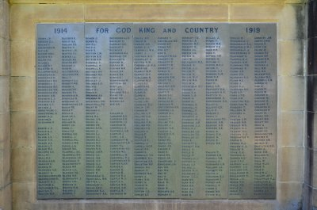
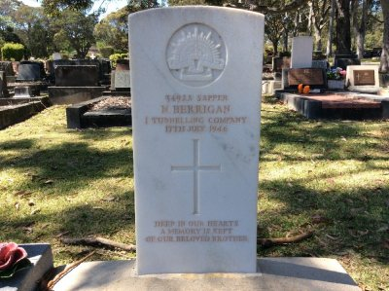
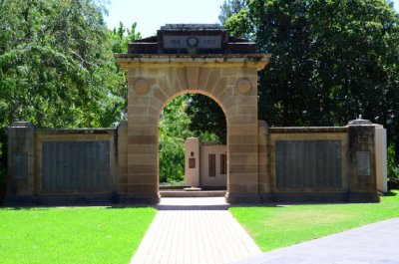
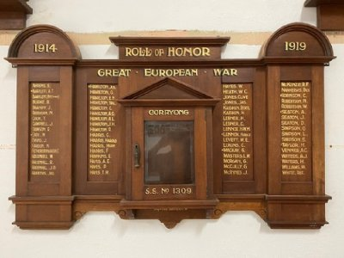
His Commonwealth War Grave in French’s Forest Cemetery, Sydney, NSW
Photo supplied by Dept of Veterans’ Affairs and used with permission
And also on the Wagga Wagga Memorial Arch
Memorial Arch and Plaque, Wagga Wagga, NSW
Photo sourced from
Virtual Anzac Website supplied by Henry Moulds
Corryong State School Roll of Honor – RSL Corryong-Towong
Photo sourced from Virtual Anzacs website

© Donna Baldey 2023
www.tunnellers.net

