SAPPER HENRY BEAUMONT
7184 – 2nd Tunnelling Company

Henry Beaumont was born at Longford, Tasmania on 29 July, 1887 the son of George and Elizabeth (Fanny) Austin. He was educated at the local State School.

In 1908 at the Baptist Church, Blackwood Creek he participated in a Band of Hope meeting which was reported in the:
Examiner (Launceston) Monday June 15, 1908:
COUNTRY NEWS – BLACKWOOD CREEK
A Band of Hope meeting and coffee supper took place at the Baptist Church, Blackwood Creek, on Wednesday, when in spite of the unpropitious weather, there was a good attendance. Pastor Gilbert E. Moore was in the chair. The following contributed to the programme: Mr Bernard Gordon, Misses Beulah Reese, Daisy Philpot, Messrs Isaac Goodie, Percy Gadsby, Cuthbert Tubbs, Mrs E. Rodgetts, Miss Bertha Beaumont, and Messrs William Reese, Henry Beaumont, Edward Adams. Selections on a phonograph, kindly lent by Mrs Bert Walsh, of Snake Banks, were given during the evening. A comprehensive vote of thanks to all who had assisted, and to the ladies who had provided the coffee supper was carried by acclamation. Supper was then handed round, and brought a very enjoyable evening to a close.

He tendered for a lease in Longford and acceptance was published in the:
Examiner Saturday March 5, 1910:
LONGFORD
The following tenders were acceptable—Eleven chains forming Blackwood creek-road, Henry Beaumont £1 7s per chain, five chains metalling from Francombes gate, Article abridged

At the local council meeting he applied for permission with proceedings published in the:
Daily Telegraph Saturday October 29, 1910:
LONGFORD
The monthly meeting of the Longford Municipal Council was held at the Council Chambers of Friday.
A letter was read from Mr Henry Beaumont, of Blackwood Creek, asking for permission to hold a dance in the schoolroom on November 9 for the use of which he would pay 10s. The letter was ordered to be sent to the Minister of Education.

In 1914 was working as a labourer at Blackwood Creek as listed in the Electoral Roll. It has been said that he was working as a miner with his brothers at Tullah before he decided to enlist.

At the recruiting depot at Tullah the twenty-nine-year-old miner applied to enlist for active service abroad and passed the medical examination on 11 October, 1916. Attestation forms describe him as177cms (5ft 10½ins) tall, weighing 65.5kgs (144lbs) with a chest expansion of 87-92cms (34-36ins) and had a fair complexion with good vision in his blue eyes and fair hair. Church of England was given as his religion. Next-of-kin nominated was his father George Beaumont of Blackwood Creek, Tas. He took and signed the Oath of Enlistment on 11 November, 1916 at Claremont camp.

Acknowledgment to the new recruits was published in the:
North Western Advocate and the Emu Bay Times Saturday November 11, 1916:
ENTERED CAMP AT CLAREMONT
HOBART, Friday To-day 20 men entered Claremont Camp, Tasmania is now 45 behind their October quota.
The following are the names of the men (15) who entered the Claremont Camp on Thursday:
H. Beaumont, miner, Longford. Article abridged

Basic training commenced with the 1st Depot Battalion, Claremont camp (6th Military District) from 9 November, 1916. During final home leave he was given a send-off which was reported in the:

Daily Telegraph (Launceston) Monday December 4, 1916:
BLACKWOOD CREEK
A large gathering assembled on Tuesday last at the Baptist Church to bid farewell to Henry Beaumont and T. Smith, who were on final leave from Claremont. Some nice, useful gifts were presented to them by Pastor Philp, on behalf of the residents, who wished them both a safe return.
Companies 1 and 2 of the Depot Battalion were sent for further training to the Miners camp at Seymour, Victoria and allotted to the February, 1917 Reinforcements to the Tunnelling Companies on 10 February, 1917.

He went sick on 18 February, 1916 to Seymour Clearing Hospital suffering diarrhoea and sent to the Rest Room and returned to the lines on February 22.

In preparation for departure his Will was noted by military authorities to be lodged with his brother Walter Beaumont, Blackwood Creek, Tas. His rank was Sapper with the regimental number 7184.

His name was included in the Roll of Honour for the four local Baptist Churches inscribed with the men associated with these churches and unveiling took place and reported in the:

Examiner (Launceston) Saturday April 14, 1917:
BAPTIST ROLL OF HONOUR
On Sunday evening last a special service was held in the Bracknell Baptist Church, the occasion being the unveiling of the roll of honour, on which are inscribed the names of the young men associated with the four Baptist Churches—Bracknell, Blackwood, Cluan and Liffey—who are now on active service. The church was crowded, and Pastor Philp preached an appropriate sermon. Taking as his text the words occurring in Kipling’s Recessional Hymn, “Lest We Forget,” the preacher sought to point out that the act of volunteering entailed suffering, discomforts, wounds and death. The result of volunteering will ultimately bring salvation, a deliverance from a world menace, an entering into a new era, in which peace will be preeminent. At the close of the sermon Pastor Philp unveiled the roll of honour which is beautifully designed in blackwood on which are the following names:
H. Beaumont Article abridged
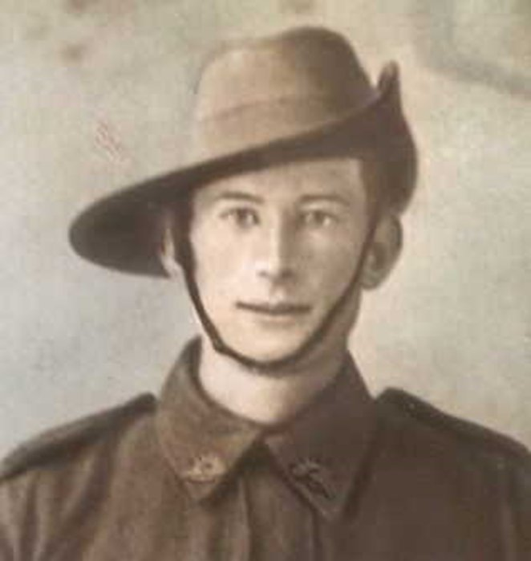
The transport HMAT A9 Shropshire embarked from Melbourne, Vic on May 11, 1917 with 168 members of the February Reinforcements on board. Sapper Beaumont left Australian waters from Fremantle harbour and after crossing the Indian Ocean the ship docked at Durban, South Africa. Next Port-of-call was Capetown to refuel about June 21, followed by another stopover at an unrecorded harbour would have completed the trip-sheet. After being at sea for 70 days the voyage terminated at Plymouth, England on July 19, 1917. The three officers and 165 other ranks were detrained to Tidworth while two were hospitalised at Plymouth and the remainder marched into the Details camp at Parkhouse for further training for the front. The Reinforcements proceeded to France on 18 August, 1917 from Southampton arriving at the Aust General Base Depot in Rouelles a day later.
Sapper Henry Beaumont
Photo sourced from Ancestry
Public Member Tree Beaumont
submitted by currie18 on 14/6/18

On 3 September marched out to the 1st Anzac Entrenching Battalion which was an advanced section of the Base Depot that organised works near the lines and through duties, usually of ten days duration, would accustom the reinforcements to war conditions before being assigned to a company in the field.
On 1 October, 1917 was attached to the 2nd Tunnelling Company who were working at Nieuport Bains sector to the extreme left of the British line on the Belgian Coast with the unit camped at St Idesbalde in the sand dunes. Sections of the company that month were working on an Infantry subway, advanced divisional headquarters and numerous machine gun positions.

Blue Chevrons were issued to wear on his uniform for serving twelve months abroad.

On 30 November 1917 was taken on strength with the company.

Leave was taken from 11 March, 1918 and returned to the Aust General Base Depot at Rouelles on 3 April then returned to his company on April 19.

He was with his unit when Peace was declared and the Tunnelling companies remained on the front as part of the Army of Occupation assisting with rehabilitation of their districts by clearing roads and bridges of booby traps and delayed action mines.

The Unit Diary recorded the following:

“The Company moved to CHARLEROI on February 16th arrived at MARCHIENNE-au-PONT at 14 hours, and stationed Headquarters at 89 Rue de Beaumont, finding excellent accommodation for billeting, the Civilians being exceptionably hospitable. The work of the Company consisted mainly of searching for mines along Railway Lines and taking out charges, afterwards filling in 12 shafts and securing Bridges”.

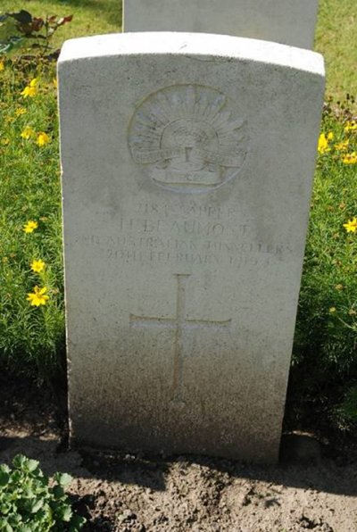
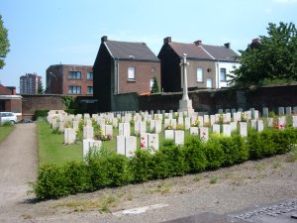
Sapper went sick on 17 February, 1919 to the 20th Casualty Clearing Station suffering influenza and placed on the dangerously ill list a day later. He died the next day on 20 February, 1919 aged 31 years. Interment took place in Charleroi Communal Cemetery, Belgium in plot 1, row C.
Photo of Charleroi Communal Cemetery, Belgium
by kind permission of
The War Graves Photographic Project www.twgpp.org

His Commonwealth War Grave
Photo sourced from Tasmanian War Casualties website

The 6th Military District was advised on 3 March, 1919 that the soldier had died on 20 February, 1919 and were investigating the cause of death. Confirmation of receipt of the cable was returned the same day.

Military authorities advised his father on 6 March and the following news was shared in the:
Zeehan and Dundas Herald Friday March 7, 1919:
DEATH OF SAPPER H. BEAUMONT
Mr George Beaumont received the sad advice by telegram yesterday of the death of his brother, Sapper Henry Beaumont. The telegram contains no particulars further than that he “died at the front,” who was a single man aged 32, enlisted in 1916 at Tullah, and during the two years on active service he enjoyed splendid health, and passed through many engagements without further harm than being buried in a trench, from which he was ultimately extricated without injury. When the telegram reached Zeehan on Wednesday, Mr George Beaumont was reading a letter from Sapper Henry, dated at Charleroi, in Belgium, December 25, 1928, wherein he stated he was in splendid health and marching into German territory.

His father wrote to Base Records on 7 March, 1919 from Blackwood Creek, Bracknell, Tas saying he received their cable to say his son Henry Beaumont had died on 20 February, 1919 and not stating the cause of death or where it occurred. Would they forward him how he came by his death and all details. His son was a brave boy and dearly loved by them all. It had come as a great shock considering the war was over and were making preparations for his return every day. It was a heavy cross to bear now as he was so lucky through the war. Would they oblige him by sending any word they could as his wife and family were most anxious. Trusting they would not fail. Yours very sincerely.

A copy of his service records was made for the Pension Department and the cause of death was named as broncho-pneumonia on 12 March, 1919.

Base Records replied to Mr Beaumont on 18 March, 1919 concerning the regrettable loss of his son and stated that advice was now to hand to the effect that he was admitted, dangerously ill, on 10 February, 1919 to the 20th Casualty Clearing Station, where he died the following day, cause of death being broncho-pneumonia. It was anticipated that official confirmatory documents coming to hand shortly by mail will contain fuller details, and these will be promptly communicated to him.

His name was listed in the Tasmanian Casualty List published in the:
Examiner (Launceston) Tuesday April 1, 1919:
DIED, OTHER CAUSES
Spr. H. BEAUMONT, Blackwood Creek, 20.2.19 (illness) Article abridged

The military paymaster, 6th Military District, Anglesea Barracks, Hobart advised in reply to Base Records about the original Will of the abovenamed deceased and that necessary action had been taken. On 12 April, 1919 the paymaster 6th Military District forwarded a checked copy of his Will to Base Records who replied on April 21 in receipt of the Will. He bequeathed his Estate to his brother Walter Beaumont.

The A.I.F. Kit Store, Hammersmith, London prepared an inventory of his personal effects from the field and placed them in a parcel containing the following items:

2 watches damaged, 2 watch chains, 1 pencil in case, 1 fountain pen, 1 pocket knife, numerals, badges, 1 safety razor and blades, 2 shaving brushes, 1 key, tobacco box, metal sovereign case, 1
Disc, 2 razors, 1 Aussie wallet, metal brooch, 1 religious medallion, photos, letters, note book, 4
Notebooks, 4 notes valued 5 francs, coins.
£1.12.0 & 35 francs have been forwarded to Chief paymaster, A.I.F. Headquarters, London to be combined with monies due and credited to Sapper Beaumont’s Ledger Account. The parcel was consigned on the transport Boonah.

His personal effects were received by Base Records who posted them to his father on 10 August, 1919.
The National Mutual Life Association requested a Certificate of Death from Base Records this was prepared on 17 May, 1919 and sent but they had to return the Certificate on 28 June and the certificate had been sent unsigned. Records apologised for their omission when they returned the Certificate on 10 July, 1919.

The district paymaster, 6th Military District wrote on 17 June, 1919 to Base Records to certify that the Public Trustee, Hobart, Tasmania had been requested to administer the above Estate.

On 30 June, 1919 Base Records was requested by the 6th Military District to forward them a Certificate of Death in connection with this soldier. This was done the same day by Records.

The circular and booklet re graves was sent to his father on 1 December, 1919 and a reminder went out on 30 April, 1920.

Mr G. Beaumont was advised by Base Records on 24 June, 1920 that his son was buried in Charleroi Communal Cemetery.

On the first anniversary of his death the following was placed in the:

Examiner (Launceston) Saturday February 19, 1921:
IN MEMORIAM
ON ACTIVE SERVICE
BEAUMONT—In affectionate remembrance of our dear son and brother, Sapper Henry Beaumont, A.I.F., died in Belgium, of pneumonia on the 20th February, 1919.
Just two years ago today
Since our loved one fell asleep;
God only knows our sorrow
In our hearts the wound is deep.
He had seen the battle through,
Soon we thought we’d see his face
But God saw fit to call him,
No other could take his place.
In a Belgian grave he’s lying,
Where our thoughts will always be,
No flowers we can take—
It’s too far across the sea.
—Inserted by his sorrowing mother, father, sisters and brothers, Blackwood Creek.
For his supreme sacrifice Sapper 7184 Henry Beaumont, 2nd Tunnelling Company was issued with the British War Medal (58923) and the Victory Medal (57843) in serving his country.

The War Medal was sent on 17 June, 1921 to the Commandant 6th Military District for distribution to his father.
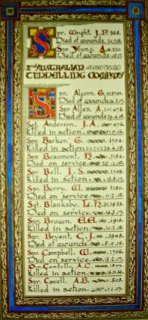
Sydney Morning Herald - Saturday 23 July 1921:
ENGINEERS' ROLL OF HONOUR
The Royal Engineer War Memorial Committee are arranging to deposit a roll of honour of all ranks of the Royal Engineers whose names were officially published as killed in action or died of wounds or disease in the war in the chapel of St. Paul's Cathedral, and the Engineer corps of the dominions, colonial, and Indian armies have been invited to deposit similar rolls of honour in St. Paul's, to be attached to that of the Royal Engineers. This invitation has been accepted in Australia. The roll will be inscribed on vellum and enclosed in a casket of Australian timbers to rest on a slab of Australian marble.

This extract from Tunnellers Roll of Honour included in profile with the kind permission of the
Dean and Chapter of St Paul’s Cathedral, London
Photos courtesy of Robin Sanderson, Paris

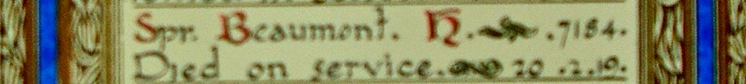

The pamphlet Where the Australians Rest went out to Mr Beaumont on 30 June, 1921 followed by the Memorial Scroll (355529) and King’s Message on 2 July, 1921.

Photographs of his grave in triplicate were transmitted to his father on 21 November, 1921.

In the Memorial Column on the second anniversary of his demise his family placed this notice:
Examiner (Launceston) Monday February 20, 1922:
IN MEMORIAM
BEAUMONT—In affectionate remembrance of our dear son and brother Sapper Henry Beaumont, A.I.F. died in Belgium, of pneumonia, on the 20th February, 1919.
Just three years ago today
Since our loved one fell asleep;
God only knows our sorrow
In our hearts the wound is deep.
He had seen the battle through,
Soon we thought we’d see his face
But God saw fit to call him,
No other could take his place.
In a Belgian grave he’s lying,
Where our thoughts will always be,
No flowers we can take—
It’s too far across the sea.
—Inserted by his sorrowing mother, father, sisters and brothers, Blackwood Creek.

The Memorial Plaque (355529) was also sent on 9 October, 1922 also to his father.

His grieving family again placed the following Memorial for the 3rd Anniversary as follows:
Examiner (Launceston) Tuesday February 20, 1923:
IN MEMORIAM
BEAUMONT—In affectionate remembrance of our dear son and brother Sapper Henry Beaumont, A.I.F. died in Belgium, of pneumonia on the 20th February, 1919.
Just four years ago today
Since our loved one fell asleep;
God only knows our sorrow
In our hearts the wound is deep.
He had seen the battle through,
Soon we thought we’d see his face
But God saw fit to call him,
No other could take his place.
In a Belgian grave he’s lying,
Where our thoughts will always be,
No flowers we can take—
It’s too far across the sea.
—Inserted by his sorrowing mother, father, sisters and brothers, Blackwood Creek.

On 24 May, 1923 forwarded by registered post (no.2279) for Mr G. Beaumont was the Victory Medal.

The Hobart Branch of the Repatriation Commission requested a copy of his service records from Base Records which were forwarded on 1 July, 1931.
The Register Form was despatched to Mr Beaumont of the Charleroi Cemetery on 18 February, 1932.

His name is commemorated at the Australian War Memorial, Canberra, ACT in the commemorative area on panel 26.

His service is also recognised on the Longford War Memorial.

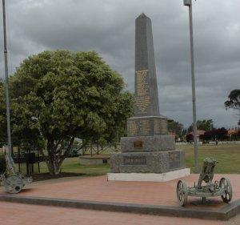
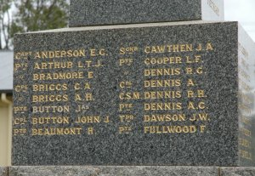
Commemoration of his name on the
Longford War Memorial, Tas
Photos sourced from Memorials Australia
submitted by Arthur Garland
LEST WE FORGET

© Donna Baldey 2024
www.tunnellers.net

